Full Name |  |  | Date
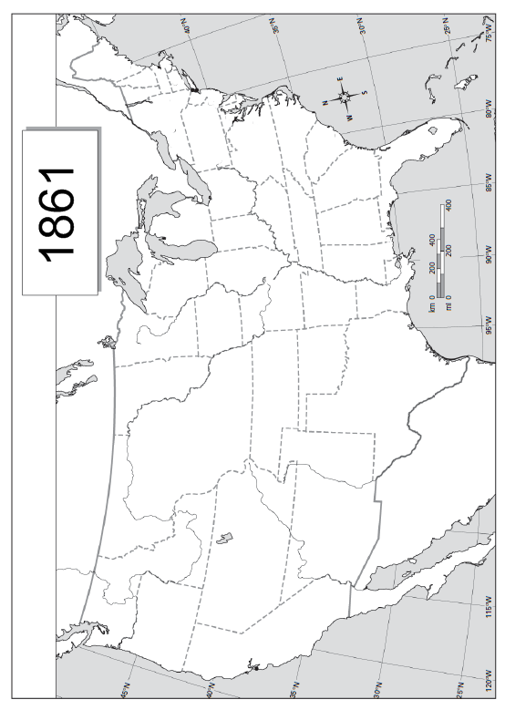
United States of America:1861
Shade in the states that made up the United States of America in 1861.

