Full Name |  |  | Date
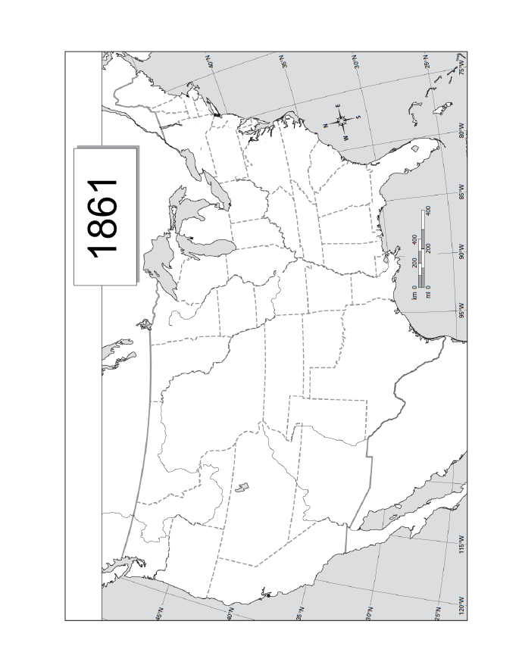
Confederate States of America:1861
Shade in the states that made up the Confederate States of America in 1861.

