Shark Seeker Worksheet:

On a separate piece of paper, please redraw and label the anatomy of the shark.

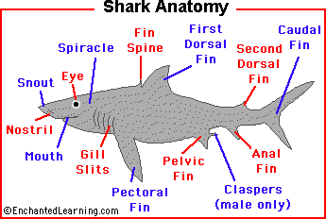

Answer the following questions. All answers need to be in complete sentences. These questions will be used in writing the overall group paper for the presentation.

- How long have sharks been around?
- Where can sharks be found?
- What are the ranges in shark sizes?
- Are sharks a type of fish? If yes, which type?
- How many teeth can sharks have?
- Which type of shark can swim the fastest?
- What is a shark’s skin like?
- Can sharks swim backwards?
- Around how many different species of sharks are there?
10. Which sharks are the most dangerous to people?

