Endangered Creature Chaser Worksheet:

Color the following drawing. Color each important area on the sea lion’s body a different color.

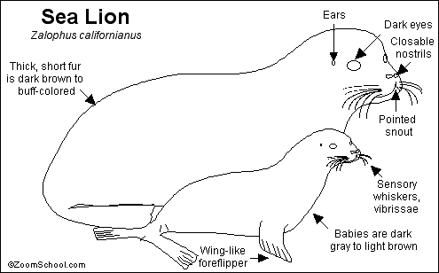

Answer the following questions. All answers need to be in complete sentences. These questions will be used in writing the overall group paper for the presentation.

- When is an animal considered endangered? ________________________________________________________
- If a sea animal is endangered, can you still hunt it or catch it to eat or to use in production? _______________________________
- List 3 marine animals that are currently considered endangered _________________, ________________, and ________________
- When was the Sea Lion added to the “endangered” list? ______
- Is it true that many types of whales are endangered and have been for quite a long time? _______________________________
- Current marine biologist are now concerned that 2 animals will become endangered. What are those 2 sea animals? ________________ and ______________
- List two ways you can help keep endangered sea animals safe _______________________________________________________ and ____________________________________________________
- Is it true that over time more animals are endangered than in the part? _______________________________________________
- Do human’s recreational activities have any influence in the death of these animals? __________________________________
10. List 2 important facts about endangered sea animals. __________________________________________________________ and ______________________________________________________

