Mammal Discoverer Worksheet:

Please label the part of the follow mammal and identify which mammal it is.

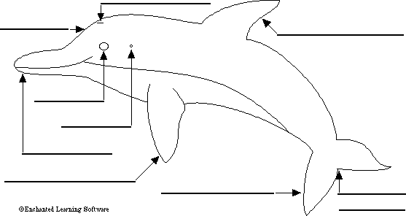
beak - the elongated part of the mouth and jaws
blowhole - the hole on the top of the head through which the dolphin breathes air (it is the dolphin's nostril)
dorsal fin - the fin on the upper side of the body
ear - hearing organs located on the head behind the eye
eye - sight organs located on the head
fluke - one half of the tail
flipper - one of a pair of wide, flat forelimbs that is used for swimming
median notch - the indentation between the two flukes
melon - the rounded structure in the top of the dolphin's head just in front of the blowhole

Answer the following questions. All answers need to be in complete sentences. These questions will be used in writing the overall group paper for the presentation.

- Name 3 types of mammals: _________________________, _________________________, and ________________________.
- The manatee is also known as the ______________.
- Describe the Beluga Whale in 1 sentence. ______________________________________________________.
- How do dolphins swim? ________________________________.
- What do bottlenose dolphins like to eat? __________________.
- The Sea Lion is a type of ______________.
- What so Sea Lions like to eat? ____________________________.
- Name 5 types of animals that are considered sea mammals. _________________ , ____________________, _______________, _____________________, and ____________________
- Is the polar bear considered a sea mammal? ________________
10. Please list one interesting fact about all sea mammals. ____________________________________________________________________________________________________________________.

