Coral Reef Hunter Worksheet:

Color the following drawing. Color each different part of the coral are different color.

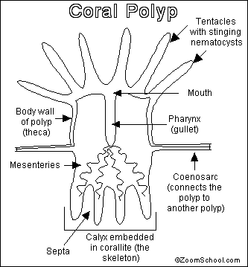

Answer the following questions. All answers need to be in complete sentences. These questions will be used in writing the overall group paper for the presentation.

- What are corals? ________________________________________________________________________________________________________________
- What are the 2 types of coral? ____________ and ____________
- Where are corals found? __________________________________
- What is the life cycle of a coral like? ________________________________________________________
- What do corals eat? ______________________________________
- At what rate do corals grow? ______________________________
- What are the three classifications of coral? __________________, _________________, and ___________________
- Where do corals reefs grow? ______________________________
- Are coral reefs being threatened? If yes, by what? ______________________________________________________
10. List 2 additional and interesting facts about coral. __________________________________________________________ and ______________________________________________________

