The
ABC’s of
SST



By: Leah Goodnoe
SST Defined:



The Student Support Team is a regular education, problem-solving process that was designed to provide support for students who are having developmental, academic, behavioral, and/or emotional difficulties that interfere with their educational progress and/or disrupt the school environment.
Academic Progress



When students fail to perform at grade- level they are identified as needing extra help in order to achieve academic proficiency.

Behavior



When students exhibit behaviors that interfere with their learning process or the ability of their classmates to learn, the student can be referred for SST.

Conference



Meetings between two parties, to discuss and make recommendation strategies for helping students reach their greatest academic potential.

Differentiation



Sometimes a teacher must modify his/ her lessons in order to meet different learning styles and different learning abilities.

Evaluation

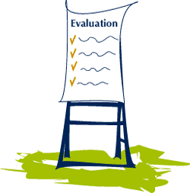

An evaluation is anything that assesses student learning. It can be formal or informal.

Feedback



Students need immediate and consistent feedback to insure they stay on the correct academic path.

Guidance



One role of the teacher is to provide guidance in order for the student to reach their full academic potential. Students must know expectations and procedures for reaching their academic goals.

Home Support



Home support can be the defining factor that leads to success or failure of the student. Parents have a lifetime responsibility, while teachers only have the student for a year.

Identify



In order to best educate students, one must be able to identify strengths and weaknesses of the learner.

Juggle



To maintain an efficient and effective learning environment, teachers must learn to juggle all different types of learners.

Kinesthetic



A kinesthetic learner needs hands-on materials in order to grasp new concepts.

Learning



There are several different learning styles and abilities in every classroom.
Modification



Any changes made to regular assignments to help students meet academic goals.
For example:
- Test orally
- Reduce number of problems
- Alternative assignments
- No time limits on tests
- Placement of student near the teacher in the classroom.

Negative

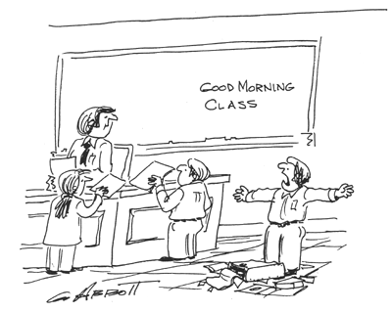

Negative comments stifle the desire to learn or attempt new tasks.

Opportunity



Each student must be given equal opportunity to develop academically.

Procedure



SST is a procedure for identifying students with academic and behavioral needs.

Questioning Techniques


The teacher questioning technique must require many different levels of thinking.
Bloom’s Taxonomy

Resources



Resources are anything that a teacher uses to enhance learning.

Strategies



Teacher must be aware of differences in learners in order to develop strategies to help the learner reach academic mastery.
Team Work

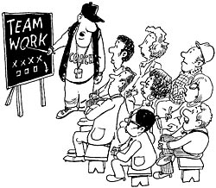

Working together “cooperatively” to ensure all students will reach academic excellence. This is a partnership between students, parents, teachers, administration, and the community.

Understanding



Understanding is one characteristic you will find in an effective teacher.

Visual



A visual learner needs much visual stimulation including graphic organizers in order to increase learning.

Wait Time



The teacher must recognize that all students have different wait times when answering questions. It is important that all students get an opportunity to answer a question.

Xtra Time



Giving students extra time is one strategy to help special need students reach their academic goals.

Yelling



Yelling at students will not help achieve the learning goals.

Zealous



Teachers and students must be enthusiastic and motivated in their pursuit of academic excellence.

Click Here to Return to Home Page

