Classroom Management Artifact:
Conduct Chart

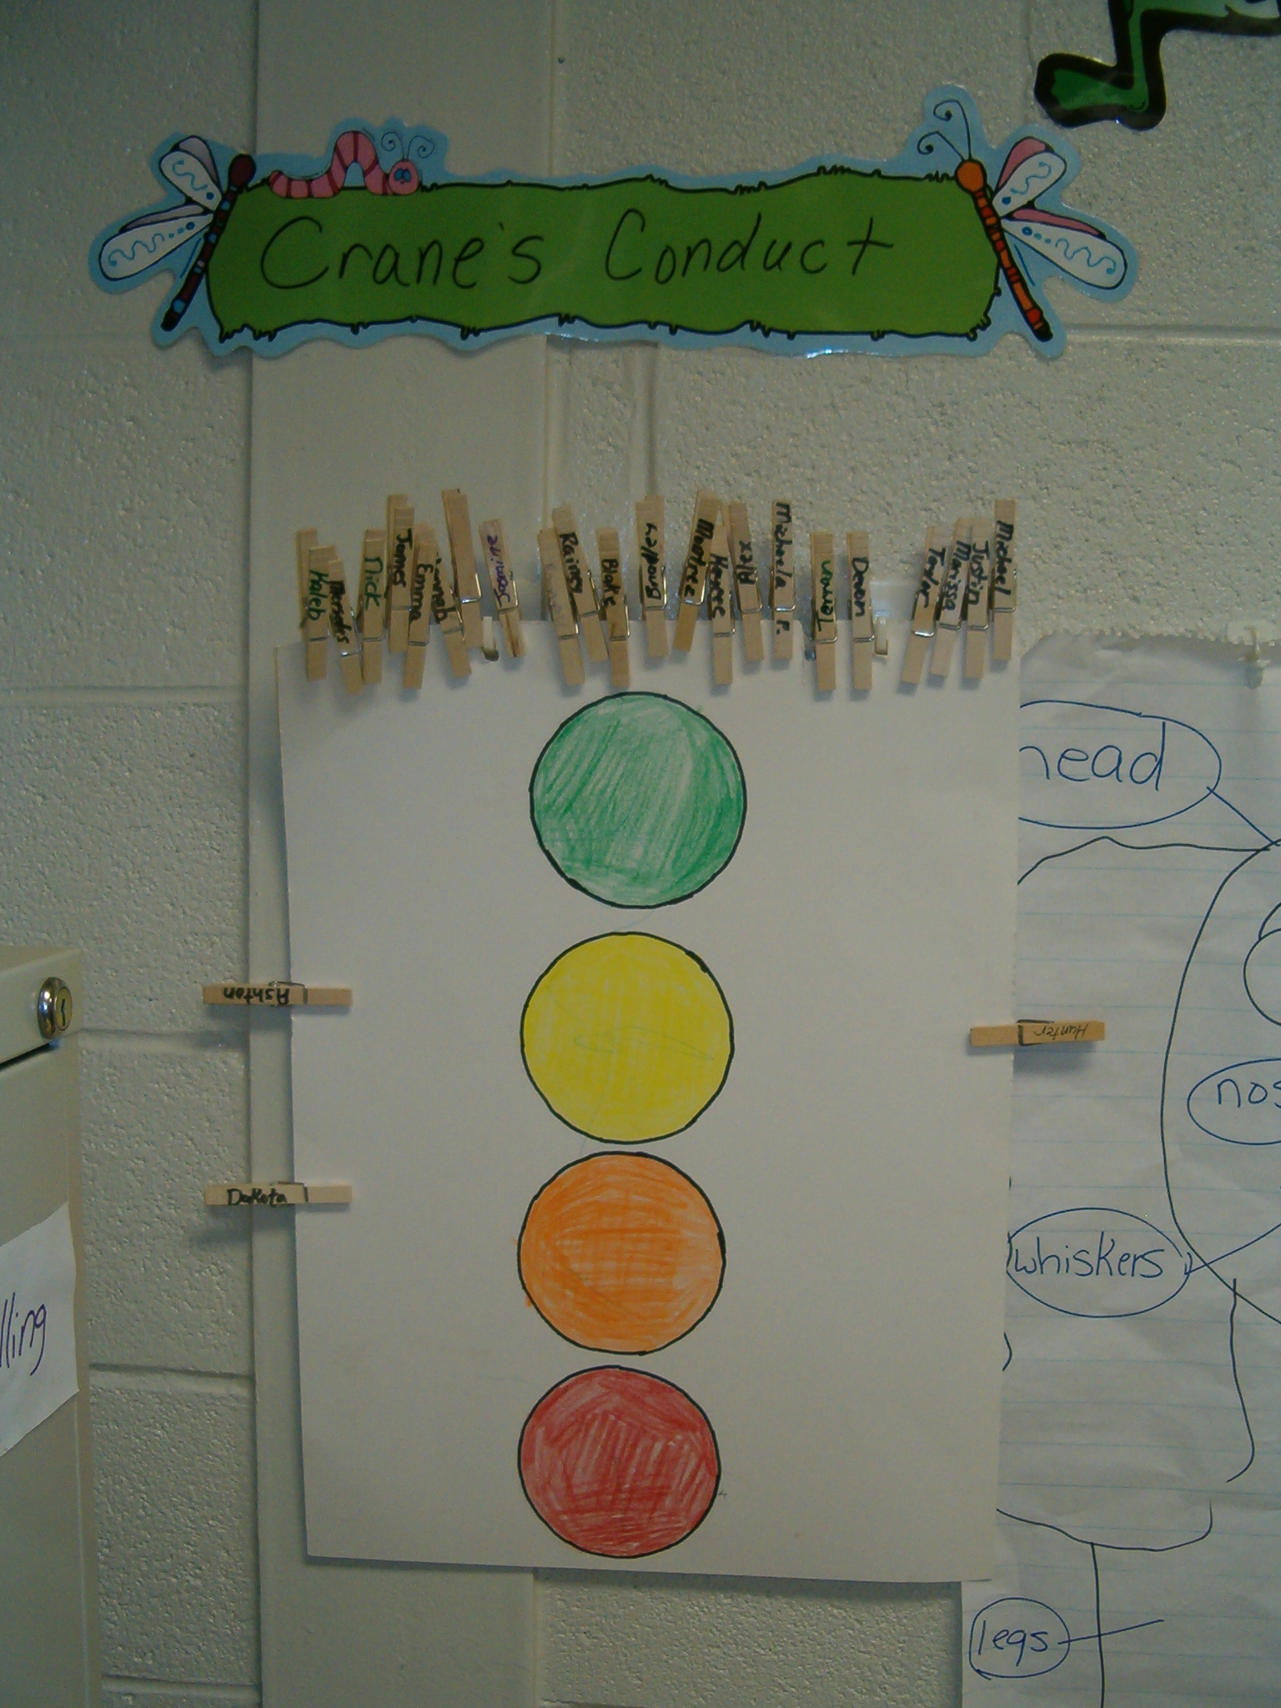

Mrs. Crane uses a behavior chart call “Crane’s Conduct”. It is a poster with four different colored circles on it; the circles (in order) are green, yellow, orange, and red. Each student has a clothes pin with their name on it, and they all start on green. If the student misbehaves then they have to move their clip. Green means they were great. Yellow is their warning, they lose one to five minutes of playtime (depending on the incorrect behavior), and a note is sent home. Orange is their second warning, they lose five to ten minutes (depending again on the incorrect behavior), and a note is sent home. If students are moved to red then they are sent to the office and the administrators call the parents or guardians.
At this particular school, each student has an agenda, and they have to take it home and have “Mom or Dad” sign it. So at the end of the each day Mrs. Crane stamps the color that the students were on in their agenda. If students were on green they got a green stamp, on yellow a yellow stamp, and so on. If they moved to yellow or orange, she would write a short note in their agenda, letting the parents know what occurred. If they made it all the way to red the parents received a phone call immediately.
This behavior method works very well, and it is a great way for parents and teachers to communicate. When students realize that the teacher and parents are constantly communicating, then there do not seem to be as many behavior problems. Also, this method allows students to see that they are responsible for their choices and the decisions they make. I feel in the long run this is beneficial and will make them a better, well rounded person.

Click Here to Return to Home Page

