Pre-Test
Basic Facts:
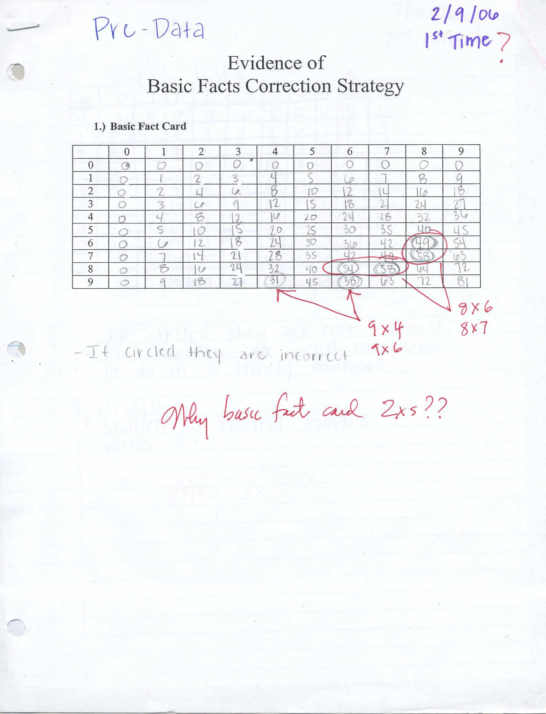
Violation of Algorithm:
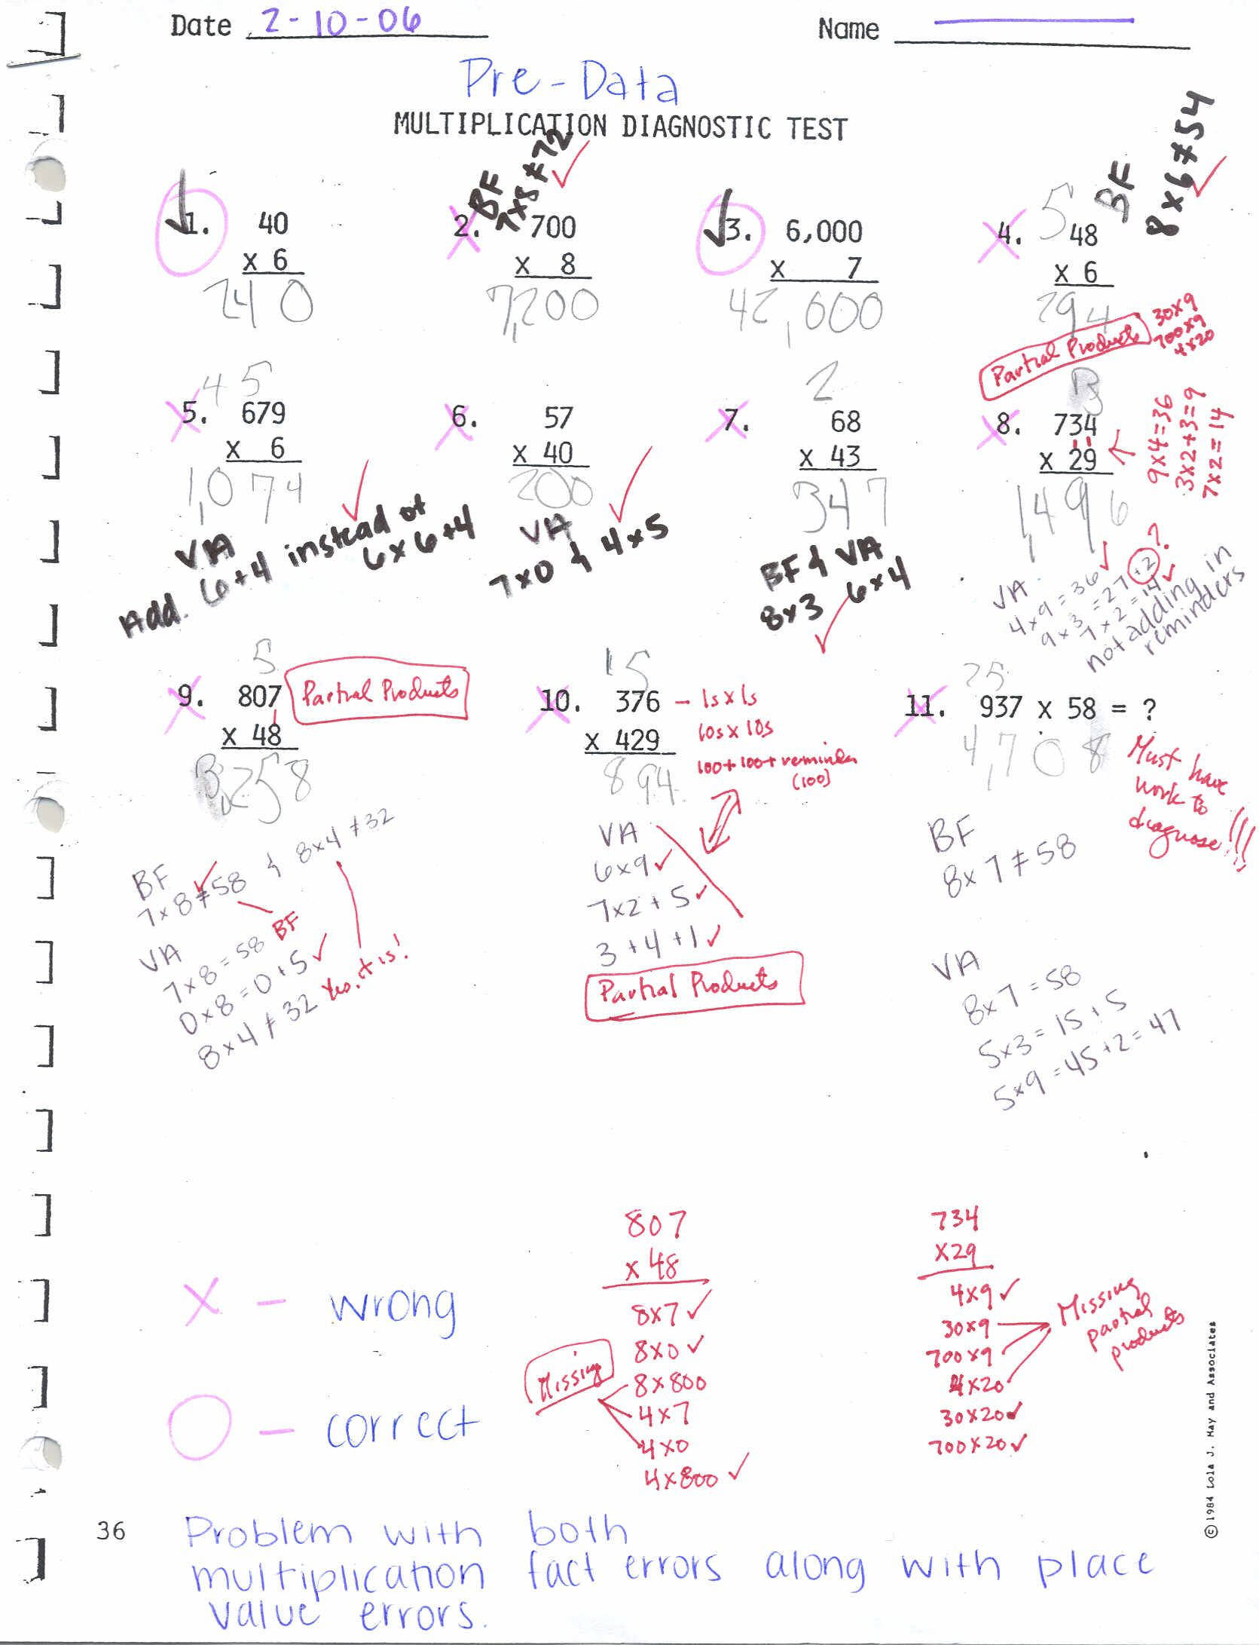
Click Here to Return to Math Case Study Home Page

