Synonyms
Lesson Plan

Title of Lesson:
Swat the “Nyms”

Grade Level:
Fifth

Date:
October 11, 2006

Description:
Students will divide up into teams and a group member from each team will come up to the board (where the synonyms are located) and try to swat the synonym with a fly swatter as the teacher reads the words aloud.

Objective:
Students will hear a word called out and try to swat/locate the synonym of the indicated word with 80% accuracy.

Standards:
ELA5R3 The student understands and acquires new vocabulary and uses it correctly in reading and writing. The student
i. Identifies and applies the meaning of the terms antonym, synonym, and homophone.

Assessment/Evaluation:
Students will be assessed/evaluated on their group participation as well as individual participation in the game.

Adaptations:
- Allow students to discuss the words before playing.
- Have students work in mixed groups.
- Complete the “Synonym Crossword Puzzle” before playing the game.
- Play synonym game on www.scholastic.com/wordgirl/synonym_toast.htm

Materials:
- Crossword Puzzle Sheet (see below)
- Synonym PowerPoint
- Computer to play game and show PowerPoint
- Swat the “Nym” Game Cards (see below)
- Two Fly Swatters

Procedures:
- Start the lesson off by briefly discussing what synonyms are. Discuss where students can locate them.
- Pass out the Crossword Puzzle sheet and allow students enough time to complete. Go over the crossword puzzle when students have finished.
- Next, show students the synonym PowerPoint. (Get the Synonym PowerPoint ready while students are doing the puzzle)
- After showing the PowerPoint, go into more detail and discussion about synonyms.
- Explain to student that they are going to being playing a game with synonyms. Divide the class into two groups. A student from each group will come to the board and stand behind a line that has been placed about a foot away from the board. Give each group member a fly swatter. Students will swat the synonym that is on the board after the teacher reads the word from her/his the card. The student whose fly swatter is on the synonym receives one point for their team. Teachers keep score on the board.

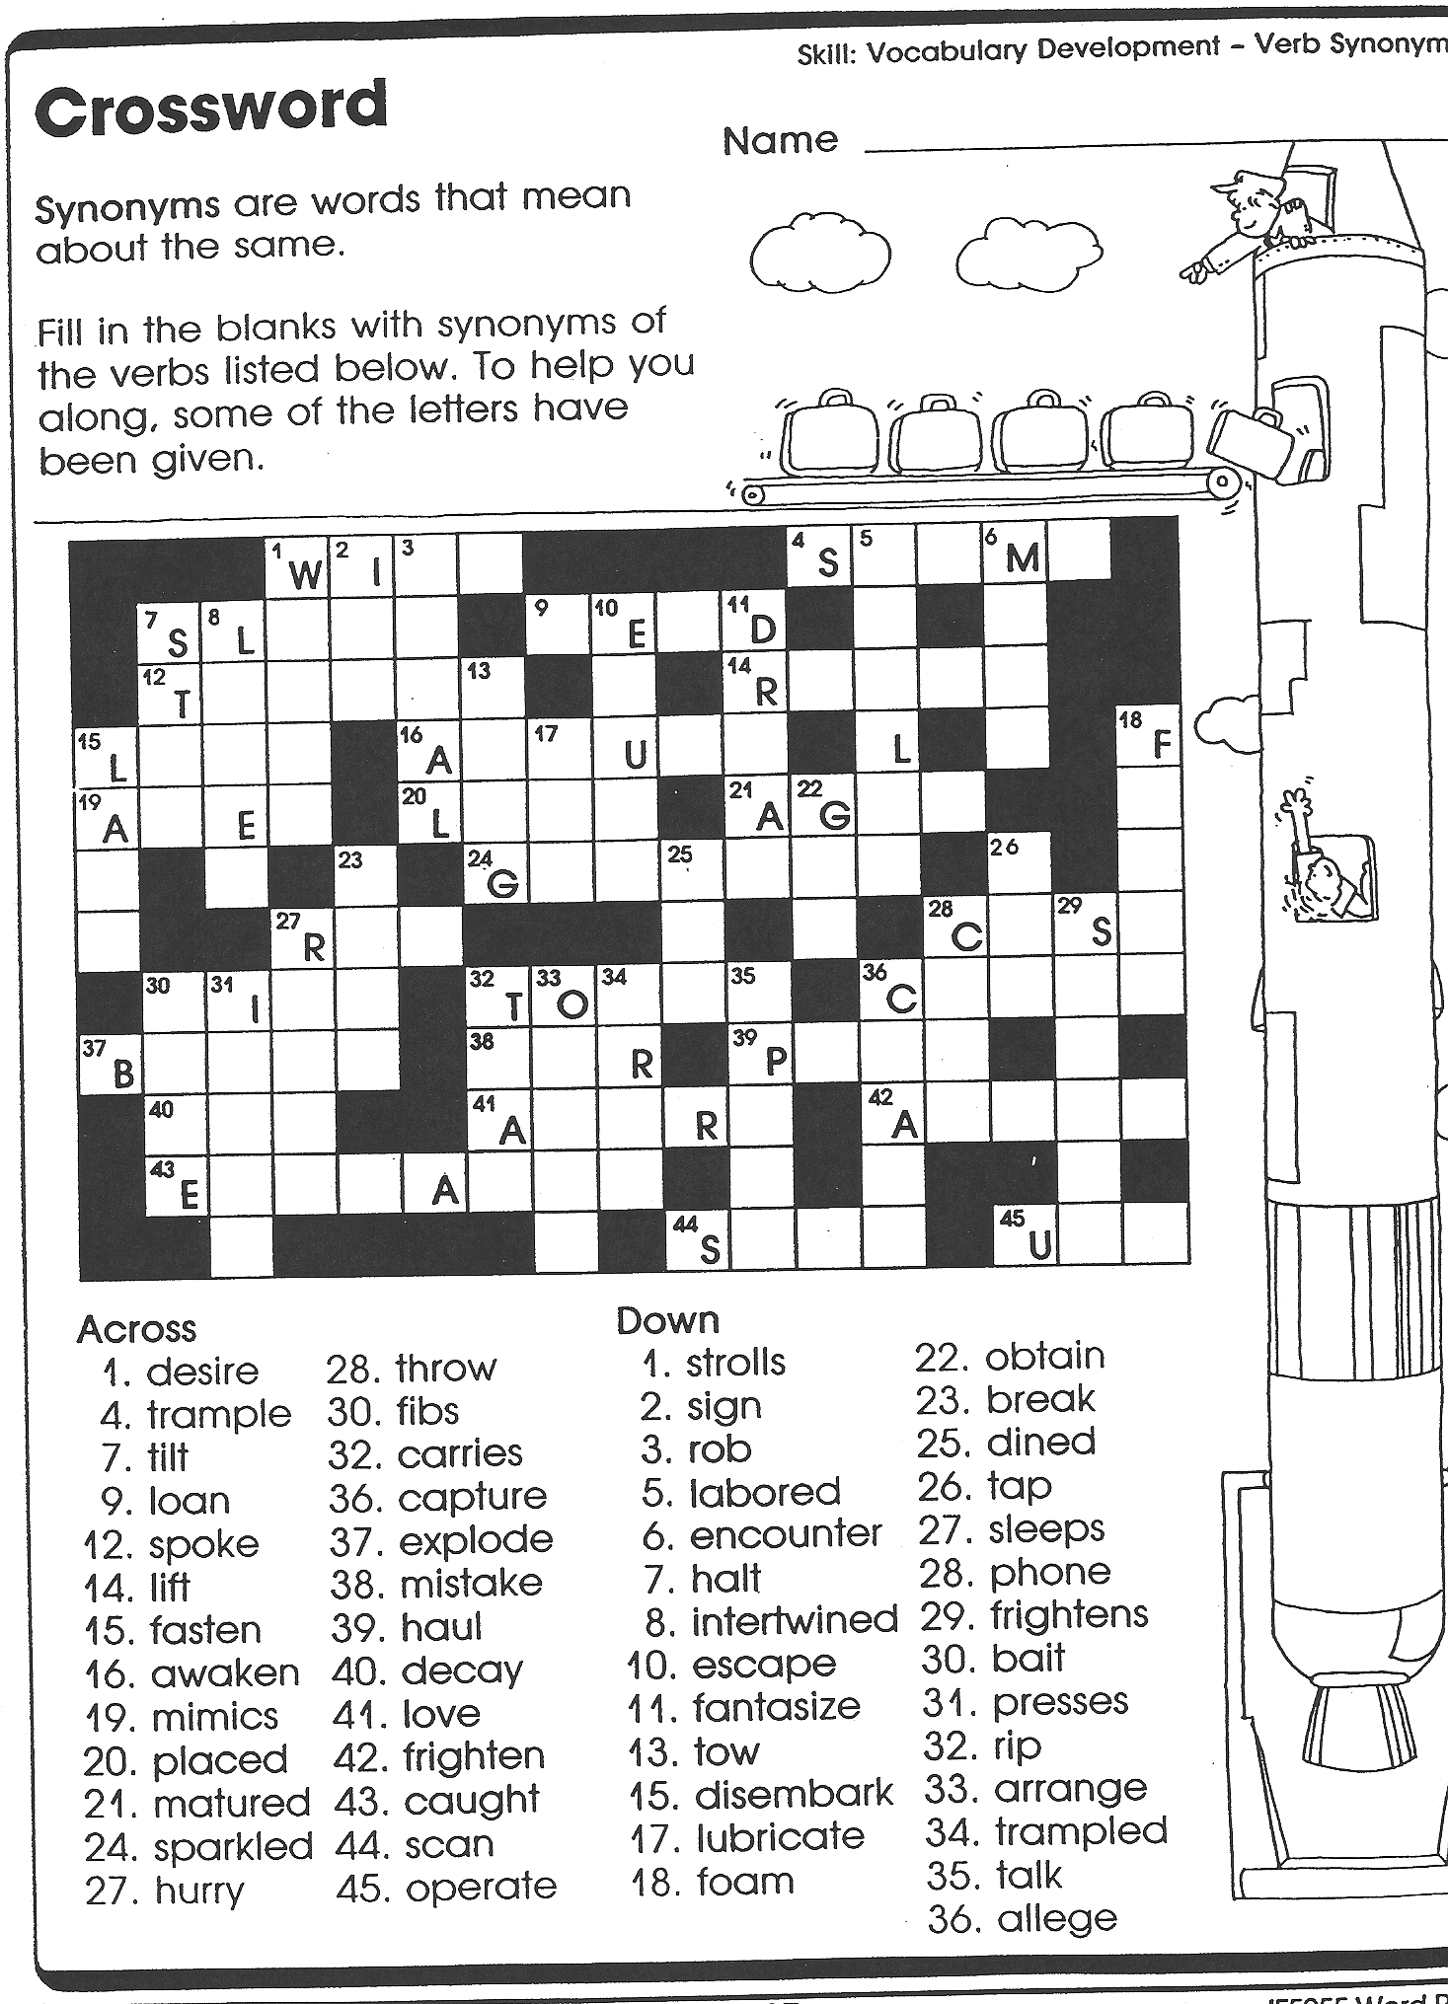

Swat the “Nym” Game
Directions: Print on card stock. Cut out the synonyms and play the game.

Card that goes on the board: Card that teacher reads aloud:
Pretty |  |  | Beautiful
Happy |  |  | Glad
Sad |  |  | Unhappy
Cold |  |  | Cool
Warm |  |  | Hot
Choose |  |  | Pick
Boat |  |  | Ship
Hat |  |  | Cap
Like |  |  | Enjoy
Quiet | Silent
Car | Automobile
Present | Gift
Small | Little
Big | Large
Nap | Rest
Close | Shut
See | Look
Quick | Fast
Alike |  | Same
Work |  | Job
Part |  | Piece
Talk |  | Speak
Hear |  | Listen
Noise |  | Sound
Friend |  | Pal
Pail |  | Bucket
Flames |  | Fire

Student Work Sample:

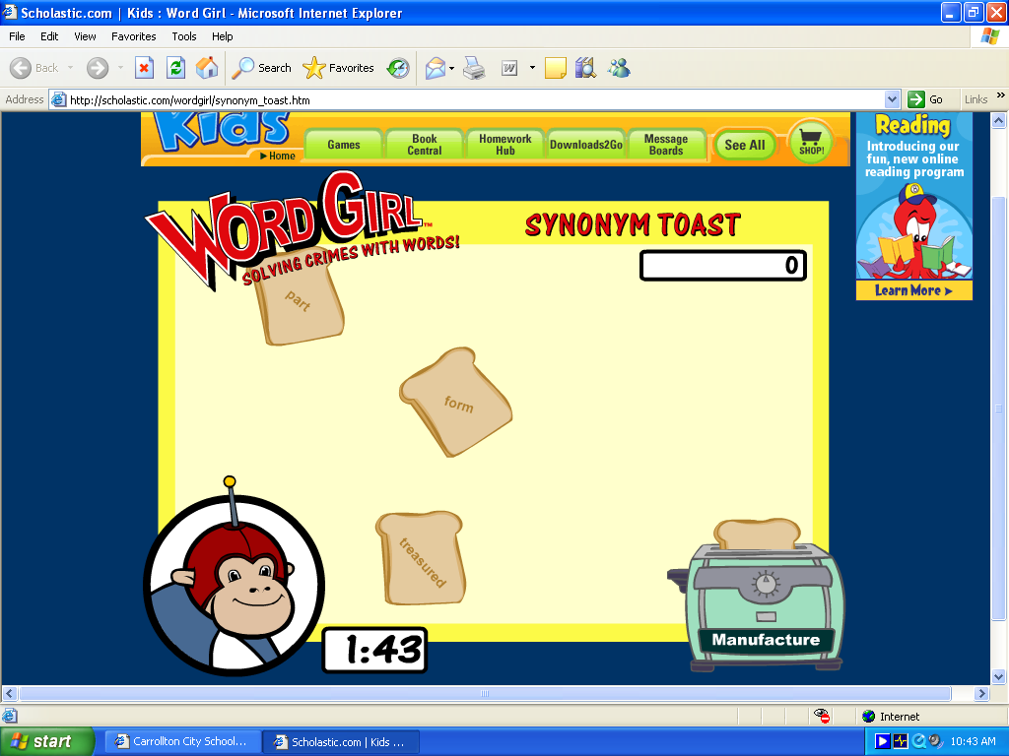
Click Here to Return to Home Page

