Suffixes
Lesson Plan

Title of Lesson:
Stupendous Suffixes

Grade Level:
Fifth

Date:
October 4-6, 2006

Description:
Students will discuss suffixes, view a PowerPoint, play a game and create a graphic organizer in order to help students realize the role/job of suffixes.

Objective:
Students will participate in suffix activity and complete a suffix graphic organizer with 80% accuracy.

Standards:
ELA5R3 The student understands and acquires new vocabulary and uses it correctly in reading and writing. The student
c. Determines the meaning of unfamiliar words using knowledge of common roots, suffixes, and prefixes.

Assessment/Evaluation:
Students will be assessed/evaluated on the accuracy of their graphic organizer and class participation. Neatness, organization, and class conduct will also be taken into consideration while evaluating.

Adaptations:
Allow students to work in mixed groups and provide time for students to discuss/share their work. Visually share/write on the board.

Materials:
- Construction Paper to create the Suffix Cards
- Tape
- Suffixes PowerPoint
- Suffix Sheets from www.bbc.com (see below)
- Computer Paper to create suffix graphic organizer
- Computer (www.bbc.co.uk/skillswise/words/spelling)

Procedures:
- As a warm-up, have students complete the Suffix Sheets (below). When students are finished review the paper and see if there are any questions, concerns, or comments.
- Watch PowerPoint on suffixes:
  - When the PowerPoint states “Board Activity”, tape all the suffix cards to the board. Discuss what each suffix means, and allow students to help with the discussion and explanation/definitions.
- Next, pass out the computer paper and instruct students on how to fold the paper so it has 8 boxes (see example below). Use the top two boxes to write the heading “Suffixes: at the end of a word”. Then, label the other six boxes with the six prefixes below.
- Complete the game/activity at the end of the PowerPoint.
- During the computer center have students go to the site www.bbc.co.uk/skillswise/words/spelling to play some online games with suffixes.

Teacher Notes:
- -er, -or
  - Noun: person or thing that does something
    - porter : a person who carries things
      - port + er
    - collector: a person who collects or gathers things
      - col + lect + or
- -er, -or
  - Verb: action
    - ponder : to think about
      - pond + er
    - clamor: to make noise, to call for loudly
      - clam + or
- -able, -ible
  - Adjective: worth, ability
    - solvable : able to be solved or explained
      - solv + able
    - incredible: not able to be believed, amazing
      - in + cred + ible
- -ous, -eous, -ose, -ious
  - Adjective: having the quality of, relating to
    - adventurous : charcterized by the desire to seek new experiences or risks
      - ad + vent + ur + ous
    - courageous : characterized by courage, brave
      - cour + ag + eous
    - verbose: having more words than needed
      - verb + ose
    - fractious: characterized by being difficult or troublesome
      - fract + ious
- -ness
  - Noun: state, condition, quality
    - kindness : the quality of being kind or nice
      - kind + ness
- -ful
  - Noun: an amount or quanity that fills
    - mouthful : an amount that fills the mouth
      - mouth + ful
- -ly
  - Adverb: in the manner of
    - fluently : marked by ease of movement, effortlessly smooth
      - flu + ent + ly

Suffixes: at the end of a word
-er | -able
-ous | -ness
-ful | -ly

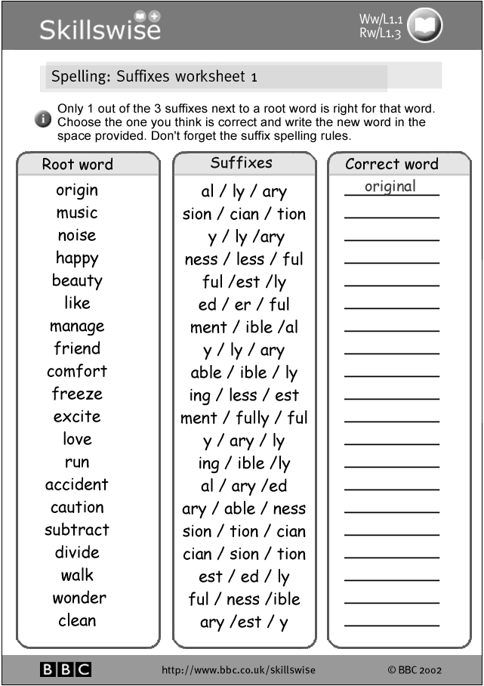
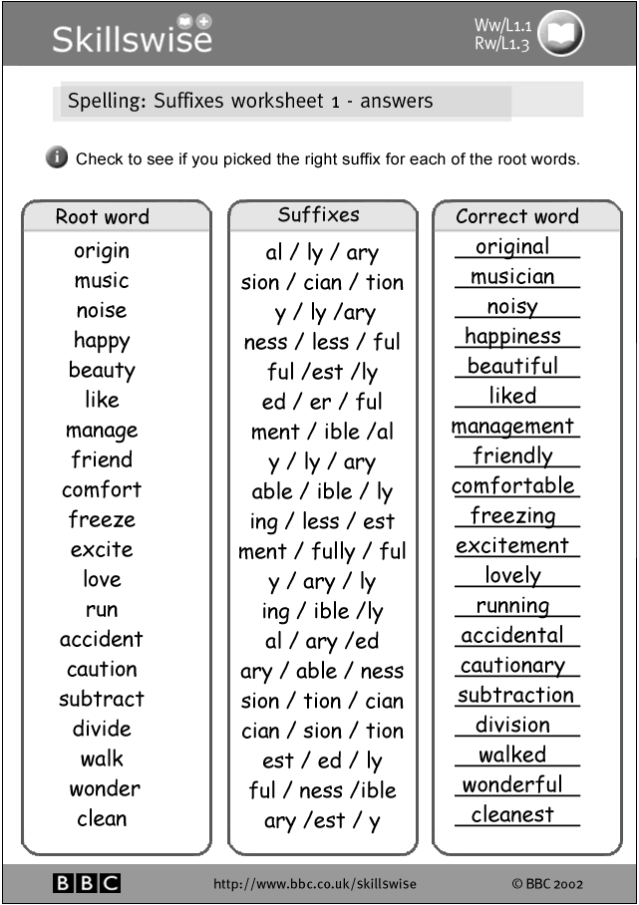
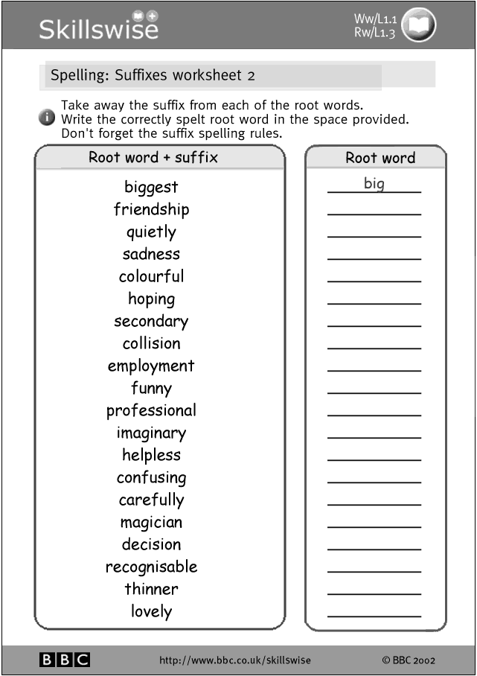
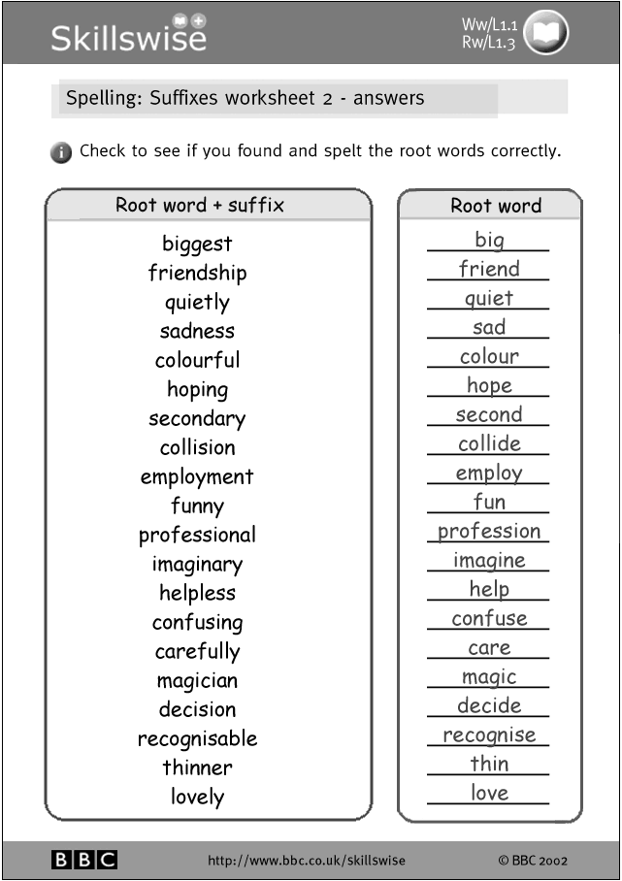
Students Sample Work

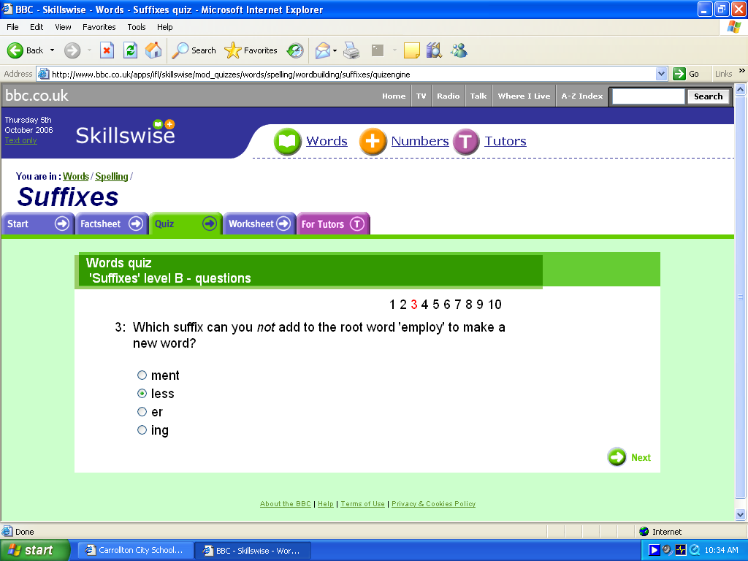

Click Here to Return to Home Page

