LESSON PLAN FORMAT

Leah Goodnoe Mrs. Ellen Crane Dr. Lyke
___________________________ _______________________ ______________________
Teacher Education Candidate Classroom Teacher UWG Supervisor

October 3, 2005 October 10, 2005
___________________________________ ___________________________________
Date of Submitted Lesson Plan Date of Implemented Lesson Plan

Block I___, II_X_, III___, or IV___ Subject: Mathematics Grade Level: 2

Leah Goodnoe
If applicable, Author(s) or Source(s) of Lesson Plan: ___________________________________

- National or Learned Society Standard(s):
NCTM:
Content Standard
Algebra: Use mathematical models to represent and understand quantitative relationships

Process Standard
Communication: talk about, write about, describe, and explain mathematical ideas
Connections: is connected to real world and to other disciplines

- State of Georgia’s QCC’s and GPS’s: (only one of each needed)
QCC’s:
Number Sense and Numeration; Fractions and Decimals
14 Topic: Money
Standard: Determines amounts of money using pennies, nickels, dimes, quarters, half-dollars, and dollars.
GPS’s:
M2N Numbers and Operations
M2N1 Students will understand the place value representation of whole numbers through four digits
c. Use money as a medium exchange. Count back change and use decimal notation and the dollar and cents symbols to represent a collection of coins and currency.

- Specific Objective(s): Use the following A-B-C-D format:
  - Audience -The students in this fifth grade;
  - Behavior - will describe the life cycle of a butterfly;
  - Condition - by writing a sentence for each stage under corresponding picture; and
  - Degree - with 90% accuracy.

The students in this second grade class will use pennies, dimes, nickels, quarters, and half dollars to represent a given amount of money in two different ways with 80% accuracy.

- Materials (List everything you and students will need to complete lesson.)
    - a real penny, nickel, dime, quarter, and half-dollar
    - paper pennies, dimes, quarters, nickels, and half dollars (need to have enough for every group)
    - unlined white paper
    - pencil
    - crayons or colored pencils
    - math textbook (as a reference) pages 109-120

- Procedures:
  - Motivation/Opener/Attention Getter. (Quick activity to stimulate everyone’s interest)
Discuss and show what each coin looks like on the front and back. Then discuss the value of each coin. Use pictures and the real thing. Pass the real coins around the room so everyone gets a chance to see what the coin really look like.

  - Tie to previous learning. (How is this lesson related to prior learning?)
This lesson that I am teaching will tie into the class’ unit on money.

  - Teaching methods sequence. (What will you do first, second, etc?)
    - First, pass around a penny, nickel, dime, quarter, and half-dollar. When they are finished looking, discuss what the coins look like and the value they hold.
    - Second, sort the students into groups. There should be about five to six groups.
    - Third, pass out the paper money to each group and have each child take out a piece of white unlined paper and crayons/colored pencils. Tell the students, as a group, they are going to try to represent the amount of money that I call out. They have to represent the amount I call out in two different ways.
    - Each student will write down the coins that their group used to represent the amount on their unlined white paper. Have them draw the coins and color them.
    - Finally, I will ask the groups to come to the board and show one of the ways they represented a certain amount. Students will compare their answers to other groups answers.

  - Closure. (How will you summarize or bring lesson to a close?)
To close the lesson, we will review the name and value of the coins. I will hold up each coin and the students will tell me the name of the coin and the value of each coin.

  - Transition (How will you move from the end of this lesson into the next lesson?)
Have students clean up their area, and turn in the white unlined paper that they drew their coins on.

  - Special needs adaptation (How will you adapt this lesson to meet special needs of students?)
Keep students actively involved, keep area clear of all obstacles, and have students work together (explain to others their answers). I will also be moving from group to group to assist, watch, and guide.

- Connections (How will this lesson be related to other content areas in the curriculum?)
This lesson will tie in with their math unit on money. This lesson is also connected with social skills and money management.

- Related independent activities. (What will students who finish early do?)
This is a class/group activity so no one will finish early.

- Evaluation (Each specific objective must be included in the evaluation design with the use of appropriate assessment instruments.)
I will be evaluating students on their papers they turned in. Did they represent the amount in two different ways? Did they color their coins? Were the coins the correct color? Did they work with their other group members? Did they participate/help or did they let others do all the work?

- Documentation or record keeping of students’ academic achievement.
I will be giving a grade based on the criteria listed in Evaluation, and the grade will be posted in the grade book.

- Reflections (After teaching and evaluating student outcomes, write a critique about the effectiveness of the procedure, your instructional skills, and your students’ reactions. Give reasons or explanations for these opinions. Also, describe and explain any alterations to this lesson if you would to teach it again.)
This lesson was very interesting to say the least. It appeared they liked doing the activity because they were very talkative. Most of them were talking about the money and what they needed to do to create a given value. Some of them did not know how to work as a group; some kept saying, “So-and-So has more coins than me and they’re not sharing.” Others would do the work by themselves and leave the rest of their group members “in the dark”. Some students wanted the other group members to give them the answer.
I really feel like this class needs some more practice at group work. One group worked perfect together and I congratulated them on their outstanding performance. They did not finish on time but they worked together and understood what they were doing. Other groups were just rushing trying to get finished with it, and it did not matter about the other group members.
I did not get to finish my math lesson because it was time for recess. The students knew it was time to go out and they were ready to go. The teacher told me I could finish the lesson on Wednesday, but I told her they got the first part completed and part of the second. Both parts repeat themselves in a way; it was just a way to reinforce what had been taught.
I would definitely do this again; I really liked it. I might not use the paper coins that are attached to the back. I would probably invest in some money manipulatives. This is what I used for my lesson and the students could see what the coins looked like. They could not do this with the paper coins.

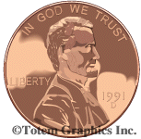

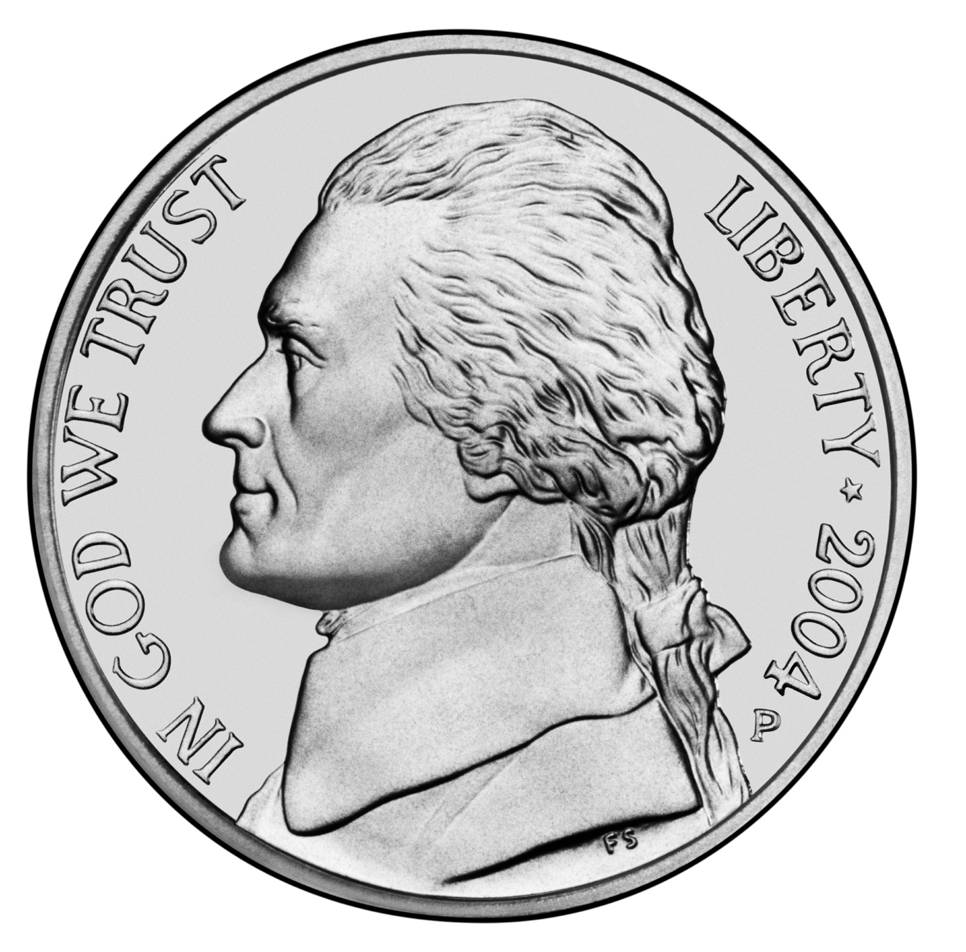

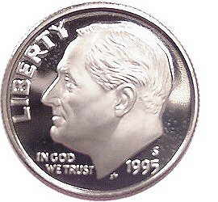

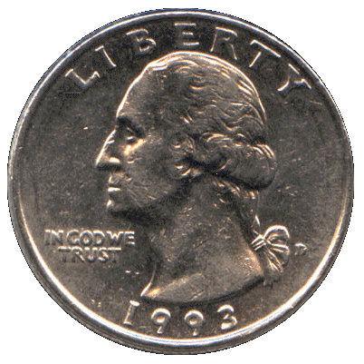

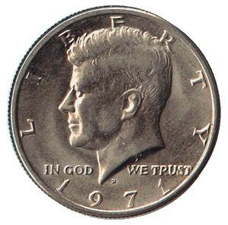

Click Here to Return to Lesson Plan Home Page

