LESSON PLAN FORMAT

Leah Goodnoe Mrs. Ellen Crane Dr. Lyke
___________________________ _______________________ ______________________
Teacher Education Candidate Classroom Teacher UWG Supervisor

October 19, 2005 October 26, 2005
___________________________________ ___________________________________
Date of Submitted Lesson Plan Date of Implemented Lesson Plan

Block I___, II_X_, III___, or IV___ Subject: Language Arts Grade Level: 2

Language Arts Activities for the Classroom
If applicable, Author(s) or Source(s) of Lesson Plan: ________________________________________

- National or Learned Society Standard(s):

- State of Georgia’s Q.C.C.’s: (only one needed)
QCC’s:
6
  Topic: Listening/Speaking
  Standard: Responds to questions on orally presented material.
32
  Topic: Reading
  Standard: Recognizes and reads compound words, contractions, possessives, and words containing the suffixes "ing," "ed," "s," and "es."

GPS’s:
ELA2R1 The student quickly applies knowledge of letter-sound correspondence and spelling patterns to decode unfamiliar words. The student
c. reads compound words and contradictions in grade appropriate texts.

- Specific Objective(s): Use the following A-B-C-D format:
  - Audience -The students in this fifth grade;
  - Behavior - will describe the life cycle of a butterfly;
  - Condition - by writing a sentence for each stage under corresponding picture; and
  - Degree - with 90% accuracy.

The students in this second class will identify compound words by playing Compound Word Bingo, with 70% accuracy.

- Materials (List everything you and students will need to complete lesson.)
- Compound Word Bingo Cards
- Compound Word Bingo Player Sheets
- Markers for the Player Sheets

- Procedures:
  - Motivation/Opener/Attention Getter. (Quick activity to stimulate everyone’s interest)
Ask the students if they want to play bingo? Review compound words before playing this game.

  - Tie to previous learning. (How is this lesson related to prior learning?)
This lesson will tie into their language art lessons and will help with their future lessons.

  - Teaching methods sequence. (What will you do first, second, etc?)
  - First I will review compound words.
  - Second, I will pass out the Compound Word Bingo Player Sheets and markers to each student.
  - Third, I will read the sentences and the students have to figure out the compound word I am talking about, and then place a marker on that word.
  - To get bingo, the student must have five in a row. The winner will receive a prize, and we may play several times so they get the hang of compound words.
  - Closure. (How will you summarize or bring lesson to a close?)
To close the lesson, I will have students tell me one example of a compound word. Then after they have given me a compound word, I will have them bring me their game board and markers.

  - Transition (How will you move from the end of this lesson into the next lesson?)
“Alright everyone lets clean up and get ready for reading.”

  - Special needs adaptation (How will you adapt this lesson to meet special needs of students?)
Keep students actively involved and have students work at their desk so there is not a lot of moving around. Allow other students to give clues, not answers.

- Connections (How will this lesson be related to other content areas in the curriculum?)
This lesson will tie in with their language arts unit and essential question (What is a compound word?).

- Related independent activities. (What will students who finish early do?)
No one will finish early because this is a game we are playing together.

- Evaluation (Each specific objective must be included in the evaluation design with the use of appropriate assessment instruments.)
To evaluate, go around and make sure students are playing the game and identifying compound words.

- Documentation or record keeping of students’ academic achievement.
Come around and check to see if everyone is participating and playing. Check them off in the grade book.

- Reflections (After teaching and evaluating student outcomes, write a critique about the effectiveness of the procedure, your instructional skills, and your students’ reactions. Give reasons or explanations for these opinions. Also, describe and explain any alterations to this lesson if you would to teach it again.)
This lesson went great, and I feel that it was very effective. We discussed compound words and had a good discussion. The students were very talkative, so this helped the discussion. When I told them we were going to play a game very similar to Bingo, they began to get very excited. We played the game three times, before we moved on to Reading. Before we did this lesson the students were still confused about compound words, but after I did this lesson they were able to identify compound words left and right.
I plan on saving this lesson plan and the game for my future classroom. I feel it is a great and fun way to learn compound words. It is also good practice for them. The only alterations I would have made would have been to have more markers out, and to have more sentences on the Teacher’s Compound Word Bingo sheet. If I had had more sentences to read to the students then I would have not had to repeat any. This would also allow the students a longer amount of time to play.

Example of the Game
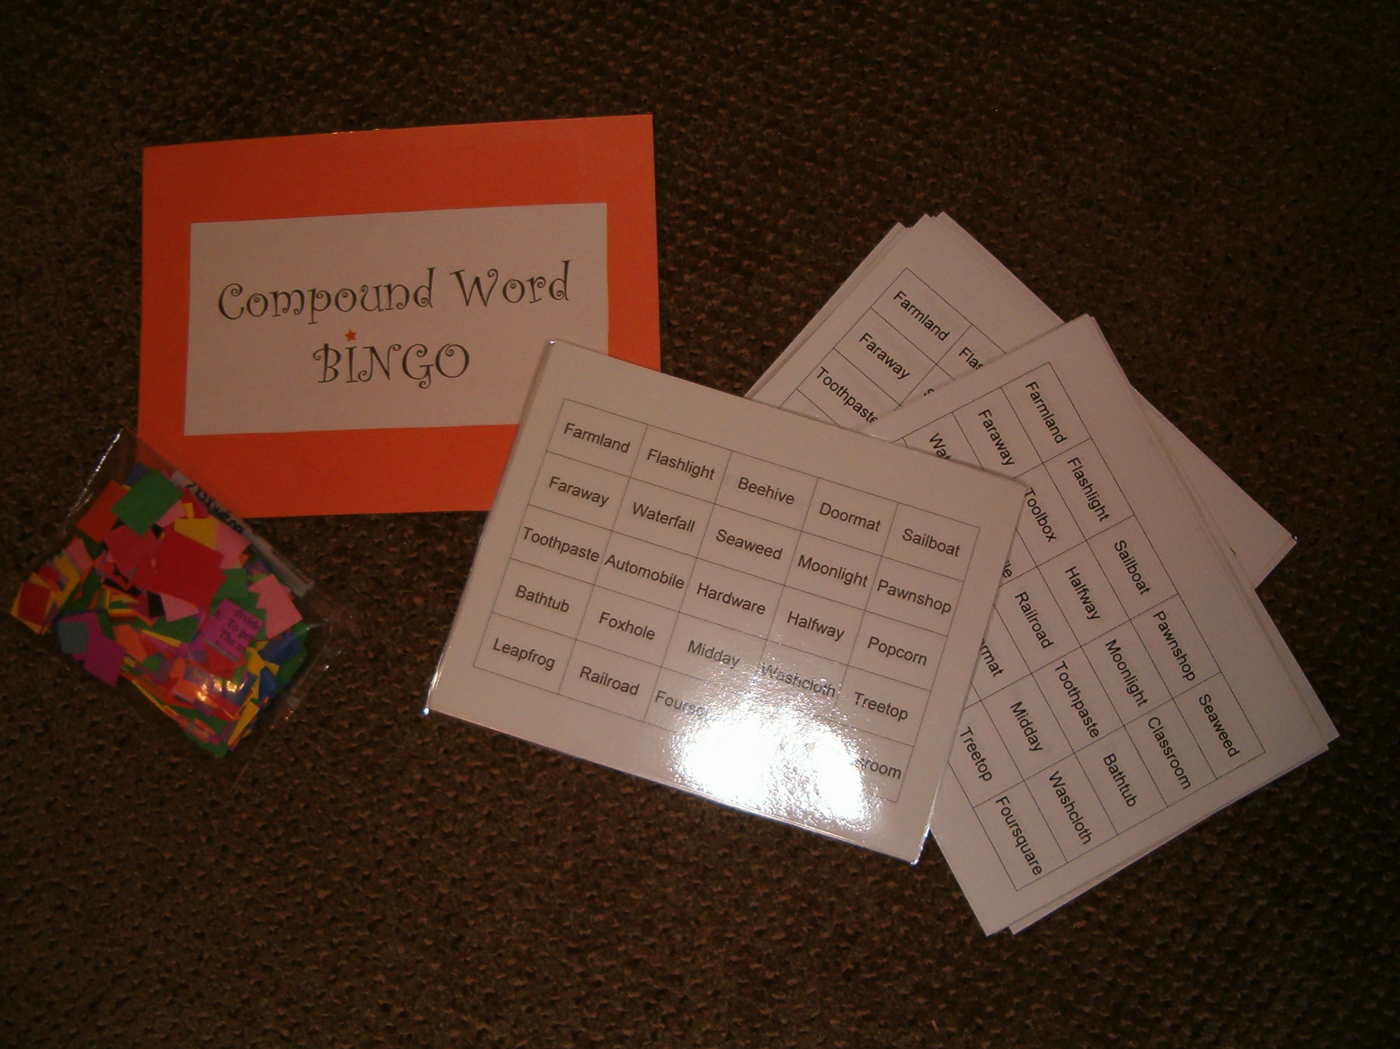

Toolbox | Flashlight | Doormat | Washcloth | Toothpaste
Moonlight | Treetop | Seaweed | Halfway | Classroom
Waterfall | Automobile | Faraway | Popcorn | Sailboat
Beehive | Foxhole | Leapfrog | Midday | Pawnshop
Bathtub | Railroad | Hardware | Farmland | Foursquare
Compound Bingo

- The top of a tree is the ___________. (Treetop)
- A room for a class is a ___________. (Classroom)
- A tub that you can take a bath in is a ___________. (Bathtub)
- Cleaning paste to scrub your teeth with is ___________. (Toothpaste)
- Looking away to a far place makes you look ___________. (faraway)
- A game in which you leap like a frog is called ___________. (Leapfrog)
- Good land that you can farm is __________. (Farmland)
- The middle of the day is sometimes called__________. (Midday)
- One ball game that four of you can play in a square is called ___________. (Foursquare)
- A road that is built for the rails of a train is a ____________. (Railroad)
- A green weed that grows in the sea is ___________. (Seaweed)
- The wares that you can buy to do hard work with are ____________. (Hardware)
- A shop in which you can pawn your goods is a _____________. (Pawnshop)
- A mobile that drives automatically is an ____________. (Automobile)
- Your tools can be stored in a box called a ____________. (Toolbox)
- If you’ve gone only half way, you’ve gone ____________. (Halfway)
- A cloth to wash yourself with is a _____________. (Washcloth)
- A hole for a fox to hide in is a ____________. (Foxhole)
- The light that is shining from the moon is ____________. (Moonlight)
- The corn kernels that pop make ______________. (Popcorn)
- A boat that uses a sail and wind to move is a _____________. (Sailboat)
- This type of light can be carried and used in the dark ______________. (Flashlight)
- A hive that bees build and live in is a ____________. (Beehive)
- A mat that goes in front of the door is a _______________. (Doormat)
- Water that flows and falls is a ______________. (Waterfall)

Click Here to Return to Lesson Plan Home Page

