LESSON PLANNING TEMPLATE

 | Overview of Lesson
Topic and grade level? | Layers of Earth’s atmosphere and Clouds- 4th grade
Standard(s)/ Elements addressed in this lesson* | S4E3 Students will differentiate between the states of water and how they relate to the water cycle and weather.  a. Demonstrate how water changes states from solid (ice) to liquid (water) to gas  (water vapor/steam) and changes from gas to liquid to solid.  b. Identify the temperatures at which water becomes a solid and at which water becomes a gas.  c. Investigate how clouds are formed.  d. Explain the water cycle (evaporation, condensation, and precipitation).  e. Investigate different forms of precipitation and sky conditions (rain, snow, sleet, hail, clouds, and fog).  S4CS4 Students will use ideas of system, model, change, and scale in exploring scientific and technological matters.  a. Observe and describe how parts influence one another in things with many parts.  b. Use geometric figures, number sequences, graphs, diagrams, sketches, number lines, maps, and stories to represent corresponding features of objects, events, and processes in the real world. Identify ways in which the representations do not match their original counterparts.  c. Identify patterns of change in things—such as steady, repetitive, or irregular change—using records, tables, or graphs of measurements where appropriate.
As a result of the lesson, students should be able to:  (from #5 on Unit Plan) | As a result of this lesson students should be able to identify cirrus clouds, cumulus clouds, stratus clouds, and cumulonimbus clouds, and tell why/how the clouds differ. They should also be able to identify the four layers of earth’s atmosphere in order to tell where clouds form.
Assessment Instrument for students to demonstrate performance. | Students will create a mobile of the layers of the earth’s atmosphere, and a cloud identification poster in order to show the different elevations clouds form.
Evaluation/grading scheme to be used with Assessment Instrument | A rubric will be used to assess the mobile and cloud chart. Students will then create their own test and answer it, but they must have questions about the types of clouds, what they look like, the atmospheric layers, and a significant fact about each one.
 | Conducting the Lesson
Materials needed | - card stock paper (in four varying blue colors)  - roll of yarn  - markers  - cotton balls  - poster board  - observational science notebook  - Harcourt science book
Strategies to elicit prior knowledge and promote engagement | - Ask students questions about the atmosphere. What occurs or is special about each level?  - Then ask students questions about clouds. Where in the atmosphere layers do they occur? Can explain what they look like and elevation (are they really high, low, or middle)?
Lesson Activities** | Do not write in this space.
A. Teacher Actions during Lesson Activities | - Lecture and discuss pages D6 – D8, and D15. Talk with students about each atmosphere layer and then the types of cloud formation.  - Allow students to observe the cloud formations outside for a week. Have them write their observations in their science notebook.  - Once the week has passed, have students discuss the type of weather that occurred with each cloud.  - Allow students to create a mobile of the atmosphere levels. They should label each layer and write a brief description of each layer. Once they finish this project have students hang their mobiles from the ceiling.  - Next, have students create a cloud identification poster with cotton balls. They should show the elevation that the clouds form, what they look like, and label everything. Hand in the room.
B. Student Actions during Lesson Activities | - Listen and participate in group lecture. Write down the layers of the atmosphere in your notebook. Explain each layer. Write down the types of clouds, draw pictures if needed in your science observation notebook.  - Go outside for a week and observe the cloud formations. Draw pictures of the clouds, give good details, and explain the weather for the day.  - After a week has passed, discuss your observations and tell if you think the weather and clouds have anything to do with each other.  - Create a mobile of the layers of the atmosphere. Label each layer and write a description of each level. When finished, hang from ceiling in the classroom.  - Create a cloud identification poster with cotton balls. Show/indicate the different elevations that each cloud forms and what they look like. Hang in the classroom when complete.
C. Student Actions for Lesson Summary | Students will create a mobile to indicate that they know the layers of the earth’s atmosphere. Then they will create a cloud identification poster to show the elevation levels of each cloud and what they look like.
To Meet Special Needs | - Provide a space that decreases distractions.  - Highlight directions.  - Demonstrate instructions.  - Utilize pictures and visual prompts.  - Repeat the information.  - Ask only one question at a time.
Resources for Lesson | - Harcourt Science Book  - Carroll County Resource Book  - Any children’s literature book on clouds or weather.

Reflection:
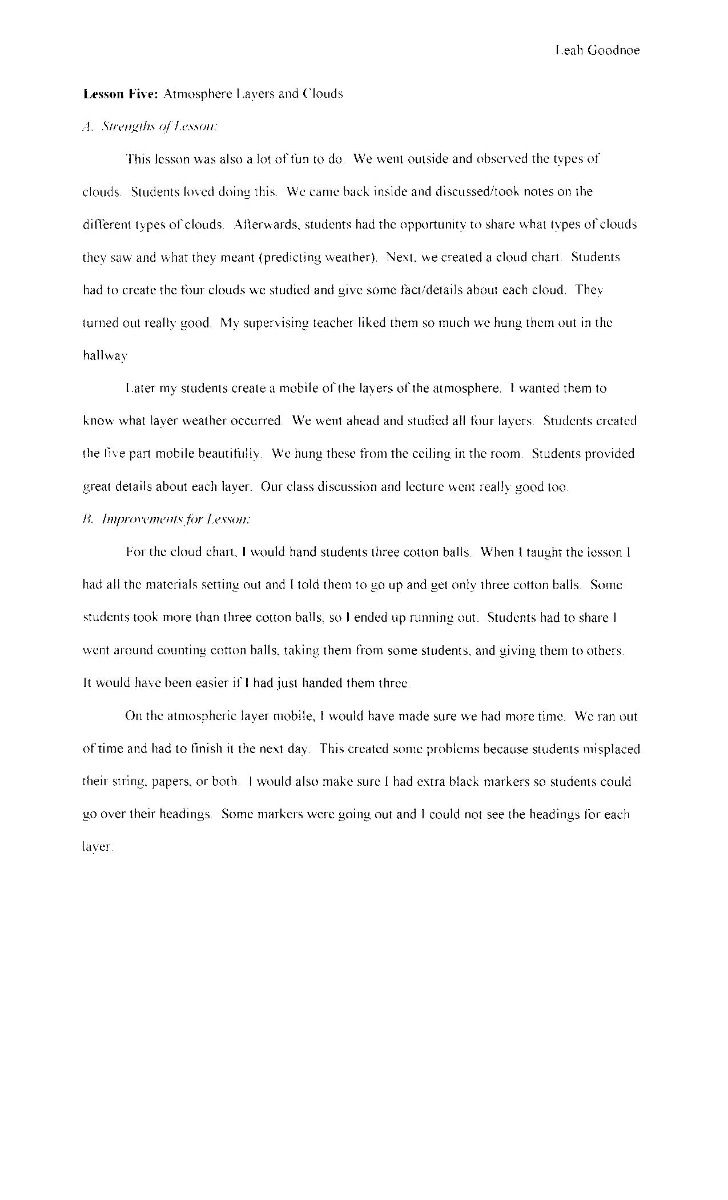

Clouds/Atmosphere Layers

Student Name: ________________________________________

CATEGORY | 4 | 3 | 2 | 1
Use of Class Time | Used time well during each class period. Focused on getting the project done. Never distracted others. | Used time well during each class period. Usually focused on getting the project done and never distracted others. | Used some of the time well during each class period. There was some focus on getting the project done but occasionally distracted others. | Did not use class time to focus on the project OR often distracted others.
Labels | All items of importance on the poster are clearly labeled with labels that can be read from at least 3 ft. away. | Almost all items of importance on the poster are clearly labeled with labels that can be read from at least 3 ft. away. | Several items of importance on the poster are clearly labeled with labels that can be read from at least 3 ft. away. | Labels are too small to view OR no important items were labeled.
Required Elements | The poster includes all required elements as well as additional information. | All required elements are included on the poster. | All but 1 of the required elements are included on the poster. | Several required elements were missing.
Attractiveness | The poster is exceptionally attractive in terms of design, layout, and neatness. | The poster is attractive in terms of design, layout and neatness. | The poster is acceptably attractive though it may be a bit messy. | The poster is distractingly messy or very poorly designed. It is not attractive.
Grammar | There are no grammatical mistakes on the poster. | There is 1 grammatical mistake on the poster. | There are 2 grammatical mistakes on the poster. | There are more than 2 grammatical mistakes on the poster.

Click Here to Return to Lesson Plan Home Page

