LESSON PLANNING TEMPLATE

 | Overview of Lesson
Topic and grade level? | The Water Cycle- 4th grade
Standard(s)/ Elements addressed in this lesson* | S4CS4 Students will use ideas of system, model, change, and scale in exploring scientific and technological matters.  a. Observe and describe how parts influence one another in things with many parts.  b. Use geometric figures, number sequences, graphs, diagrams, sketches, number lines, maps, and stories to represent corresponding features of objects, events, and processes in the real world. Identify ways in which the representations do not match their original counterparts.  c. Identify patterns of change in things—such as steady, repetitive, or irregular change—using records, tables, or graphs of measurements where appropriate.  S4E3 Students will differentiate between the states of water and how they relate to the water cycle and weather.  a. Demonstrate how water changes states from solid (ice) to liquid (water) to gas  (water vapor/steam) and changes from gas to liquid to solid.  b. Identify the temperatures at which water becomes a solid and at which water becomes a gas.  c. Investigate how clouds are formed.  d. Explain the water cycle (evaporation, condensation, and precipitation).  e. Investigate different forms of precipitation and sky conditions (rain, snow, sleet, hail, clouds, and fog).
As a result of the lesson, students should be able to:  (from #5 on Unit Plan) | As a result of this lesson students should be able to identify the processes that occur in the water cycle and how the weather is affected by precipitation.
Assessment Instrument for students to demonstrate performance. | Students will create a poster to show the different processes that occur in the water cycle and relate it back to the different states of water.
Evaluation/grading scheme to be used with Assessment Instrument | A rubric will be used to assess students on their poster. Students will create a story to explain solids, liquids, gasses, evaporation, condensation, and precipitation.
 | Conducting the Lesson
Materials needed | - poster board for each group  - crayons/markers/colored pencils  - Harcourt science book
Strategies to elicit prior knowledge and promote engagement | - Ask questions like where do you see evaporation in nature? Condensation?  - Ask questions to promote higher level thinking.
Lesson Activities** | Do not write in this space.
A. Teacher Actions during Lesson Activities | - Lecture from pages D34 – D35, and discuss.  - Explain the directions about the water cycle poster.  - Pass out poster board and have student complete.  - Have students hang posters around and explain.
B. Student Actions during Lesson Activities | - Participate and discuss in the group lecture/discussion.  - Create the water cycle poster.  - Hang poster somewhere in the classroom.  - Explain how the water cycle occurs.  - Evaluate your poster, and complete the rubric.
C. Student Actions for Lesson Summary | Students will create the water cycle, explain and show to the class, and then hang in the classroom.
To Meet Special Needs | - Be sure to have student(s) attention.  - Ask concrete questions.  - During discussions, use speech literally and avoid idioms.
Resources for Lesson | - Harcourt Science Book  - Carroll County Resource Book
Reflection:
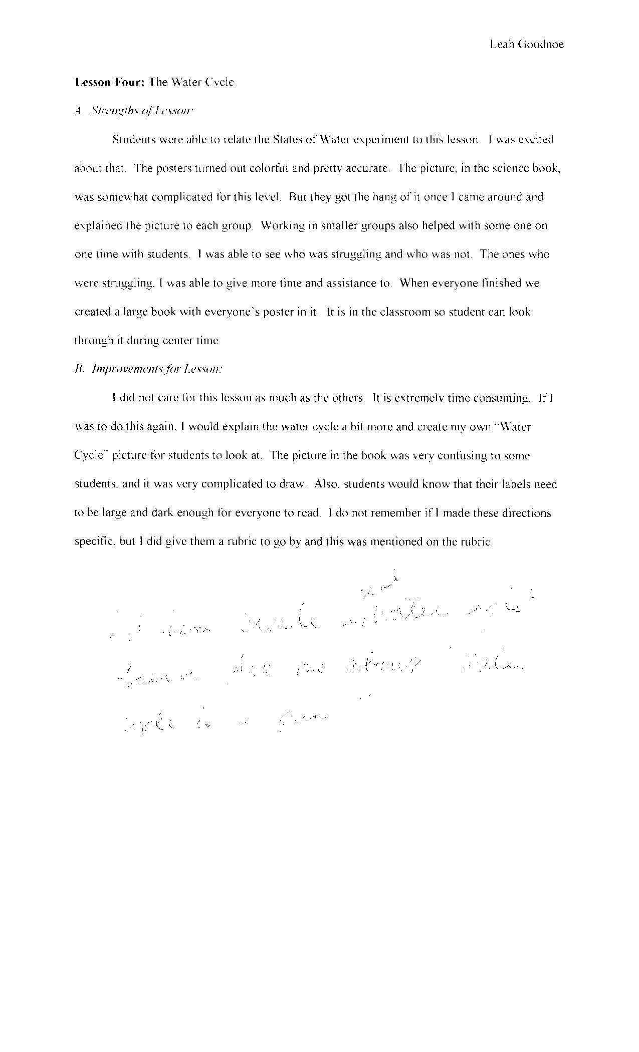

Water Cycle Poster

Teacher Name: Ms. Goodnoe
Student Name: ________________________________________

CATEGORY | 4 | 3 | 2 | 1
Title | Title is informative, centered, and larger than other text. | Title is informative and larger than other text. | Title is informative and centered. | The title is incomplete and does not clearly indicate what organism is pictured.
Labels | Every item that needs to be identified has a label. It is clear which label goes with which structure. | Almost all items (90%) that need to be identified have labels. It is clear which label goes with which structure. | Most items (75-89%) that need to be identified have labels. It is clear which label goes with which structure. | Less than 75% of the items that need to be identified have labels OR it is not clear which label goes with item.
Informational Details | All assigned details have been added. The details are clear and easy to identify. | Almost all assigned details (at least 85%) have been added. The details are clear and easy to identify. | Almost all assigned details (at least 85%) have been added. A few details are difficult to identify. | Fewer than 85% of the assigned details are present OR most details are difficult to identify.
Spelling | All words are spelled correctly in the title, labels and caption/description. | All common words are spelled correctly in the title, labels and description. 1-2 scientific words may be misspelled. | 75% of the words are spelled correctly in the title, labels, and description. | Fewer than 80% of the words are spelled correctly in the title, labels, and description.
Drawing - illustrations | Lines are clear and not smudged. There are almost no erasures or stray marks on the paper. Color is used carefully to enhance the drawing. Stippling is used instead of shading. Overall, the quality of the drawing is excellent. | There are a few erasures, smudged lines or stray marks on the paper, but they do not greatly detract from the drawing. Color is used carefully to enhance the drawing. Overall, the drawing is good. | There are a few erasures, smudged lines or stray marks on the paper, which detract from the drawing OR color is not used carefully. Overall, the quality of the drawing is fair. | There are several erasures, smudged lines or stray marks on the paper, which detract from the drawing. Overall, the quality of the drawing is poor.

Click Here to Return to Lesson Plan Home Page

