LESSON PLANNING

 | Overview of Lesson
Topic and grade level? | States of Water – 4th grade
Standard(s)/ Elements addressed in this lesson* | S4CS8 Students will understand important features of the process of scientific inquiry.  Students will apply the following to inquiry learning practices:  a. Scientific investigations may take many different forms, including observing what things are like or what is happening somewhere, collecting specimens for analysis, and doing experiments.  b. Clear and active communication is an essential part of doing science. It enables scientists to inform others about their work, expose their ideas to criticism by other scientists, and stay informed about scientific discoveries around the world.  c. Scientists use technology to increase their power to observe things and to measure and compare things accurately.  d. Science involves many different kinds of work and engages men and women of all ages and backgrounds.  S4E3 Students will differentiate between the states of water and how they relate to the water cycle and weather.  a. Demonstrate how water changes states from solid (ice) to liquid (water) to gas  (water vapor/steam) and changes from gas to liquid to solid.  b. Identify the temperatures at which water becomes a solid and at which water becomes a gas.  c. Investigate how clouds are formed.  d. Explain the water cycle (evaporation, condensation, and precipitation).  e. Investigate different forms of precipitation and sky conditions (rain, snow, sleet, hail, clouds, and fog).
As a result of the lesson, students should be able to:  (from #5 on Unit Plan) | Students should be able to identify the states of water: liquid (water), solid (ice), and gas (steam/water vapor).  Students should also be able to identify the parts of the water cycle: condensation, evaporation, and precipitation.
Assessment Instrument for students to demonstrate performance. | Students will tell/share their hypothesis and conclusion. An explanation of what a solid, liquid and gas is after watching the experiment. Students will then tie this into the water cycle.
Evaluation/grading scheme to be used with Assessment Instrument | A checklist will be used to evaluate students’ participation in the experiment. Then, students will take on solids, liquids, gases, condensation, evaporation, and precipitation.
 | Conducting the Lesson
Materials needed | - ice  - hot plate  - pot  - pan  - “Demonstration Science Experiment” observation sheet
Strategies to elicit prior knowledge and promote engagement | - Ask questions like: “When does condensation occur?” “What is a solid? Liquid? Gas?” “Where do you see the states of water occur in everyday life?”  - Ask and promote high level thinking questions.
Lesson Activities** | Do not write in this space.
A. Teacher Actions during Lesson Activities | - Set up the science experiment.  - Lecture on the states of water and use science book pages D34-D35  - Pass out the “Demonstration Science Experiment” observation sheet Allow students to create a hypothesis  - Do the experiment on condensation and evaporation.  - Have students complete the “Demonstration Science Experiment” observation sheet. During this time, students should complete the Conclusion and Significance section.  - Discuss students’ hypothesis and conclusions. Also, discuss evaporation and condensation; tie this into solid, liquids, and gases.  - Have students complete the checklist form.
B. Student Actions during Lesson Activities | - Listen and participate in class lecture.  - Observe the instruments/materials that will be used in the experiment. Create and write a hypothesis on your “Demonstration Science Experiment” observation sheet.  - Watch, listen, and observe the experiment on condensation and evaporation.  - Share your hypothesis and conclusion with the class and teacher. Try to explain evaporation and condensation, based on what you just observed.  - Complete the checklist form and turn in to the teacher.
C. Student Actions for Lesson Summary | Students will write a conclusion and tell the significance of this experiment. They will also  discuss what they observed and share their thoughts.
To Meet Special Needs | - Provide a space with few distractions  - Demonstrate instructions.  - Show/demonstrate safety skills.  - Repeat the information.
Resources for Lesson | - Harcourt Science Book  - Carroll County Resource Book  - Weather Unit Book
Reflection: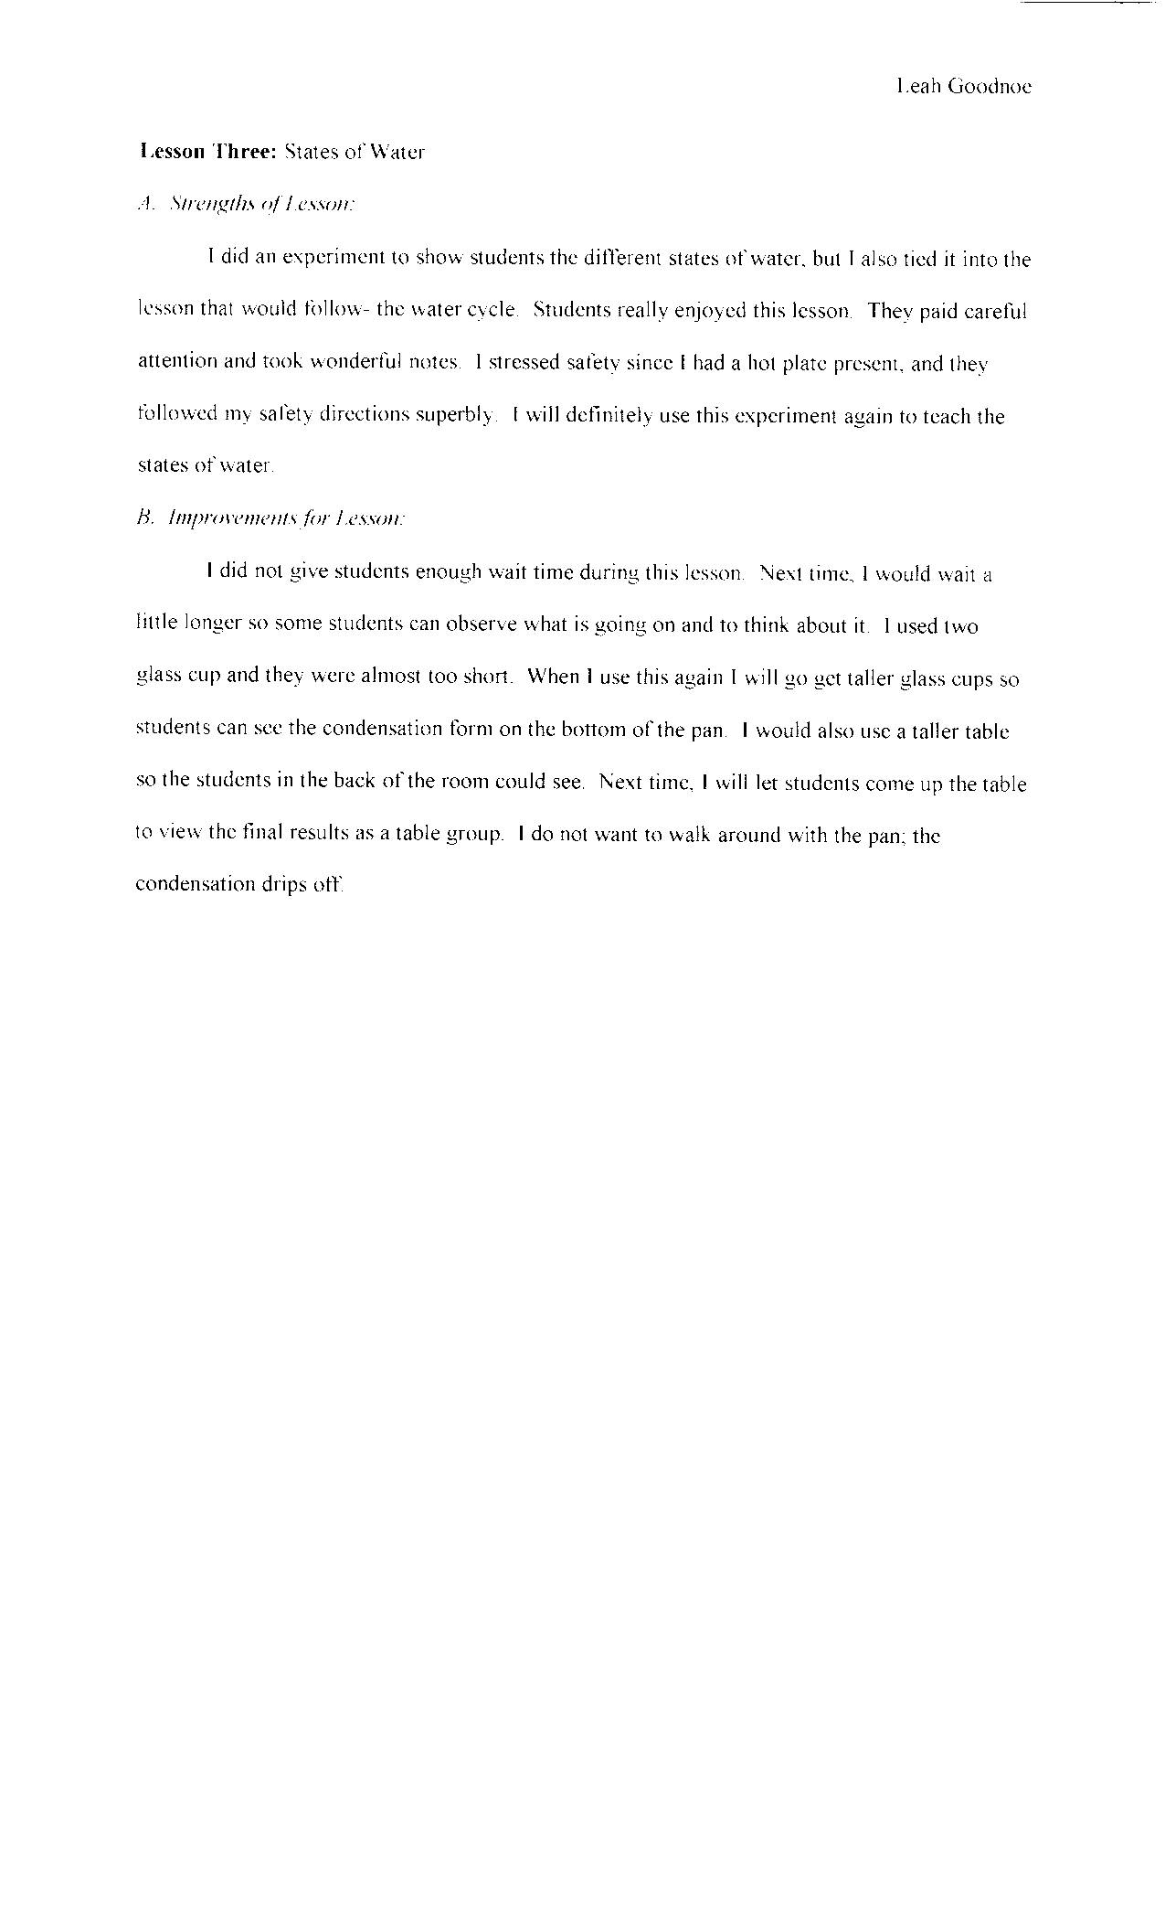

Condensation/Evaporation Checklist:

Name: ______________________________ Date: _____________

- Did you listen and participate in class discussion?
______ Yes ______ No

- Did your hypothesis match the experiment?
______ Yes ______ No

- Did you pay full attention to the experiment?
______ Yes ______ No

- Did you share your hypothesis and conclusion with the class?
______ Yes ______ No

- Did any students distract you while you were trying to observe and learn?
______ Yes ______ No

- Did you enjoy this experiment?
______ Yes ______ No

- Did you learn something from this lesson?
______ Yes ______ No

Click Here to Return to Lesson Plan Home Page

