LESSON PLANNING

 | Overview of Lesson
Topic and grade level? | Weather Maps/Forecasting- 4th grade
Standard(s)/ Elements addressed in this lesson* | S4CS4 Students will use ideas of system, model, change, and scale in exploring scientific and technological matters.  a. Observe and describe how parts influence one another in things with many parts.  b. Use geometric figures, number sequences, graphs, diagrams, sketches, number lines, maps, and stories to represent corresponding features of objects, events, and processes in the real world. Identify ways in which the representations do not match their original counterparts.  c. Identify patterns of change in things—such as steady, repetitive, or irregular change—using records, tables, or graphs of measurements where appropriate.  S4E4 Students will analyze weather charts/maps and collect weather data to predict weather events and infer patterns and seasonal changes.  a. Identify weather instruments and explain how each is used in gathering weather data and making forecasts (thermometer, rain gauge, barometer, wind vane, anemometer).  b. Using a weather map, identify the fronts, temperature, and precipitation and use the information to interpret the weather conditions.  c. Use observations and records of weather conditions to predict weather patterns throughout the year.  d. Differentiate between weather and climate.
As a result of the lesson, students should be able to:  (from #5 on Unit Plan) | Students should be able to identify and use weather symbols like: high pressure, low pressure, cold fronts, warm fronts, and stationary fronts. They will also know what a front is and what influences it.
Assessment Instrument for students to demonstrate performance. | Students will create a “live weather segment” to demonstrate their knowledge of the different weather forecasting symbols.
Evaluation/grading scheme to be used with Assessment Instrument | A rubric will be used to evaluate students on their performance as a weather anchor and the validity of their information. Then, students will take a quiz on weather forecasting symbols.
 | Conducting the Lesson
Materials needed | - Weather symbols (weather map cutouts)  - Video camera  - United States map  - Props  - Harcourt Science book  - Weather section from local newspaper  - “Figuring Out Fronts” worksheet
Strategies to elicit prior knowledge and promote engagement | - Ask questions like: “Why is it important for a farmer to what the weather will be like?” “Why do airports need to know what the weather is going to be like?” “Why do you and I need to know what the weather is going to do?”  - Promote and ask higher level thinking questions.  - Relate lesson to prior knowledge, skills, and experiences.
Lesson Activities** | Do not write in this space.
Teacher Actions during Lesson Activities | - Discuss and teach the weather forecasting symbols. Use the weather transparency and science book pages D12-D14 to aid in lecture.  - Show video clips real weather segments. Allow students to look through local papers, observe the weather predictions, and complete the Figuring Out Fronts worksheet.  - Break students into groups and have them create a live weather forecasting segment. Allow time for students to gather information and practice.  - Record each group with the video camera. After every group has gone show the video to the class.
Student Actions during Lesson Activities | - Participate in the group discussion on weather symbols.  - Study the weather forecasting symbols in the video clips and local newspapers.  - Complete the “Figuring Out Fronts” worksheet by using the local paper.  - Get into groups, assign roles, and create a weather clip for the 6 o’clock news.  - Watch video.
Student Actions for Lesson Summary | - Observe others “live weather segment” and critic.  - Then, fill out a critic form on themselves and their group. Allow students to tell what they liked about their presentation and what they would do differently.
To Meet Special Needs | - Provide a space that decreases distractions.  - Highlight directions.  - Demonstrate instructions.  - Utilize pictures and visual prompts.  - Repeat the information.  - Ask only one question at a time.
Resources for Lesson | - Harcourt Science book  - Carroll County Resource Book  - Atlanta Journal-Constitution weather sections  - Weather Unit book
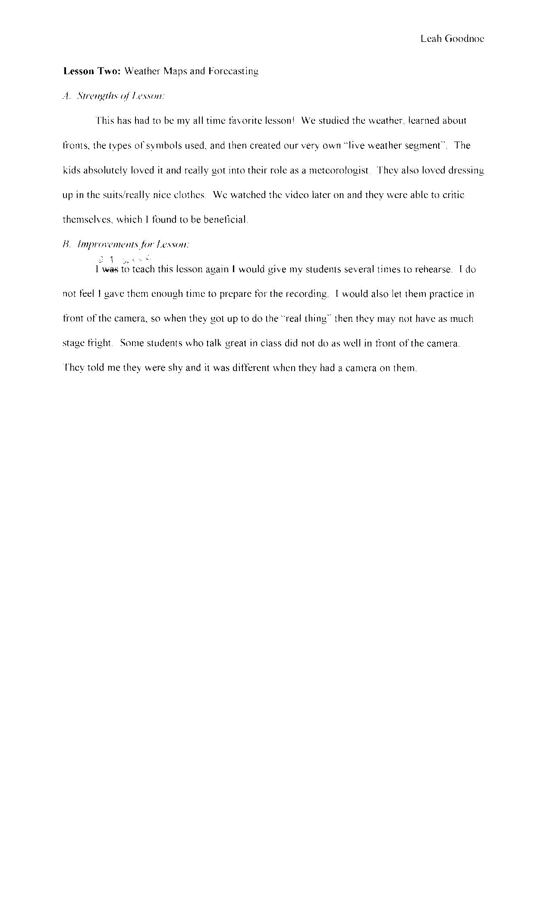

Weather Forecasting Segment

Teacher Name: Ms. Goodnoe
Student Name: ________________________________________

Your Predicted Score: ___________________________________

Teacher’s Score: _______________________________________

CATEGORY | 4 | 3 | 2 | 1
Enthusiasm | Facial expressions and body language generate a strong interest and enthusiasm about the topic in others. | Facial expressions and body language sometimes generate a strong interest and enthusiasm about the topic in others. | Facial expressions and body language are used to try to generate enthusiasm, but seem somewhat faked. | Very little use of facial expressions or body language. Did not generate much interest in topic being presented.
Preparedness | Student is completely prepared and has obviously rehearsed. | Student seems pretty prepared but might have needed a couple more rehearsals. | The student is somewhat prepared, but it is clear that rehearsal was lacking. | Student does not seem at all prepared to present.
Speaks Clearly | Speaks clearly and distinctly all (100-95%) the time, and mispronounces no words. | Speaks clearly and distinctly all (100-95%) the time, but mispronounces one word. | Speaks clearly and distinctly most ( 94-85%) of the time. Mispronounces no more than one word. | Often mumbles or can not be understood OR mispronounces more than one word.
Props | Student uses several props (could include costume) that show considerable work/creativity and which make the presentation better. | Student uses 1 prop that shows considerable work/creativity and which make the presentation better. | Student uses 1 prop which makes the presentation better. | The student uses no props OR the props chosen detract from the presentation.
Collaboration with Peers | Almost always listens to, shares with, and supports the efforts of others in the group. Tries to keep people working well together. | Usually listens to, shares with, and supports the efforts of others in the group. Does not cause "waves" in the group. | Often listens to, shares with, and supports the efforts of others in the group but sometimes is not a good team member. | Rarely listens to, shares with, and supports the efforts of others in the group. Often is not a good team member.
Posture and Eye Contact | Stands up straight, looks relaxed and confident. Establishes eye contact with everyone in the room during the presentation. | Stands up straight and establishes eye contact with everyone in the room during the presentation. | Sometimes stands up straight and establishes eye contact. | Slouches and/or does not look at people during the presentation.
Click Here to Return to Lesson Plan Home Page

