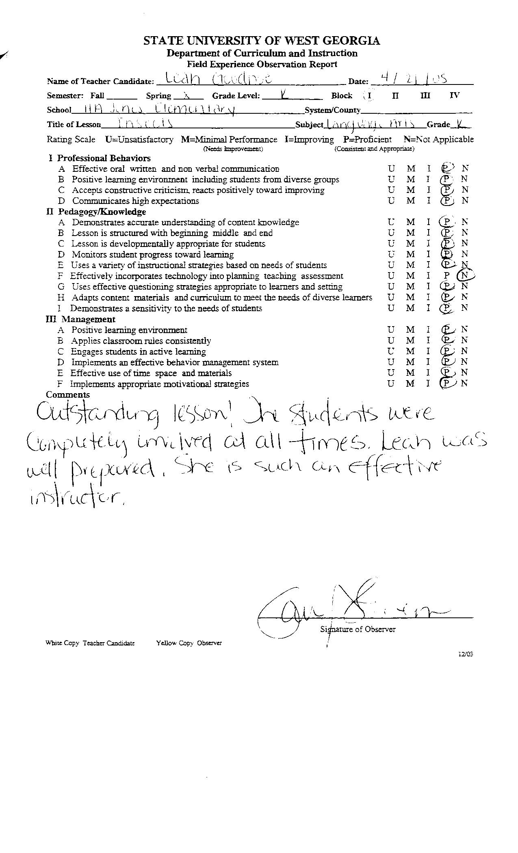
Click Here to Return to Lesson Plan Home Page

