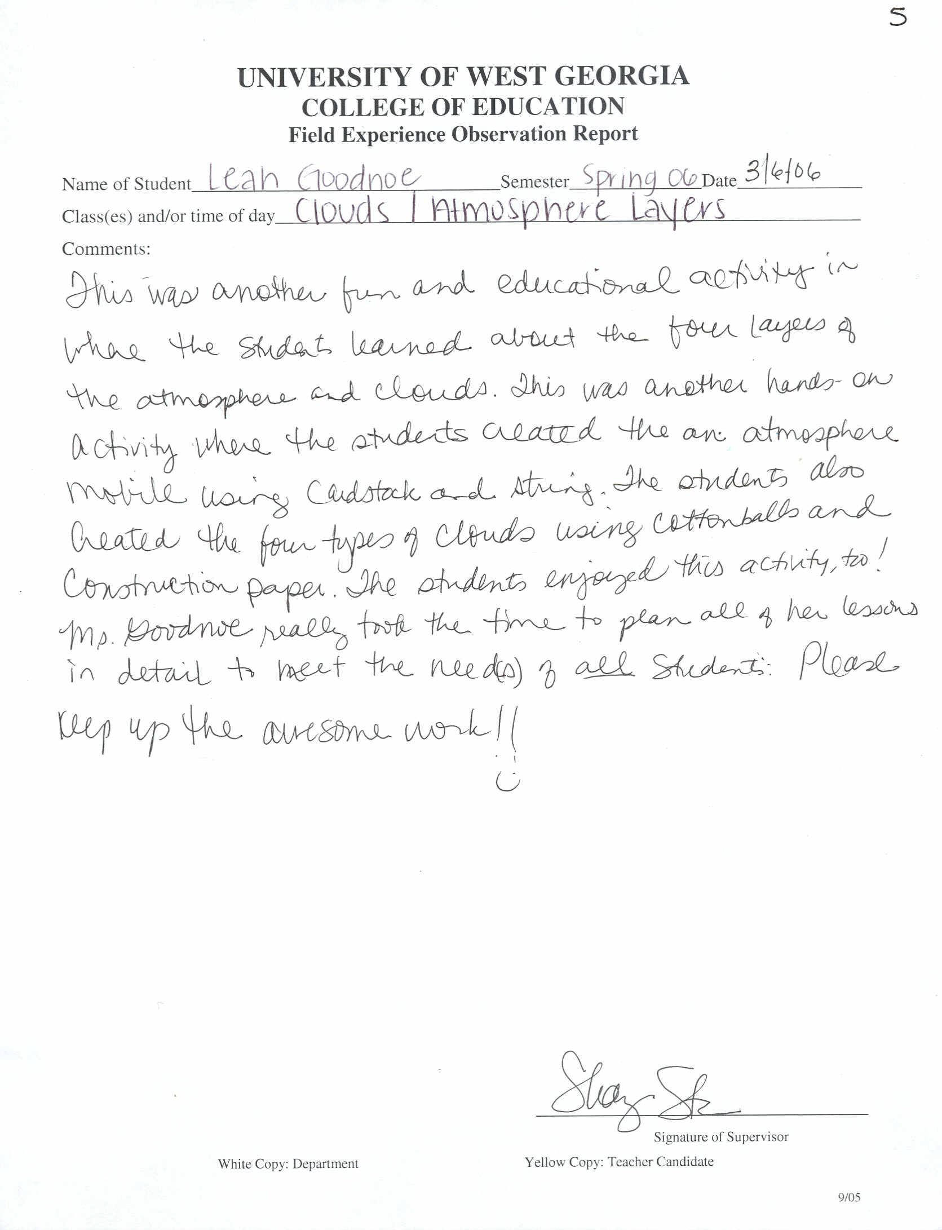

Click Here to Return to Lesson Plans Home Page

