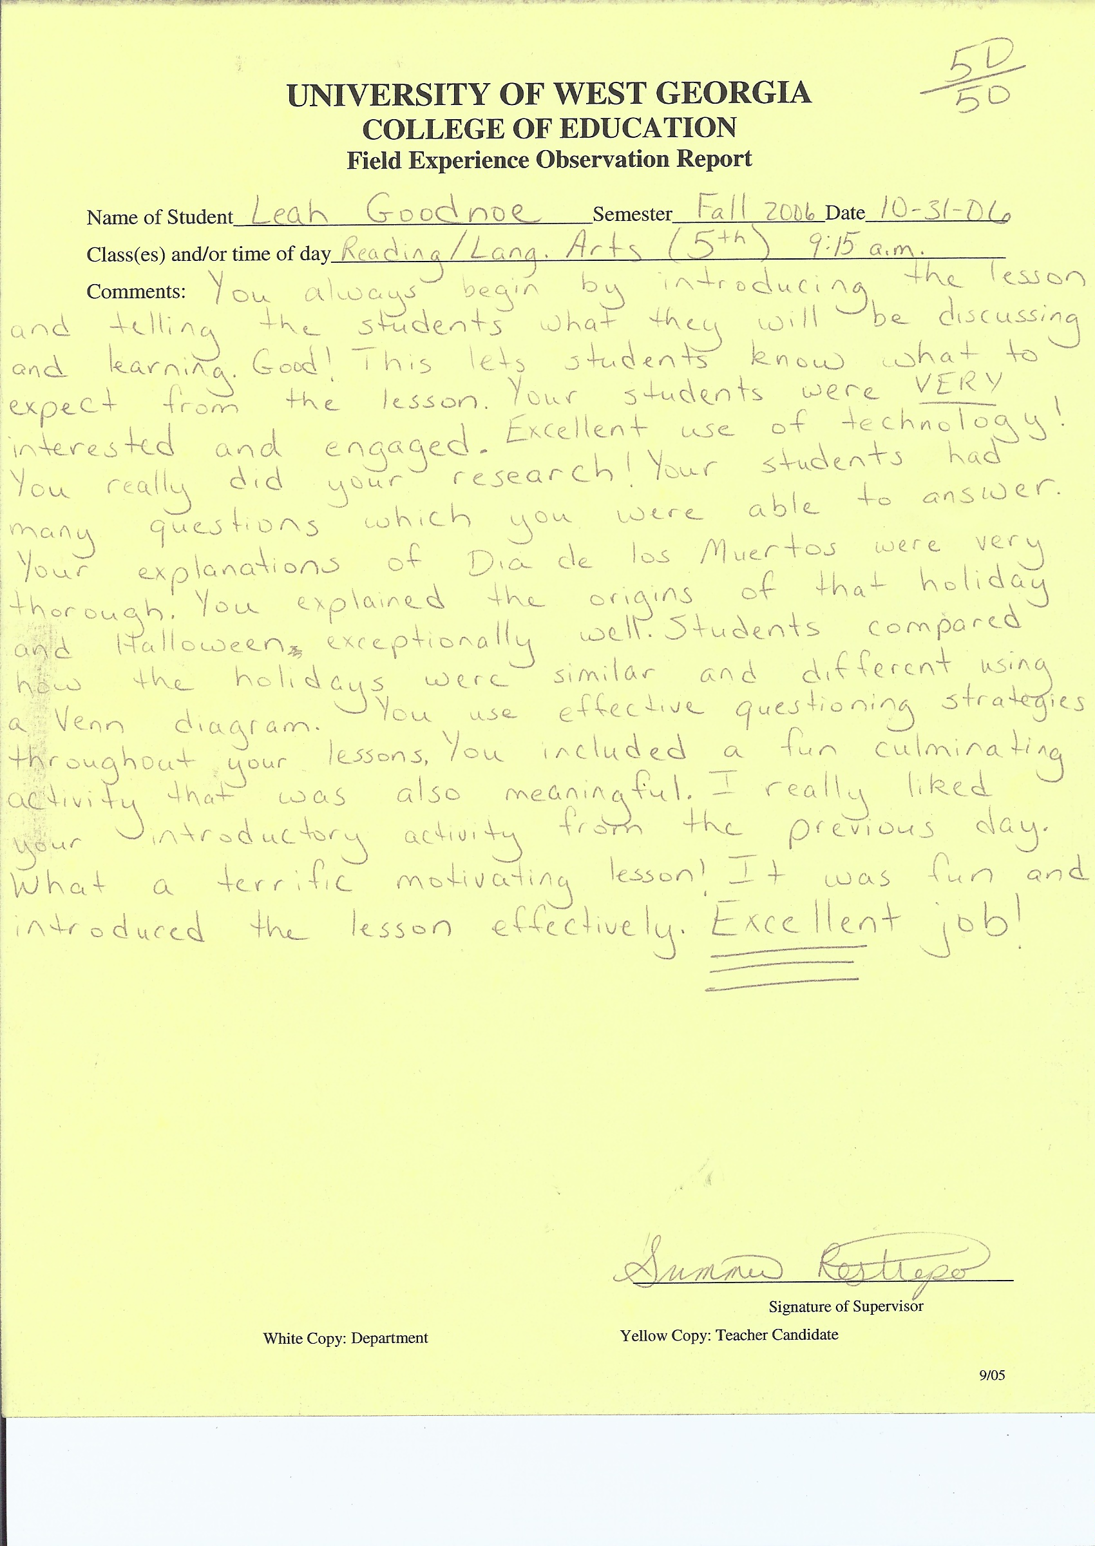

Click Here to Return to Evaluation Home Page

