A is for art.
Art is the physical expression of creativity or imagination. Art is commonly understood as an act and process of making material works (or artworks). The term 'art' may be taken to include forms as diverse as prose writing, poetry, dance, acting, music, sculpture and painting. Art may also be understood as relating to creativity, aesthetics, and generation of emotion.
There are a variety of arts, including visual arts and design, decorative arts, plastic arts, and the performing arts. Artistic expression takes many forms: painting, drawing, printmaking, sculpture, music, literature, and architecture are the most widely recognized forms. Since the technological revolution, new forms have emerged: photography, film, video art, performance art, land art, fashion, comics, computer art, and video games.
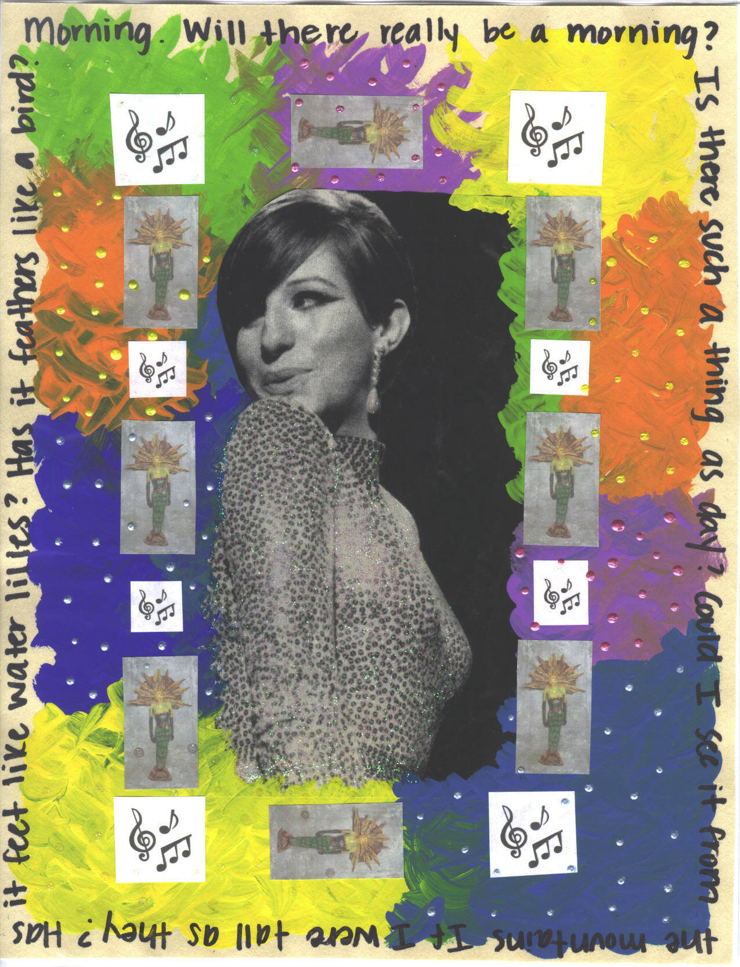
C is for collage.
A collage is a picture or design created by adhering flat elements such as newspaper, wallpaper, printed text and illustrations, photographs, cloth, string, etc., to a flat surface. If the collage becomes three-dimensional it may be called a relief sculpture, construction, or an assemblage. The materials used in most collages are "found" materials.
Collage art was introduced by Cubism artists. This process was and still is widely used by artists who study and follow Cubism. Collage is a familiar technique in contemporary art.
"Collage" was originally a French word, derived from the word coller, meaning "to paste" or "paste up."

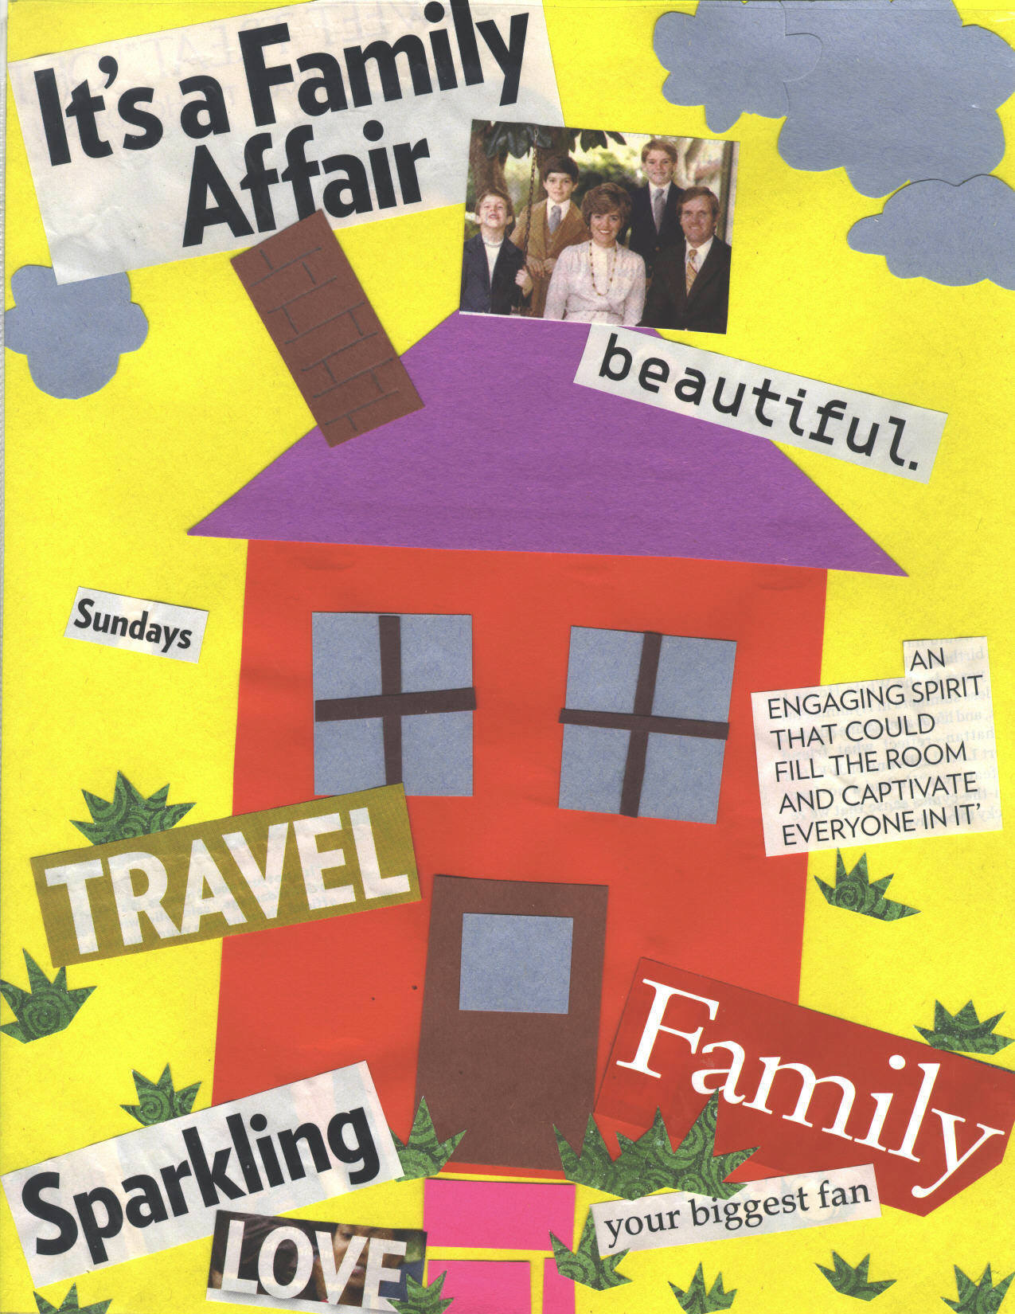

D is for drawing.
Drawing is an illustration that is drawn by hand and is published in a book or magazine. Drawing is representing an image by means of adding lines and shades, with a pencil, crayon, pen, chalk, pastels, etc. The marks on the paper may represent what the artist sees when drawing, a remembered or imagined scene, or in the case of automatic drawing, may have to do with the motion of the artist’s hand across the paper or surface.
Drawing is the depiction of shapes and forms on a surface by means of lines. Color and shading may be included. A major fine art technique in itself, drawing is the basis of all pictorial representation, and an early step in most art activities. Though an integral part of most painting, drawing is generally differentiated from painting by the dominance of line over mass.

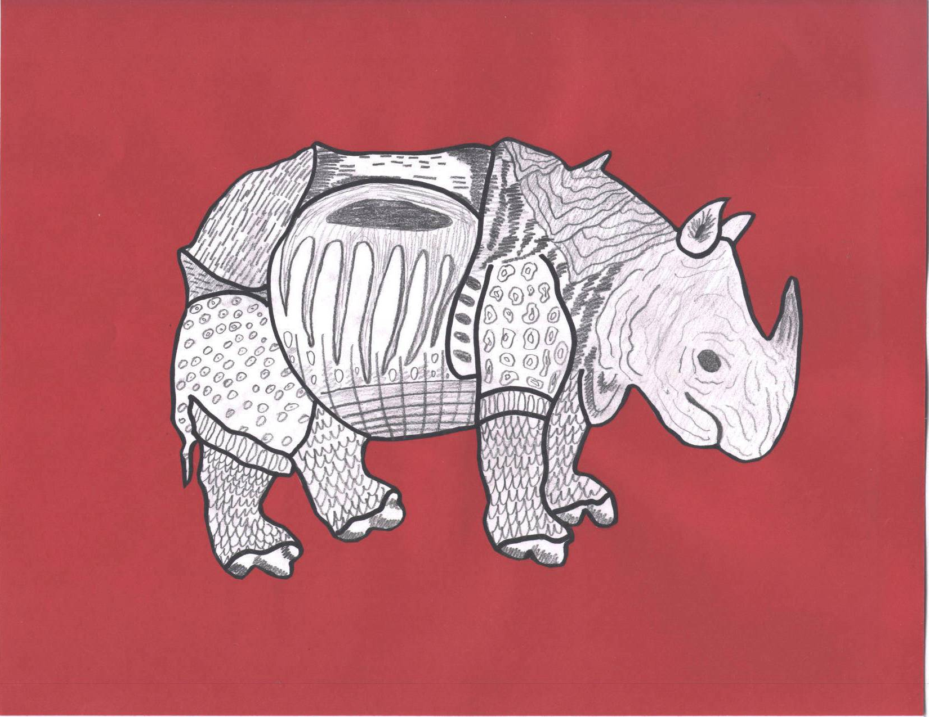
F is for Folk Art.
Folk Art is art created by people who are unschooled artist; people who have had little or no formal schooling in art. It originating among the common people of a nation or region and usually reflects their traditional culture, especially everyday or festive items.
Folk Art does not come out of the fine art tradition. Folk Artists are typically from rural or pre-industrial societies. Folk Artists are more closely related to craftsmen than they are to fine artists. Folk artists usually make works of art with traditional techniques and content, in styles handed down through many generations.
Paintings, sculptures, ceramics, metalwork, costume, tools, and other everyday objects all may be folk art. Other terms for Folk Art are Outsider Art, Self-Taught Art, and Naïve Art.
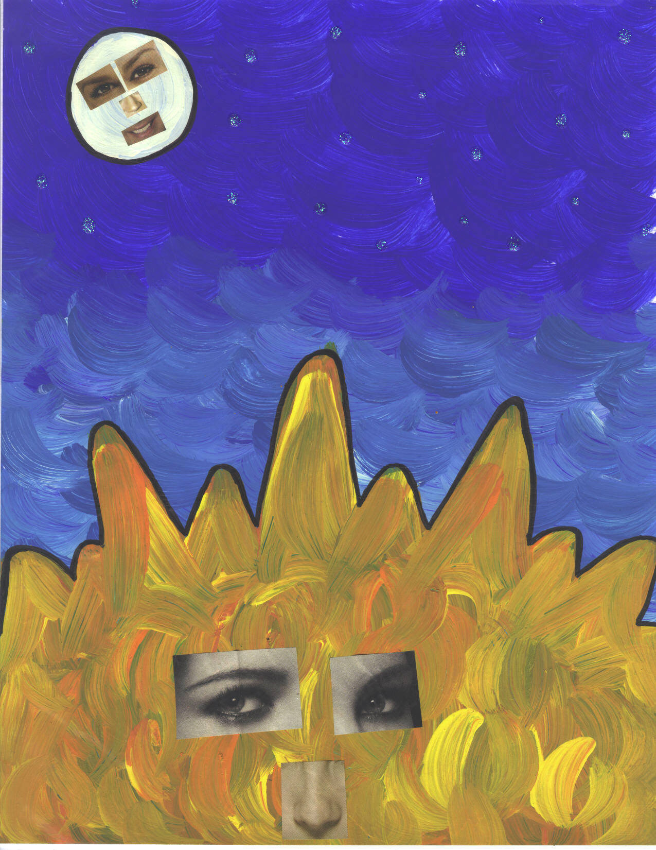
P is for pastels.
Pastels are pigments mixed with gum and water, and pressed into a dried stick to form a type of crayon. Chalk is similar to pastel, but more tightly bound.
A picture made with pastels may be called either a drawing or a painting. The principal reason to call it one or the other has nothing to do with whether it has ever been wet. It has entirely to do with whether the resulting image shows shapes or forms created with patches of color, exploiting color and tonal relationships.
The term "pastel" has been used by some to mean tints or pale colors -- soft colors, lightened with white -- having little saturation and great lightness.
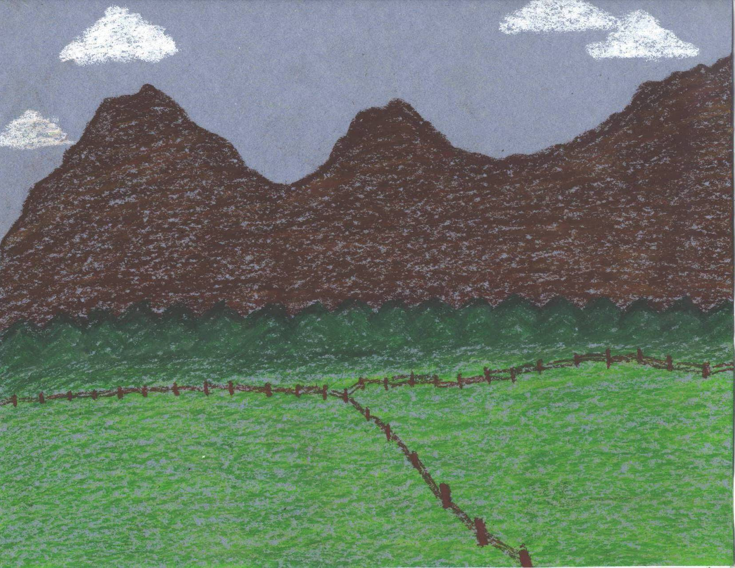
R is for repetition.
Closely related to harmony, a principle of design, this term refers to a way of combining elements of art so that the same elements are used over and over again. Repetition can be used on all of the Visual Elements. If things are repeated without any change they can quickly get boring.
However, repetition with variation can be both interesting and comfortably familiar. A certain color or shape might be used several times in the same picture. Repetition gives motion, and can contribute movement and rhythm in a work of art.

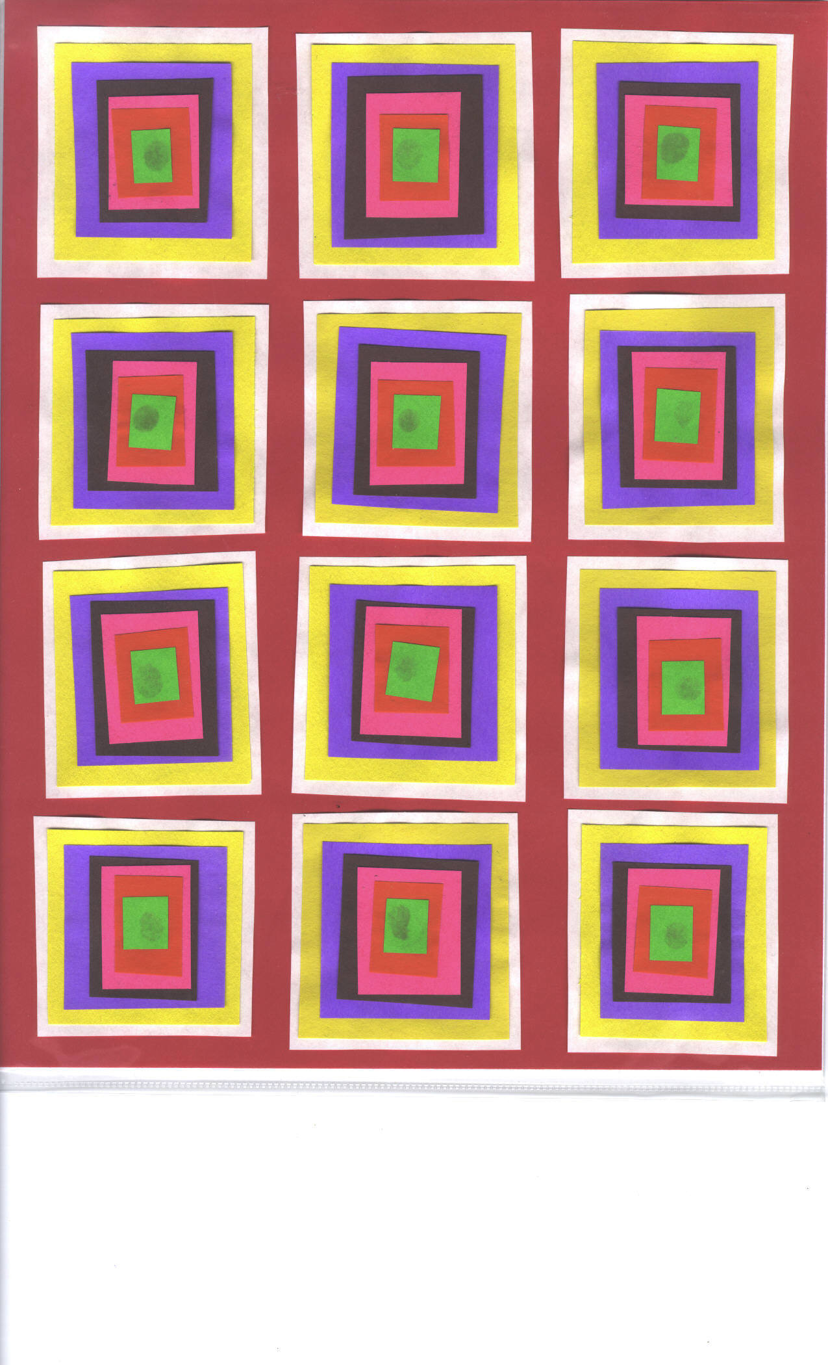

V is for van Gogh.

Vincent Van Gogh is a famous artist who was born in 1853 in the Netherlands. Van Gogh was born in Groot-Zundest, Holland. The son of a pastor, brought up in a religious and cultured atmosphere, Vincent was highly emotional and lacked self-confidence. Van Gogh had major health issues; he suffered from fits of madness and lucidity. He was sent to an asylum for treatment. Two months later he was dead, having shot himself "for the good of all."

During his brief career he sold one painting. Van Gogh's finest works were produced in less than three years. Van Gogh's fusion of form and content is powerful; dramatic, imaginative, and emotional, for the artist was completely absorbed in the effort to explain either his struggle against madness or his comprehension of the spiritual essence of man and nature.
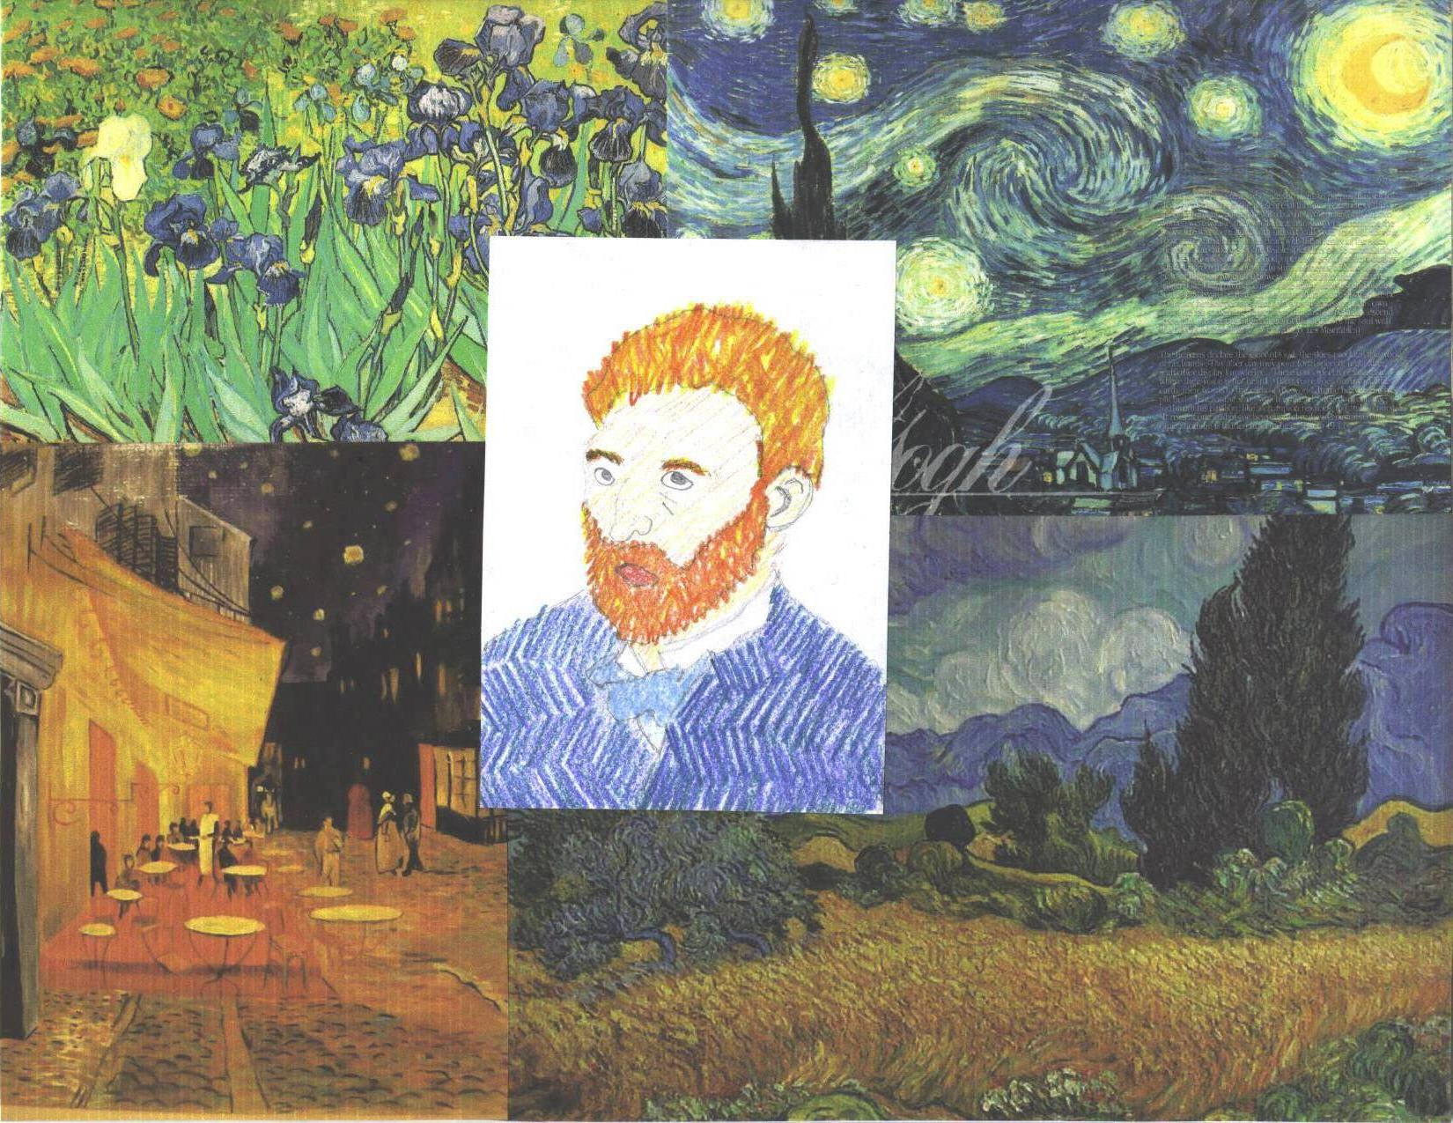
Click Here to Return to Collaborative Home Page

