INTRODUCTION TO GLIFFY

You will use Gliffy to create a graphic organizer that shows Web 2.0 tools that you have used before.

- Go to www.gliffy.com

- Click on: Click on the orange tab that says: “Get Started Now, No Sign Up Required.”
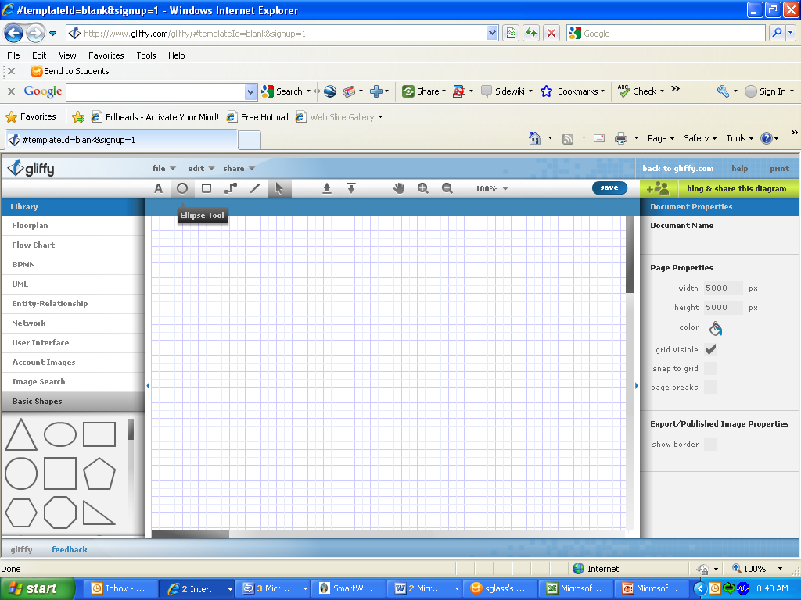
- Click on the ellipse/circle button on the toolbar.

Use your mouse to draw an oval in the work area.
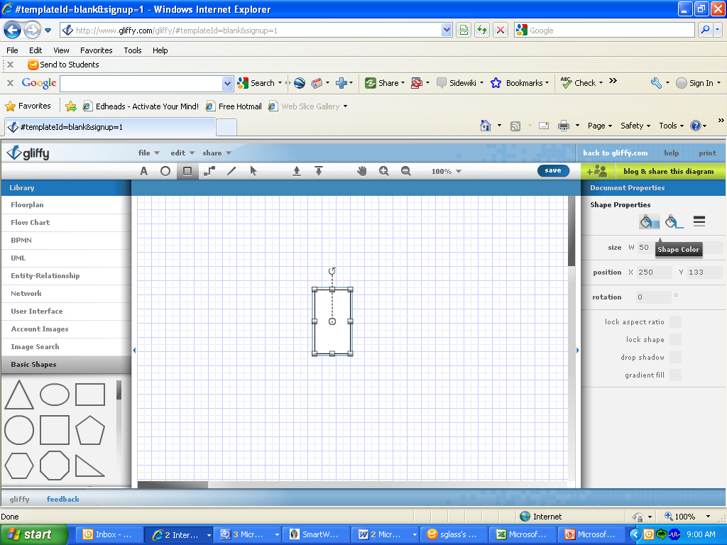
Please note: You will have to click on the pointer tool if you want to select an object in your work area.
- Click on the text button on the toolbar.

Draw a textbox inside the oval in the work area. Then type “Web 2.0 Tools” inside it.
- Click on the rectangle button on the toolbar.

Use your mouse to draw a rectangle somewhere in the work area.

- Using the text button, type “Gliffy” inside the rectangle that you just drew.

- Click on the line button on the toolbar.

- Use your mouse to draw a line connecting the oval (Web 2.0 Tools) to the rectangle (Gliffy).

- Now add at least 4 rectangles and connect them to the oval (Web 2.0 Tools) using the line tool.

- Use the text tool to type the names of Web 2.0 Tools you have used inside each rectangle.

- Be sure to keep your assignment on your screen until your instructor checks it.

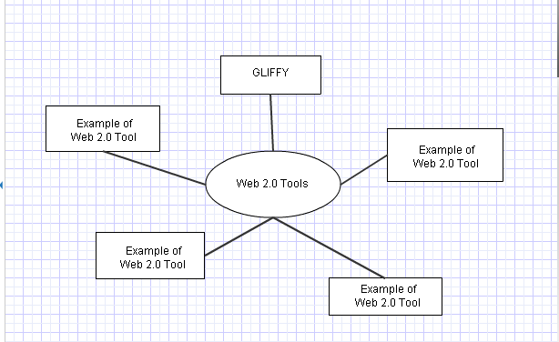

Your graphic organizer should look similar to this one:

**If you have time, you can select your shapes using the pointer tool and add color to them by using the fill button (paint bucket) that appears on the right side of the screen once a shape is selected.

