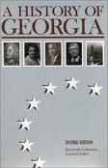
Name: _____________________________

Grouping Form for Webquest:
GA Historical Figures

Directions: Please write down 3 historical figures that you would be interested in researching. Please hand this in as soon as possible to the teacher.

- ___________________________________________ - Favorite
- ___________________________________________
- ___________________________________________ - Least favorite

- Note: I will try my best to match everyone as closely as I can to their top choices. I will have the group lists shortly. Get excited!

Here are your choices, write down ONLY 3:

James Oglethorpe
Tomochichi
Mary Musgrove
Sequoyah
Jackie Robinson
Martin Luther King, Jr.
Jimmy Carter

