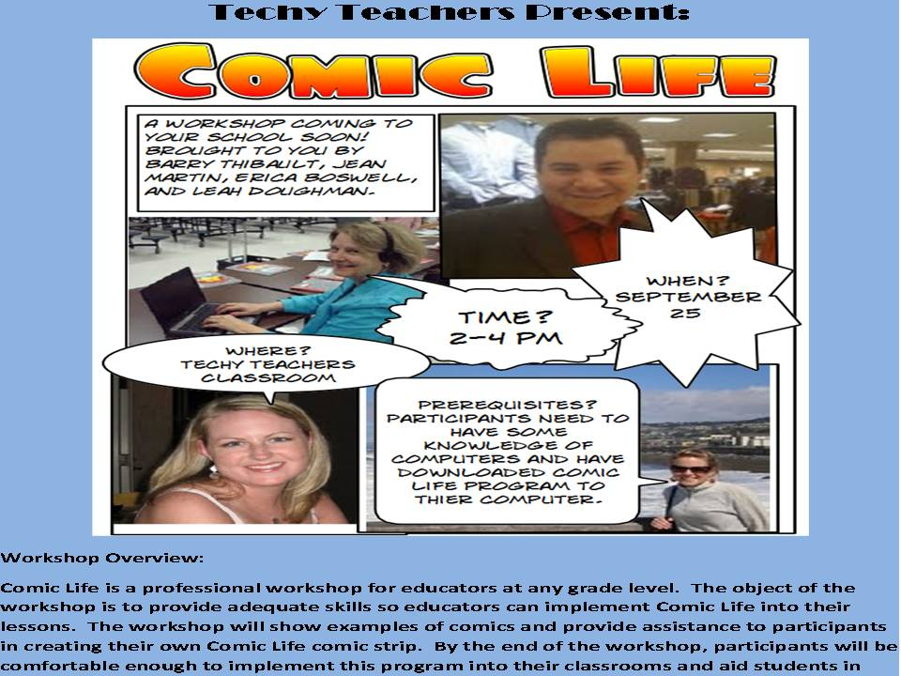
Comic Life: Putting a Technological Twist on Teaching
Project Leader – Barry Thibault
Group Members- Erica Boswell, Leah Doughman, Jean Martin
Date Submitted: September 27, 2009

Introduction
Under the direction of Dr. Baylen at the University of West Georgia, Carrollton, Georgia, the MEDT 7464 collaborative group, Techy Teachers ,came together to learn a powerful software that could enhance any classroom. The Comic Life Software was new to everyone in the group; however, with practice each member generated example instructional lessons for the development of a workshop. This workshop would be available to help with the instruction of educators at the secondary level using Comic Life. The two and a half hour workshop will include valuable resources for all to take home including tips on integrating technology into the classroom as well as other teaching ideas outlined below.
Overview
Workshop Title:
Comic Life: Putting a Technological Twist on Teaching
Goals:
In this professional learning workshop, participants will learn how to use and create a comic strip through the program Comic Life to aid middle school students.

Objectives:
In the workshop, Comic Life: Putting a Technological Twist on Teaching”, educators will be given the opportunity to develop their skills on implementing an effective Comic Life. The program will expose educators to projects that have been created through the use of Comic Life. The program will also give participants a hands-on opportunity to create their very own Comic Life comic strip which will be useable in their classrooms. By the end of the program, participants will feel comfortable enough to implement this program into their classroom and meet the individual needs of their students.
Rationale
The educational and multimedia software called Comic Life was designed to introduce fun, hands on instruction with creativity for today’s students using the latest in digital media technology. The program uses intuitive resources presently available in most classrooms – a computer, camera, scanner, and other digital media. Additionally, the software can be used to facilitate student projects in all types of classrooms and with some creativity; anyone can develop exciting imagery to bring to life textbooks and classroom lessons. This innovative approach to delivering instruction can enhance the performance of each student.
This Comic Life workshop is designed to aid instruction by introducing ideas and examples of software using technology that will engage their students in creative and artistic learning. The teachers joining the workshop will go away with sample projects they can use instantaneously in their classroom. Participants will become comfortable with the technology and learn how to fulfill the state and national standards using Comic Life in their lessons while fulfilling recent technology requirements.
Prerequisites:
Comic illustration expertise is not necessary! Participants need only to have a basic knowledge of computers and digital image formats with a desire to increase the creativity and performance of their students. During the workshop teachers will select and start to develop their own Comic Life example that they can then start using in their classroom. Those comfortable with digital imaging will work with those who are not. All participants will be learning and producing a Comic Life sample together based on the learning needs of the students in their classrooms. You may come prepared with images from your favorite textbook, story, scrapbook or photo gallery.

Resources:
For highest participant impact, each participant will be able to see a presentation board comfortably with Internet capabilities (ie. ActiveBoard, Smartboard, LDC computer projector, etc.) in a whole group session. Then, for small group work, one computer for every 3 participants is recommended to provide every participant an opportunity to have hands-on access to the technology while collaborating with colleagues. Each computer will need Internet access and the free trial of Comic Life downloaded. This program can be found at: http://plasq.com/downloads/.The four workshop providers will each work with a small group of teachers from different content areas - math, language arts, social studies, and connections and science - during the small group portion of the workshop. This hands-on, small group structure with a knowledgeable resource will accelerate learning of the technology and the creation of an initial project that will be usable in the classroom.

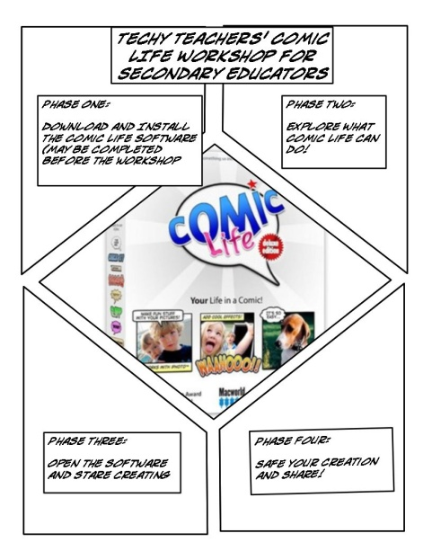
Processes:
The workshop will be conducted in four phases:
Phase One: Download and Install the Comic Life Software (if needed);
Phase Two: Find out what Comic Life Can Do;
Phase Three: Start Creating in Comic Life; and Phase Four: Save Your Creation and/or Share. Participants will bring their own laptops pre-loaded with the Comic Life software and participate in a hand-on session in one of four content areas of their choosing: Social Studies, Mathematics, Language Arts, and Science/Connections. The schedule for the workshop is outlined below:
Comic Life Workshop Schedule
1:30 p.m. Large central presentation room setup is complete and available for participants to take a seat, boot up their laptops, and make sure Comic Life is installed and working on their equipment. Internet access for all laptops is required. If all laptops have already installed the software, the Internet is not a requirement.
2:00 p.m. Whole group session begins – Phase One – installing Comic Life, if participants if needed by the participants. This Phase may be eliminated and the sessions will start in the individual content area locations.
2:10 p.m. Participants move to one of four content area sessions: Social Studies, Mathematics, Language Arts, and Science/Connections.
2:15 p.m. Phase Two – The leader of each group will provide examples in the specific content area of Comic Life creations and the group will brainstorm on ideas they have for potential uses in their classrooms and share resources for images.
2:45 p.m. Phase Three – Each participant will open the software and start creating. They will be paired with other participants – one who is more comfortable with the software and one who is less comfortable. The participants will work in teams to discuss questions through the process, but each working on their own individual comic. The facilitator will move from pair to pair to answer any questions and to monitor progress.
3:45 p.m. Phase Four – The participants will select a minimum of two formats to save their comics. After work is saved, the participants will circulate to the work stations of others to view their projects.
3:55 p.m. Once all participants complete and save their projects, the workshop evaluations will be distributed in paper form if the Internet is not available, or the link to the on-line evaluation will be provided either at the front of the room or on a paper handout. The workshop facilitator will be available at the front of the room to answer any additional questions and ensure the evaluations are completed.
4:00 p.m. Participants will depart.

Feedback:
Participants will evaluate the quality of this workshop and its relevance to their instruction through an on-line workshop evaluation. This tool is available to preview at: http://spreadsheets.google.com/viewform?formkey=dHlGUGFQM3kzSklOX0Q0SGp6WGttcHc6MA
Before participants leave the workshop, each will complete the on-line evaluation. The results will be compiled through an automated process and be available to the workshop sponsor that same day.

Expertise:
Barry D. Thibault is the third project leader for the Comic Life Workshop. Mr. Thibault is presently pursuing his Masters degree in Instructional Technology at the University of West Georgia and plans to continue an additional Specialist degree in Instructional Technology. Mr. Thibault holds a Bachelors of Arts degree in Elementary Education from the University of South Florida and has been certified to teach in Florida and Georgia. Present certifications for Mr. Thibault include: Music K-12, Theater Arts K-12, Math middle grades, Language Arts middle grades and elementary education. Currently, he teaches theater classes at Douglass High School in an inner city school in Atlanta, Georgia where he hopes to implement additional instructional technology procedures for all the Fine Arts programs. As Mr. Thibault continues to work on his “Working Definition of Technology Instruction,” he is energized about the possibilities of using technology and instruction to make the arts exciting and creative for all students.

Summary

Additional Resources
- Workshop Flyer for October (included in electronic folder)
- Participant Handout with Comic Life Instructions (included in electronic folder)
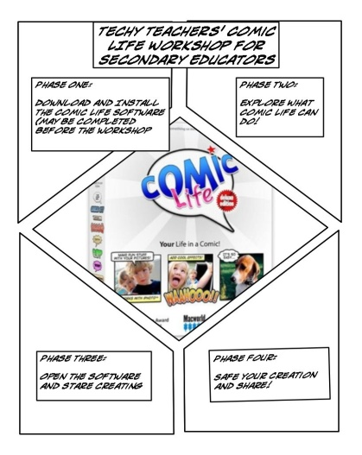
- Electronic Survey Form (Word document included in electronic folder)
Also available at: http://spreadsheets.google.com/viewform?formkey=dHlGUGFQM3kzSklOX0Q0SGp6WGttcHc6MA
- Website on Techy Teachers
http://www.martybray.net/bthibau1/medt7471/comiclife.html
- Links to Team Member’s Comic Life examples for Workshop

Jean Martin
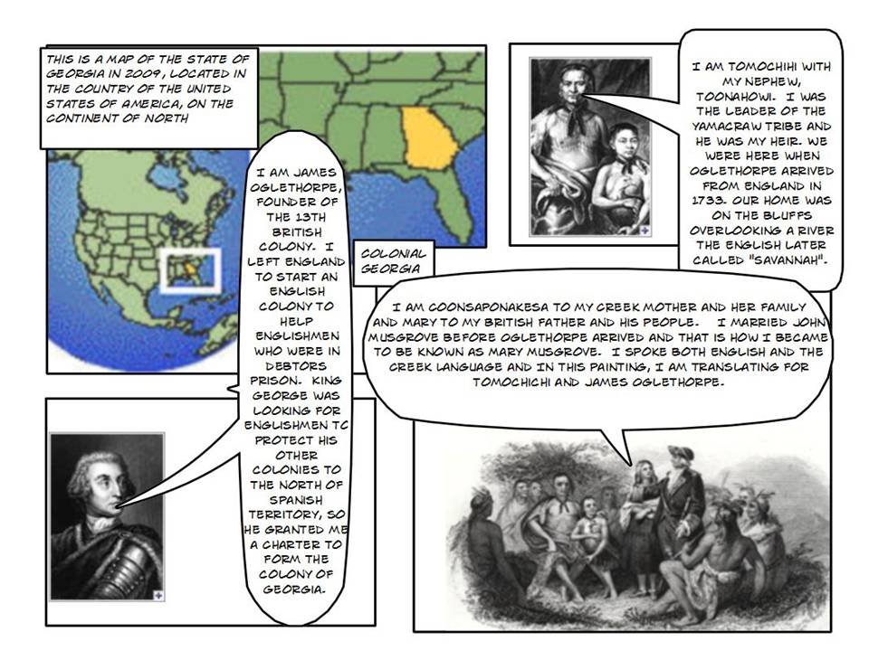

Click on picture for link to Jean’s Comic Life example.

Erica Boswell
Click on picture for link to Erica’s Comic Life example.
Leah Doughman
Click on picture for link to Leah’s Comic Life example.

Barry Thibault
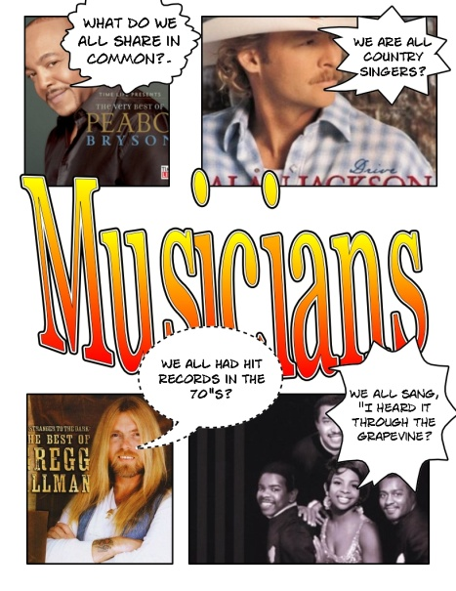
Click on picture for link to Barry’s Comic Life example.

