
Qwik Start Guide
Destiny Library Manager
Tracy Stewart, Claudie Wallen, Stephanie Gauthia
MEDT 6468
Dr. Snipes
Fall 2010
Table of Contents:

Section One: In the Beginning 3

Section Two: Online Patron Access Catalog 8

Section Three: Cataloging (Maintaining the Collection Database) 19

Section Four: Circulating Materials & Interlibrary Loans 25

Section Five: Reports and Utilities 32

Section Six: General Troubleshooting Tips 43

Most directions assume the user is already logged into the system

Section One: In the Beginning

Setting up Patron Types

Patron Types allow you to group patrons by similar characteristics. You have the option of using preset types (Faculty and Student) or setting up patron types to meet your specific needs.

•From the main screen click on the Back Office tab

•Select Library Policies from the left menu

•Click on Patron Type

•From the Add Patron Type page you can enter the patron type name and specifications

for the patron’s circulation.

•Click on Save

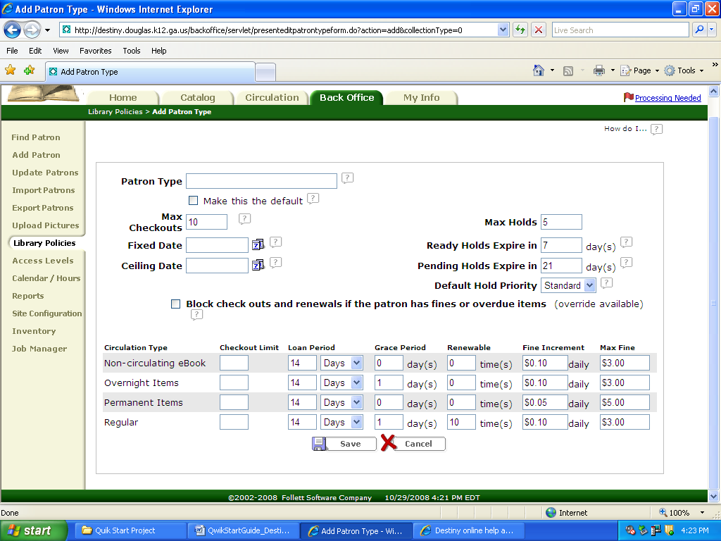

Adding or Updating Patrons
Creating New Patrons
•From the main screen click on the Back Office tab
•Select Add Patron from the left menu
•Fill in the necessary information in the spaces provided.
•Click on Save

Importing New Patron Records from a Database
•From the main screen click on the Back Office tab
•Select Import Patrons from the left menu
•Choose between barcode or ID number as the patron identifier.
•Choose what you want to do in the case of a 2nd identifier.
•Choose how you want to handle duplicate records (Keep current record, merge records,
replace current record)
•Click Browse
•Select the import file
•Click Import
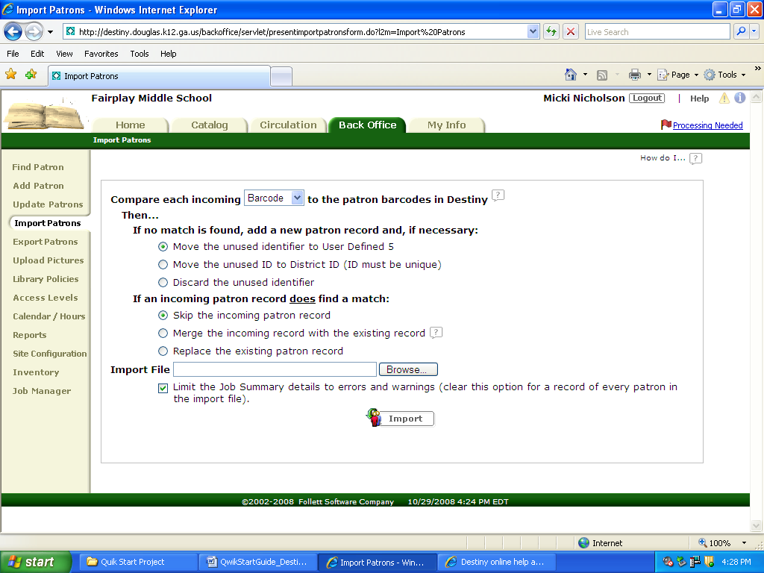
•Wait until you see the message “The patron import you requested has been submitted”.

Updating Existing Patron Records
Individual Updates
Use this feature to change up to three fields at once for a few individual patron records.
•From the main screen click on the Back Office tab
•Select Update Patron from the left menu
•Click on the Individual Update tab
•Click the down arrow of the select a patron field
•Select a field to update
•Select the new information for the field from the “to” list.
•Select the patron by clicking in the patron search box and typing in or scanning in the patron barcode.
***to search for a patron by name enter the name, select “only search”
and click Update
•Select from the list provided by clicking the patron name.
•To verify the update click Edit Patron for the patron updated

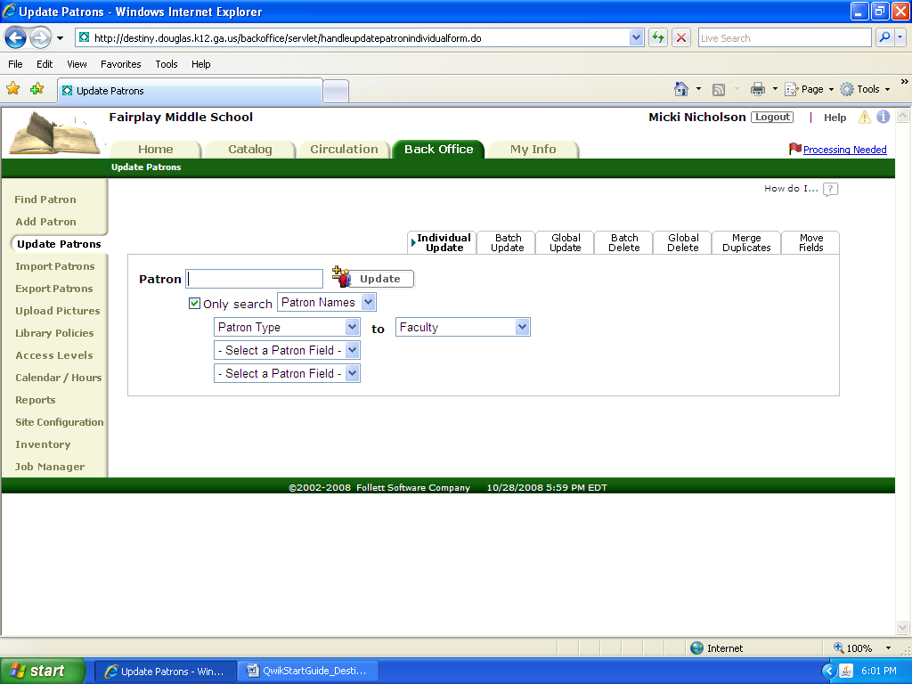
Batch Updates
Use this feature to update up to three fields for a selected list of patrons.
•From the main screen click on the Back Office tab.
•Select Update Patron from the left menu
•Click on the Batch Update tab
•Select a field to update by clicking on Select a Patron Field and selecting from the drop down menu.
•Select the field’s new contents from the “to” list (leave blank to clear the field)
•Select Create List
•Enter search criteria in first box and select the field to search in from the drop down menu.
•Click Search
•Click Select for each patron to be added to the list.
•Click Update

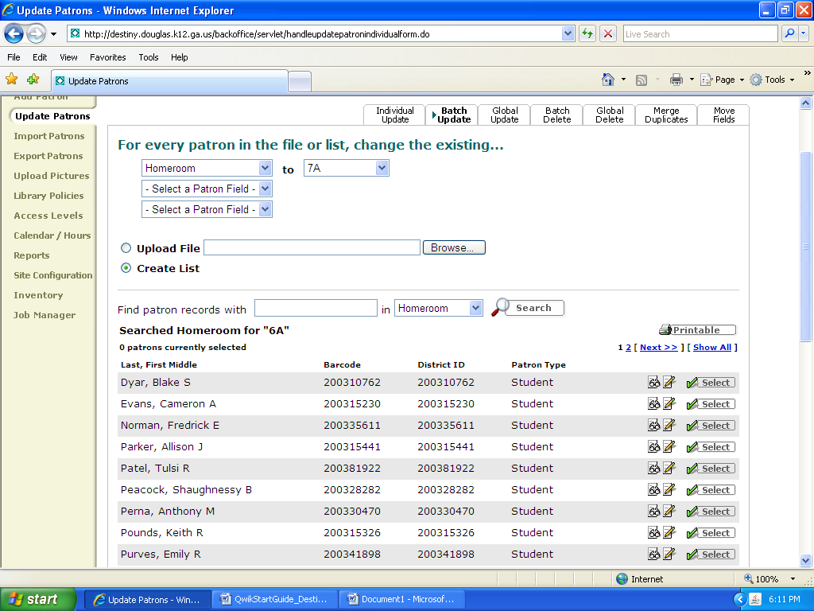

Global Updates
Use this feature to update all patron records that share a common field.
•From the main screen click on the Back Office tab.
•Select Update Patron from the left menu
•Click on the Global Update tab
•Set up the group
From the “whose” list, select the field to update and then select the field contents to search for from the “is” list.
•From the “change” list select the field you want to change.
•From the “to” list select the new information for the field
***if you want to delete the contents of the field leave this box empty.
•Click Update
•To verify the update go to the main screen, click on the Back Office tab and
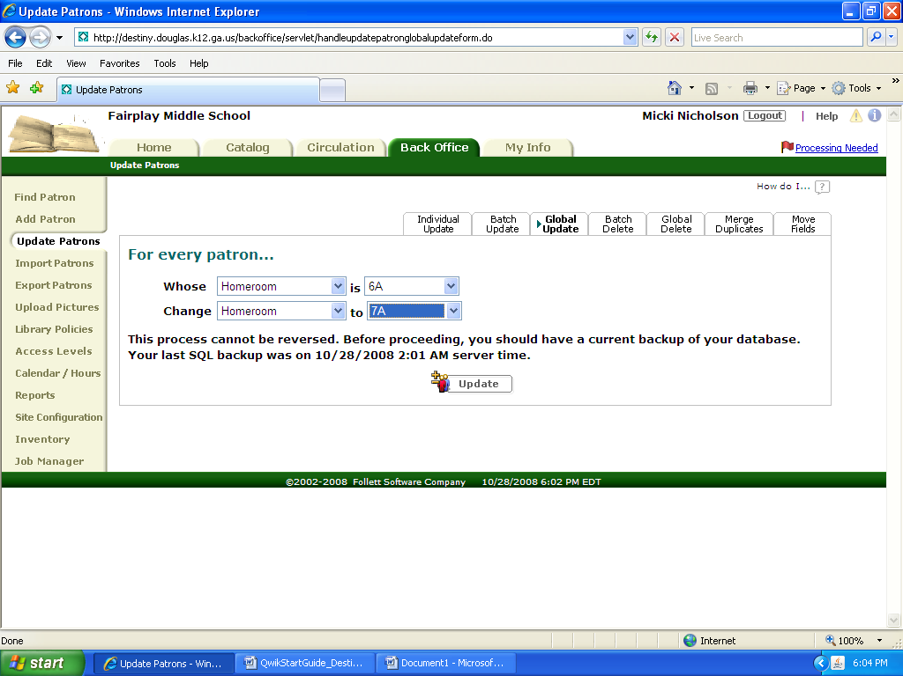
select Job Manager from the left menu

Deleting Patron Records
Deleting Records Individually
•From the main screen click on the Back Office tab.
•Select Find Patron from the left menu.
•Type the patron’s name or barcode
•Select search criteria from the drop down menu
•Click the trash can next to the patron to be deleted

Batch Deleting
Use this feature to delete a created list of patrons.
•From the main screen click on the Back Office tab.
•Select Update Patron from the left menu
•Click on the Batch Delete tab
•Check the Allow box to ensure deletion of patrons with outstanding checkout, fines, or refunds. Note: checked out books will be marked Lost.
•Select Create List
•Enter search criteria in first box and select the field to search in from the drop down menu.
•Click Search
•Click select for each patron to be added to the list.
•Click Delete all
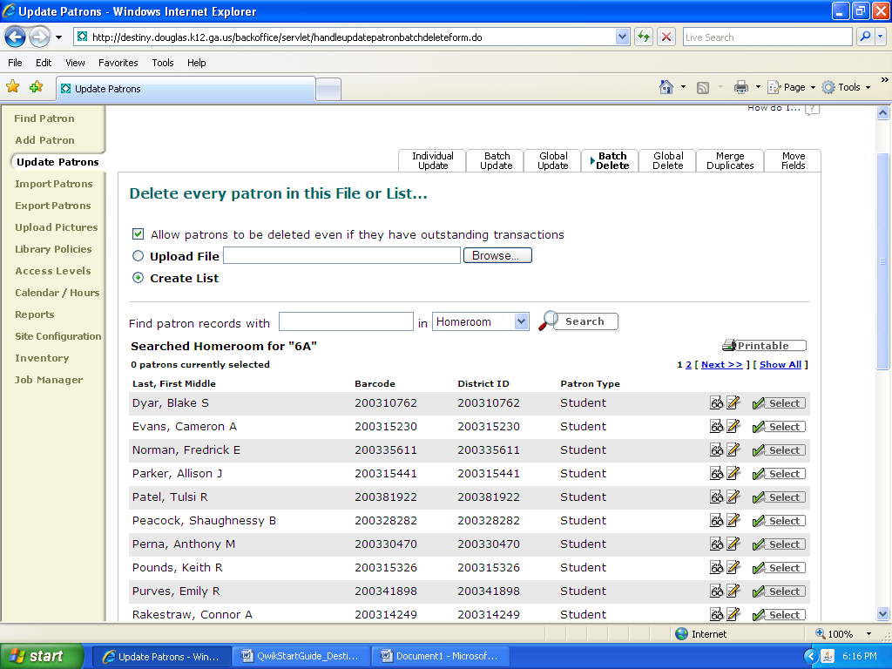

Global Deleting
Use this feature to delete a group of patron records at one time based on a common field.
•From the main screen click on the Back Office tab.
•Select Update Patron from the left menu
•Click on the Global Delete tab
•Select the Field from the “whose list” and from the “is” list specify the criteria
•Select the patron type.
•Click Delete All
•Select Yes
***To ensure deletion of patrons with outstanding checkout, fines, or refunds check the Allow box. Note: checked out books will be marked Lost.

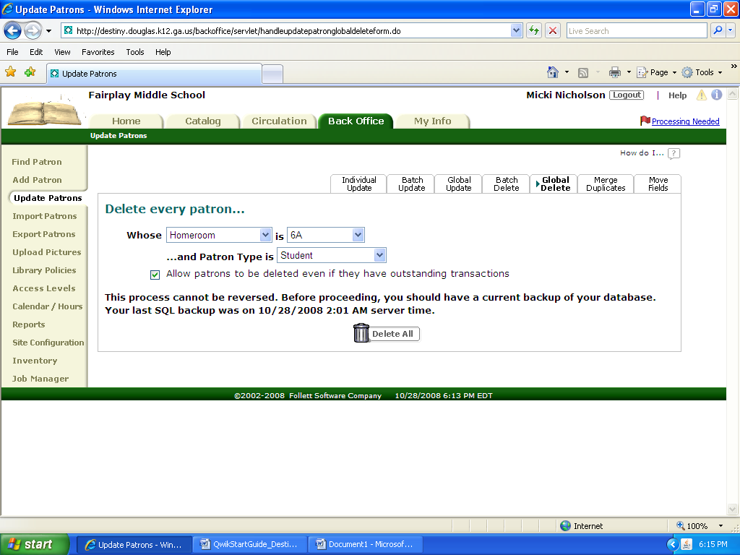
Assigning Passwords and Patron Numbers
•From the main screen click on the Back Office tab

•Select Find Patron from the left menu (for new patrons follow directions in Section 1.2 to create a new patron and get to the Patron Info. Page.)
•Type the Patron’s Name or Barcode in the “find” box
•Select search criteria from the “in” box
•Click Search
•Click box next to the patron’s name to view the Patron Info Page.
•In the Barcode box enter the Patron number to be assigned
•Scroll down to the Access level box and select the appropriate level
•In New Password box type the password to be assigned
•In the Confirm Password box retype the assigned password
•Click Save

Section 2: Online Patron Access Catalog

How to Open the OPAC
There are several ways to access the Online Patron Access Catalog or (OPAC) depending on your location in the school. If you are using the media specialst computer or a media center computer simply click on the library catalog icon and enter your username and password. After loggining in you will see the screen below.

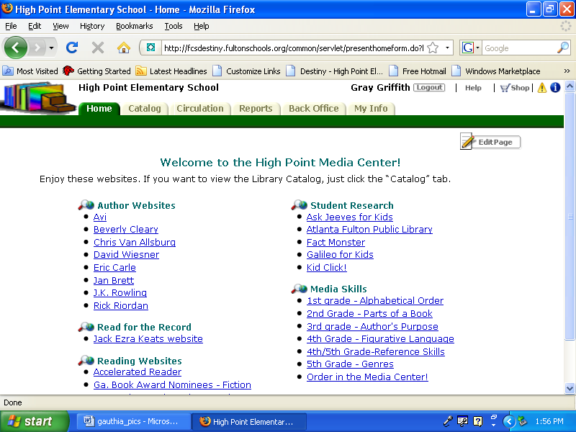

Types of Searches

There are 3 search tabs in a Destiny OPAC Basic, Power, and Visual. You can find these tabs in the upper right corner. Click the appropriate tab according to which type of search you would like to perform.
A basic search will locate all titles for a particualr search term .
A power search allows you to narrow your search term and/or limit the titles found for a particular search.
A visual search shows pictures of general search topics and categories. You can click on pictures within a topic to narrow the list even further. This will then produce a list of titles found with limited text and icon picture support.

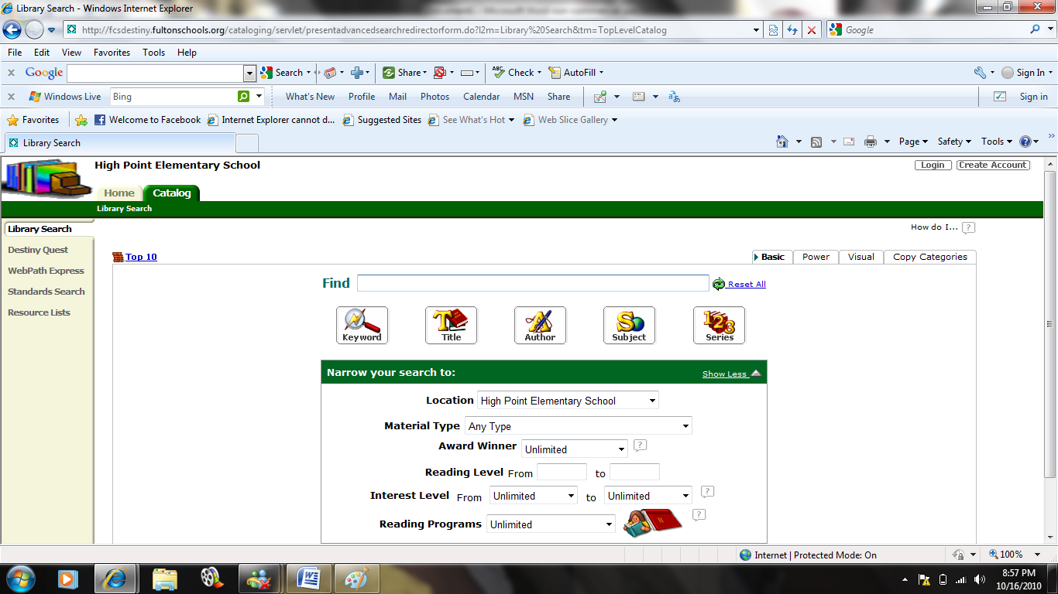
Types of Searches

Basic Search

The basic search page is the default page for the catalog. Here you are able to perform searches by keyword, title, author, subject, or series. For each of these types of searches simply type your search term into the box marked FIND and click on the appropiate type of search.

For example, to perform a search for cats. Type cats into the FIND box and then click on keyword.

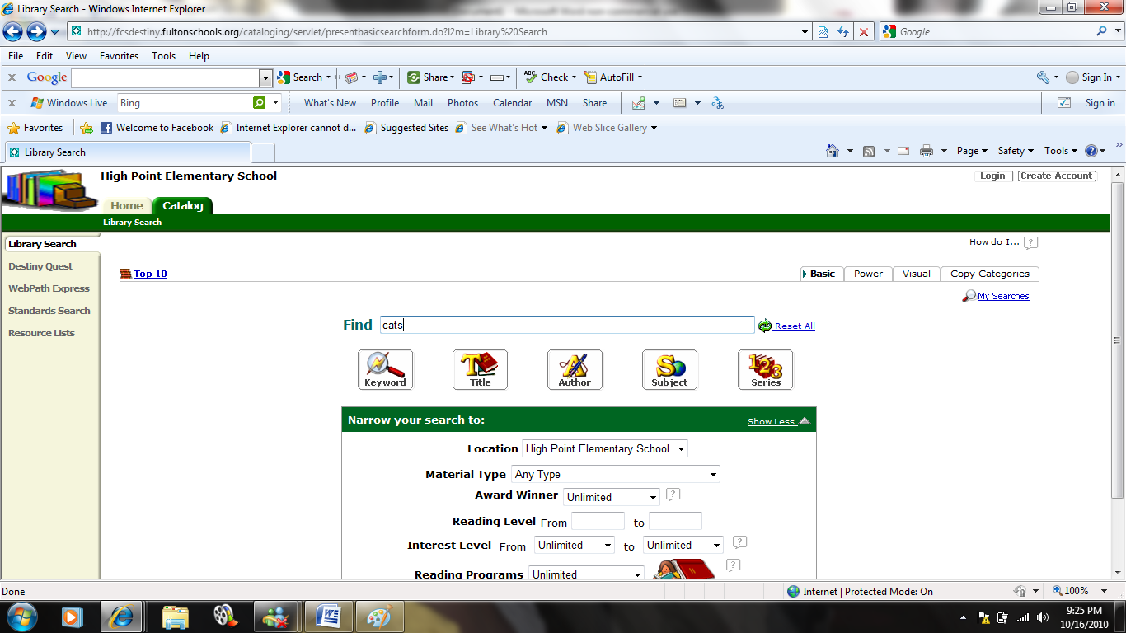

The title, author, subject, and series search all work the same way.
You can also narrow your search by identifying the location or school. Click arrow to open the drop down menu and select the specific school, all elementary schools, all middle schools, all high schools, or the entire school district.
If you want to search by material type click on the arrow to open the drop down menu and select the type of material.
If you want to search award winners click on the arrow to open the drow down menu and choose the type of award you would like to search by.
If you want to search by reading level in information for starting and ending reading level to search.
If you want to search by interest level click on the arrows to open the drop down menus for starting and ending reading level to search. You can search by grade level, preschool, adult, young adult or professional.
If you want to search by reading program click on the arrow to open the drop down menu and choose either lexile or accelerated reader.

Power Search

With the power search feature you can use Boonlean descriptors to narrow your search. The drop down menus on the left allow you to search by keyword, title, author, suject, series, or note.

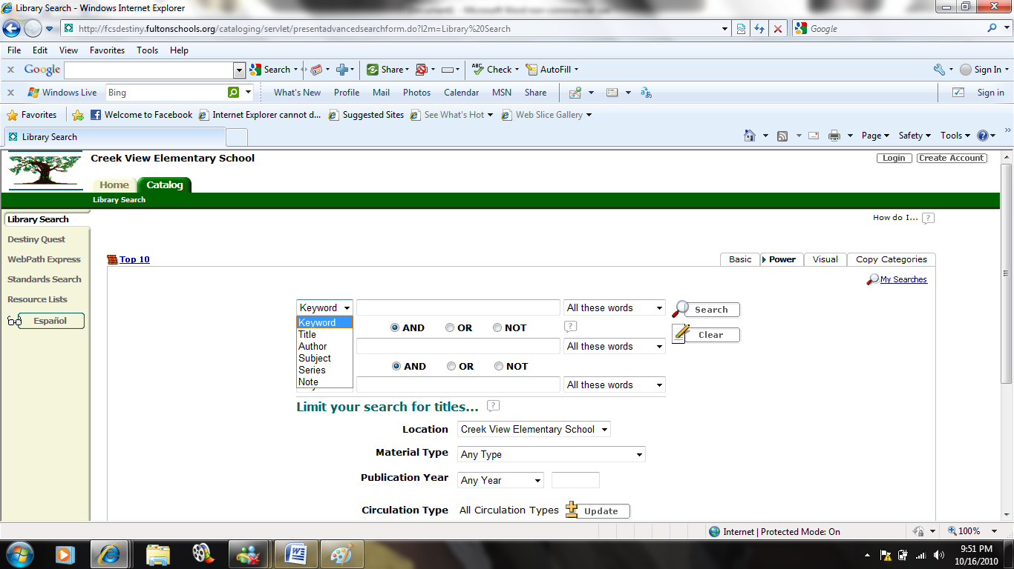

The drop down menus on the right allow you to search all words, any words, or an exact phrase. Titles can also be limited to location, material type, publication year, circulation type, award winner, reading level, interest level, and reading programs.

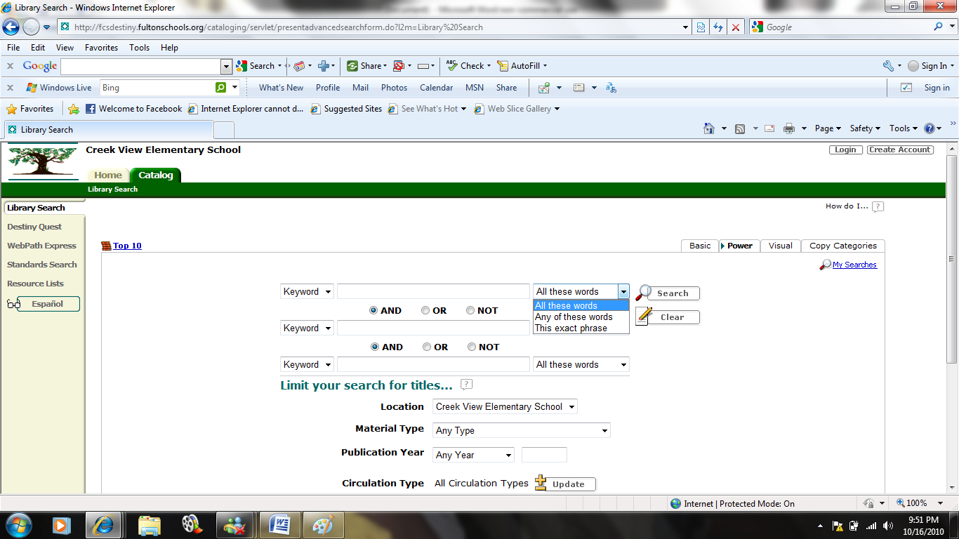

Visual Search

To perform a visual search click on a picture for a subject.
For example, to search for cats click on animals.
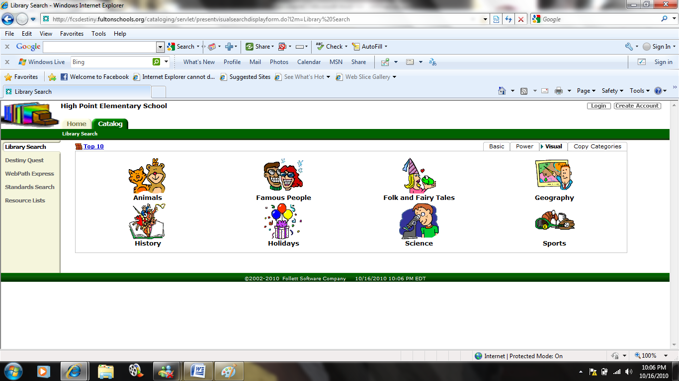
This will take you to a narrow list of animals. Click on cats.
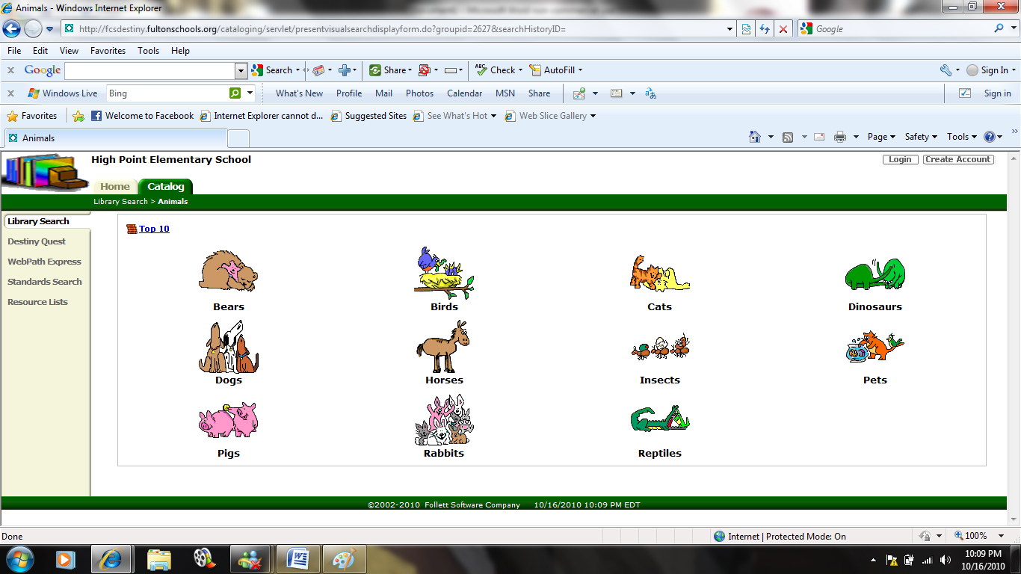
This will give you list of titles for the search term cats.
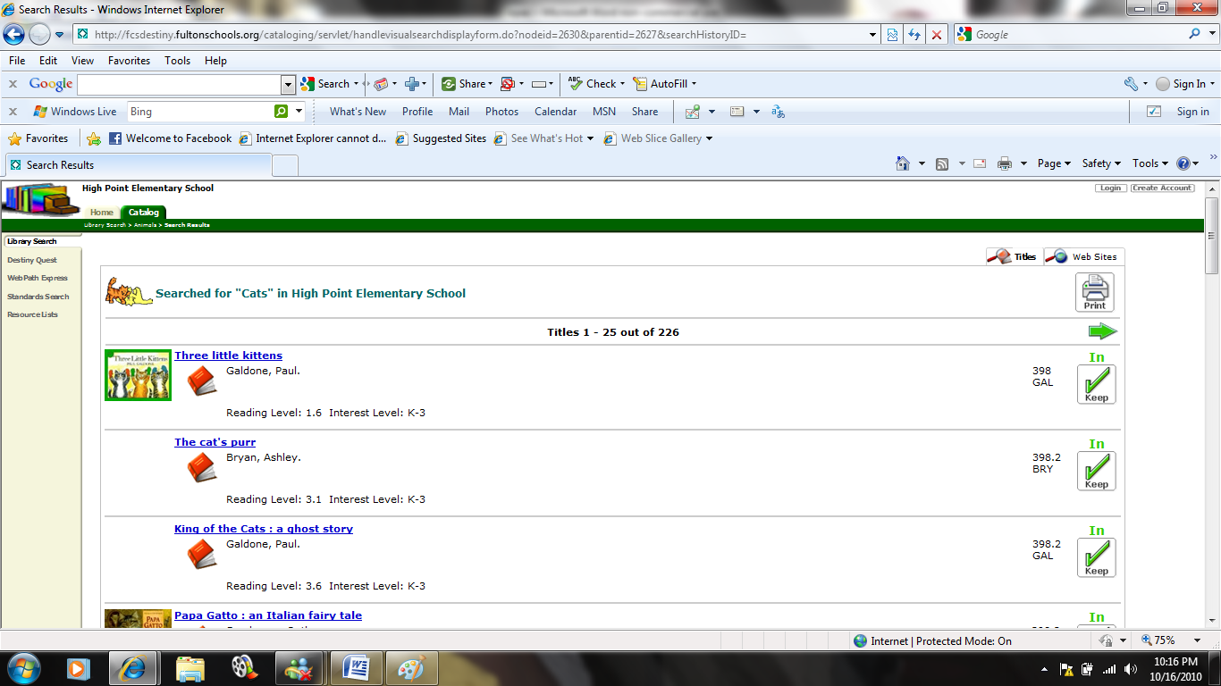

Reading an OPAC Results List

The results list will tell you what search term was used and where it was searched. Information found on this page includes:
1. total number of records found
2. how many are showing on the current page.
3. Items are listed by material type
Dewey number. All of the 000’s that are books will be listed first.
4. Title call number
5. author
6. publication year
7. reading level
8. interest level
9. This list also will let you know the availablitity of an item.
10. Lexile and Accelerated Reader Level are listed where applicable.

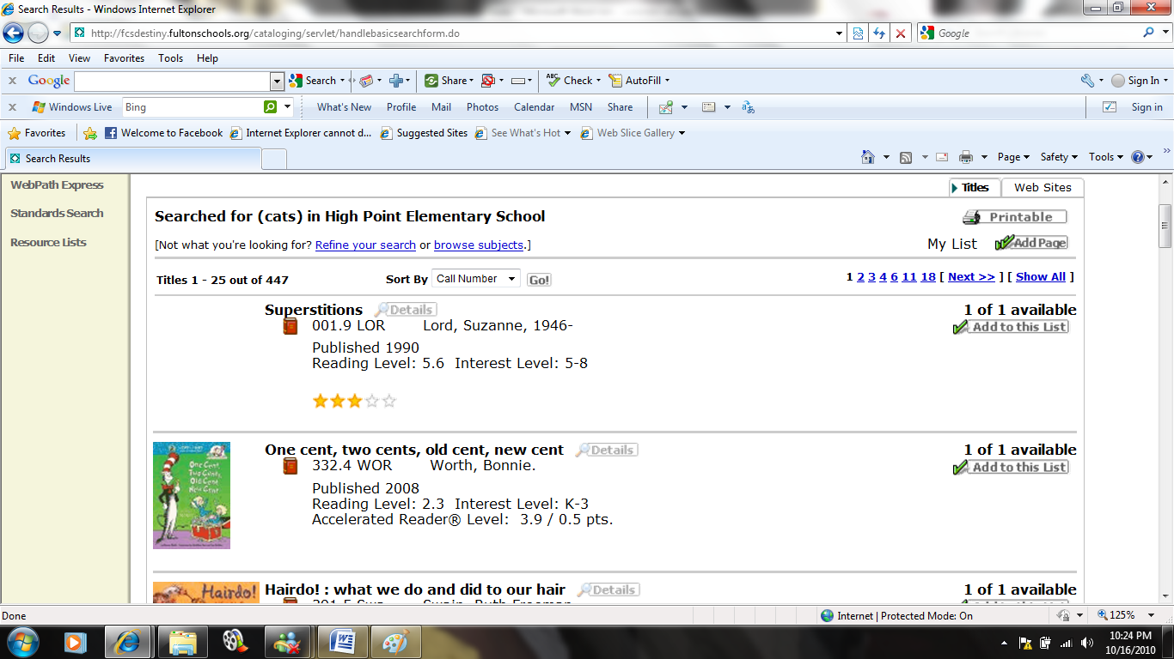

Reading an OPAC Item Record

When you click on a particular item you can view the item record. This screen includes additional information about the book. Here you can find information about how many copies are availble throughout the school district, publicaiton information, award information, locations of reviews for the item, and online resoures.

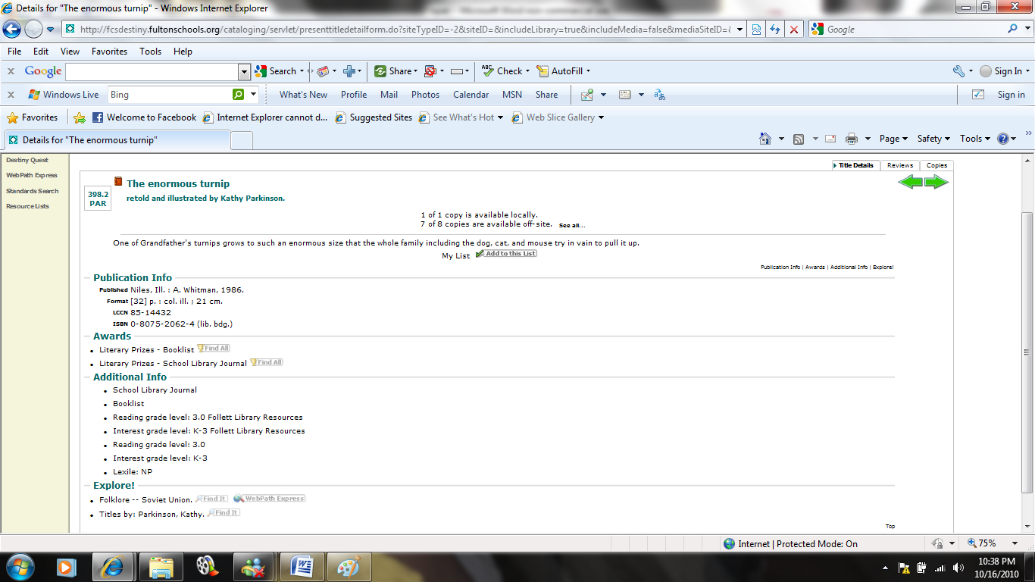
Sorting Results List
If you would like to sort your results list simply click on the arrow to show the drop down menu which will allow you to sort results by call number, title, author, date, type, status, or relevance.

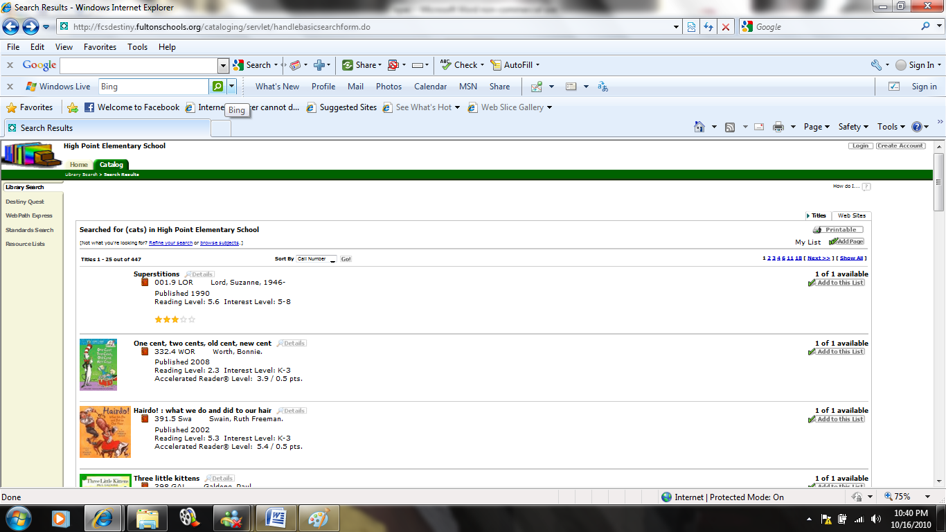

Call number will sort results by Dewey decimal number starting with the 000’s.
Title will sort results alphabetically by title.
Author will sort results alphabetically by author’s last name.
Date will sort results by publication year with the most recent year occuring first.
Type will sort results by material type.
Status will sort results by availability.

Printing a Results List
To print a resulst list simple click the printer icon next to the word printable.

This is what an unsorted results list will look like printed.
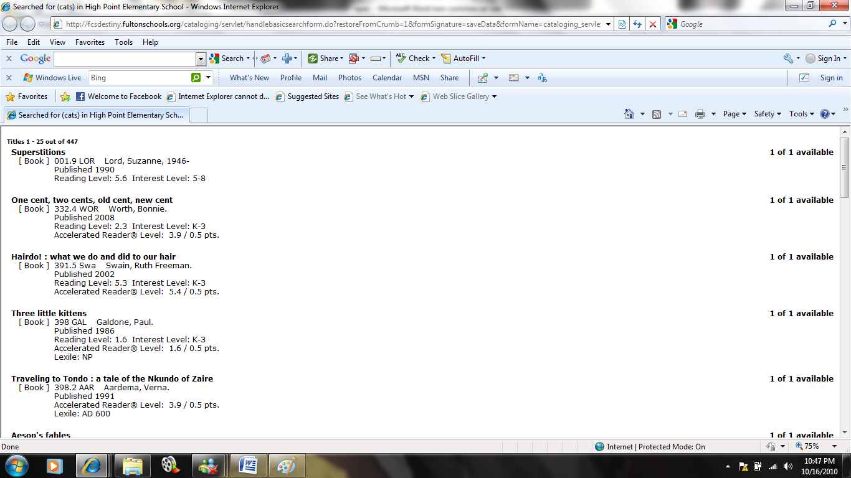
This is what a results list sorted by availability will look like.
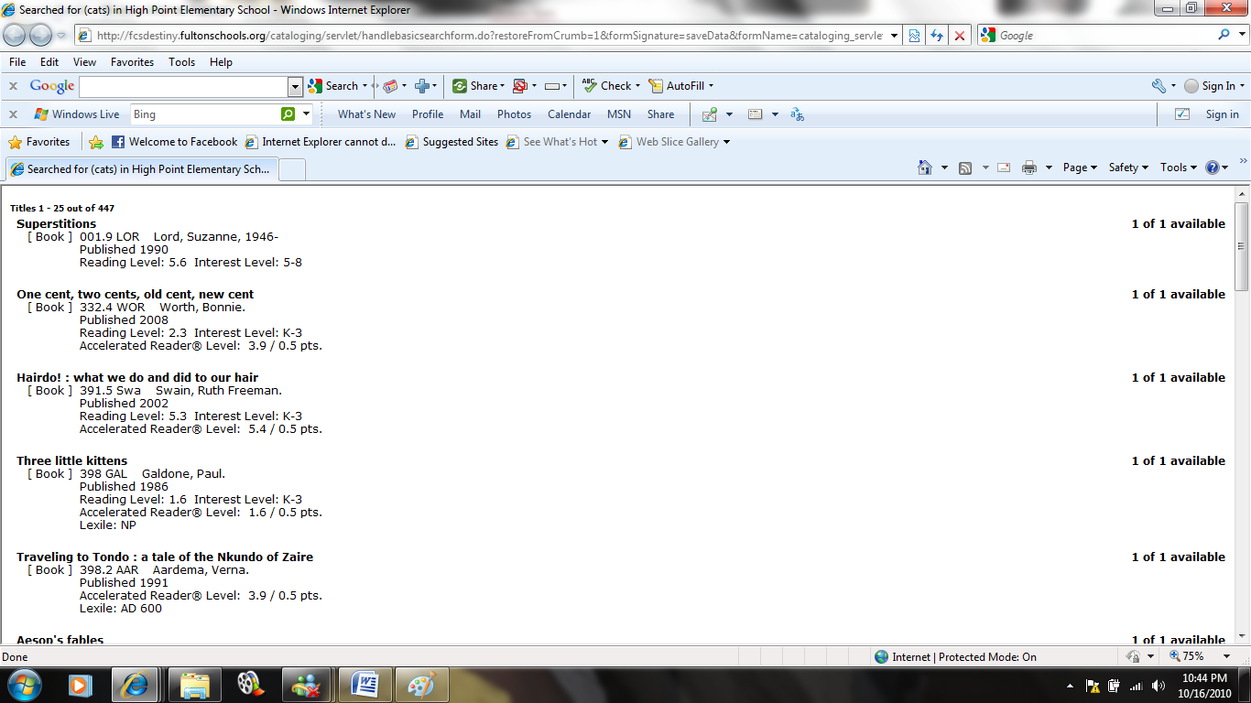
Reserving Materials Online
Reserving materials online can be done by the media specialist or by patrons if you have set up their accounts to allow those priviledges.

From the media specialist login click the green circulation tab at the top and then find Holds/ILL on the right.
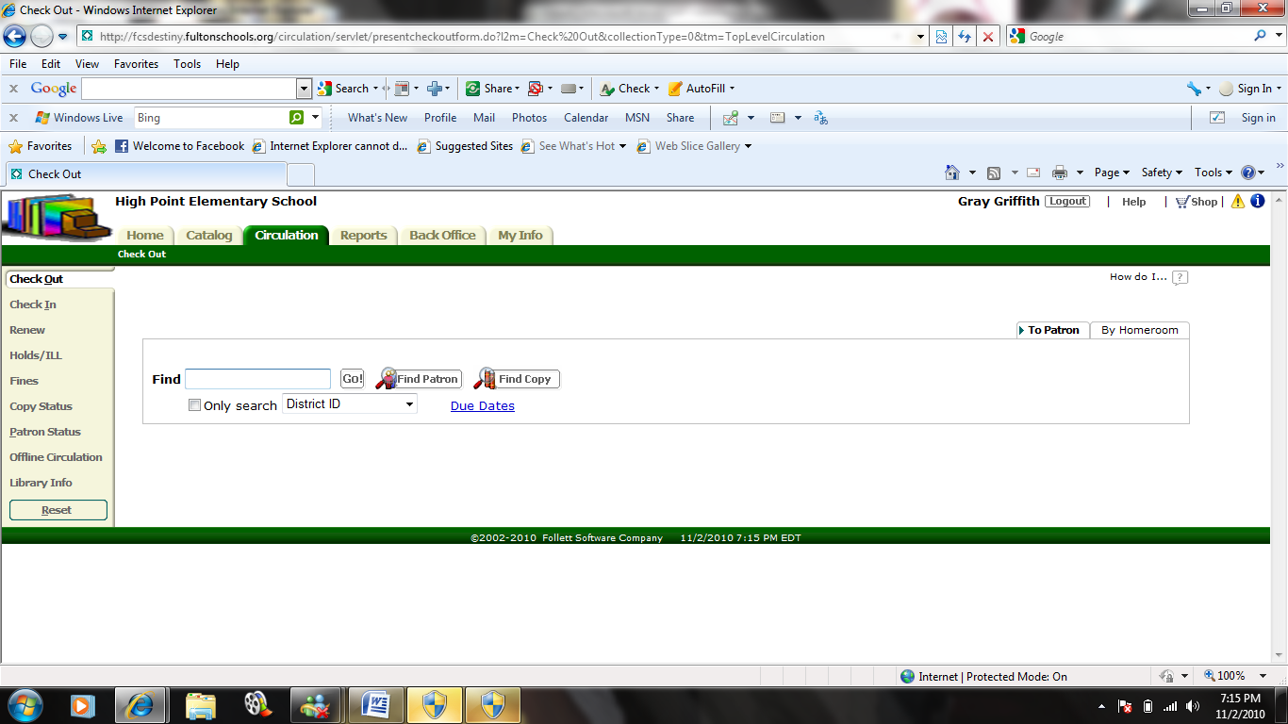

This will take you to the Holds/ILL page where you need to search for a patron by name. Click on the blue hyperlink of their name.
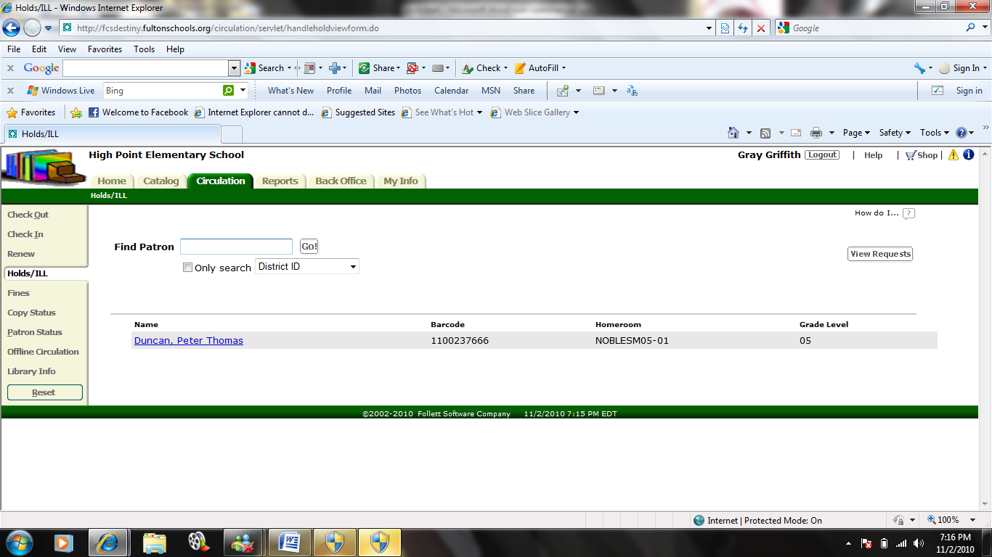

Their patron record will come up. You can see if they have any overdue materials, owe fines, or have any items already on hold. Click Add Hold in the bottom righthand corner to place an item on hold.
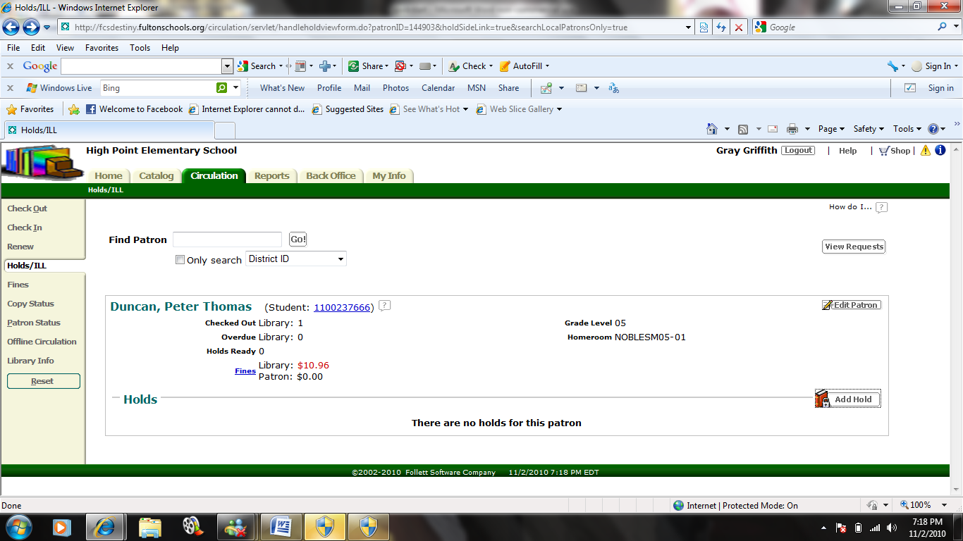

Enter title information for what the patron would like to place on hold into the Find Title search box and click Go. Find the item the patron is requesting and click Hold It.

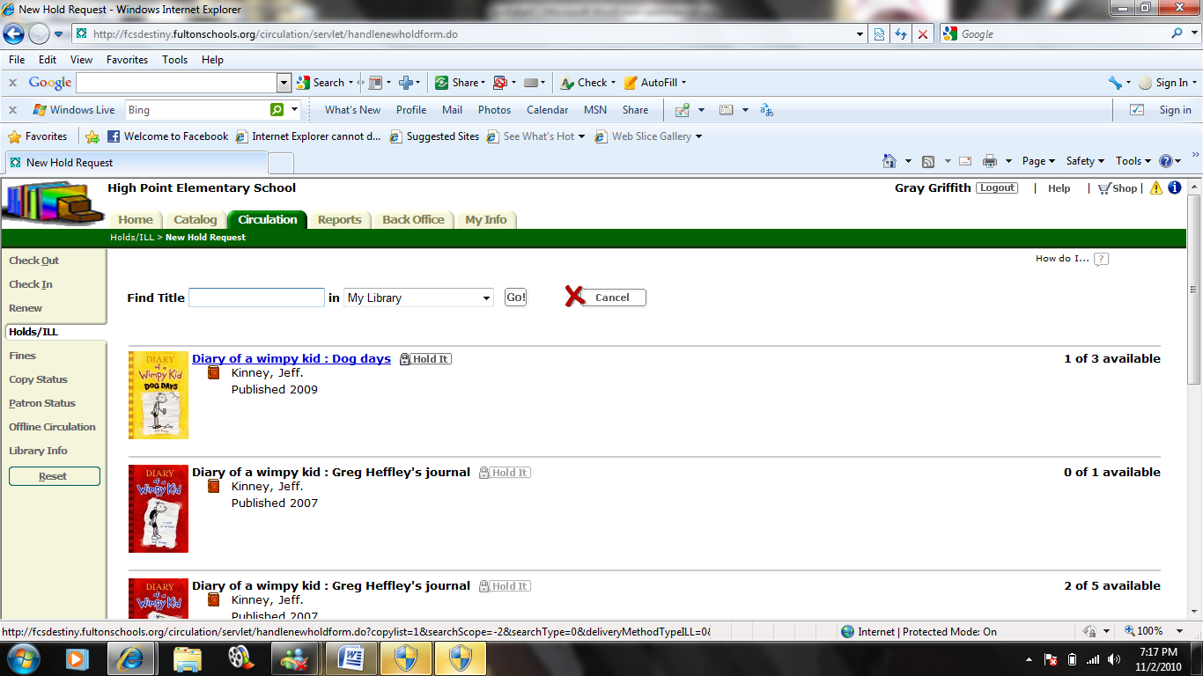

A new screen will come up verifying that the patron has requested that specific item. You can choose if they can get the item as soon as possible or enter a specific date. You can also add a priority rating, request expiration date, and copy information. You need to make sure you save the information for the materials reservation to become active.

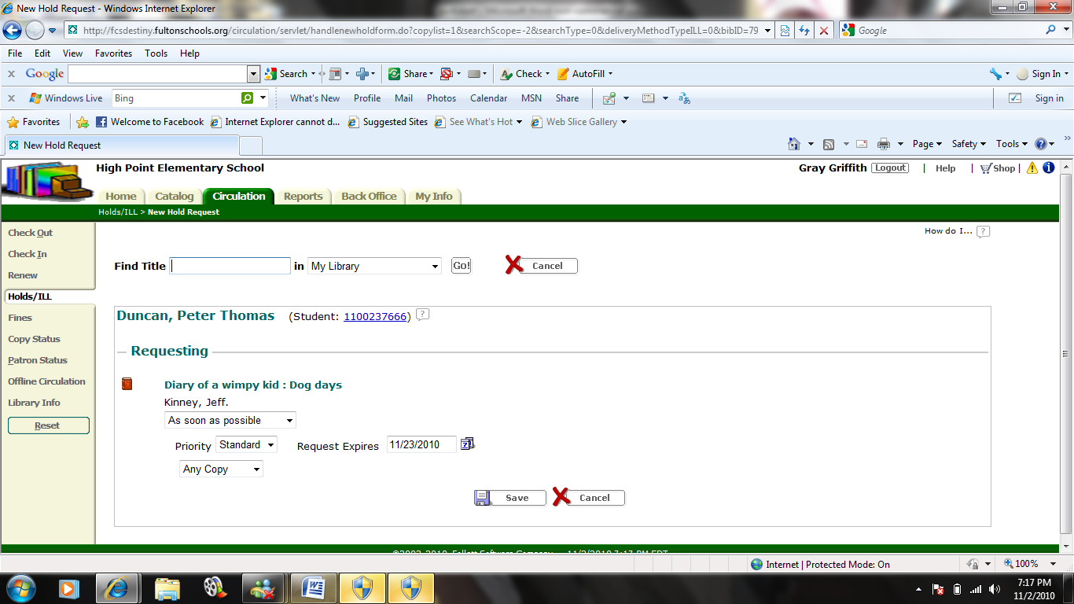

Opening the Cataloging Module
After logging on to Destiny 9.8 you will be at the home screen. To open the cataloging module simply click the green tab with the title Catalog. All of the functions that can be performed in this module are listed on the left.

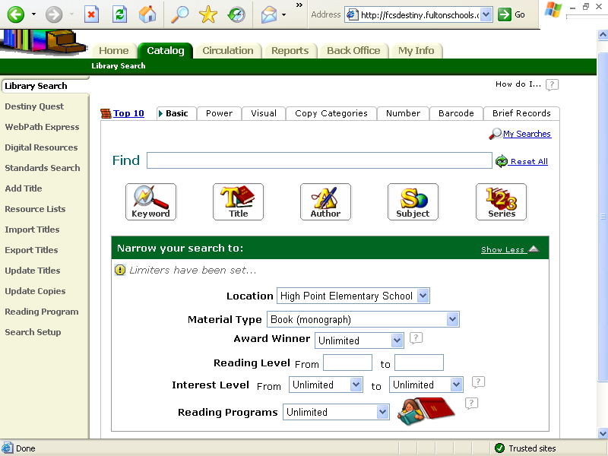
Catalog Module Functions

Section 3: Cataloging (Maintaining the Collection Database)

Setting up Material Types and Designators
Setting up material types and designators allow you to customize information about the resources you have available in your media center.
To set up material types and designators: 1) Click on the Back Office tab at the top of the page so that it is highlighted in green.
2) Find and click on library policies on the left. This will open up to the patron types page.
3) Click on the Circulation types tab next to patron types tab. Here you will add infomration about the material, how long it can be loaned for, fine information, etc.

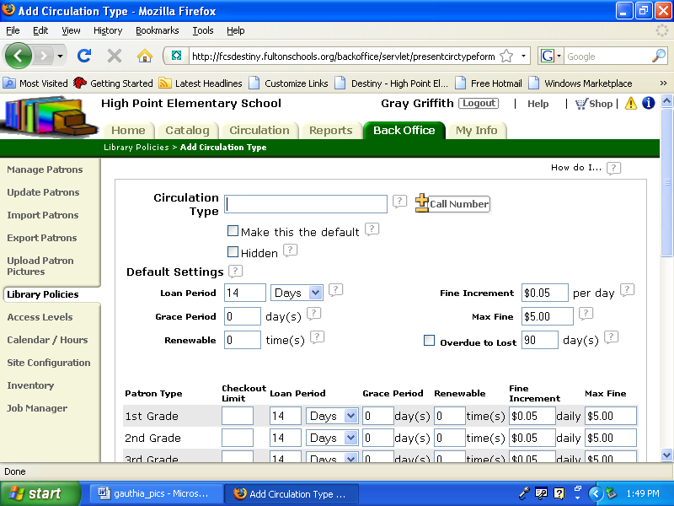
2.
3.
1.

Deleting Materials

Individual Delete
To delete an individual item from your catalog:
1) Click on the Catalog tab at the top of the page so that it is highlighted in green.
2) Find and click on update copies on the left. This will open up to the update copies page.
3) Click on the individual delete tab. Scan the barcode for the item you would like to delete or enter it manually.
4) Click Go!
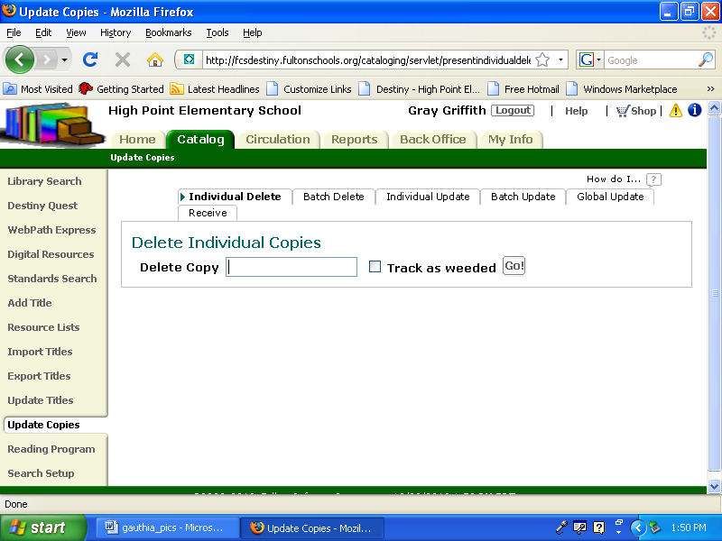
1.
4
3
2

Batch Deleting Lost or Discarded Materials
A batch delete is used when you are discarding multiple items. This type of delete can be found the same place as an individual delete. You need to go to the catalog tab, update copies screen, and then the batch delete tab. Here you will be asked to upload a file. To complete a batch delete you will have to have created a file of items that need to be deleted. Scan items to be deleted with your Follett Panther scanner and save the file to your desktop or my documents folder. You will be able to access this file via the browse button. When you have located and selected the file click update and all the items in that file will be deleted.
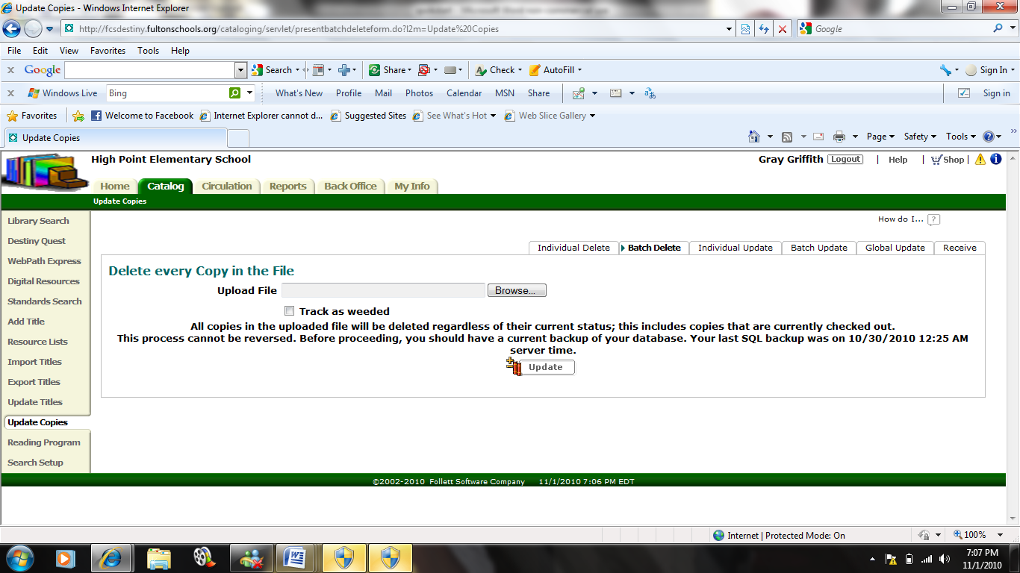

Adding Materials

Destiny 9.8 will allow you to add items to your catalog by providing easy access to other MARC records for copy cataloging or allowing you to create your own MARC record.

Manually Creating the MARC Record
Under the catalog tab open the Add Title screen. Look to the left to find Nonexistent? Add the Title hyperlink

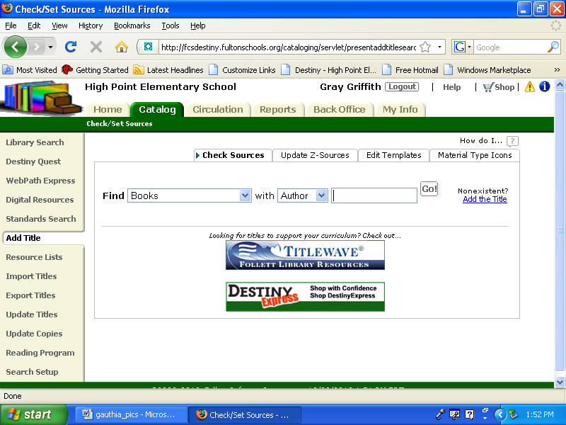

You can either choose to use the MARC Editor which looks like this:
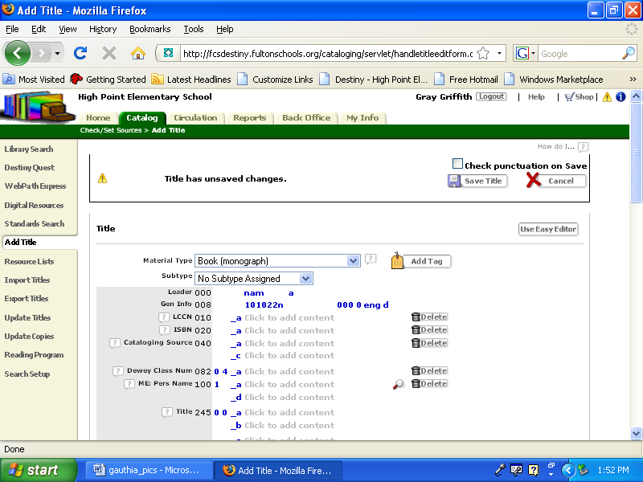
Click here to use the Easy Editor instead

Or the Easy Editor which looks like this:

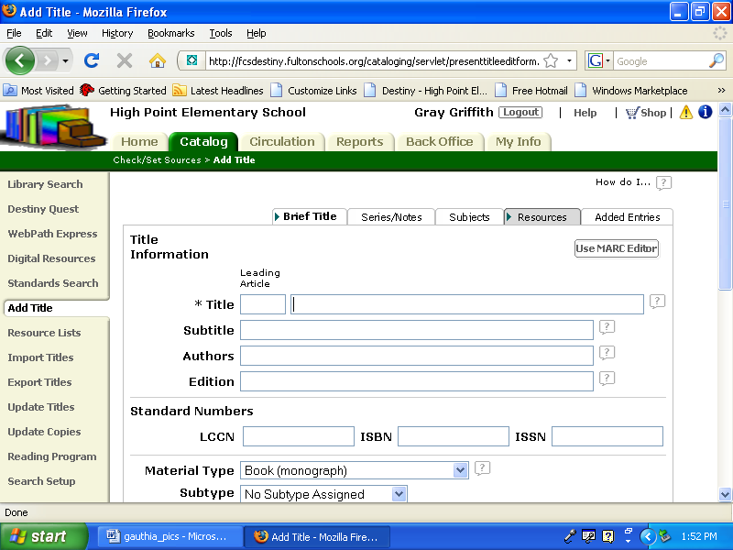
Click here to use the MARC Editor instead

The MARC Editor requires information for several different tags. The Easy Editor requires basic information about an item.

Importing Records from a Vendor or Other Source
Records can be imported or copied from other resources by searching for items within the school district database. Use the drop down menus to narrow your search for existing records.

Correcting Existing MARC Records

If you have MARC records that need to be cleaned up or corrected. Open the Catalog tab and perform a library search for a particular item. When the item record is displayed click on MARC View and then Edit Title.
1

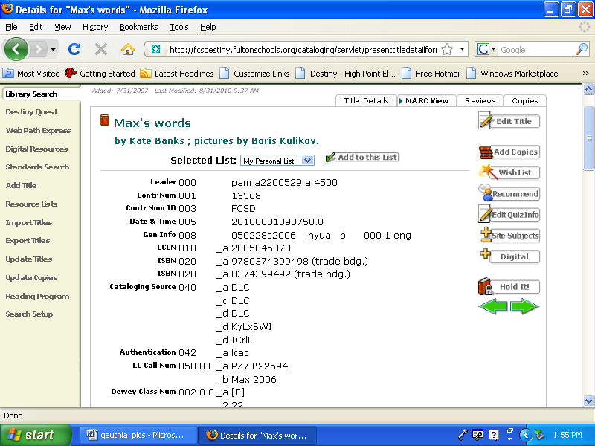
2

The MARC record will be displayed and is now editable. Information that can be edited is displayed in blue. Simply click there to change or revise information. You also have the option of deleting information by clicking on the trash cans or the word delete. Make sure you save any changes that are made to the MARC record.

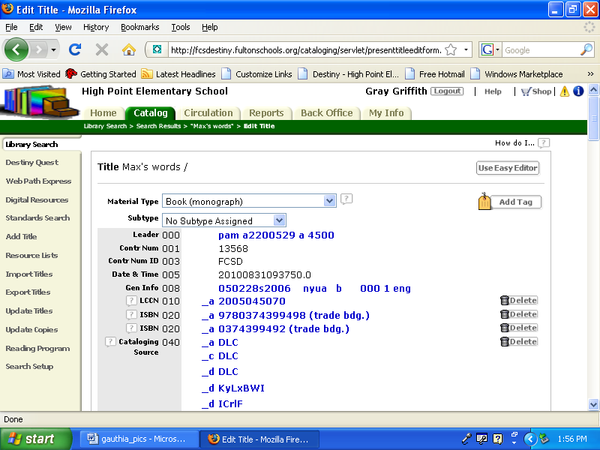
Using an Authority File for Subject Headings
When performing original cataloging you may need to refer to an authority file for subject headings. Destiny 9.8 allows you to search for Sears subject headings while creating MARC records. When using the MARC Editor, you can click on sears and several boxes will pop up. If you click on the magnifying glass with the title heading you will be taken to a search screen where you can search for authorized Sears headings.

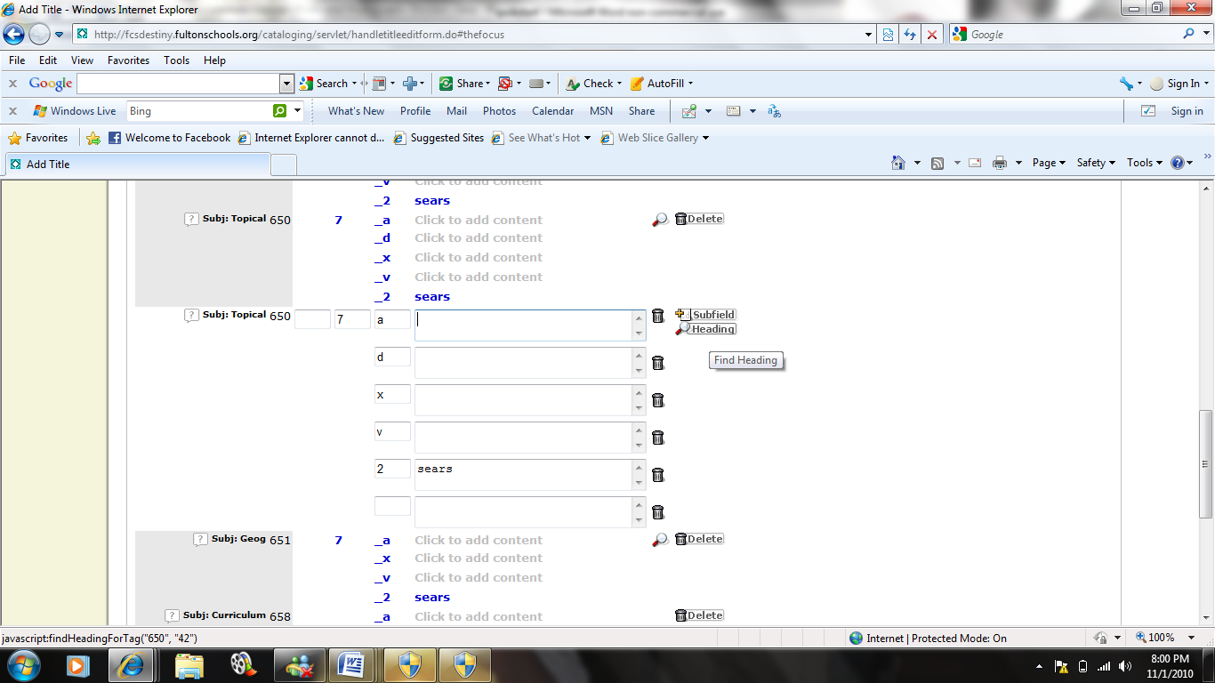
2
1

Search for Sears authorized subject headings here.
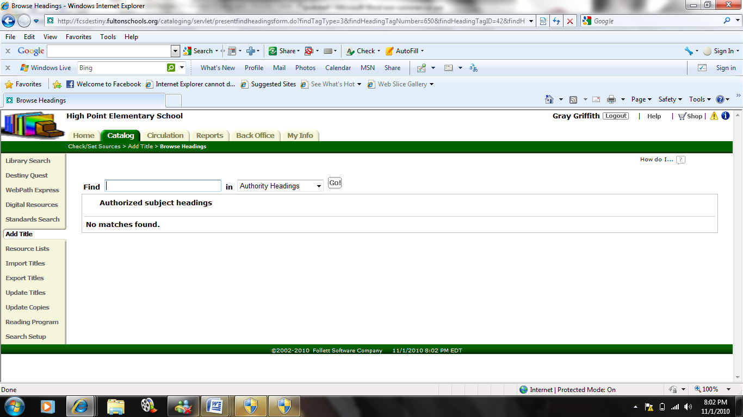

Section Four: Circulating Materials & Interlibrary Loans

Opening the Circulation Module & Using Passwords
Internet
Library Lookup (on the top tool bar)
Catalog
Login
- Enter the user name in the User Name box
- Enter the password in the Pass Word box
Login
Circulation

Checking out Materials
Circulation
Check Out
To Patron
- Enter the patron barcode number in the Find box
Find Patron
- Enter the item barcode number in the Find box or use the handheld scanner to scan the Item Barcode Number
Find Copy
If the check out was successful, the item title should appear on the Items Out section of the page.
Note: Student patron accounts can also be accessed by using the By Homeroom option by selecting the student’s homeroom teacher and then selecting the student’s name.

Checking in Materials
Circulation
Check In
- Enter the item barcode number in the Find box or use the handheld scanner to scan the Item Barcode Number
Go
If the Check In was successful, the item title should appear on the Items Checked In portion of the page.

Setting up the system so students/parents/volunteers can do limited check in and out
Back Office
Access Levels
Add New Access Level – to create an access level for volunteers or student aids
- Enter the name of the new access level to be added (Student Aid, Parent Volunteer, etc.) in the Access Level box
- Select the items that the new access level will be given access in each category under the headings Library Materials, Patrons, and General
- To allow access to check in and out, remember to select Check In Library Materials, Check Out Library Materials, and Renew Library Materials
Save

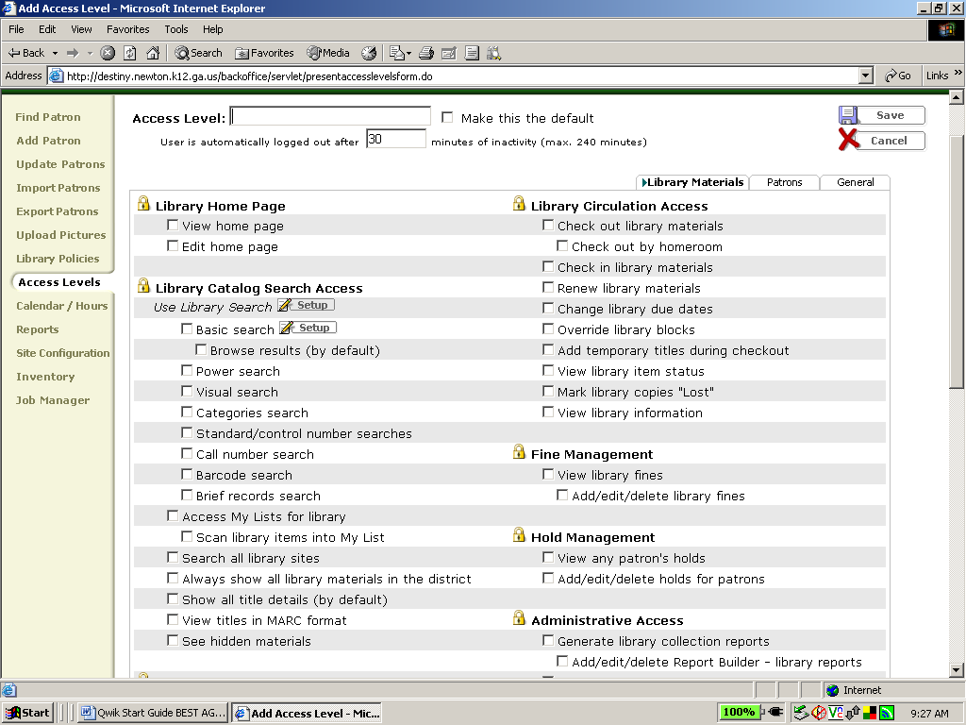
Add Access Level

Modifying due dates for special cases
Circulation
- Enter the patron’s barcode into the Find box
- Select Barcode from the pull down menu
Go – to obtain an Items Out list
Renew All - to renew all items currently checked out to the patron
OR
Renew – next to only those items for which the due date should be extended
Change Due Date
Select Date
- Enter the new due date in the Selected Date box
OR
- Use the clickable calendar to enter the new due date
- Select For this item from the pull down menu
Save
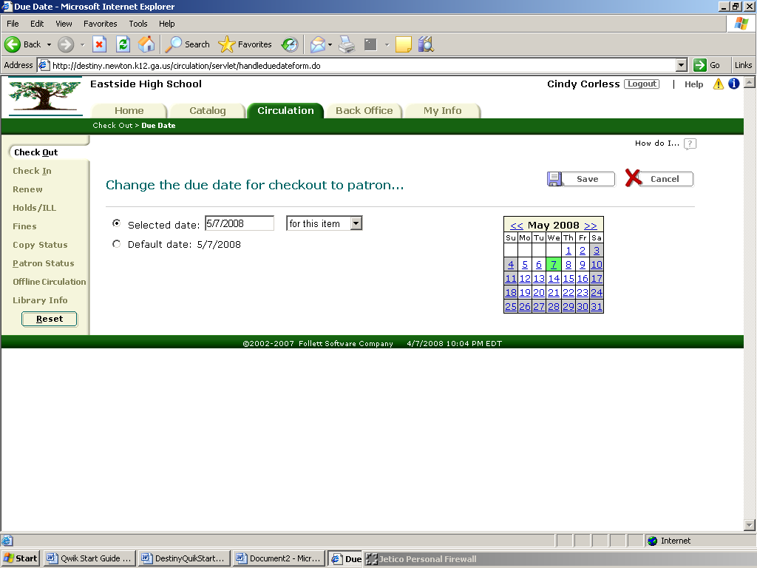

Entering fines, reserves & messages
To set up fines for Patron Type
Back Office
Library Policies
Patron Types
- Decide for which patron type fine policies are to be set
Edit
- Enter the daily monetary amount to be charged for each circulation type in the boxes under the Fine Increment column.
- Enter the maximum monetary amount to be charged for each circulation type in the boxes under the Max Fine column.
Save
If this action was successfully completed, fines will be automatically generated for overdue materials.
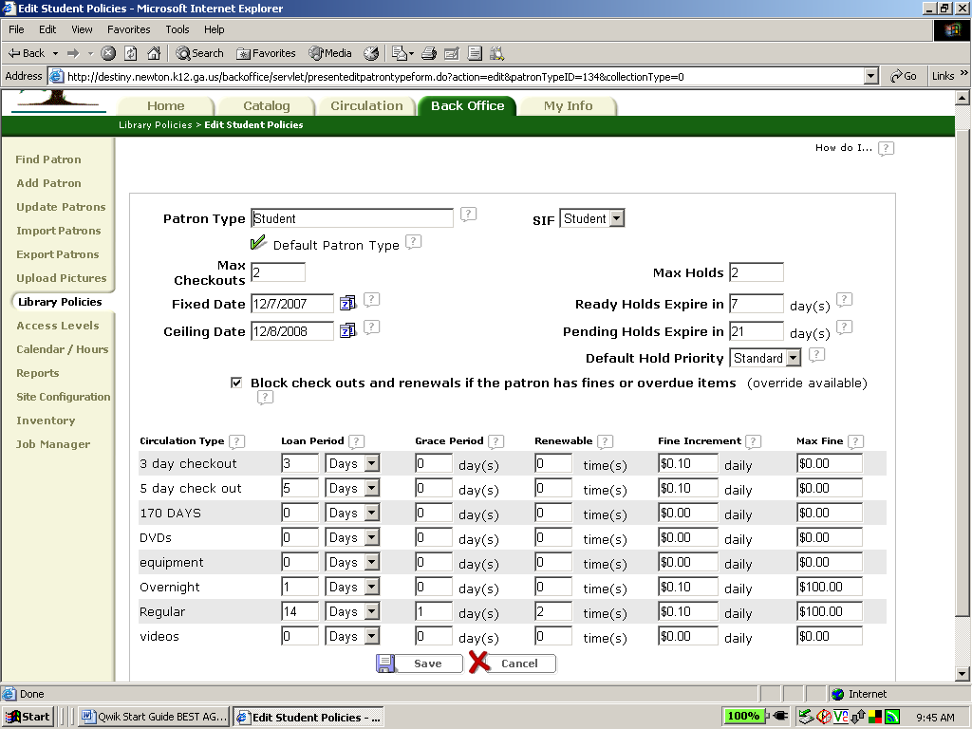

To set up fines for Circulation Type
Back Office
Library Policies
Circulation Types
- Decide for which circulation type fine policies are to be set
Edit
- Enter the daily monetary amount to be charged for each patron type for that circulation type in the boxes under the Fine Increment column.
- Enter the maximum monetary amount to be charged for each patron type for that circulation type in the boxes under the Max Fine column.
Save

If this action was successfully completed, fines will be automatically generated for overdue materials.

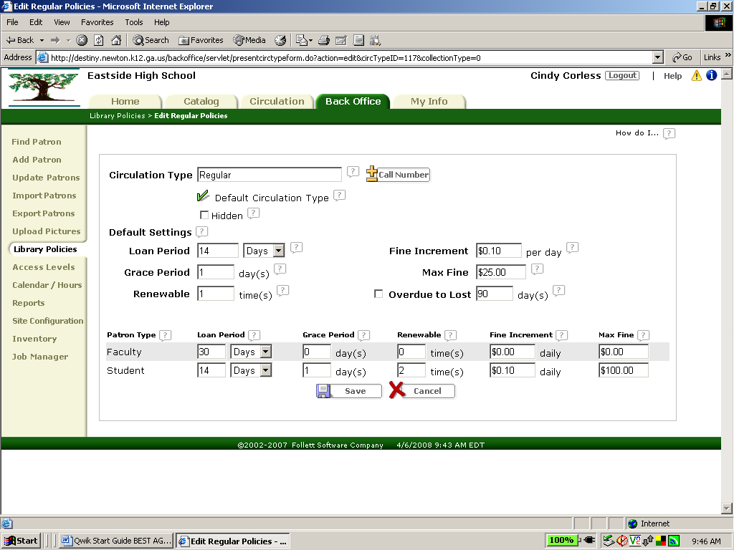

To add fines manually
Back Office
Find Patron
- Enter the patron’s barcode into the Find box
- Select Barcode from the pull down menu
Search
Add Fine
- Select the reason for the fine from the Reason pull down menu
- Enter the item barcode in the Copy box by typing it in or by scanning it in using the hand held scanner
Go – to retrieve copy information about the item including purchase price
- Enter the monetary amount to be charged in the Amount box
- Enter the monetary amount to waived in the Waive box
- Enter the monetary amount paid by the patron in the Pay box
Print Receipt – to print a receipt
Save

Looking up materials & patrons
To look up materials
Circulation
Copy Status
- Enter the item’s barcode by typing it into the Find Copy box or by scanning the barcode with the hand held scanner
Go – to obtain information such as current availability, circulation statistics, circulation type, etc.

To look up patrons
Back Office
Find Patron
- Enter the patron’s barcode into the Find box
- Select Barcode from the pull down menu
Search
View Status – to view patron’s current status, list of items currently checked out, etc.
Edit – to edit patron’s information
Delete – to delete patron from the system

Running overdue notices
Back Office
Reports
Patrons
Checked Out Materials and Unpaid Fines
- Select Overdues
- Select Individual Notices
Continue
- Select the appropriate patron type
- Select the appropriate patron status
- Select the types of overdue items to include
Continue
- Select the range of patrons to include
- Select the order of printing for the patron range
- Select the number of notices to be printed per page
- Customize the salutation and write a message if desired
- Select any additional information to be included in the notice
Run Report – to generate the list of overdue notices
Save Setup – to save the setup of this report so that a similar report can be generated in the future.
Note: Overdue notice reports can be setup create a report for email.

Printing bills, fines, receipts. Include sample print outs
To print Bills
Back Office
Reports
Patrons
Checked Out Materials and Unpaid Fines
- Select Fines
- Select Individual Notices
Continue
- Select the appropriate patron type
- Select the appropriate patron status
- Select the types of overdue items to include
Continue
- Select the range of patrons to include
- Select the order of printing for the patron range
- Select the number of notices to be printed per page
- Customize the salutation and write a message if desired
- Select any additional information to be included in the notice
Run Report – to generate the list of overdue notices
Save Setup – to save this report so that a similar report can be generated in the future.
Note: Bill reports can be setup to create a report for email.

To print Fine Notices
Back Office
Reports
Patrons
Checked Out Materials and Unpaid Fines
- Select Fines
- Select Individual Notices
Continue
- Select the appropriate patron type
- Select the appropriate patron status
- Select the types of overdue items to include
Continue
- Select the range of patrons to include
- Select the order of printing for the patron range
- Select the number of notices to be printed per page
- Customize the salutation and write a message if desired
- Select any additional information to be included in the notice
Run Report – to generate the list of overdue notices
Save Setup – to save the setup of this report so that a similar report can be generated in the future.
Note: Fine Notices reports can be setup for email.

To print Receipts
- Circulation
- Fines
- Enter the patron barcode in the Find Patron box
- Select Barcode from the pull down menu
- Select Search Only
Go
Edit Fine
- Enter the monetary amount paid by the patron towards the fine
Print Receipt
Save

Using temporary barcodes
Circulation
Check Out
To Patron
- Enter the patron barcode number in the Find box
Find Patron
Add Title
- Enter one of the available temporary barcode numbers in the Barcode box
- Attach temporary barcode card to the item
- Select Title is deleted when checked in
- Select the appropriate Circulation Type using the pull down menu
- Select the appropriate Material Type using the pull down menu
Save
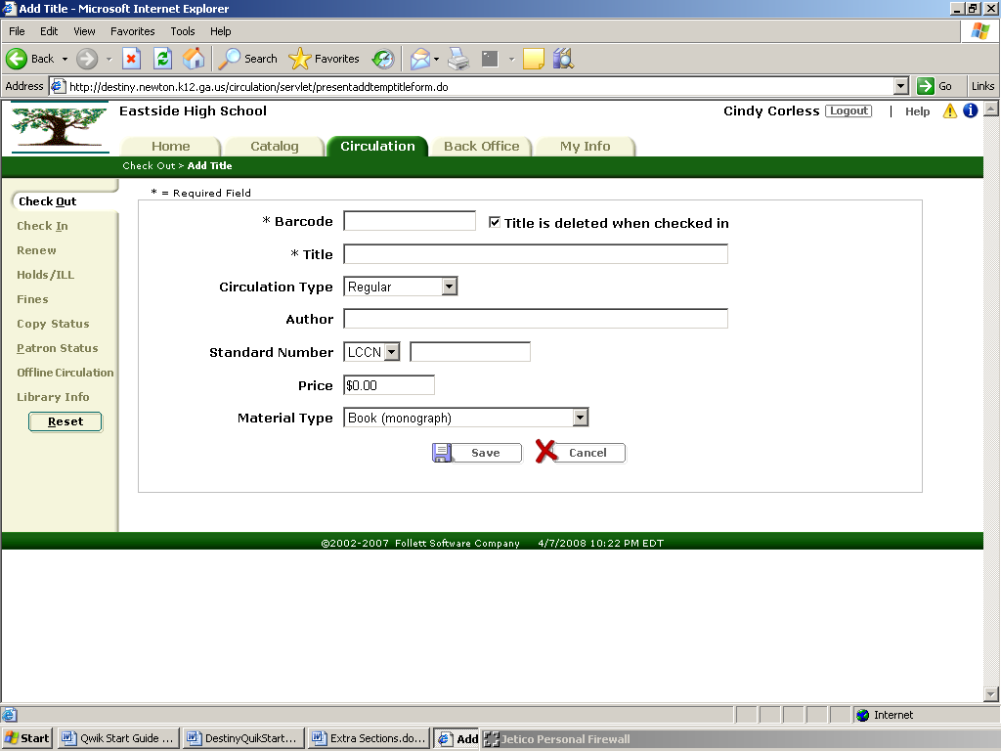
Add Title

Looking up circulation logs

To Look Up Circulation Log for a Single Item
Circulation
Copy Status
- Enter the item barcode into the Find box by typing it or by scanning it using the hand held scanner
Go – to obtain the copy status of the specified item
View History – to obtain the circulation history of the item

To Look Up Circulation Log for a Single Patron
Back Office
Find Patron
- Enter the patron barcode into the Find box
- Select Barcode on the pull down menu
Search – to obtain patron information of the specified patron
View Status
View History – to obtain the circulation history of the patron
Doing Interlibrary Loans

Our district is not set up for the interlibrary loan option. However, we follow this procedure to make interlibrary loans for teachers:
Circulation
Check Out
- Uncheck the "My School Only" option
- Search the district catalog for item needed
- Communicate by email with the appropriate school to borrow item
- The item is checked out and sent to the borrowing school through school district mail
- Once at the borrowing school a temporary barcode should be made.
- Check the item out to patron
Section Five: Reports & Utilities

- Backing up the system
- Backups are conducted at District Level.
- Tips for managing your back-ups.

- Who to call: ____________________________________________________
- DISTRICT: _______________________________________________
- OPAC Tech Support:_______________________________________
www.fsc.follett.com
- Backup DAY:______________________
- Backup TIME: _____________________
- Calendar dates that conflict: (holidays, school closed, etc…..) ___________________
- Do I need to leave a computer turned on? _____
- Do I need to have storage disks available? _____
- What type: Flash CD Diskette External Drive
- What size: ______________
- Where are my backups physically stored. ___________________________
- Who I call for a restore of my system? ______________________________

- Use the Destiny Technician’s Guide to conduct your own backups.

- 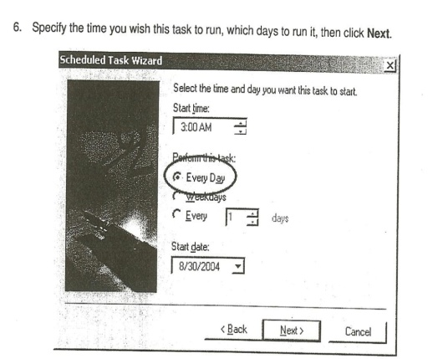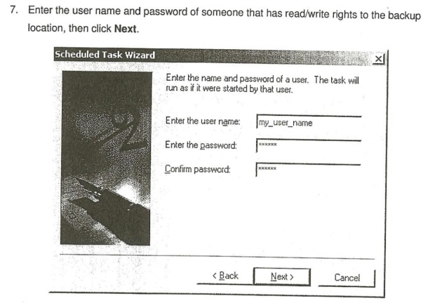
- 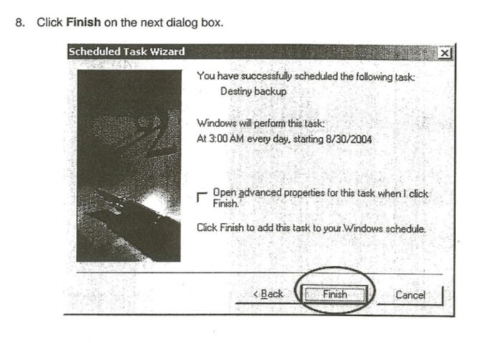
- Running circ reports (samples). Several options:
- Use the ‘Reports’ module.
- Use system reports in the Patron tab.
- Customize your reports using Report Builder.

- 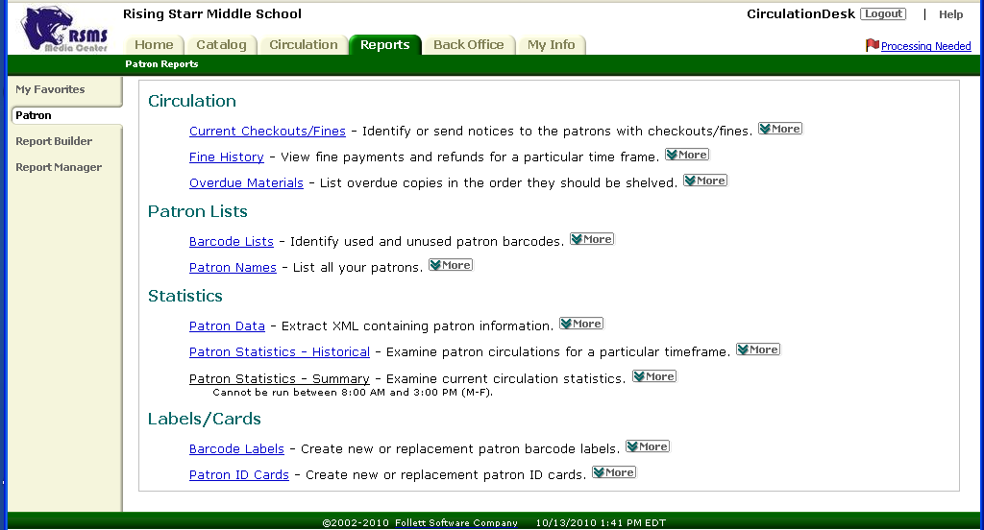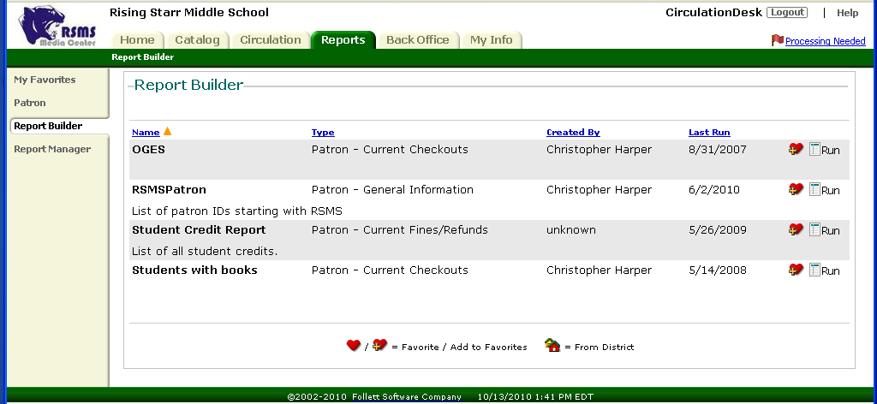

- Schedule routine running times using Report Manager.
  - Don’t schedule running times during the busiest part of the day.
  - Consider holidays and school test days as GOOD times to run recurring reports.
- SAMPLE of a Circ report looks like this.
- 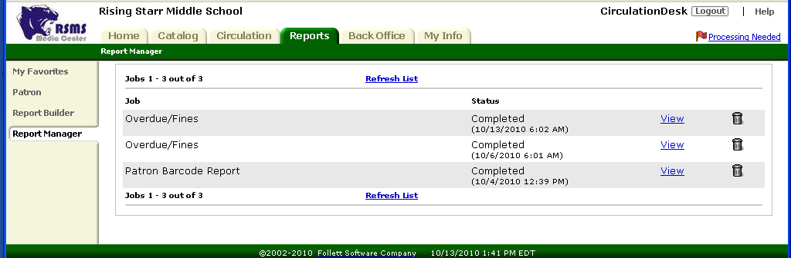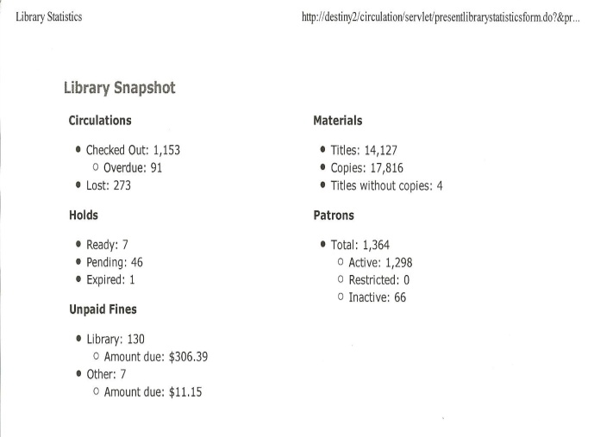
- Inventory
- Use the Destiny Online Help and Support Checklist before you start your inventory.
- When is the inventory? ________________________________
- How many days: ______________________________________
- Will the library be open or closed? _______________________
- Have you weeded your collection? _______________________
- Will you use remote scanners? __________________________ Are they charged?

- Here are samples of the checklists
- 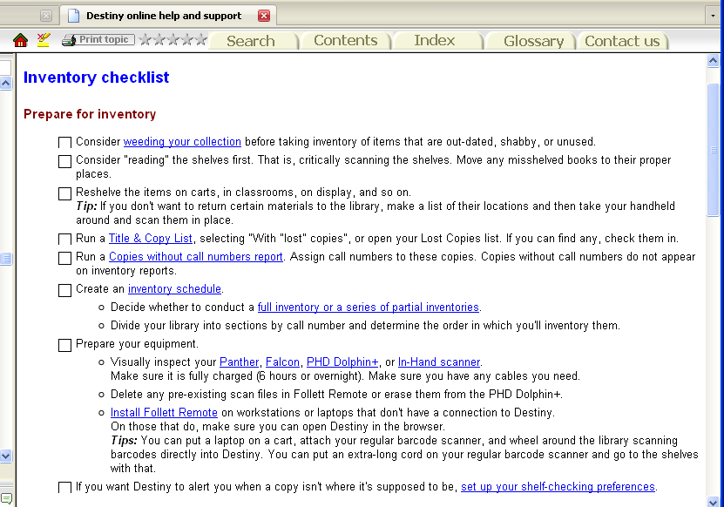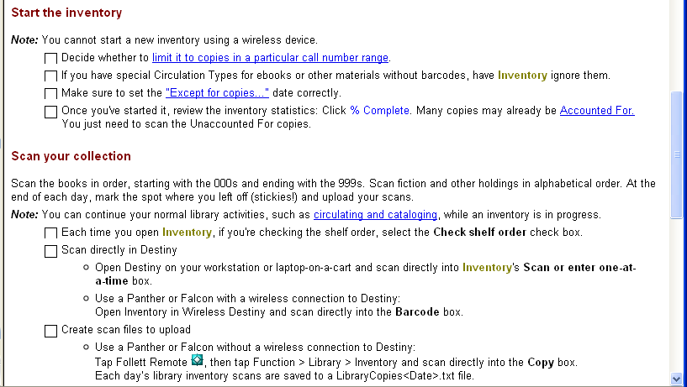

- 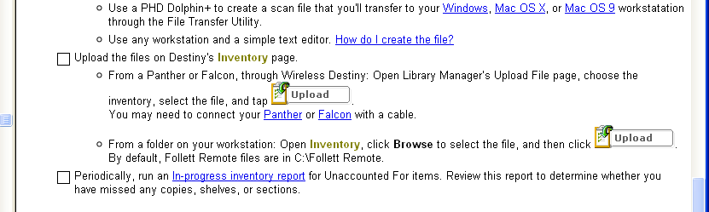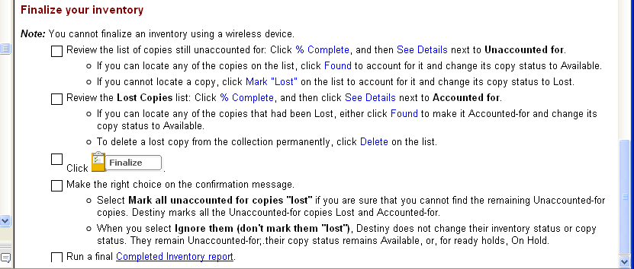

- Then from Back Office, use the ‘Inventory’ module to conduct your inventory. Notice you can have a ‘limited’ inventory selecting only certain items or spans of DDCs to inventory and you can run more than one inventory at a time.
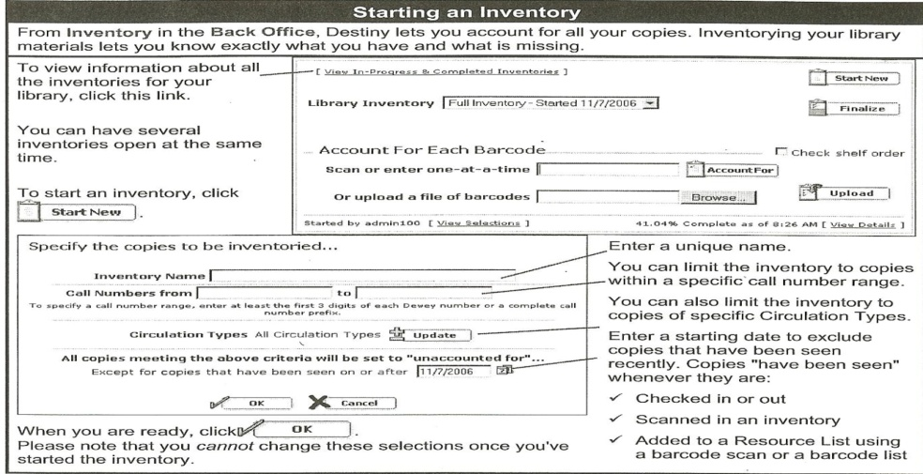
- It is possible to check books in while conducting the inventory.
- It is possible to have several inventories running at the same time.

- Shelflist (a listing of materials that can be displayed in various manners)
- Use Destiny online help and support to generate a Shelflist.
- Spot check your inventory against stacks by generating shelflists for certain sections (biographies, reference,..) at a time. Use your shelflist to generate a ‘series’ lists to help with acquisitions and ordering copies.
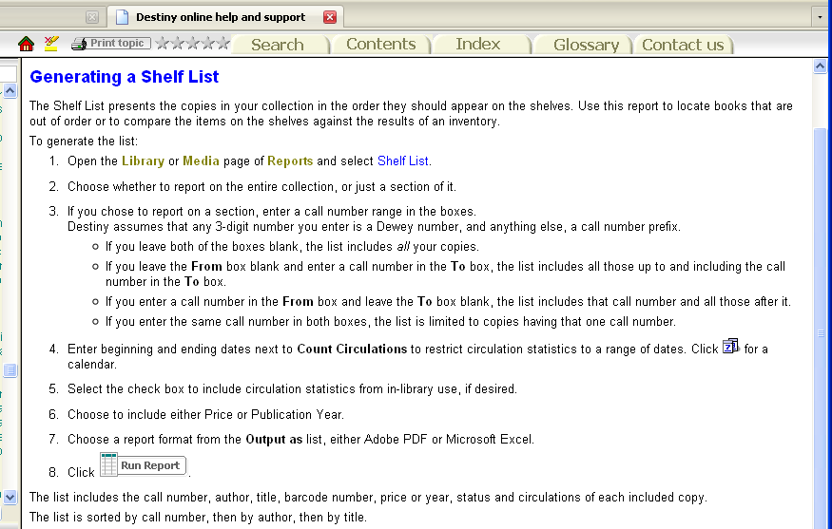

- Collection age report (sample)
- Use Destiny online help and support to generate a collection age report.
- Use the age report to consider future purchases and weeding candidates.
- Analyze your reference section for relevancy.

- 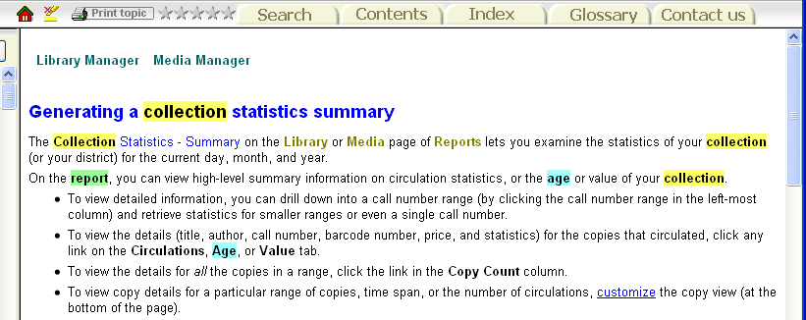

Consider a:
- TitleWise Collection Analysis 2 from www.titlewave.com gives you a collection analysis in great detail for an age comparison. Here is a Sample format:
- Collection Analysis (by 10s)
- The Hundreds Divisions Age Items % of Collection
- 000 Generalities 1996 76 0.50%
- 010 Bibliography 1997 4 0.03%
- 020 Library and Information Sciences 1996 8 0.05%
- 030 General Encyclopedic Works 1996 33 0.22%
- ……..
- Collection By Year
- Decade # of Books
- 1900 2
- 1910 3
- 1920 3
- ……
- 2000 3470
- No year given/out of range 607
- Total 15714
- Age Sensitivity
- Dewey Ranges Acceptable Items in Aged
- Age (Years) Collection
- 003-007 Systems Data/Computer Programs 3 36 34 94.44%
- 320-329 Political Science 5 93 82 88.17%
- 361-369 Social Problems and Services 5 256 240 93.75%
- 370-379 Education 5 52 44 84.62%

- Bar codes/spine labels
- Use Destiny online help and support for barcode labels.
  - Check the label sizes necessary for the barcodes.
  - Be sure to have adequate printer ink. It is hard to stop and restart the printing if you have to change ink cartridges.
  - Be sure your labels will fit every item. You may need to use smaller labels for DVDs. You can set up your barcode print parameters to print specicific types of items. Then use the right size label
- 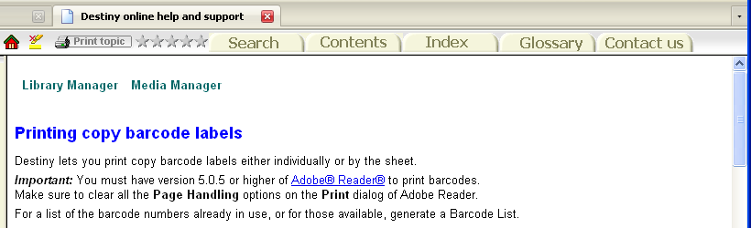

- BAR CODE and SPINE LABEL POSITIONING. Try to standardize your placement of barcodes and spine labels. It makes it much easier to read the call numbers on the shelf and to conduct an inventory.
- What labels do I need?
- Call #, AR or Lexile level, series #, foreign language, …….
- Place the barcode in an area easily accessible for inventory, and not to be confused with the ISBN barcode.
- Cover all labels/barcodes with a strong clear coverings to protect them.

- Custom indexes (sample)

- Use Destiny online help and support for building custom indexes (reports).
- Save your recurring reports to the Favorites, or schedule them to run on a recurring basis.

- 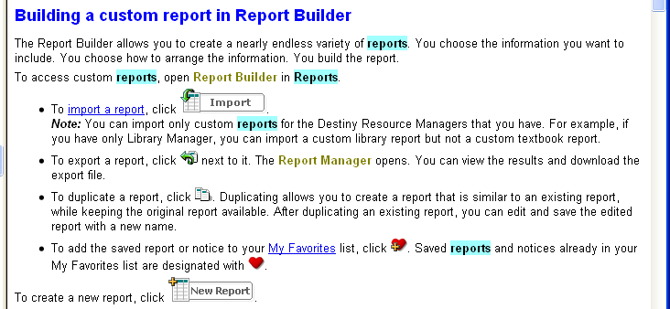

- A SAMPLE custom index of a partial inventory would look like this:

- Rising Starr Middle School
- Title Barcode Call Number Author Last Seen
- Accounted For
- Title created by Remote Circulation on RSMS32 4/22/2008
- VCR T 20 RCA/VR538 5/22/2009
- Means and probabilities : using statistics in T 18294 001.4 KRI Krieger, Melanie Jacobs. 5/19/2009
- Discovering graph secrets : experiments, T 19519 001.4 Mar Markle, Sandra. 5/19/2009
- Discovering graph secrets : experiments, T 13871 001.4 MAR Markle, Sandra. 5/19/2009
- Graphs T 12491 001.4 SMO Smoothey, Marion, 1943- 5/19/2009
- The census and America's people : T 14418 001.4 WIL Wilson, Natashya. 5/19/2009
- The abominable snowman T 20987 001.9 ANT Antonopulos, Barbara, 1947- 5/19/2009

- Unused barcode report
- Use Destiny online help and support for generating an unused barcode report or labels.
- Determine the range you want to print.
- Decide if you want the District or school name on the label list also.
- How many will you need?

- 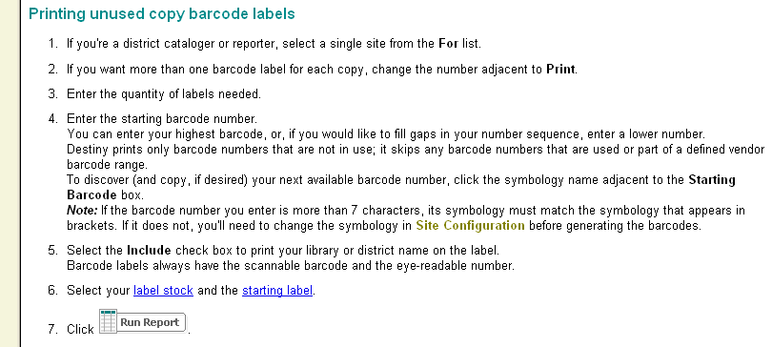
- IF barcodes numbers are issued by DISTRICT:

  - What do the numbers mean.
  - How do I get more numbers.
  - How can I reuse numbers.
  - Are there any temporary barcode numbers?.

- Diagram of a barcode:

- Rebuilding the system from backup
- Use your Destiny Technician Guide to Restore your Site Database.

  - Coordinate with DISTRICT
  - Be sure to write down the date of the information being restored.
  - Make a list of all actions that have happened since that date that you may have to recreate.
- An example of the restore function from the Technical Guide:

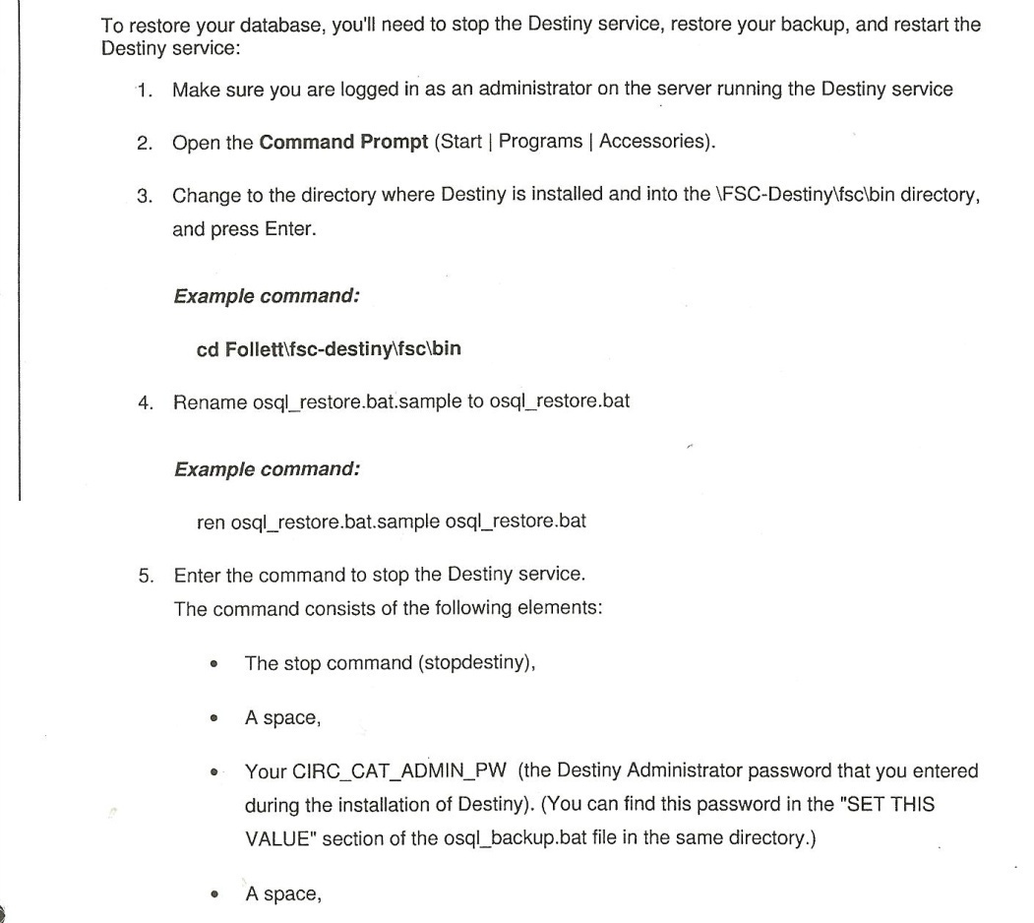
- Run the restore function.
- Double check your results.
- Determine what other information must be added.

Section Six: Troubleshooting. Destiny provides 2 sources of help. (1) On-page help and (2) on-line help

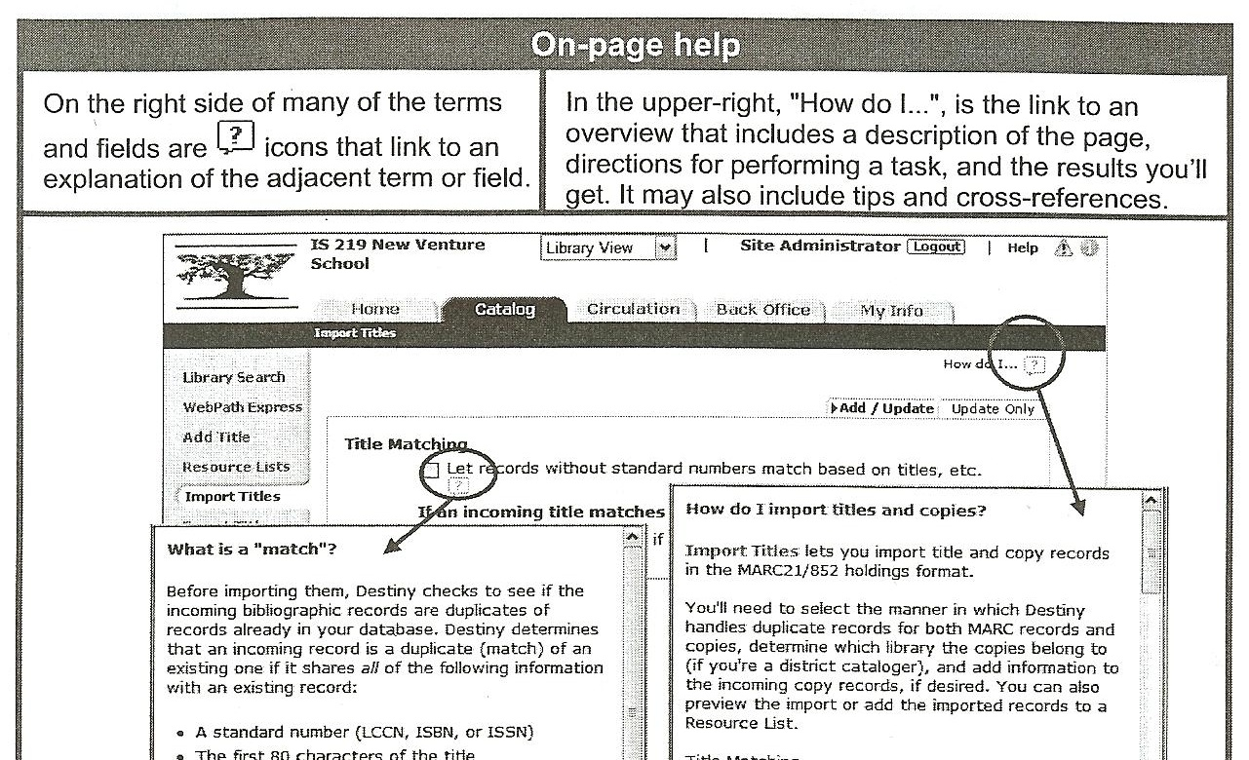

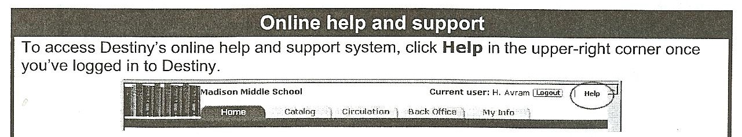

- Destiny online help. Type in what you are looking for, future options help narrow down your search.

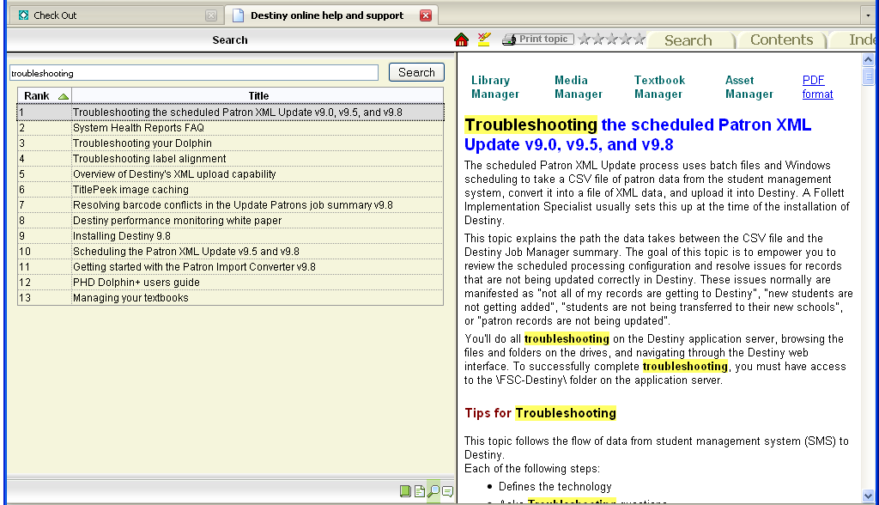

- Trouble with AR. Consider these options if you are having trouble with AR.
- Go to the Reading Program Services (RPS) and recheck your configuration settings.
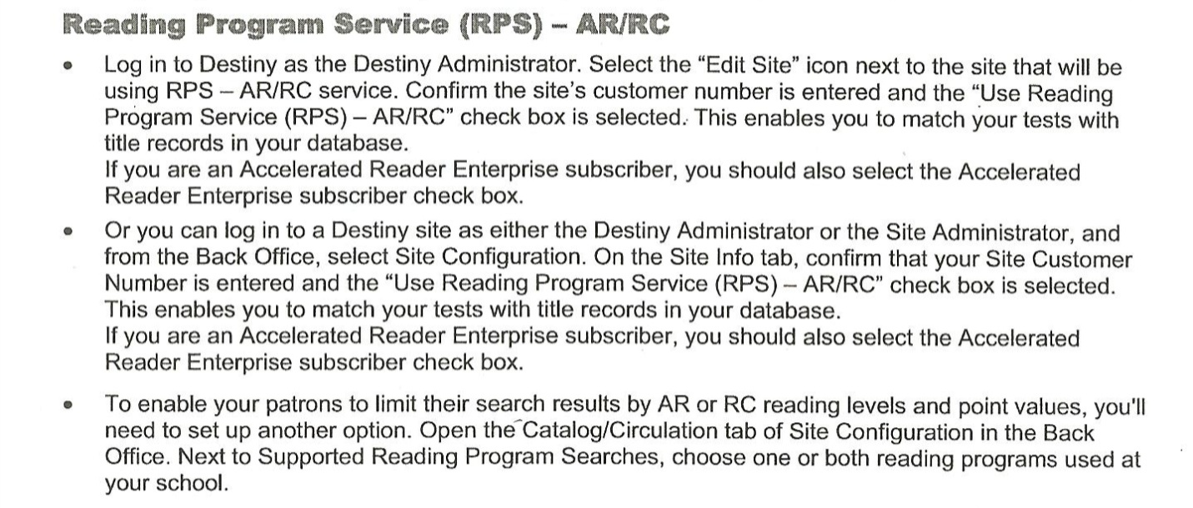
- Check the quizzes and titles.
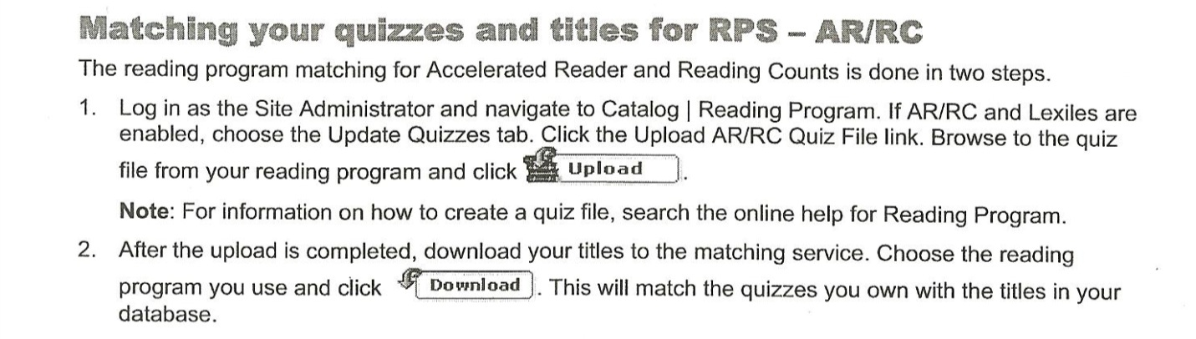
- Check Job Manager and look at Reading Program reports.
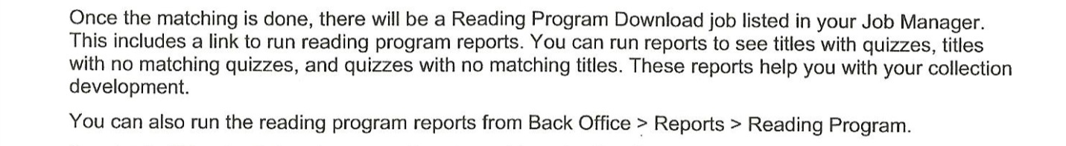
- If AR is OK, check Patron data.
- Are they authorized AR access?
- Are they using the correct password?
- 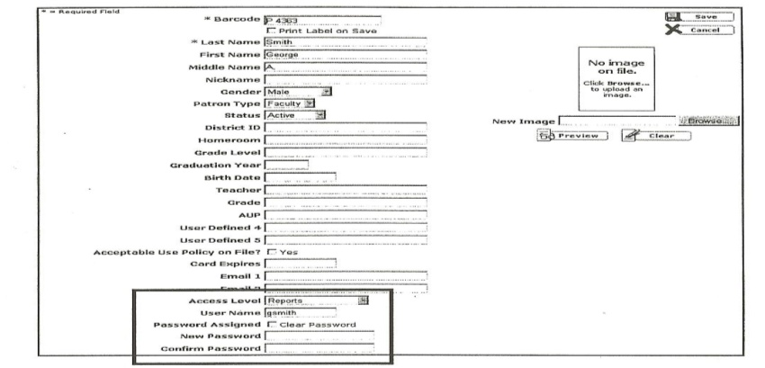
- CALL CALL CALL
- Know your Tech Support by first name.
- Keep a Troubleshooting Log
- Don’t forget to blog! Everyone in your DISTRICT has the same issues.
  - 