Stephanie Gauthia
Media Specialist Add-On Certification
University of West Georgia
Fall 2010

Table of Contents

Policies
I. Purpose Statement……………………………………………………………… 4
1. Name and demographics of system and school ………………………… 4
2. Clarkesville Elementary Media Center Mission Statement …..………… 5
3. Clarkesville Elementary Media Center Philosophy ……………..……… 5

II. Public Relations/Marketing.…………………………………………………… 6

III. Selection Policy………………………………………………………………….7
1. Statement of Philosophy………………………………………………… 7
2. Objectives ………….…………………………………………………… 7
3. Responsibility for Selection.…………………………………………….. 7

IV. Reconsideration of Materials Policy ……………………………………………8

V. Media Services………………………………………………………………….. 9
1. Operation ……………………………………………………………...… 9
2. Circulation ……………………………………………………..………... 9
3. Overdue Books …………………………………………………..……… 9
4. Damaged Books ……..……………………………................................. 10
5. Lost Books ………………..……………………………………………. 10
6. Inventory…………………………………………………………………10
7. Video……………………………….……………………....................... 10
8. Weeding ……………..….……………………………………………… 11
9. Mending and Repairing ……………………………………………….…11

VI. Definition of Scope of Technical Services …………..…………………………12

VII. Copyright ………………………………………………………………...…… 13

VIII. Leadership and Professional Growth………………………….………………16

IX. Interlibrary Loan …..………………………………………………………………17

X. Donated Materials Policy ………..…………………………………………………18

Procedures
I. Collection Management …………………………….……………………………… 19
1. Consideration File ...………...……………….…………………………….. 19
2. Ordering Procedures ……………………………………..………………… 20
3. Selection of Book, Non-book, and Equipment ………………………..…… 20
4. Receiving Procedures …………………..…………………………...……… 21
5. Periodical/Serials/Newspaper Control ……………………………...……… 23

II. Technical Services…………………….…………………………………………… 24
1. Circulation Procedures ………………..…………………………………… 24
2. Overdue Procedures ………………..……………………………………… 24
3. Damaged Books Procedures ……………………………………………… 25
4. Lost Books Procedures …………………………………………………… 25

III. Circulation and Cataloging Procedures: Qwik Start Guide…………………...……28

IV. Collaboration Resources……………………………………………..…………….70
1. Interlibrary Loan Procedures……………………………………………….71
2. Reconsideration of Materials Procedures…………………………………...71
3. Scheduling of LMC…………………………………………………………72
4. Paraprofessionals and Volunteers Duties……………………………………72

V. Floor Plans…………………………………………………………………………..73

VI. Appendices…………………………………………………………………………74

References (Page 89)

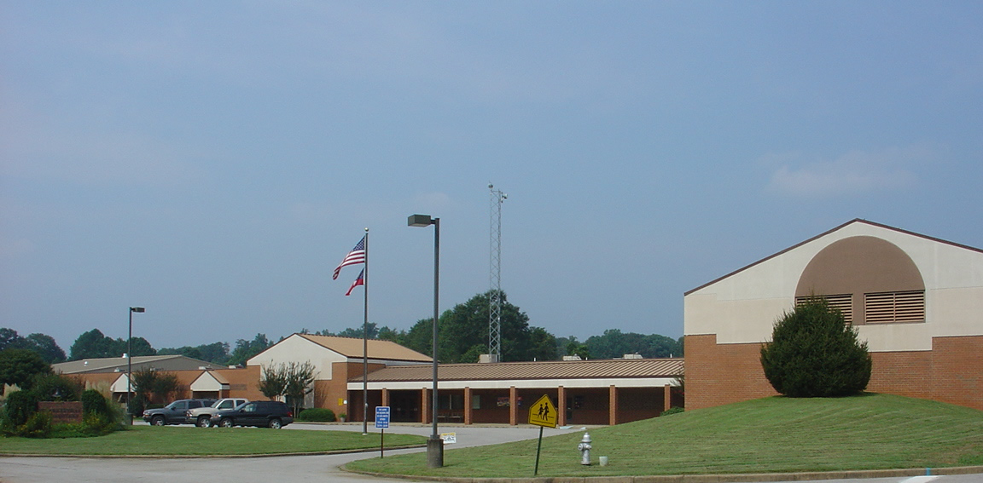

Purpose Statement

Demographics

Clarkesville Elementary School is located in Habersham County. It is one of six elementary schools operating in the county. Clarkesville Elementary contains grades from Kindergarten through fifth grade. The projected enrollment for the 2008-2009 school year is 501 students.

There are approximately 27 classroom teachers employed at Clarkesville Elementary School. There are 17 other certified faculty members and two full-time administrators. Of the 501 students attending Clarkesville Elementary School, eighty-three percent of those are Caucasian, nine percent Hispanic, four percent Multiracial, two percent Asian, two percent African American and one percent Native American. Sixteen percent of the total student enrollment receives special education services, fifteen percent benefit from the Early Intervention Program and five percent of the students benefit from ESOL services. Currently, forty-two percent of the students are eligible for free or reduced lunch. The faculty, staff and administrators will work hard to provide each child with a climate that is conducive to learning.

Clarkesville Elementary Media Center Philosophy

A student-centered media center is the core of Clarkesville Elementary School. The Clarkesville Elementary media program forms an integral part of the learning environment and is an extension of the classroom. The library media specialist plays a role that supports and enriches the curriculum, promotes a love of reading and teaches skills in accessing, processing and communicating information. The intent is to provide opportunities for critical thinking and decision-making, build self-reliance, enhance self-esteem and promote life-long learning. Students learn to use information competently and responsibly. The library media specialist connects students and teachers to the resources they need to successfully learn and teach each day.

Clarkesville Elementary Media Center Mission Statement

The mission of the library media center at Clarkesville Elementary School is to promote a lifelong love of reading, provide instructional leadership in the use of informational resources and allow students access to an abundance of quality resources in all formats that enhance and reinforce the curriculum.

Public Relations/Marketing

Habersham County Schools believes that school media centers are integral to the literacy development and academic achievement of all students. School media centers in this district are designed to be a “supportive component of the overall educational program.” The media specialist is expected to support the curriculum based on the needs of the schools and students. Media center support is given in a variety of ways one of which is promotional activities.

Annual media center activities may include:
- Scholastic Book Fairs
- Accelerated Reader and Book It Contests
- Weekly Newsletter for teachers
- Parent events

A detailed list of media center activities for Clarksville Elementary can be found in Appendix A.

The media specialist will meet with the principal and interested stakeholders every nine weeks to update and inform about the current status of the media center. The media specialist will get approval for upcoming activities and see promotional support from the PTA.

The media specialist will keep faculty informed by giving monthly booktalks on the morning broadcast about new books available in the media center. The media specialist will also attend grade level meetings once a semester for collaborative planning with teachers.

All media center activities are carried out in accordance with the guidelines and policies of Habersham County Schools. Therefore, any marketing information from an individual school to the community must be approved by the principal prior to release.

Selection Policy

Statement of Philosophy

The main priority of the media center is to select materials to support the curriculum as well as the interest, information, and enlightenment of the media center patrons. In order to maintain a well-balanced library media collection, the collection should include materials suitable to grade level, curriculum correlation, and personal interest of teachers and students. The library media center provides materials in a wide range of difficulty in a variety of formats, representing multiculturalism and differing points of view.

Objectives

The Clarkesville Elementary selection policy reflects the philosophy and goals of the Pretend County School System and supports the principles of intellectual freedom described in Information Power: Partnerships for Learning and the Library Bill of Rights (ALA), and other position statements on intellectual freedom from the American Library Association, the American Association of School Librarians and the National Council of Teachers of English.

Responsibility for Selection

The Pretend County School Board is ultimately responsible for all materials selection. However, the school board usually delegates the responsibility for purchasing to the media center staff that has professional training in selection. The responsibility is divided amongst the media specialist, the media committee and other local stakeholders. The media committee, consisting of administrators, students and teachers, will aid in the final selection process.

RECONSIDERATION POLICY

Despite the process of selection, objections to instructional materials will occasionally be voiced. The Pretend County School District supports the principles of intellectual freedom supported by the First Amendment of the Constitution of the United States of America. The school district also supports the American Library Association’s statements on the Library Bill of Rights. The Library Bill of Rights can be read on the website, http://www.ala.org/work/freedom/lbr.html.
The Freedom to Read statement, which can be accessed on the website, http://www.ala.org/ala/oif/statementspols/ftrstatement/freedomread
statement.htm, is also supported by the school district. If materials selected by library media specialists are even in question, the principles of intellectual freedom, the right to access of materials, and the integrity of the professional library staff will be defended.

Any Pretend County resident or any employee of Pretend County Schools may formally challenge learning resources used in the Pretend County School District on the basis of appropriateness. This policy allows for the consideration of the opinions of those persons in the schools and in the community who are not directly involved in the selection process. If any parent challenges materials, he or she may only determine the reading, viewing, or listening materials for his or her own child.

Media Services Policies

Operation

The Clarksville Elementary media center is open during school hours from 7:05-2:15. It operates using flexible schedule. Teachers can schedule book checkouts, storytimes, or lessons using the sign up book at the circulation desk or online. For lessons, teachers can choose media specialist led lessons such as for library skills or they can plan collaboratively with the media specialist for curriculum related lessons. Teachers must remain in the media center with their class at all times. Students are allowed in the media center without teacher supervision as long as they have a media pass with them.

Circulation

The Clarksville Elementary media center has over 20,000 resources available for checkout. These include a variety of print and non print materials. There are ten computers available at all times for searching the library catalog or researching. Students in grades K-2 can check out two books for up to two weeks. Students in grades 3-5 can check out three items for up to two weeks. Books can be renewed at any time before their due date. Students are not allowed to check out reference materials or audio visual resources. Teachers can checkout different reference materials for one day.

Overdue Materials

All patrons are expected to return materials on or before the due date. Overdue notices are sent out once a month and monies are expected to be paid. There is no fine system in place for students or teachers at the elementary level. Checkout privledges are suspended until overdue items are returned or paid for.

Damaged Books

Damaged books will be examined by media personnel to determine the cost and relevancy of repair. If an item is beyond repair students are expected to pay for damaged books. Damaged books that will be weeded from a collection will follow district level policies for the discarding of items from a school.

Lost Books

Students at Clarksville Elementary are held responsible for lost books in accordance with district policies. A student who loses a book or other materials is required to pay for the lost item. Students will not be allowed to check out any materials until the missing items have been paid for. The Clarksville Elementary Media Center also has the right to withhold report cards until restitution is made. Teachers or other school personnel who lose books or other items are not required to pay for missing items.

Video
During instructional hours videos and DVDs from the media center collection may be shown in the classroom if a teacher has completed a video request form. This form should identify how the video or DVD relates to curriculum standards. During non instructional hours media center videos and DVDs may be checked out for recreational use. Any videos or DVDs that are a part of the media collection and rated PG require parent permission before viewing.

Inventory

Inventory of all print and non-print materials is conducted at the end of every school year. The media center staff will use handheld scanners to inventory materials that are currently in the media center. Equipment and non-print materials are also inventoried at this time. Students are not allowed to checks books out during this time which is why inventory usually coincides with the spring book fair. This is a great time to get some weeding done as you are very hands on with the collection. Items that are lost are scanned into the automation system as such.

Weeding and Repairing

The Clarksville Elementary School Media Center follows district level policies regarding the weeding of books and other materials. District policy states that weeding should be done systematically and only after a collection is 5 years old. Policy also recommends that a media specialist should begin weeding after serving one full year in a particular media center. Media specialists are to follow the district level adopted guidelines when evaluating items for weeding. These guidelines have been adopted from the American Library Association, in cooperation with the Texas State Library and are known as the acronym MUSTY. This acronym stands for:
M- Misleading
U- Ugly
S- Superseded
T- Trivial
Y- Your Collection
The aforementioned is just a guideline and district policy suggests that media specialists consider the unique needs of its stakeholders to make final decisions. Items identified for weeding are not to be placed in the classroom but should be marked as DISCARDED or WEEDED and then packed and sent to the warehouse for disposal. Records should be kept of weeded materials

Mending

It is the policy of this media center to repair items as often as necessary so that they can remain a part of the collection When deemed necessary by the media specialist materials will be mended so that they can continue circulation. This could also include cleaning and serious repair. All damaged books or other items identified for repair will done by Clarksville Elementary media personnel.

Definition and Scope of Technical Processing

Technical services are those provided by media specialists with regard to the cataloging and processing of print and nonprint materials. School media centers in Pretend County are required to keep up-to-date records of all of the holdings in their collection. District policy states, “All school-owned instructional resources are organized and managed through the media program.” Media specialists at the school level are responsible for developing organized systems to manage their collections. The Pretend County Media Department advises, “Whenever possible, resources that are purchased for a media center should be pre-processed by the resource vendor, i.e., Follett. This will usually include the receipt of the MARC records, spine labels, and bar codes. The minimal cost of vendor processing of resources will save valuable time as well as ensure professional catalog records.” Resources that are purchased without processing must be cataloged individually at the discretion of the media specialist.

In order to ensure uniformity codes used on print and non print materials should reflect that of the current collection. Per district policy the media specialist at the local level has the authority to determine, change, or revise codes if necessary.

Copyright

Copyright is granted to the creators of works to protect their interest in the work and to encourage people to take risks and disseminate information. The copyright law is intended to protect against unauthorized printing, publishing, importing, or selling of multiple copies of a work. A fair use law was developed to provide guidelines in the use of copyrighted materials.
Fair use is intended to balance the interest of the copyright owners with the needs of the users. There are four requirements that must be passed to determine fair use:
- the purpose and character of use
- the nature of the work
- the amount, substantiality or portion
- the potential market

Students and employees should comply with federal, state or local laws governing copyrighted material. Adherence to fair use guidelines and other relevant copyright laws shall be assured. In no instance shall media and/or equipment be used in such a manner as to violate Board policy or state and federal law.
The media specialist will be responsible for ensuring the availability of copyright information, dealing with copyright and clearance questions. Neither the Board of Education nor the school system shall assume responsibility for actions of system employees or students in violation of the above-mentioned laws. See appendix for fair use chart.

Copyright Policy

Guidelines for reproduction and use of copyrighted material in print:
- Teachers may make or have made a single copy of the following for instructional uses:
- a chapter from a book
- an article from a newspaper or periodical
- a short story, essay or short poem, whether or not from a collective work
- a chart
- a graph
- a diagram
- a drawing cartoon
- a picture from a book, periodical or newspaper

- Teachers may make multiple copies (not to exceed one per student) of the following for classroom use or discussion provided all of these requirements are met:
  - The copying meets the tests of brevity and spontaneity as defined below.
  - The copying meets the cumulative effect test as defined below.
  - Each copy includes a notice of copyright.

Brevity:
- a complete poem of less than 250 words
- an excerpt of no more than 250 words from a longer poem
- a complete prose work if it is less than 2,500 words
- an excerpt of no more than 500 words from a prose work of between 2,500 and 5,000 words
- an excerpt of not more than 10 percent of a prose work of between 5,000 and 10,000 words
- an excerpt of not more than 1,000 words from a prose work which is greater than 10,000 words
- one illustration per book or periodical use
- not more than two pages and 10 percent of the words of "special works" which are poetic or prose works which combine illustrations and less than 2,500 words (such as many children's books)

Guidelines for reproduction and use of copyrighted music:
- Teachers may make a single copy of a song, movement or short section from a printed musical work that is unavailable except in a larger work for purposes of preparing for instruction.
- Teachers may make multiple copies for classroom use of an excerpt of not more than 10 percent of a printed musical work if it is to be used for academic purposes other than performance, provided that the excerpt does not comprise a part of the whole musical work which would constitute a performable unit such as a complete section, movement or song.
- Teachers may make and retain a single recording of student performances of copyrighted material when it is made for purposes of evaluation or rehearsal.

Plagiarism and copyright infringement:
- Employees will not plagiarize works found on the Internet. Plagiarism is taking the ideas or writings of others and presenting them as if they were the writer’s.
- Employees will respect the rights of copyright owners. Copyright infringement occurs when an individual inappropriately reproduces a work that is protected by a copyright. If a work contains language that specifies appropriate use of that work, employees must follow the expressed requirements. If an employee is unsure whether or not a work can be used, he/she should request in writing permission from the copyright owner.
- Employees will not copy/install district owned software on personal computers at work or at home. This is a violation of the federal copyright law.
- Employees will not install single user software on more than one machine. This is in violation of the federal copyright law.
- Employees will not install personal software and/or personal computer equipment on district owned computers and/or the district network system.

Guidelines for reproduction and use of copyrighted audiovisual material:
- No type of audiovisual work may be copied in any form without permission from the copyright holder.
    - The teacher must use videotapes in accordance with labels on audiovisual materials. Restrictions printed on videotapes or DVD’s are binding. Use is subject to licensing or other written permission.

Guidelines for reproduction and use of copyrighted materials in library:
- A library may make a single copy of the following.
- an unpublished work which is in its collection
- a published work in order to replace it because it is damaged, deteriorated, lost or stolen, provided that an unused replacement cannot be obtained at a fair price
  - A library may provide a single copy of copyrighted material at no cost to a student or staff member. The copy must be limited to one article of a periodical issue or a small part of other material, unless the library finds that the copyrighted work cannot be obtained elsewhere at a fair price. In the latter circumstance, the entire work may be copied. In any case, the copy will contain the notice of copyright and the student or staff member will be notified that the copy is to be used only for private study, scholarship or research. Any other use may subject the person to liability for copyright infringement.

Leadership and Professional Growth

The school library media specialist provides instructional leadership in the use of information resources and literature. Professional growth, advancement and evaluation of media specialists and media centers include:

- University courses- Media specialists are encouraged to enroll in courses provided by accredited colleges and universities.
- In-service training programs - Media specialists are urged to participate in in-service training programs that the principal and county-level personnel plan for curriculum improvement. Workshop meetings are considered a part of in-service training. All K-12 media specialists are expected to attend library media workshops offered on the district’s professional planning days.
- Professional organizations - Media specialists are eligible and encouraged to apply for membership in national, state, and local educational organizations.
- Personal evaluation - All library media specialists are evaluated according to procedures prescribed in their contract.

See Appendix B for professional organizations.

Interlibrary Loan

Interlibrary Loan (ILL) among the Pretend County school library media specialists is permitted, with loans being made from the library media specialist at the loaning school to the library media specialist at the borrowing school. An ILL request might be denied if the owning school’s staff or students are using or have immediate plans to use the material in question. If an item borrowed through ILL is lost or damaged, the borrowing school should replace the material.

When using email to request materials from other library media centers, please do the following:
Before sending out an email requesting materials, check the automated system to see which schools own the item you are looking for. Send out only one email at a time, to these schools, until you get the material you need. This will save other library media specialists from checking for the materials when you already have the item(s) that you need.
When sending out the email request, use ILL in the subject. Include the author, title, and call number of the item you are requesting in your message. Always sign your request with your name and school.
Library media specialists should be the one to contact other schools to make an interlibrary loan request. Teachers should not be contacting other schools, although they may go to the school to pick up the materials, if necessary.

Donated Materials Policy

Materials donated to the media center as gifts are willingly accepted and greatly appreciated. However, not all donations will be placed in circulation and the media center reserves the right to dispose of gifts through the regular weeding procedures. As a matter of fact, prior to cataloguing, the donated materials will be evaluated using the same standards as used in the new material selection process. Evaluation criteria includes, but is not limited to:

- Materials are not age appropriate,
- Materials do not satisfy curricular requirements,
- Frequent duplication in rarely used areas,
- Materials are very badly worn or significantly damaged.

If a donated item is not accepted for circulation in the school’s media center, it will be donated to the local public library.

Collection Management

Consideration File

It is recommended that media specialists maintain a consideration file. This file should include bibliographic information for print and non print materials that would be an asset to the collection in the event that additional funds become available for collection development. The Clarksville Elementary School media center will maintain a consideration file of print and nonprint materials to purchase that are related to curriculum needs or overall goals of the media center. The Pretend County Media Handbook states that media specialists are advised to seek “input from and informs students, staff, and community about the media center, its resources, services, and program.” Items to be considered can come from teachers, students, or parents.

Teacher Recommendations
Teachers have invaluable insight into the needs of the students whom a media center serves. Therefore they will have the opportunity to make suggestions or requests for the collection throughout the school year. To do so a teacher must complete the Book Request Form found in the Appendix.
Student Recommendations
Students at Clarksville Elementary also have the opportunity to make suggestions for the media center collection. The media center will house two boxes for Star Suggestions. Students that would like to suggest items must complete a form and submit it to the Star Suggestions box. This form can also be found in the Appendix.

Parent Recommendations

The Clarksville Elementary media center also will consider parent requests for materials. Parents or other community stakeholders are also required to submit the Book Request form detailing information about their request.

Ordering Procedures

The Clarksville Elementary School media center follows county procedures regarding the ordering and cataloging of materials. It is suggested that schools use the Follett, the recommended vendor, for print materials. However, media specialists are not limited to this vendor. All purchased under $2,500 can be purchased using the purchasing card (PCard) given to them by the school district. Please remember to keep a log of all items purchased with the PCard. District procedures for purchases over $2,500 states the following, “Books or Equipment over $2500.00: If a purchase for over $2500 is desired for either books or equipment from a non-bid list vendor the media specialist must submit two bids from two different orders. Contact Media Services for more information.”

Selection of Book, Non-book, and Equipment

As the selection policy states media specialists will act in compliance with district policy when selecting materials for purchase. The media committee which is comprised of one teacher from every grade level, one special area teacher, one parent and at least one student collaborates with the media specialist to consider print, non-print, and equipment resources to order. Teachers and students are also allowed to request materials via the suggestion box in the front of the media center. All print resources are considered for their value, relevancy, interest, and relationship to the curriculum. Non-print items are evaluated primarily for their relationship to curriculum standards.

Receiving Procedures

The Clarksville Elementary media center is required to follow very specific guidelines for receiving purchases. Those guidelines are as follows:

Processing Procedures
1. Order arrives.
2. Media specialist or paraprofessional unpacks resources and verifies all resources have been received per school's Order List. Check authors and publishers carefully. Next, compare to the Packing List.
3. If any discrepancies, media specialist or media paraprofessional will contact vendor.
4. Next, media staff should:
* a. affix bar codes and spine labels
* b. stamp resources with school name / media center
* c. if applicable, insert security tape inside books and periodicals; never insert book
security tape onto DVDs or video cassettes(A-V software has different security
"tapes")
* d. cover some resources with VistaFoil or similar self-adhesive to increase durability
of resources
* e. some may wish to write cost of resource and material number inside the resources
* f. where applicable, a book pocket or "Date Due" slip may be added to resources
* g. where applicable, a specialty label designating a specific section may be added to certain resources, i.e., Reference, Careers
5. If resources were purchased from Follett vendor, the media specialist or media paraprofessional may:
* a. Option 1: Download MARC records from Follett's web site
* b. Option 2: Download MARC records from disk sent by Follett
Processing of Periodicals (Journals, Magazines, Newspapers)
Most media centers maintain a checklist for the receipt of journals, magazines, newspapers, and other periodicals. If a media center prefers to catalog the periodicals, please use the same guidelines.

Processing of Equipment
It is recommended that each media center process and catalog all media center equipment in the automation system. This will be helpful for County audits and the maintenance of equipment assigned to each media center. Most media centers use the County bar code ( 31 E 000 _ _ _ _ _ _ ) when available. If equipment is donated, a County bar code with a configuration designating a donation ( 31 E DON _ _ _ _ _ _ ) may be present on the equipment. Otherwise, each media center should affix a bar code with the school's name on the bar code. If a media center decides to check out equipment to specific departments or staff during the year, there must be an accurate record of the name and room location of the department / staff, including the bar code(s) / model number(s) / serial number(s).

Periodicals/Serials/Newspaper Control

Circulating periodicals need to have barcodes affixed and entered into the automation system. They are shelved on one specific shelf in the periodical section. Teacher magazines should be placed in the Professional Reference area. Non-circulating periodicals need to be entered into the automation system for inventory purposes. Current copies are kept on the shelf and older copies are stored in the media center supply room. Newspapers are kept on the table in the reference section and are only kept for two days.

Repair and Mending

Print or non print materials that are in need of repair will be handled by the media specialist. Please see the Damaged Book Procedures in this handbook for more details. Equipment that is need of repair will either be addressed by the media specialist or the technology specialist.

Technical Services

Circulation Procedures

Check-out
- Student ID numbers serve as library patron numbers for checking out of print materials.
- County issued teacher ID numbers will serve as library patron numbers for teachers and staff.
- Patrons choose materials they would like to check out and then bring it to the circulation desk to be scanned.
- The item will be scanned by the media staff member, who will also check the screen to verify that the material is entered into the system and that the ID/badge number coincides with the patron checking out the material. If for some reason the scanner is not working barcode information for patrons or materials can also be entered manually.

Check-in Procedures
- The student/staff member will return their material(s) to the book drop.
- The material(s) will be scanned and the screen will be checked to verify that the item checked into the system.
- Materials will be sorted and reshelved by media staff or volunteers

Overdue Procedures

- Students are allowed a two week checkout period.
- Teachers can check out items for up to a month with the exception of CD players, overhead projectors, and maps.
- Fine notices are sent out once a month.

Damaged and Lost Book Procedures

In any elementary school setting it is likely that books will be in need of repair from time to time in order to preserve these items for circulation. The Clarksville Elementary Media Center is proactive in collection preservation by teaching students how to handle and care for books. However in the event that books they will be evaluated for possible discard or repair. If the book in question is one that you would like to keep in your collection and repair is a more cost effective option then please use the guidelines found in the Appendices for mending books. Most of these procedures were adapted from Brodart’s Simplified Step-By-Step Guide to Book Repair and Protection.

Students are responsible for turning in all books checked out from the media center at the end of the academic year. In the event that a student has lost a book they will be notified in writing about the cost of the book. Students are expected to pay for the lost item those who do not will not receive progress reports as per school policy.

The following is the Brodart list of suggested book repair items to keep on hand:

- Clear Packing Tape
- Transparent Tape
- White Glue/Adhesive
- Duct Tape
- Scissors
- Black Permanent Marker
- Wax Paper
- Ruler
- Clear Book Tape
- Page Mending Tape
- Book Glue
- Cloth Binding Tape
- Bone Folder

(Brodart, n.d.)

Cleaning Marked Pages:
Materials Needed: Eraser (Art-Gum or Plastic), Knife, Liquid Ink Eradicator

Removing Pencil Marks
Gently erase from the inside margin outward. Be careful not to wrinkle the page.

Removing Food, Gum, and Crayon Marks
Use a plastic eraser to remove first layer of markings. A knife can also be useful to chip away material

Removing Ink Marks
Apply Liquid Ink Eradicator to mark. If this does not remove it then leave it alone.

Mending Torn Pages:
Materials: Clear Tape, Bone Folder

Cut an appropriate length of tape. Place the tape over the center of the tear and apply. Trim away any excess. Use a bone folder to smooth tape and remove any air pockets or wrinkles. Repeat process on the other side of the tear.

Tipping-In Loose Pages:
Materials: adhesive, wide strips of scrap paper, waxed paper, a bone folder, a glue brush, a pressing board or glass plate, and a weight.

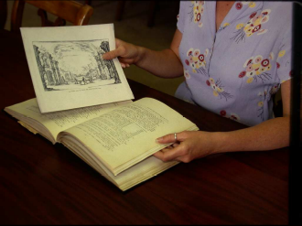
Place the page that will be tipped-in between two sheets of scrap paper.
Then carefully apply adhesive to the page using a glue brush. Place the
page into position (See Figure 1). Keep in mind you should aim to glue
the page as close to the center as possible. Using the bone folder,
carefully press the tipped-in page on the non-glued side to secure it in
place. Put the waxed paper on the glued side to protect pages from excess
adhesive. Place a weight on the book for several hours to secure page.

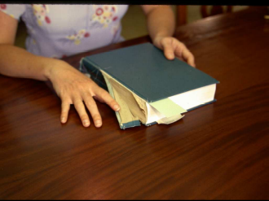
Mending Torn Spine:
Materials: adhesive, weight

Apply adhesive to torn area of the spine. Press and hold together firmly.
Place a weight against the spine and leave for several hours to secure.
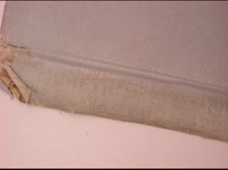

Torn Spine

Mending Worn Spine:
Materials: mending tape

Cut an appropriate length of tape. Place the spine of the book on the center
of the strip of tape. Press to secure fold the middle overlap into the top and
bottom of the spine.

Cataloging Procedures

There are currently no district wide policies for cataloging. Media Specialists are expected to follow standard guidelines to create MARC records. Specifics for doing this are determined by media specialist at the local school level. Follett’s Destiny Online Patron Access Catalog has features that support creating original MARC records.

Tools Necessary for Cataloging

Pretend County recommends purchasing cataloging for items whenever possible. In the event that an item is not processed the media specialist will need to use available resources for manual or original cataloging. Follett offers a service called Alliance for this purpose or you can use the Destiny union catalog for system wide holdings. The following are online resources that are also available:

1. Library of Congress
http://www.loc.gov/
2. Bergen County
http://www.bccls.org/
3. Sunlink
http://sunlink.brodart.com/
4. Ohio Link
http://olc1.ohiolink.edu/search/

Circulation and Cataloging Procedures: Qwik Start Guide

Table of Contents:

Section One: In the Beginning 3

Section Two: Online Patron Access Catalog 8

Section Three: Cataloging (Maintaining the Collection Database) 19

Section Four: Circulating Materials & Interlibrary Loans 25

Section Five: Reports and Utilities 32

Section Six: General Troubleshooting Tips 42

Most directions assume the user is already logged into the system

Section One: In the Beginning

Setting up Patron Types

Patron Types allow you to group patrons by similar characteristics. You have the option of using preset types (Faculty and Student) or setting up patron types to meet your specific needs.

•From the main screen click on the Back Office tab

•Select Library Policies from the left menu

•Click on Patron Type

•From the Add Patron Type page you can enter the patron type name and specifications

for the patron’s circulation.

•Click on Save

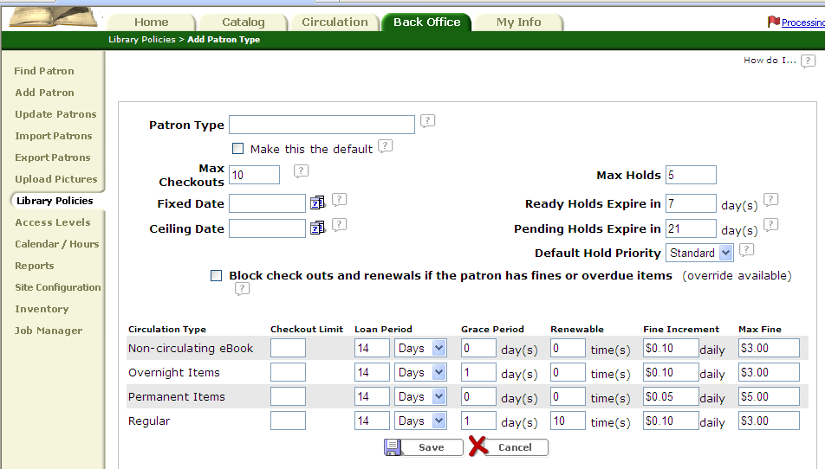

Adding or Updating Patrons
Creating New Patrons
•From the main screen click on the Back Office tab
•Select Add Patron from the left menu
•Fill in the necessary information in the spaces provided.
•Click on Save

Importing New Patron Records from a Database
•From the main screen click on the Back Office tab
•Select Import Patrons from the left menu
•Choose between barcode or ID number as the patron identifier.
•Choose what you want to do in the case of a 2nd identifier.
•Choose how you want to handle duplicate records (Keep current record, merge records,
replace current record)
•Click Browse
•Select the import file
•Click Import
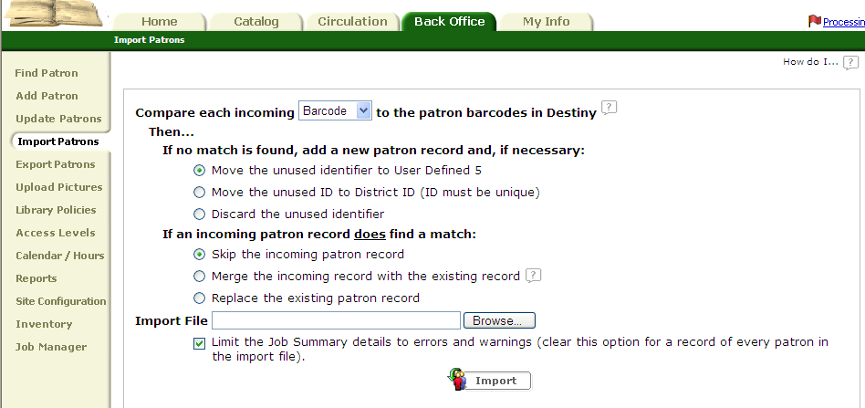
•Wait until you see the message “The patron import you requested has been submitted”.

Updating Existing Patron Records
Individual Updates
Use this feature to change up to three fields at once for a few individual patron records.
•From the main screen click on the Back Office tab
•Select Update Patron from the left menu
•Click on the Individual Update tab
•Click the down arrow of the select a patron field
•Select a field to update
•Select the new information for the field from the “to” list.
•Select the patron by clicking in the patron search box and typing in or scanning in the patron barcode.
***to search for a patron by name enter the name, select “only search”
and click Update
•Select from the list provided by clicking the patron name.
•To verify the update click Edit Patron for the patron updated

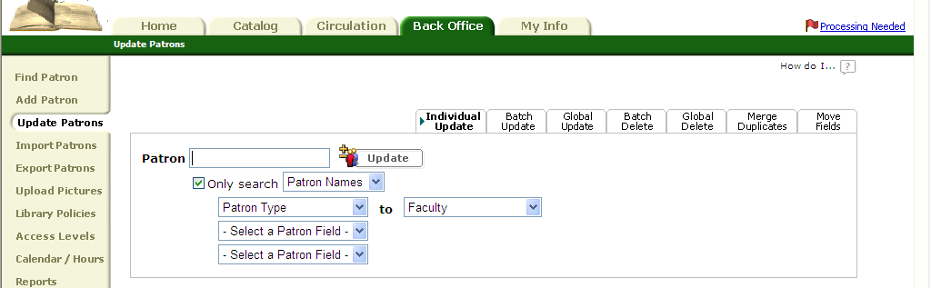
Batch Updates
Use this feature to update up to three fields for a selected list of patrons.
•From the main screen click on the Back Office tab.
•Select Update Patron from the left menu
•Click on the Batch Update tab
•Select a field to update by clicking on Select a Patron Field and selecting from the drop down menu.
•Select the field’s new contents from the “to” list (leave blank to clear the field)
•Select Create List
•Enter search criteria in first box and select the field to search in from the drop down menu.
•Click Search
•Click Select for each patron to be added to the list.
•Click Update

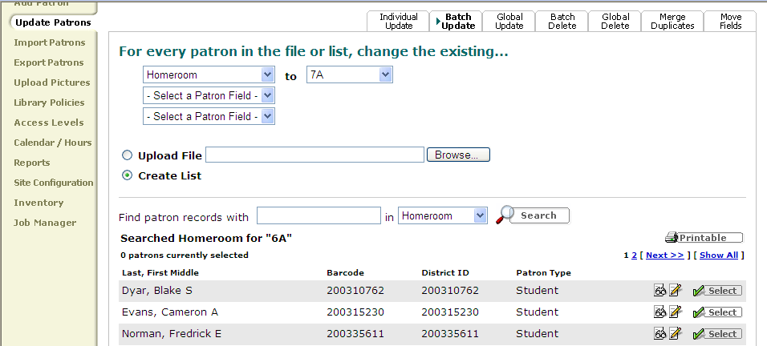

Global Updates
Use this feature to update all patron records that share a common field.
•From the main screen click on the Back Office tab.
•Select Update Patron from the left menu
•Click on the Global Update tab
•Set up the group
From the “whose” list, select the field to update and then select the field contents to search for from the “is” list.
•From the “change” list select the field you want to change.
•From the “to” list select the new information for the field
***if you want to delete the contents of the field leave this box empty.
•Click Update
•To verify the update go to the main screen, click on the Back Office tab and
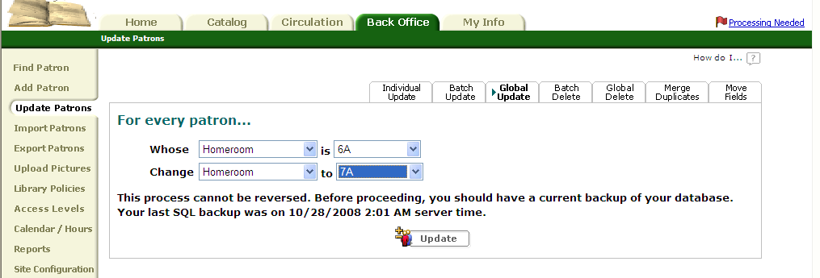
select Job Manager from the left menu

Deleting Patron Records
Deleting Records Individually
•From the main screen click on the Back Office tab.
•Select Find Patron from the left menu.
•Type the patron’s name or barcode
•Select search criteria from the drop down menu
•Click the trash can next to the patron to be deleted

Batch Deleting
Use this feature to delete a created list of patrons.
•From the main screen click on the Back Office tab.
•Select Update Patron from the left menu
•Click on the Batch Delete tab
•Check the Allow box to ensure deletion of patrons with outstanding checkout, fines, or refunds. Note: checked out books will be marked Lost.
•Select Create List
•Enter search criteria in first box and select the field to search in from the drop down menu.
•Click Search
•Click select for each patron to be added to the list.
•Click Delete all
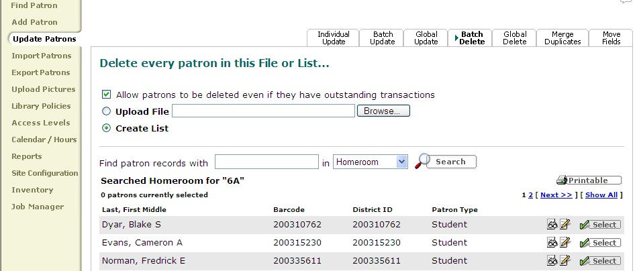

Global Deleting
Use this feature to delete a group of patron records at one time based on a common field.
•From the main screen click on the Back Office tab.
•Select Update Patron from the left menu
•Click on the Global Delete tab
•Select the Field from the “whose list” and from the “is” list specify the criteria
•Select the patron type.
•Click Delete All
•Select Yes
***To ensure deletion of patrons with outstanding checkout, fines, or refunds check the Allow box. Note: checked out books will be marked Lost.

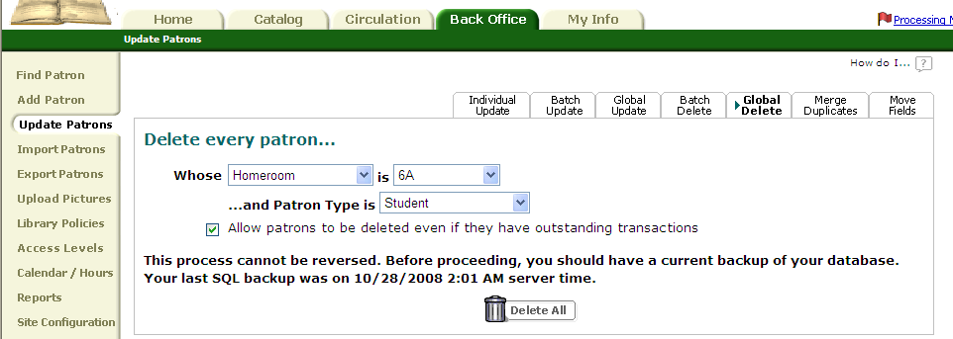
Assigning Passwords and Patron Numbers
•From the main screen click on the Back Office tab

•Select Find Patron from the left menu (for new patrons follow directions in Section 1.2 to create a new patron and get to the Patron Info. Page.)
•Type the Patron’s Name or Barcode in the “find” box
•Select search criteria from the “in” box
•Click Search
•Click box next to the patron’s name to view the Patron Info Page.
•In the Barcode box enter the Patron number to be assigned
•Scroll down to the Access level box and select the appropriate level
•In New Password box type the password to be assigned
•In the Confirm Password box retype the assigned password
•Click Save

Section 2: Online Patron Access Catalog

How to Open the OPAC
There are several ways to access the Online Patron Access Catalog or (OPAC) depending on your location in the school. If you are using the media specialst computer or a media center computer simply click on the library catalog icon and enter your username and password. After loggining in you will see the screen below.

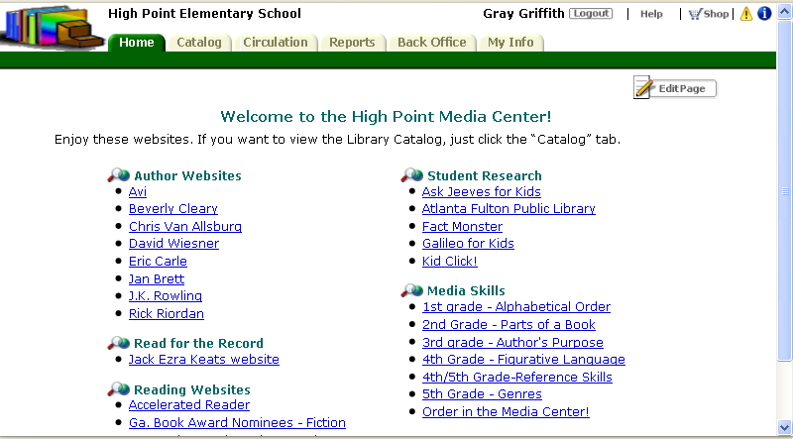

Types of Searches

There are 3 search tabs in a Destiny OPAC Basic, Power, and Visual. You can find these tabs in the upper right corner. Click the appropriate tab according to which type of search you would like to perform.
A basic search will locate all titles for a particualr search term .
A power search allows you to narrow your search term and/or limit the titles found for a particular search.
A visual search shows pictures of general search topics and categories. You can click on pictures within a topic to narrow the list even further. This will then produce a list of titles found with limited text and icon picture support.

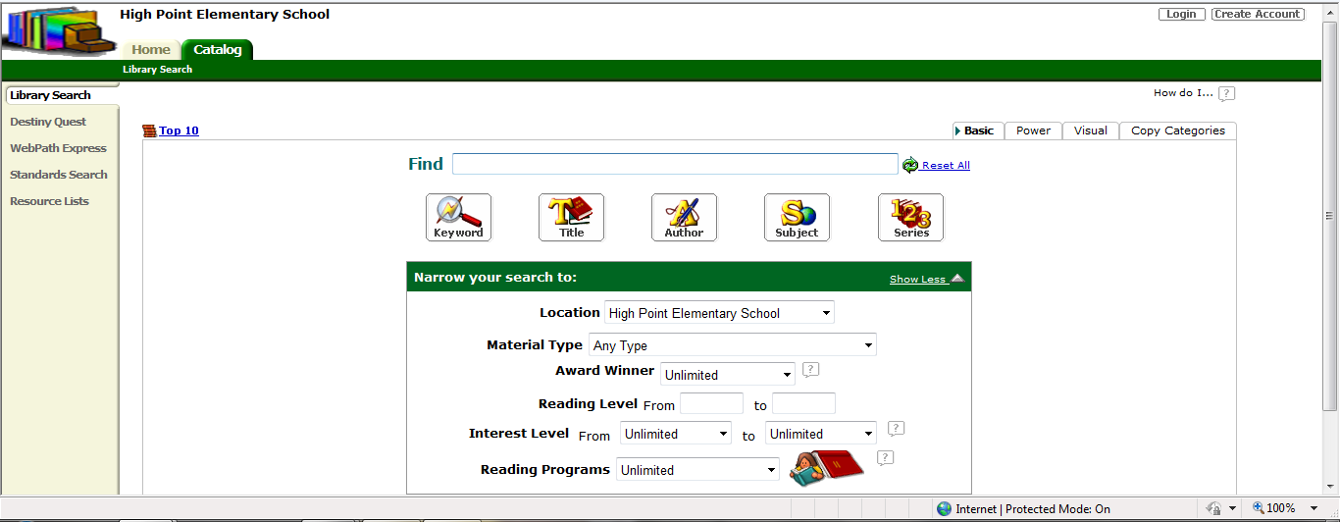
Types of Searches

Basic Search

The basic search page is the default page for the catalog. Here you are able to perform searches by keyword, title, author, subject, or series. For each of these types of searches simply type your search term into the box marked FIND and click on the appropiate type of search.

For example, to perform a search for cats. Type cats into the FIND box and then click on keyword.

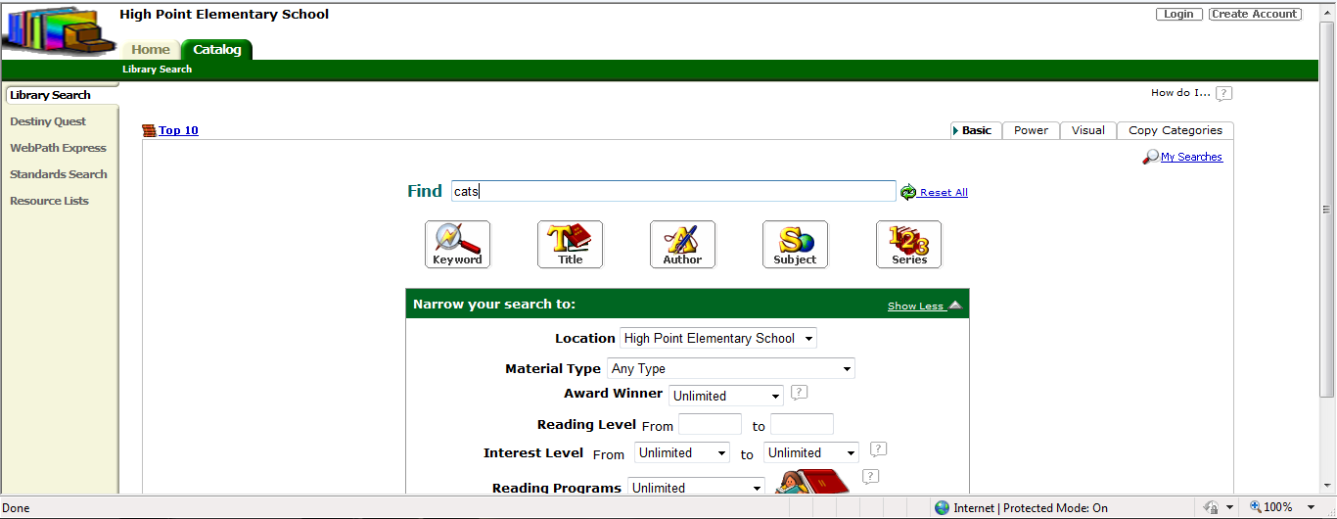

The title, author, subject, and series search all work the same way.
You can also narrow your search by identifying the location or school. Click arrow to open the drop down menu and select the specific school, all elementary schools, all middle schools, all high schools, or the entire school district.
If you want to search by material type click on the arrow to open the drop down menu and select the type of material.
If you want to search award winners click on the arrow to open the drow down menu and choose the type of award you would like to search by.
If you want to search by reading level in information for starting and ending reading level to search.
If you want to search by interest level click on the arrows to open the drop down menus for starting and ending reading level to search. You can search by grade level, preschool, adult, young adult or professional.
If you want to search by reading program click on the arrow to open the drop down menu and choose either lexile or accelerated reader.

Power Search

With the power search feature you can use Boonlean descriptors to narrow your search. The drop down menus on the left allow you to search by keyword, title, author, suject, series, or note.

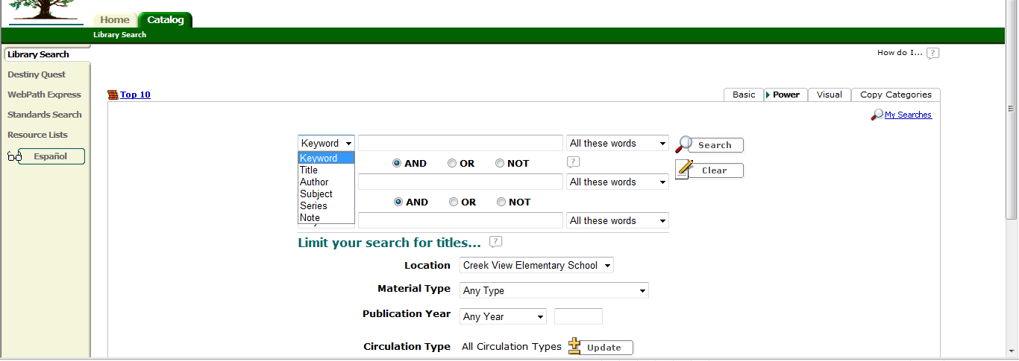

The drop down menus on the right allow you to search all words, any words, or an exact phrase. Titles can also be limited to location, material type, publication year, circulation type, award winner, reading level, interest level, and reading programs.

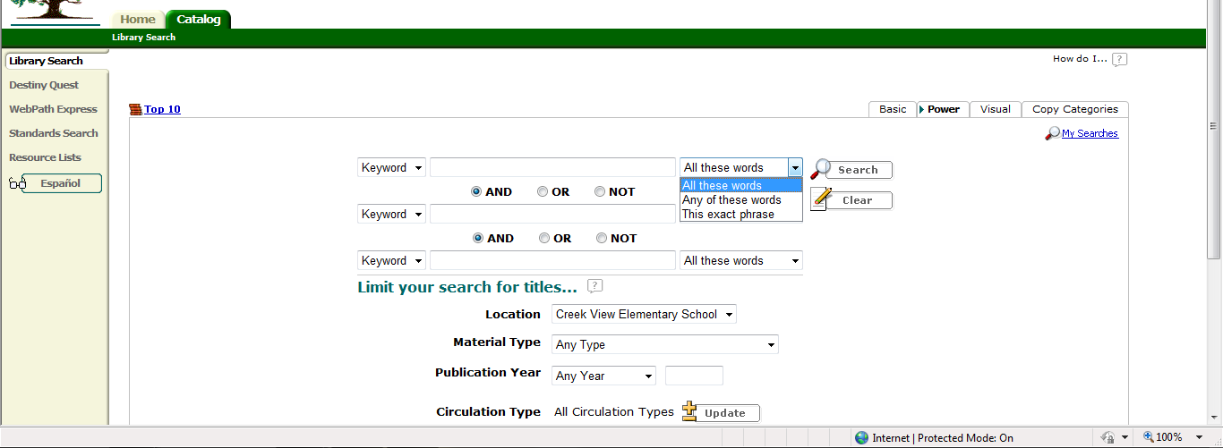

Visual Search

To perform a visual search click on a picture for a subject.
For example, to search for cats click on animals.
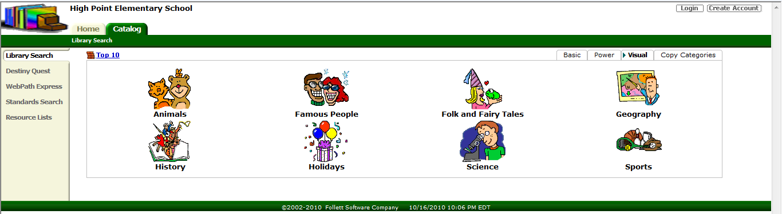
This will take you to a narrow list of animals. Click on cats.
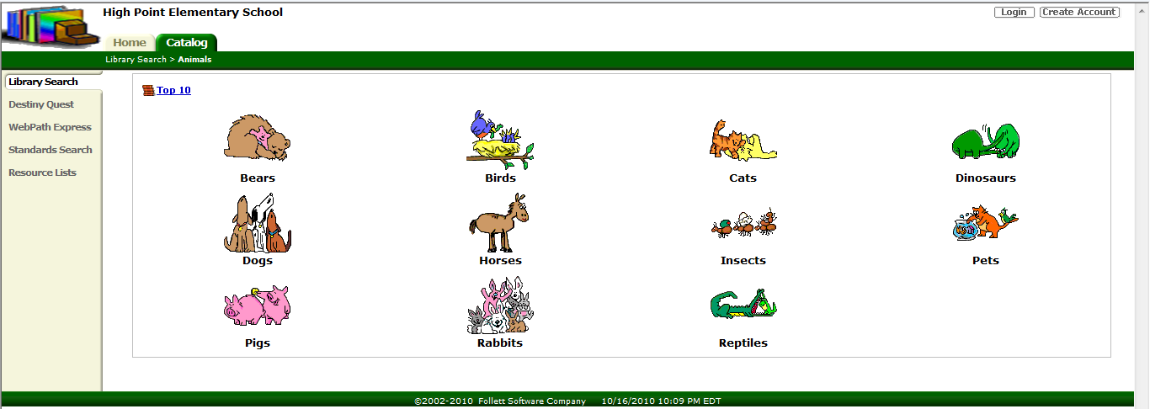
This will give you list of titles for the search term cats.
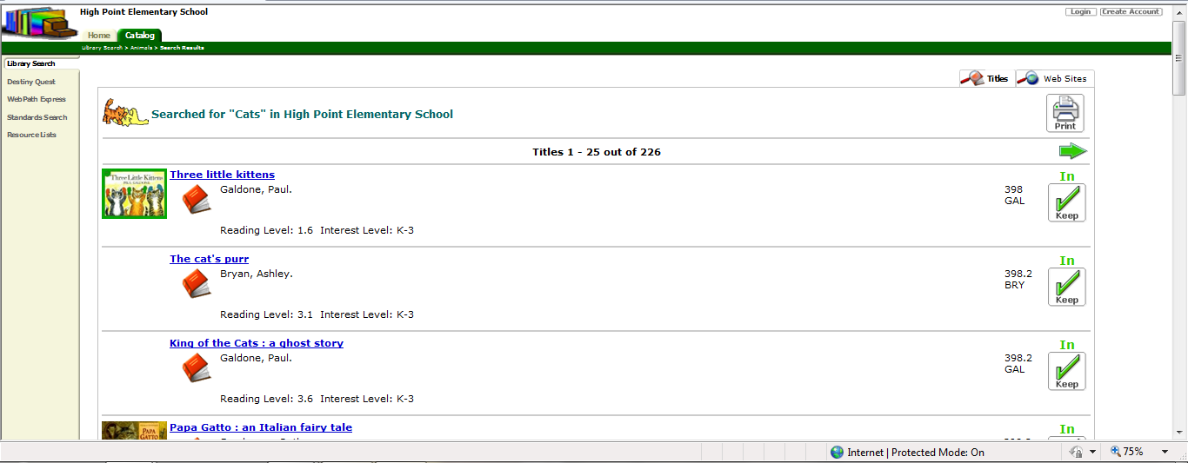

Reading an OPAC Results List

The results list will tell you what search term was used and where it was searched. Information found on this page includes:
1. total number of records found
2. how many are showing on the current page.
3. Items are listed by material type
Dewey number. All of the 000’s that are books will be listed first.
4. Title call number
5. author
6. publication year
7. reading level
8. interest level
9. This list also will let you know the availablitity of an item.
10. Lexile and Accelerated Reader Level are listed where applicable.

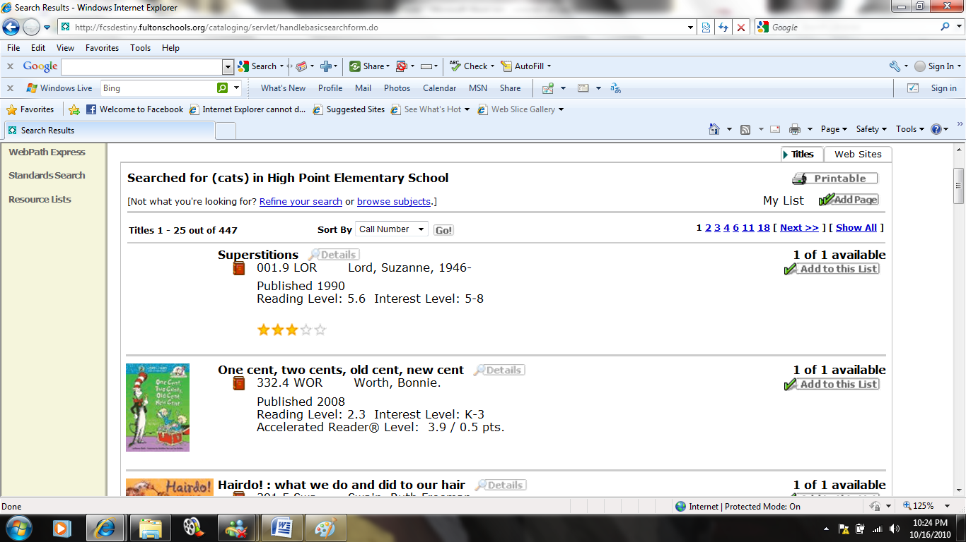

Reading an OPAC Item Record

When you click on a particular item you can view the item record. This screen includes additional information about the book. Here you can find information about how many copies are availble throughout the school district, publicaiton information, award information, locations of reviews for the item, and online resoures.

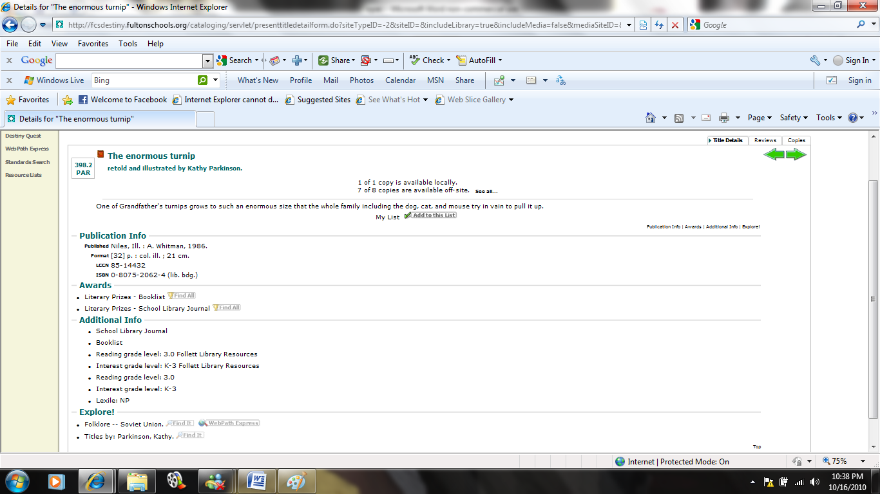
Sorting Results List
If you would like to sort your results list simply click on the arrow to show the drop down menu which will allow you to sort results by call number, title, author, date, type, status, or relevance.

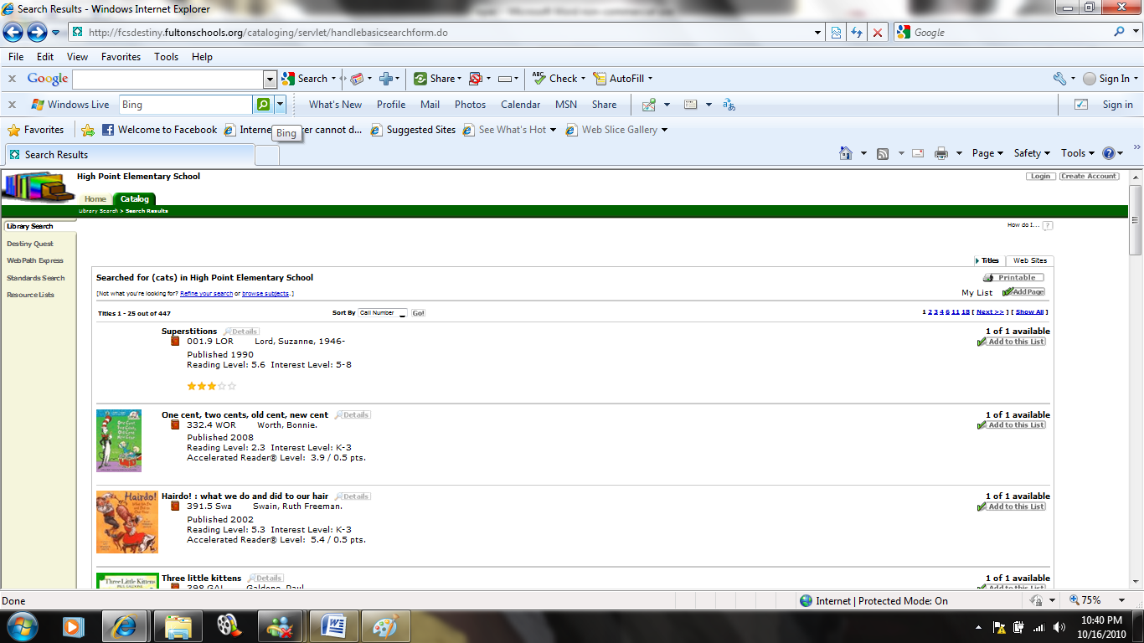

Call number will sort results by Dewey decimal number starting with the 000’s.
Title will sort results alphabetically by title.
Author will sort results alphabetically by author’s last name.
Date will sort results by publication year with the most recent year occuring first.
Type will sort results by material type.
Status will sort results by availability.

Printing a Results List
To print a resulst list simple click the printer icon next to the word printable.

This is what an unsorted results list will look like printed.
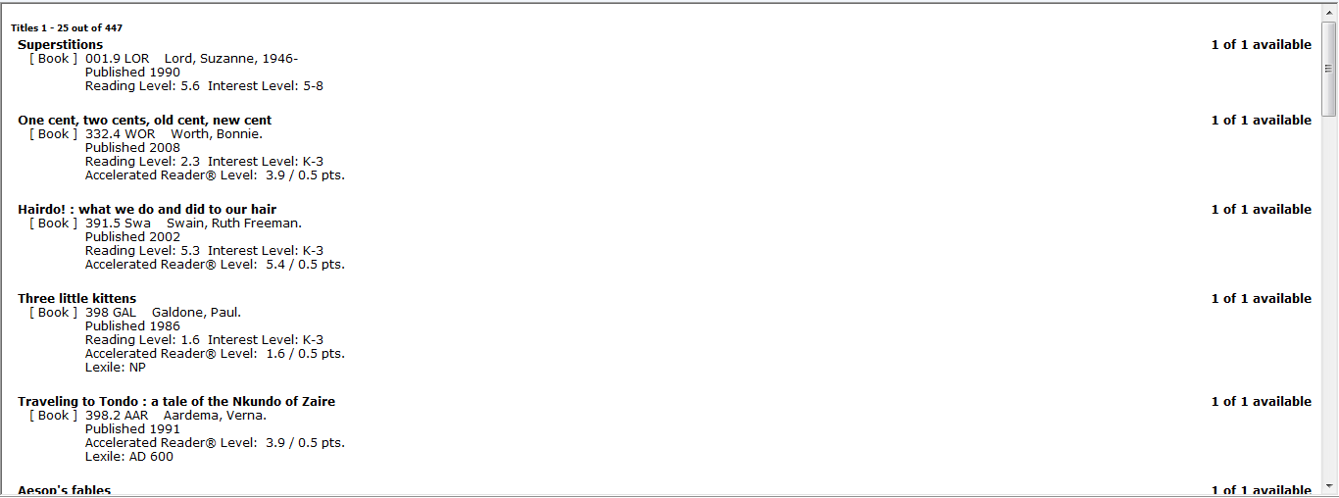
This is what a results list sorted by availability will look like.
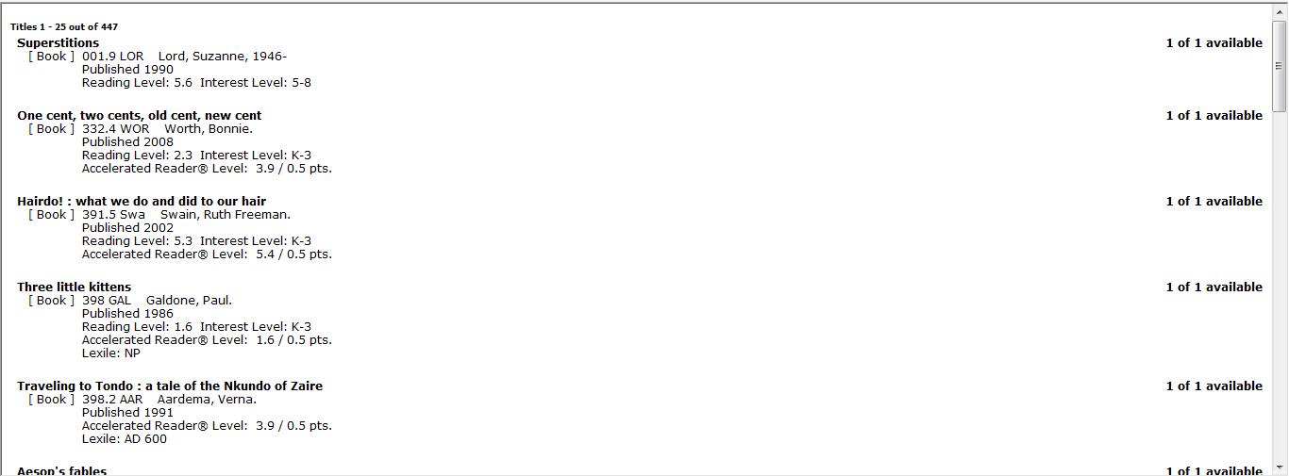
Reserving Materials Online
Reserving materials online can be done by the media specialist or by patrons if you have set up their accounts to allow those priviledges.

From the media specialist login click the green circulation tab at the top and then find Holds/ILL on the right.
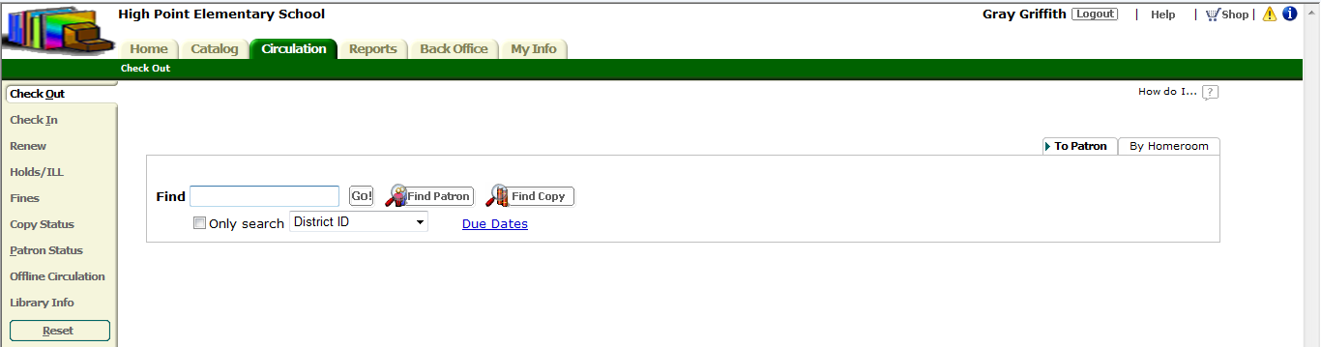

This will take you to the Holds/ILL page where you need to search for a patron by name. Click on the blue hyperlink of their name.
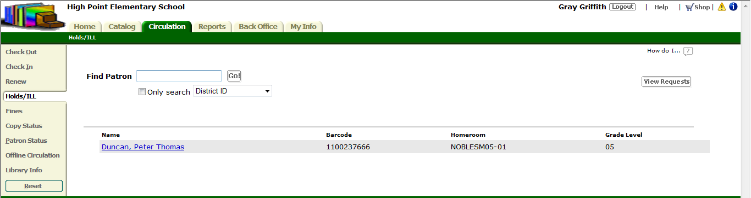

Their patron record will come up. You can see if they have any overdue materials, owe fines, or have any items already on hold. Click Add Hold in the bottom righthand corner to place an item on hold.
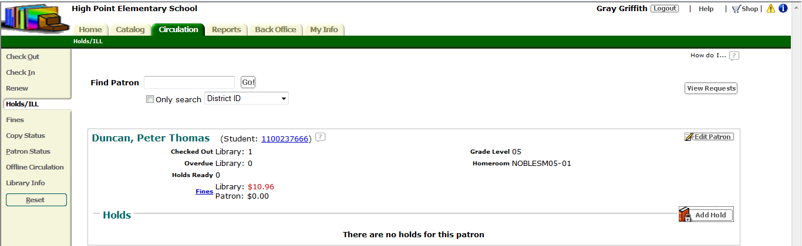

Enter title information for what the patron would like to place on hold into the Find Title search box and click Go. Find the item the patron is requesting and click Hold It.

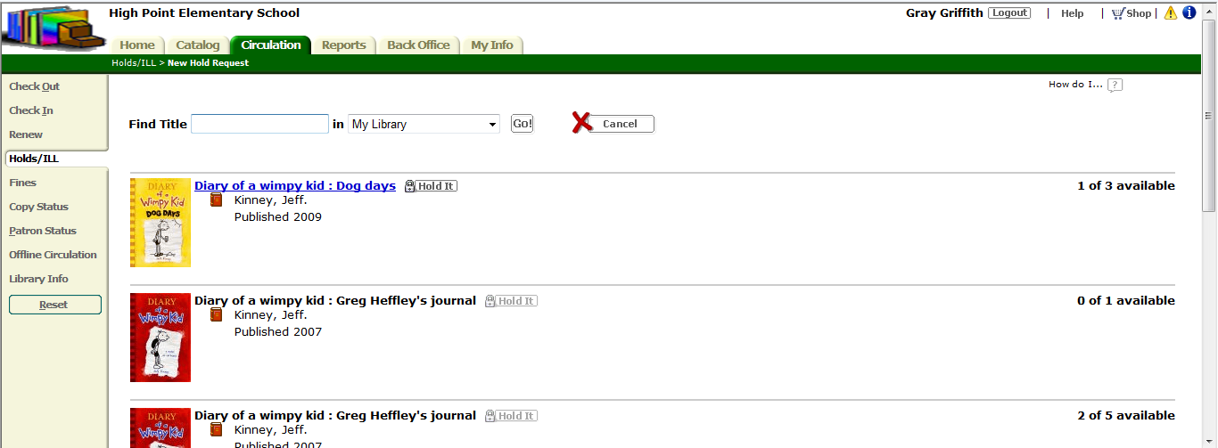

A new screen will come up verifying that the patron has requested that specific item. You can choose if they can get the item as soon as possible or enter a specific date. You can also add a priority rating, request expiration date, and copy information. You need to make sure you save the information for the materials reservation to become active.

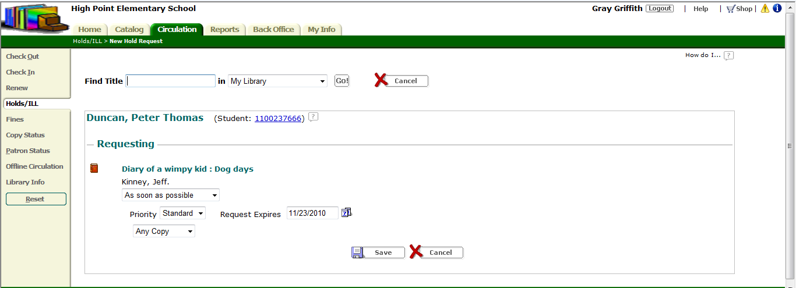

Opening the Cataloging Module
After logging on to Destiny 9.8 you will be at the home screen. To open the cataloging module simply click the green tab with the title Catalog. All of the functions that can be performed in this module are listed on the left.

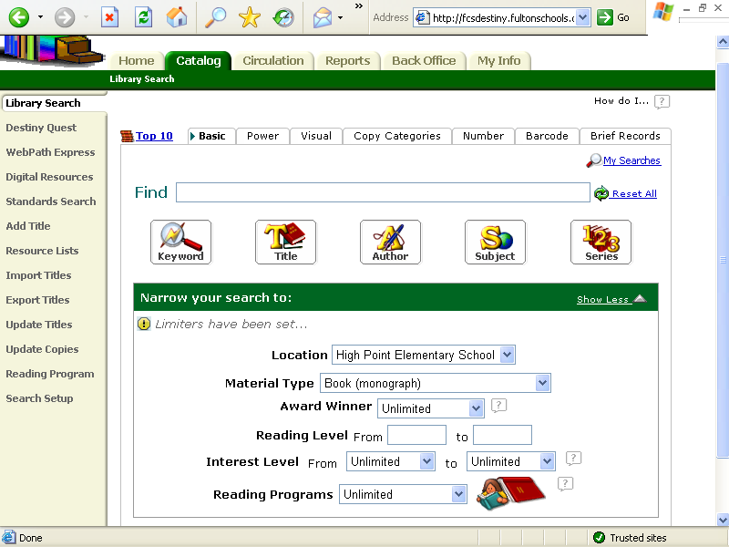
Catalog Module Functions

Section 3: Cataloging (Maintaining the Collection Database)

Setting up Material Types and Designators
Setting up material types and designators allow you to customize information about the resources you have available in your media center.
To set up material types and designators: 1) Click on the Back Office tab at the top of the page so that it is highlighted in green.
2) Find and click on library policies on the left. This will open up to the patron types page.
3) Click on the Circulation types tab next to patron types tab. Here you will add infomration about the material, how long it can be loaned for, fine information, etc.

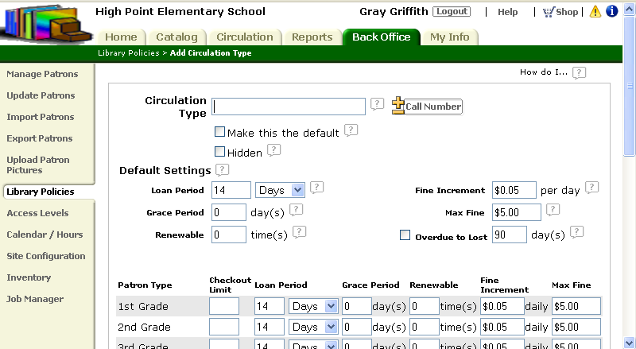
1.
2.
3.

Deleting Materials

Individual Delete
To delete an individual item from your catalog:
1) Click on the Catalog tab at the top of the page so that it is highlighted in green.
2) Find and click on update copies on the left. This will open up to the update copies page.
3) Click on the individual delete tab. Scan the barcode for the item you would like to delete or enter it manually.
4) Click Go!
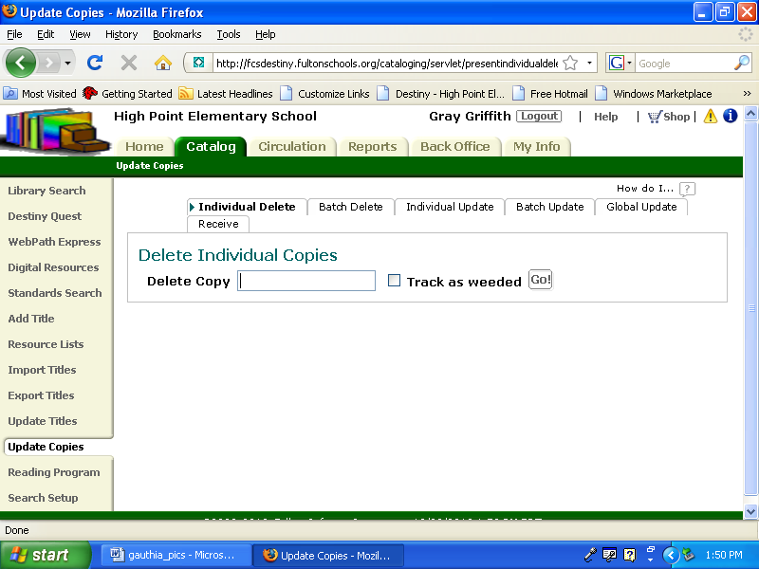
1.
2
3
4

Batch Deleting Lost or Discarded Materials
A batch delete is used when you are discarding multiple items. This type of delete can be found the same place as an individual delete. You need to go to the catalog tab, update copies screen, and then the batch delete tab. Here you will be asked to upload a file. To complete a batch delete you will have to have created a file of items that need to be deleted. Scan items to be deleted with your Follett Panther scanner and save the file to your desktop or my documents folder. You will be able to access this file via the browse button. When you have located and selected the file click update and all the items in that file will be deleted.
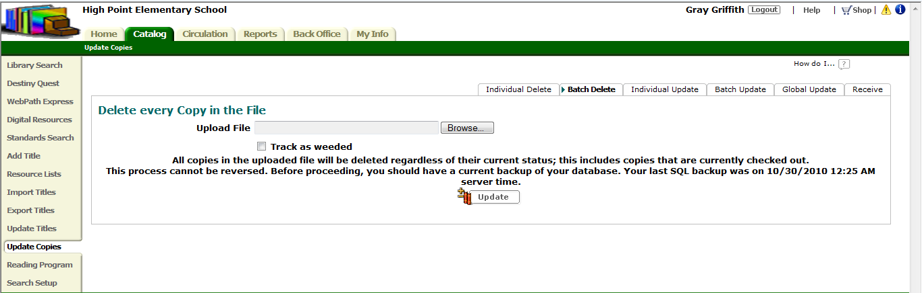

Adding Materials

Destiny 9.8 will allow you to add items to your catalog by providing easy access to other MARC records for copy cataloging or allowing you to create your own MARC record.

Manually Creating the MARC Record
Under the catalog tab open the Add Title screen. Look to the left to find Nonexistent? Add the Title hyperlink

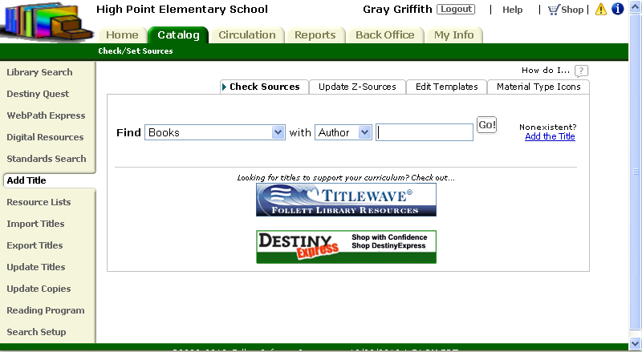

You can either choose to use the MARC Editor which looks like this:
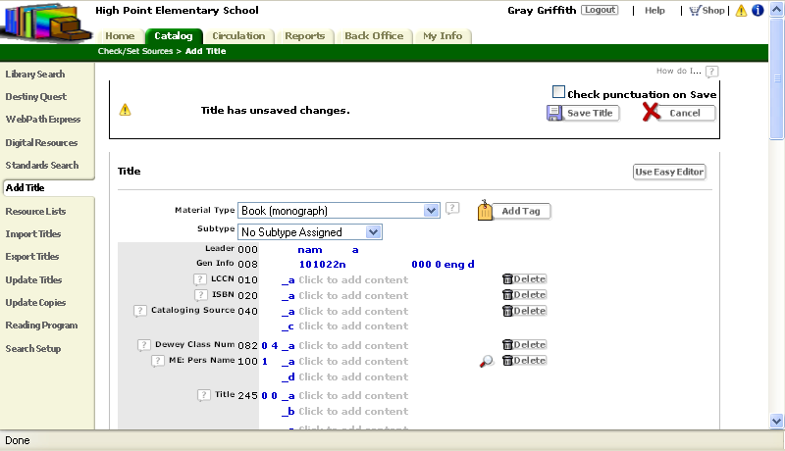
Click here to use the Easy Editor instead

Or the Easy Editor which looks like this:

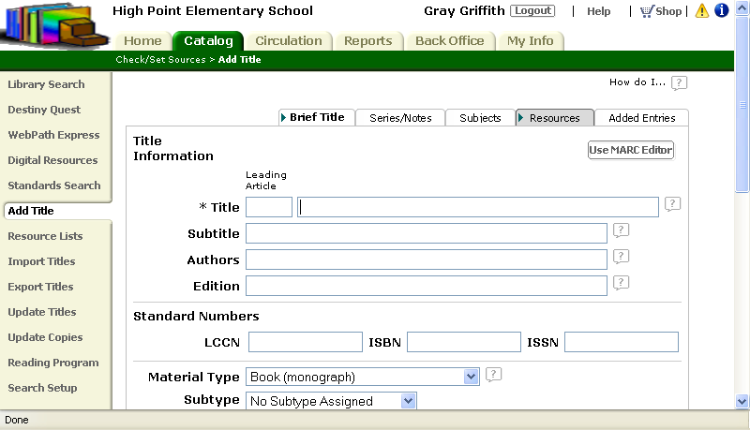
Click here to use the MARC Editor instead

The MARC Editor requires information for several different tags. The Easy Editor requires basic information about an item.

Importing Records from a Vendor or Other Source
Records can be imported or copied from other resources by searching for items within the school district database. Use the drop down menus to narrow your search for existing records.

Correcting Existing MARC Records

If you have MARC records that need to be cleaned up or corrected. Open the Catalog tab and perform a library search for a particular item. When the item record is displayed click on MARC View and then Edit Title.
1

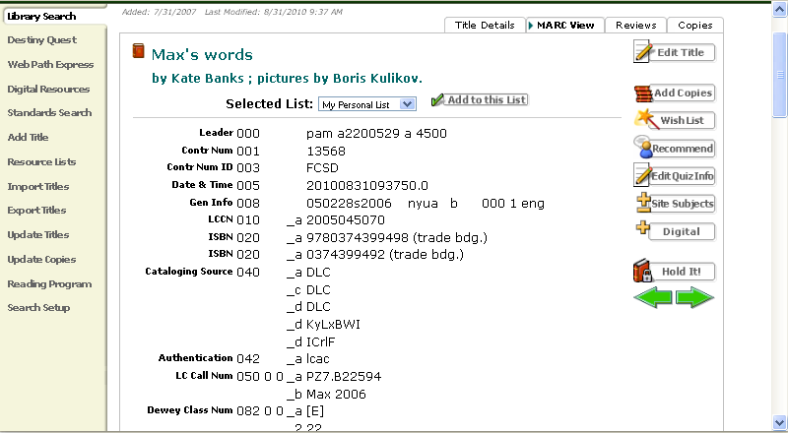
2

The MARC record will be displayed and is now editable. Information that can be edited is displayed in blue. Simply click there to change or revise information. You also have the option of deleting information by clicking on the trash cans or the word delete. Make sure you save any changes that are made to the MARC record.

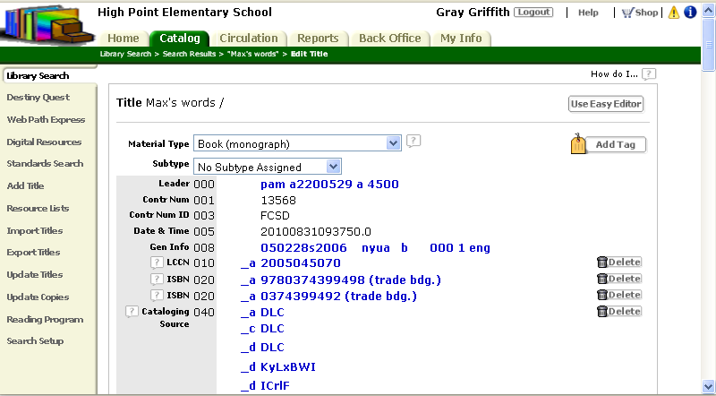
Using an Authority File for Subject Headings
When performing original cataloging you may need to refer to an authority file for subject headings. Destiny 9.8 allows you to search for Sears subject headings while creating MARC records. When using the MARC Editor, you can click on sears and several boxes will pop up. If you click on the magnifying glass with the title heading you will be taken to a search screen where you can search for authorized Sears headings.

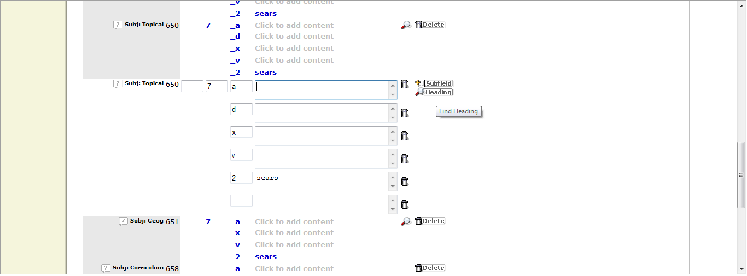
1
2

Search for Sears authorized subject headings here.
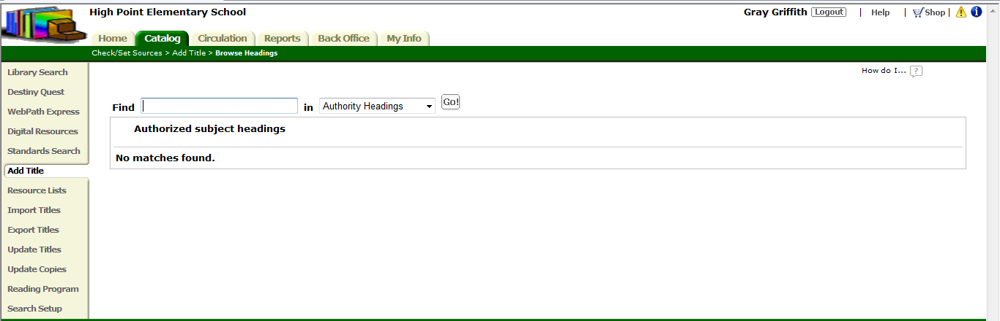

Section Four: Circulating Materials & Interlibrary Loans

Opening the Circulation Module & Using Passwords
Internet
Library Lookup (on the top tool bar)
Catalog
Login
- Enter the user name in the User Name box
- Enter the password in the Pass Word box
Login
Circulation

Checking out Materials
Circulation
Check Out
To Patron
- Enter the patron barcode number in the Find box
Find Patron
- Enter the item barcode number in the Find box or use the handheld scanner to scan the Item Barcode Number
Find Copy
If the check out was successful, the item title should appear on the Items Out section of the page.
Note: Student patron accounts can also be accessed by using the By Homeroom option by selecting the student’s homeroom teacher and then selecting the student’s name.

Checking in Materials
Circulation
Check In
- Enter the item barcode number in the Find box or use the handheld scanner to scan the Item Barcode Number
Go
If the Check In was successful, the item title should appear on the Items Checked In portion of the page.

Setting up the system so students/parents/volunteers can do limited check in and out
Back Office
Access Levels
Add New Access Level – to create an access level for volunteers or student aids
- Enter the name of the new access level to be added (Student Aid, Parent Volunteer, etc.) in the Access Level box
- Select the items that the new access level will be given access in each category under the headings Library Materials, Patrons, and General
- To allow access to check in and out, remember to select Check In Library Materials, Check Out Library Materials, and Renew Library Materials
Save

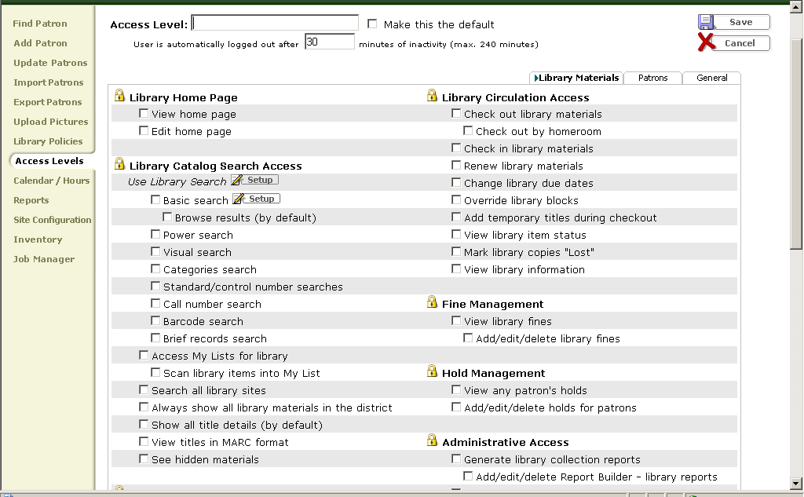
Add Access Level

Modifying due dates for special cases
Circulation
- Enter the patron’s barcode into the Find box
- Select Barcode from the pull down menu
Go – to obtain an Items Out list
Renew All - to renew all items currently checked out to the patron
OR
Renew – next to only those items for which the due date should be extended
Change Due Date
Select Date
- Enter the new due date in the Selected Date box
OR
- Use the clickable calendar to enter the new due date
- Select For this item from the pull down menu
Save
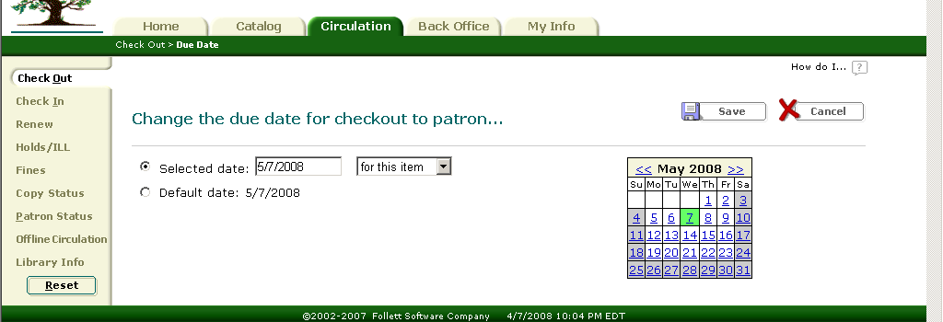

Entering fines, reserves & messages
To set up fines for Patron Type
Back Office
Library Policies
Patron Types
- Decide for which patron type fine policies are to be set
Edit
- Enter the daily monetary amount to be charged for each circulation type in the boxes under the Fine Increment column.
- Enter the maximum monetary amount to be charged for each circulation type in the boxes under the Max Fine column.
Save
If this action was successfully completed, fines will be automatically generated for overdue materials.
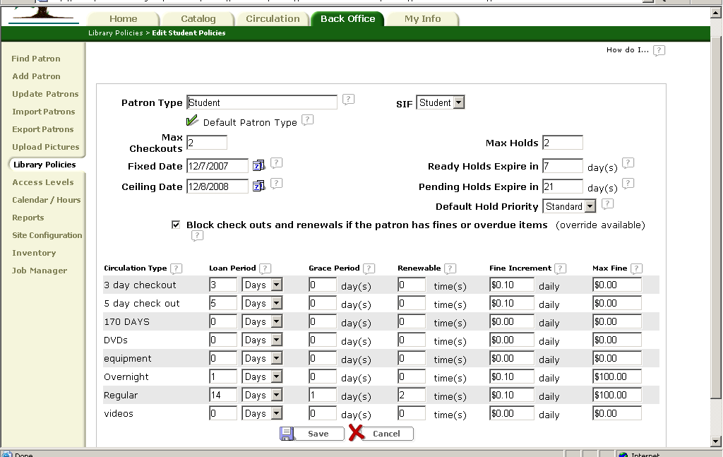

To set up fines for Circulation Type
Back Office
Library Policies
Circulation Types
- Decide for which circulation type fine policies are to be set
Edit
- Enter the daily monetary amount to be charged for each patron type for that circulation type in the boxes under the Fine Increment column.
- Enter the maximum monetary amount to be charged for each patron type for that circulation type in the boxes under the Max Fine column.
Save

If this action was successfully completed, fines will be automatically generated for overdue materials.

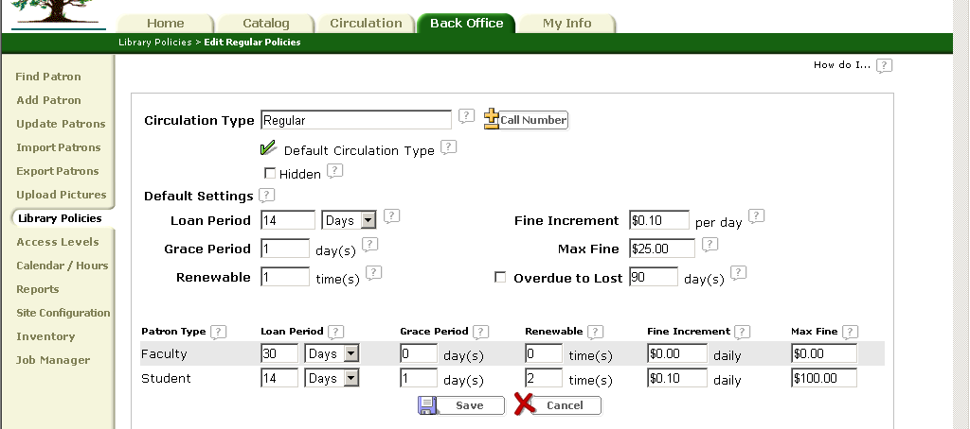

To add fines manually
Back Office
Find Patron
- Enter the patron’s barcode into the Find box
- Select Barcode from the pull down menu
Search
Add Fine
- Select the reason for the fine from the Reason pull down menu
- Enter the item barcode in the Copy box by typing it in or by scanning it in using the hand held scanner
Go – to retrieve copy information about the item including purchase price
- Enter the monetary amount to be charged in the Amount box
- Enter the monetary amount to waived in the Waive box
- Enter the monetary amount paid by the patron in the Pay box
Print Receipt – to print a receipt
Save

Looking up materials & patrons
To look up materials
Circulation
Copy Status
- Enter the item’s barcode by typing it into the Find Copy box or by scanning the barcode with the hand held scanner
Go – to obtain information such as current availability, circulation statistics, circulation type, etc.

To look up patrons
Back Office
Find Patron
- Enter the patron’s barcode into the Find box
- Select Barcode from the pull down menu
Search
View Status – to view patron’s current status, list of items currently checked out, etc.
Edit – to edit patron’s information
Delete – to delete patron from the system

Running overdue notices
Back Office
Reports
Patrons
Checked Out Materials and Unpaid Fines
- Select Overdues
- Select Individual Notices
Continue
- Select the appropriate patron type
- Select the appropriate patron status
- Select the types of overdue items to include
Continue
- Select the range of patrons to include
- Select the order of printing for the patron range
- Select the number of notices to be printed per page
- Customize the salutation and write a message if desired
- Select any additional information to be included in the notice
Run Report – to generate the list of overdue notices
Save Setup – to save the setup of this report so that a similar report can be generated in the future.
Note: Overdue notice reports can be setup create a report for email.

Printing bills, fines, receipts. Include sample print outs
To print Bills
Back Office
Reports
Patrons
Checked Out Materials and Unpaid Fines
- Select Fines
- Select Individual Notices
Continue
- Select the appropriate patron type
- Select the appropriate patron status
- Select the types of overdue items to include
Continue
- Select the range of patrons to include
- Select the order of printing for the patron range
- Select the number of notices to be printed per page
- Customize the salutation and write a message if desired
- Select any additional information to be included in the notice
Run Report – to generate the list of overdue notices
Save Setup – to save this report so that a similar report can be generated in the future.
Note: Bill reports can be setup to create a report for email.

To print Fine Notices
Back Office
Reports
Patrons
Checked Out Materials and Unpaid Fines
- Select Fines
- Select Individual Notices
Continue
- Select the appropriate patron type
- Select the appropriate patron status
- Select the types of overdue items to include
Continue
- Select the range of patrons to include
- Select the order of printing for the patron range
- Select the number of notices to be printed per page
- Customize the salutation and write a message if desired
- Select any additional information to be included in the notice
Run Report – to generate the list of overdue notices
Save Setup – to save the setup of this report so that a similar report can be generated in the future.
Note: Fine Notices reports can be setup for email.

To print Receipts
- Circulation
- Fines
- Enter the patron barcode in the Find Patron box
- Select Barcode from the pull down menu
- Select Search Only
Go
Edit Fine
- Enter the monetary amount paid by the patron towards the fine
Print Receipt
Save

Using temporary barcodes
Circulation
Check Out
To Patron
- Enter the patron barcode number in the Find box
Find Patron
Add Title
- Enter one of the available temporary barcode numbers in the Barcode box
- Attach temporary barcode card to the item
- Select Title is deleted when checked in
- Select the appropriate Circulation Type using the pull down menu
- Select the appropriate Material Type using the pull down menu
Save
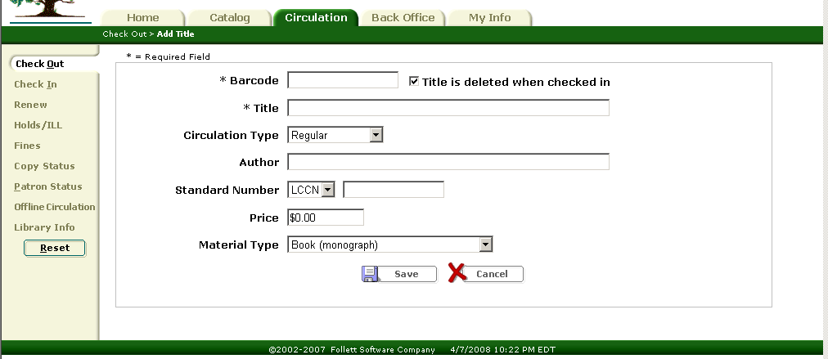
Figure 4.4: Add Title

Looking up circulation logs

To Look Up Circulation Log for a Single Item
Circulation
Copy Status
- Enter the item barcode into the Find box by typing it or by scanning it using the hand held scanner
Go – to obtain the copy status of the specified item
View History – to obtain the circulation history of the item

To Look Up Circulation Log for a Single Patron
Back Office
Find Patron
- Enter the patron barcode into the Find box
- Select Barcode on the pull down menu
Search – to obtain patron information of the specified patron
View Status
View History – to obtain the circulation history of the patron
Doing Interlibrary Loans

Our district is not set up for the interlibrary loan option. However, we follow this procedure to make interlibrary loans for teachers:
Circulation
Check Out
- Uncheck the "My School Only" option
- Search the district catalog for item needed
- Communicate by email with the appropriate school to borrow item
- The item is checked out and sent to the borrowing school through school district mail
- Once at the borrowing school a temporary barcode should be made.
- Check the item out to patron

Section Five: Reports & Utilities

- Backing up the system
- Backups are conducted at District Level.
- Tips for managing your back-ups.

- Who to call: ____________________________________________________
- DISTRICT: _______________________________________________
- OPAC Tech Support:_______________________________________
www.fsc.follett.com
- Backup DAY:______________________
- Backup TIME: _____________________
- Calendar dates that conflict: (holidays, school closed, etc…..) ___________________
- Do I need to leave a computer turned on? _____
- Do I need to have storage disks available? _____
- What type: Flash CD Diskette External Drive
- What size: ______________
- Where are my backups physically stored. ___________________________
- Who I call for a restore of my system? ______________________________

- Use the Destiny Technician’s Guide to conduct your own backups.

- 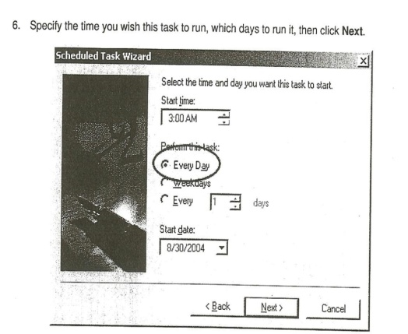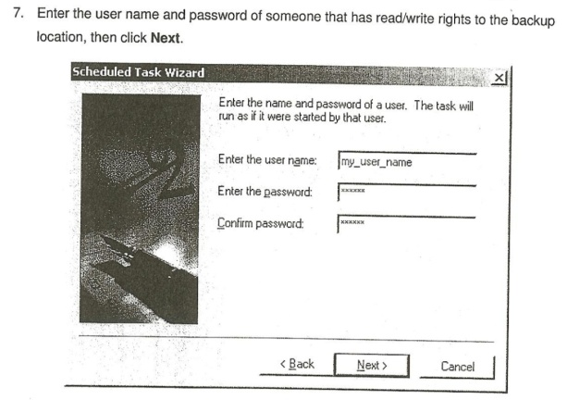
- 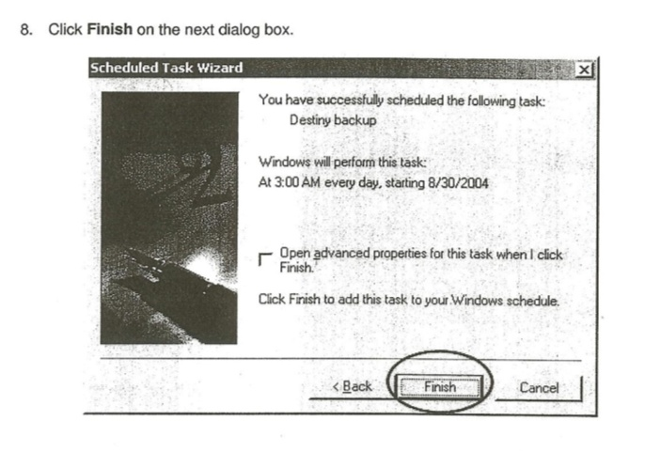
- Running circ reports (samples). Several options:
- Use the ‘Reports’ module.
- Use system reports in the Patron tab.
- Customize your reports using Report Builder.

- 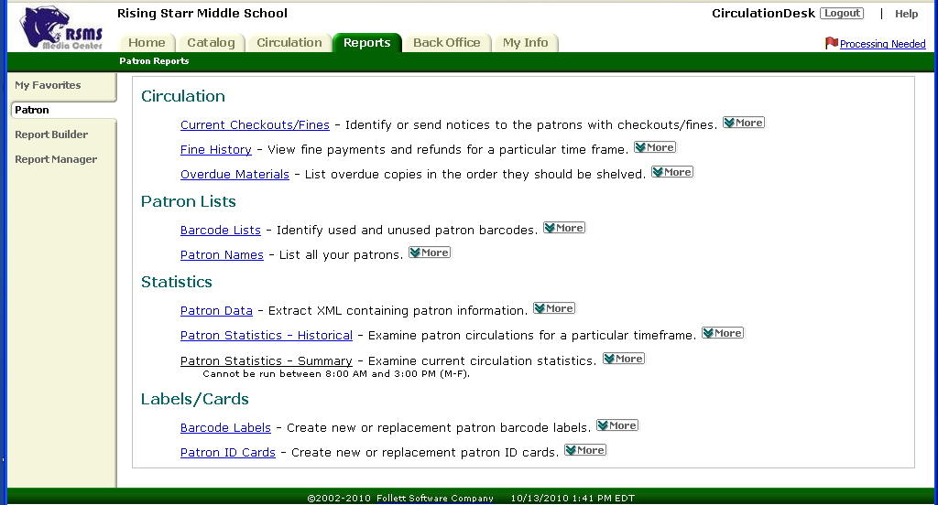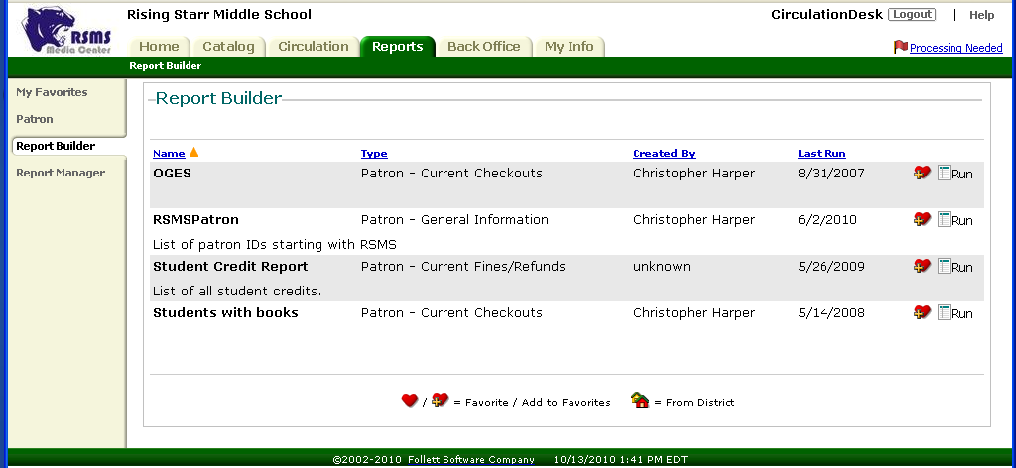

- Schedule routine running times using Report Manager.
  - Don’t schedule running times during the busiest part of the day.
  - Consider holidays and school test days as GOOD times to run recurring reports.
- SAMPLE of a Circ report looks like this.
- 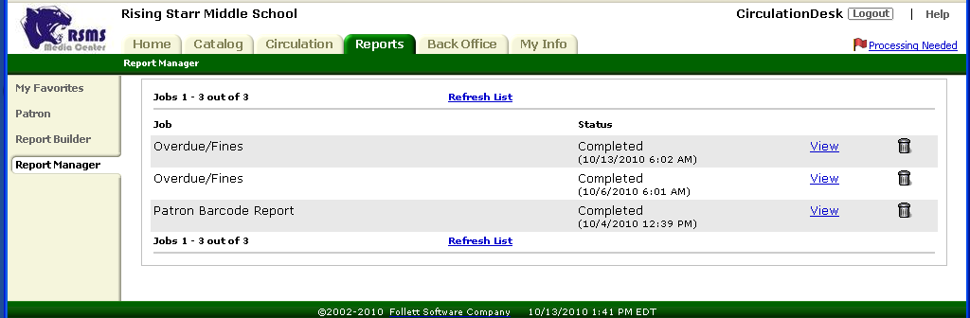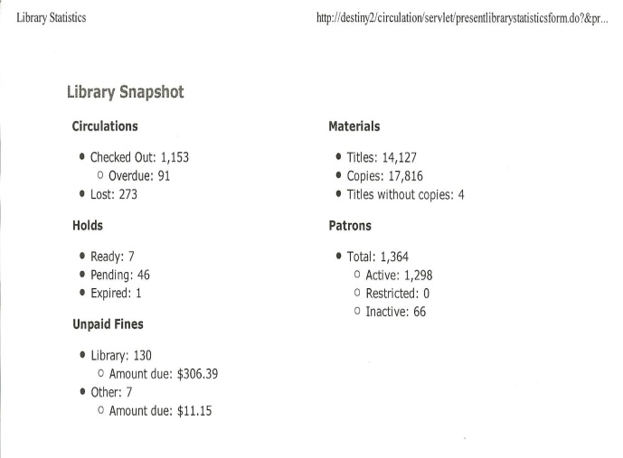
- Inventory
- Use the Destiny Online Help and Support Checklist before you start your inventory.
- When is the inventory? ________________________________
- How many days: ______________________________________
- Will the library be open or closed? _______________________
- Have you weeded your collection? _______________________
- Will you use remote scanners? __________________________ Are they charged?

- Here are samples of the checklists
- 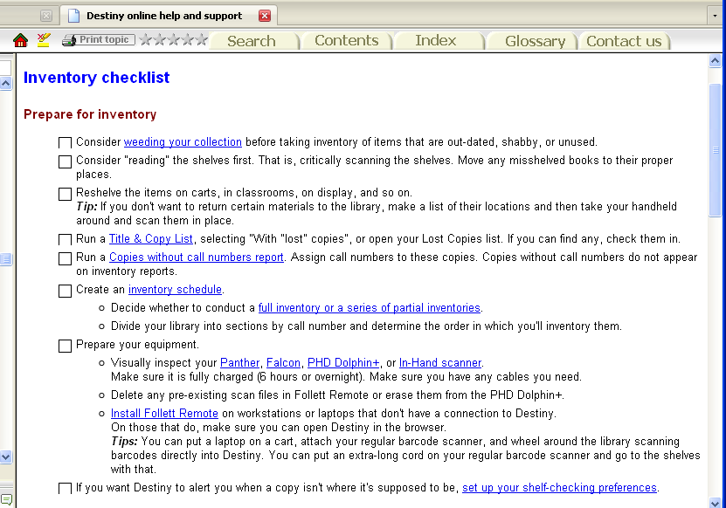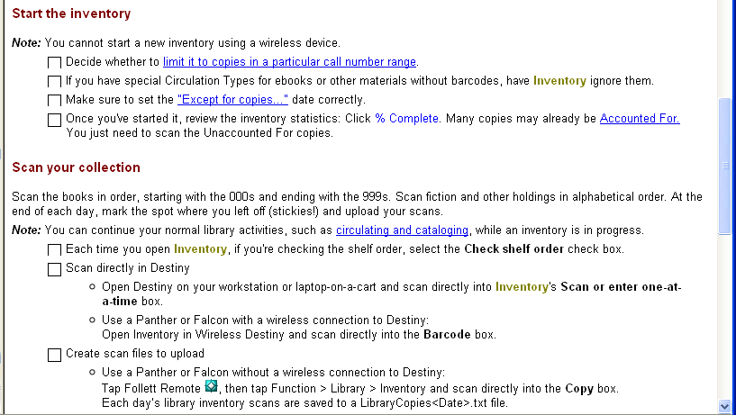

- 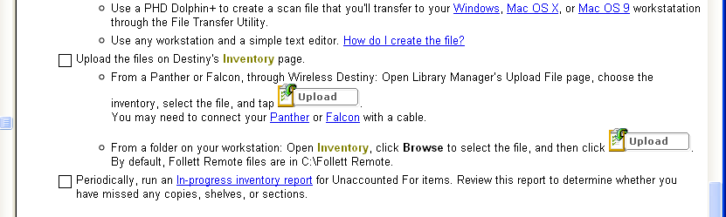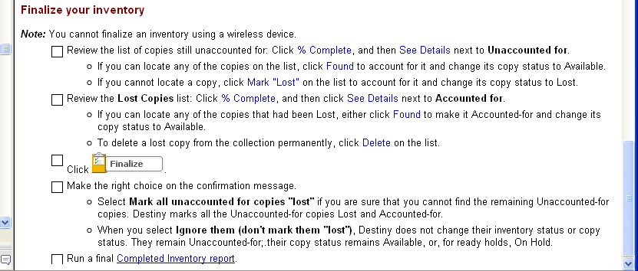

- Then from Back Office, use the ‘Inventory’ module to conduct your inventory. Notice you can have a ‘limited’ inventory selecting only certain items or spans of DDCs to inventory and you can run more than one inventory at a time.
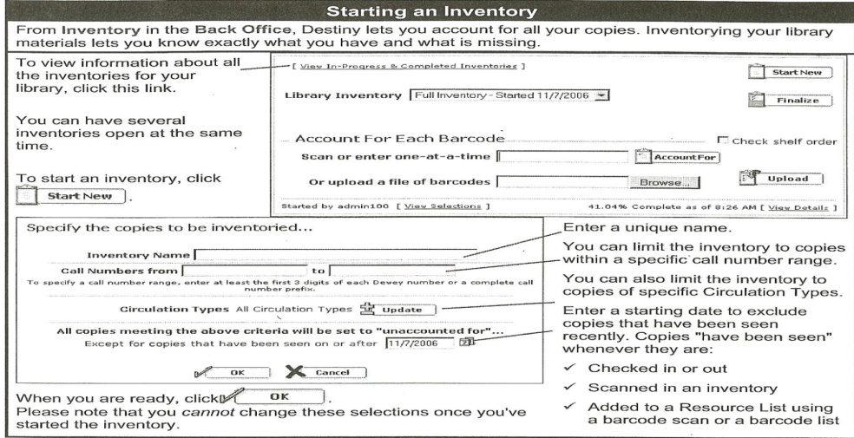
- It is possible to check books in while conducting the inventory.
- It is possible to have several inventories running at the same time.

- Shelflist (a listing of materials that can be displayed in various manners)
- Use Destiny online help and support to generate a Shelflist.
- Spot check your inventory against stacks by generating shelflists for certain sections (biographies, reference,..) at a time. Use your shelflist to generate a ‘series’ lists to help with acquisitions and ordering copies.
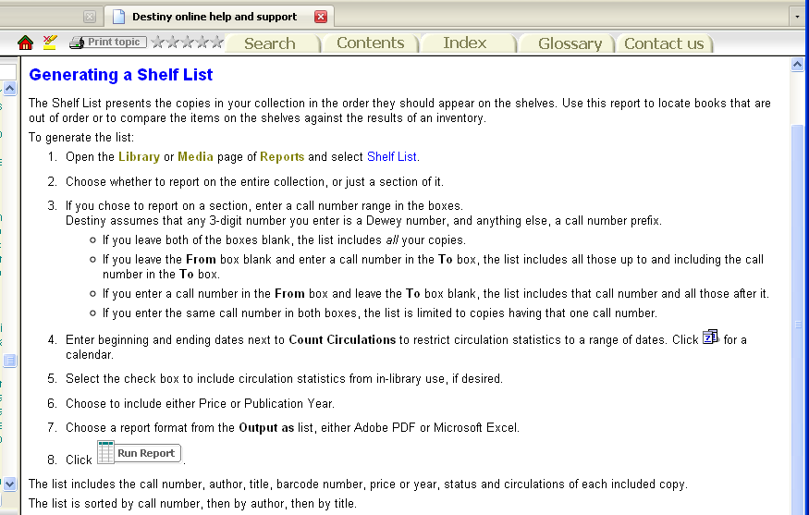

- Collection age report (sample)
- Use Destiny online help and support to generate a collection age report.
- Use the age report to consider future purchases and weeding candidates.
- Analyze your reference section for relevancy.

- 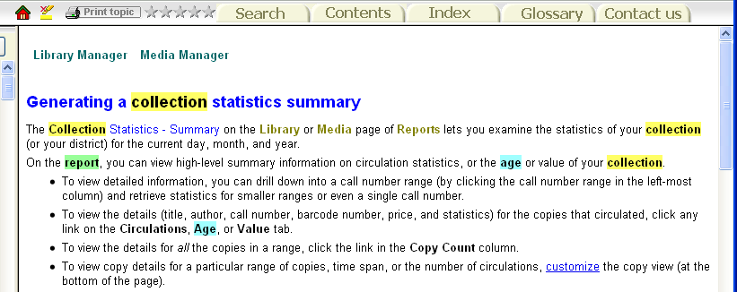

Consider a:
- Title Wise Collection Analysis 2 from www.titlewave.com gives you a collection analysis in great detail for an age comparison. Here is a Sample format:
- Collection Analysis (by 10s)
- The Hundreds Divisions Age Items % of Collection
- 000 Generalities 1996 76 0.50%
- 010 Bibliography 1997 4 0.03%
- 020 Library and Information Sciences 1996 8 0.05%
- 030 General Encyclopedic Works 1996 33 0.22%
- ……..

- Collection By Year
- Decade # of Books
- 1900 2
- 1910 3
- 1920 3
- ……
- 2000 3470
- No year given/out of range 607
- Total 15714
- Age Sensitivity
- Dewey Ranges Acceptable Items in Aged
- Age (Years) Collection
- 003-007 Systems Data/Computer Programs 3 36 34 94.44%
- 320-329 Political Science 5 93 82 88.17%
- 361-369 Social Problems and Services 5 256 240 93.75%
- 370-379 Education 5 52 44 84.62%

- Bar codes/spine labels
- Use Destiny online help and support for barcode labels.
  - Check the label sizes necessary for the barcodes.
  - Be sure to have adequate printer ink. It is hard to stop and restart the printing if you have to change ink cartridges.
  - Be sure your labels will fit every item. You may need to use smaller labels for DVDs. You can set up your barcode print parameters to print specific types of items. Then use the right size label
- 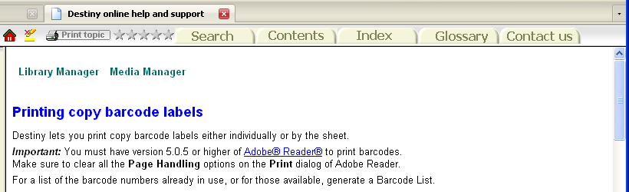

- BAR CODE and SPINE LABEL POSITIONING. Try to standardize your placement of barcodes and spine labels. It makes it much easier to read the call numbers on the shelf and to conduct an inventory.
- What labels do I need?
- Call #, AR or Lexile level, series #, foreign language, …….
- Place the barcode in an area easily accessible for inventory, and not to be confused with the ISBN barcode.
- Cover all labels/barcodes with a strong clear coverings to protect them.

- 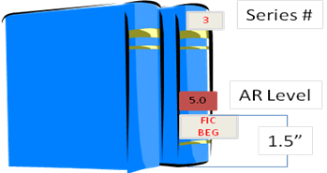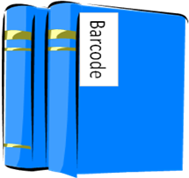
- Custom indexes (sample)

- Use Destiny online help and support for building custom indexes (reports).
- Save your recurring reports to the Favorites, or schedule them to run on a recurring basis.

- 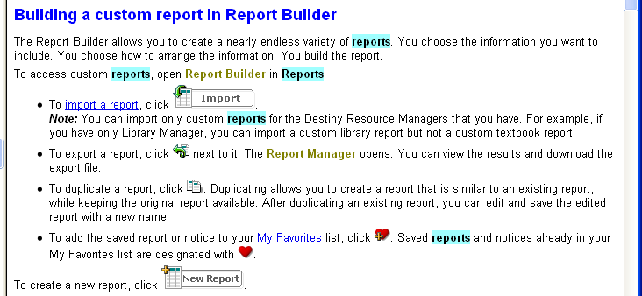

- A SAMPLE custom index of a partial inventory would look like this:

- Rising Starr Middle School
- Title Barcode Call Number Author Last Seen
- Accounted For
- Title created by Remote Circulation on RSMS32 4/22/2008
- VCR T 20 RCA/VR538 5/22/2009
- Means and probabilities : using statistics in T 18294 001.4 KRI Krieger, Melanie Jacobs. 5/19/2009
- Discovering graph secrets : experiments, T 19519 001.4 Mar Markle, Sandra. 5/19/2009
- Discovering graph secrets : experiments, T 13871 001.4 MAR Markle, Sandra. 5/19/2009
- Graphs T 12491 001.4 SMO Smoothey, Marion, 1943- 5/19/2009
- The census and America's people : T 14418 001.4 WIL Wilson, Natashya. 5/19/2009
- The abominable snowman T 20987 001.9 ANT Antonopulos, Barbara, 1947- 5/19/2009

- Unused barcode report
- Use Destiny online help and support for generating an unused barcode report or labels.
- Determine the range you want to print.
- Decide if you want the District or school name on the label list also.
- How many will you need?

- 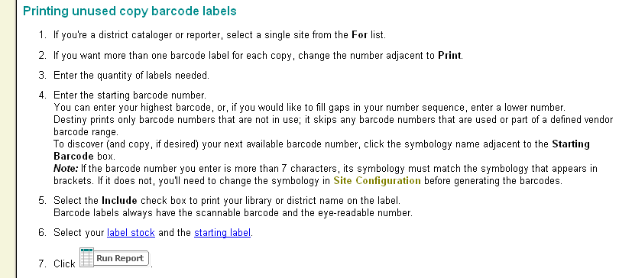
- IF barcodes numbers are issued by DISTRICT:

  - What do the numbers mean.
  - How do I get more numbers.
  - How can I reuse numbers.
  - Are there any temporary barcode numbers?.

- Diagram of a barcode:
  - 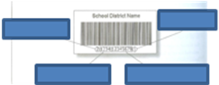

- Rebuilding the system from backup
- Use your Destiny Technician Guide to Restore your Site Database.

  - Coordinate with DISTRICT
  - Be sure to write down the date of the information being restored.
  - Make a list of all actions that have happened since that date that you may have to recreate.
- An example of the restore function from the Technical Guide:

- 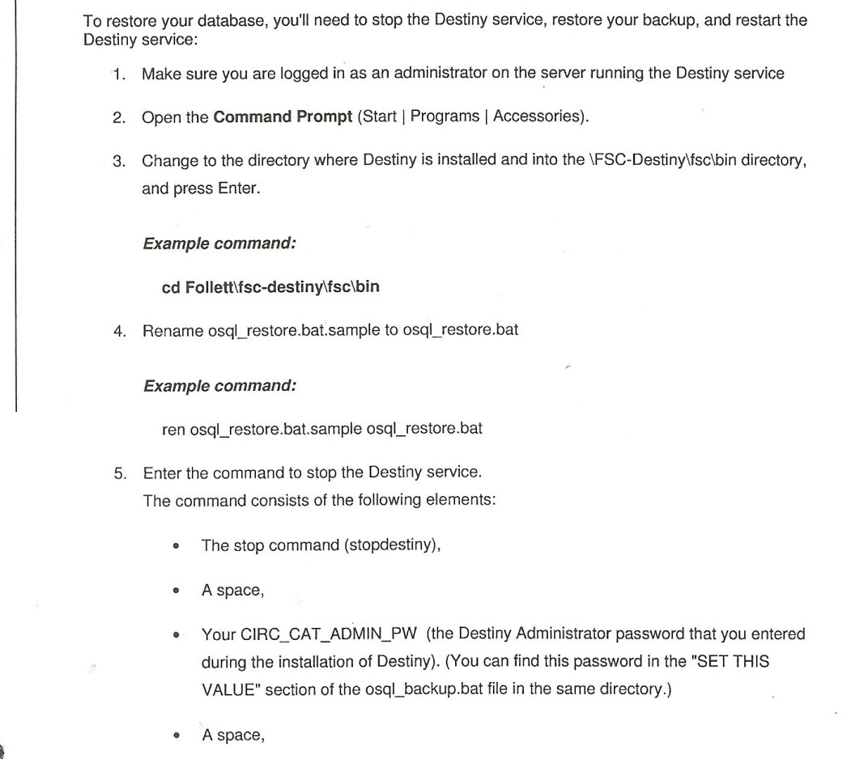
- Run the restore function.
- Double check your results.
- Determine what other information must be added.

- Section Six: Troubleshooting. Destiny provides 2 sources of help. (1) On-page help and (2) on-line help

- 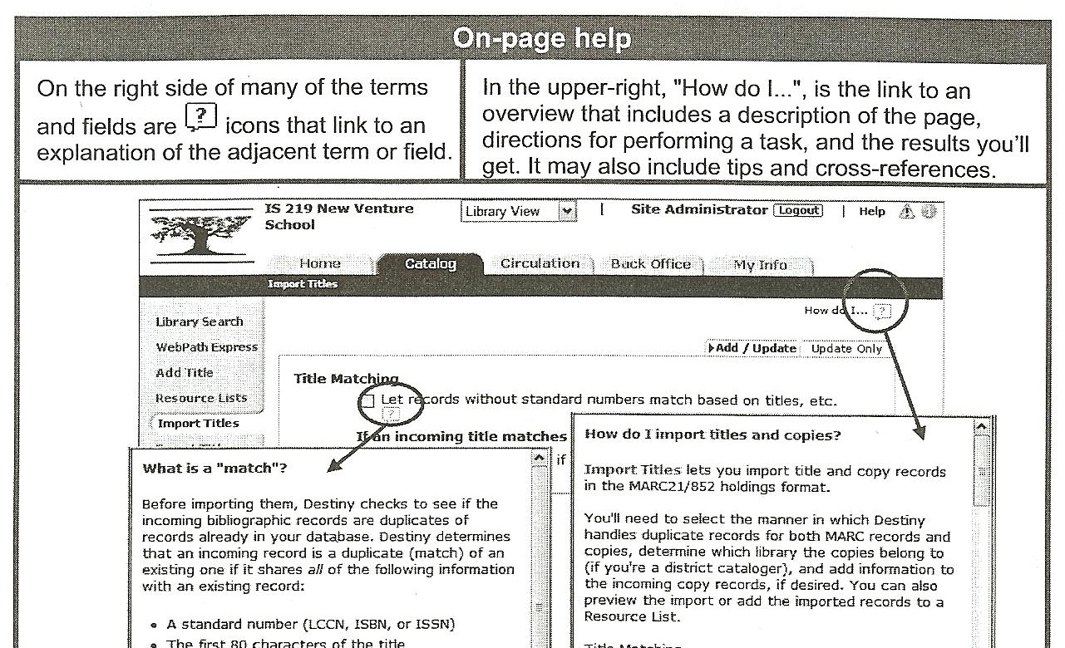

- 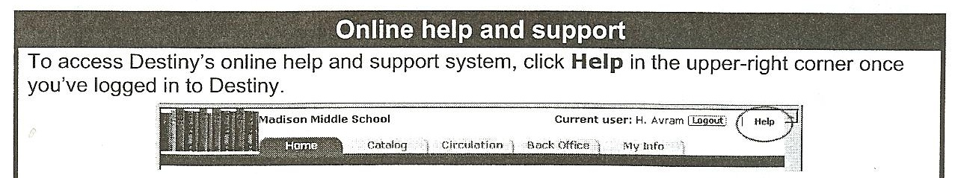

- Destiny online help. Type in what you are looking for, future options help narrow down your search.

- 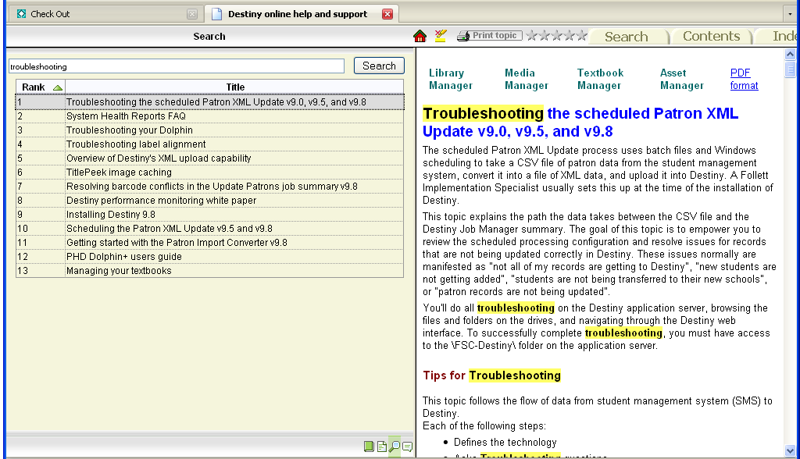

- Trouble with AR. Consider these options if you are having trouble with AR.
- Go to the Reading Program Services (RPS) and recheck your configuration settings.
- 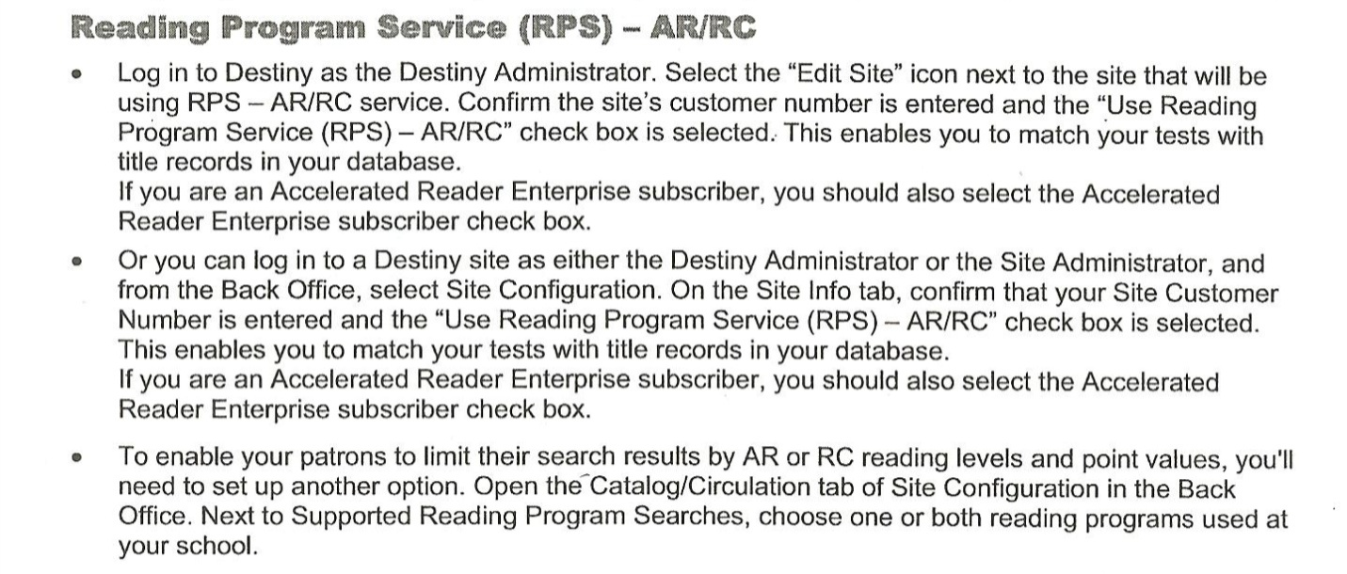
- Check the quizzes and titles.
- 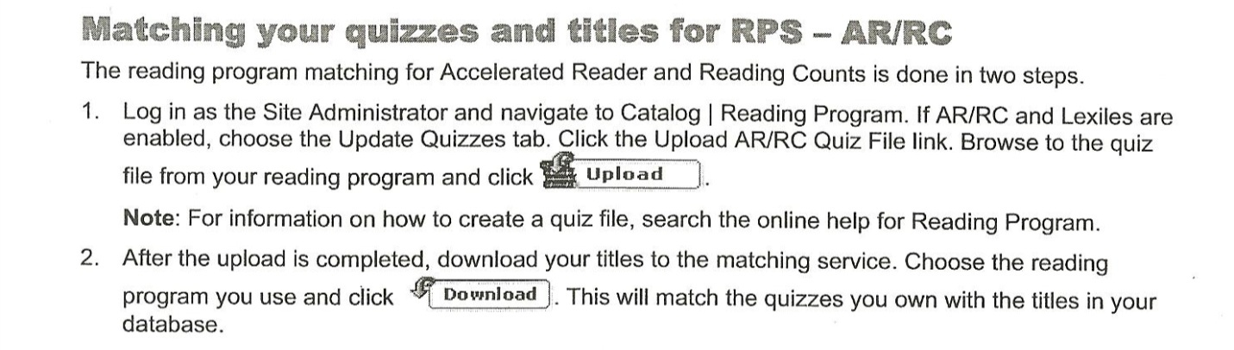
- Check Job Manager and look at Reading Program reports.
- 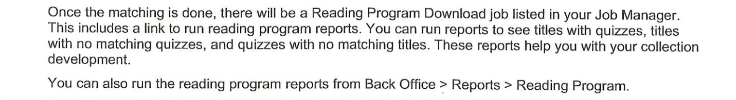
- If AR is OK, check Patron data.
- Are they authorized AR access?
- Are they using the correct password?
- 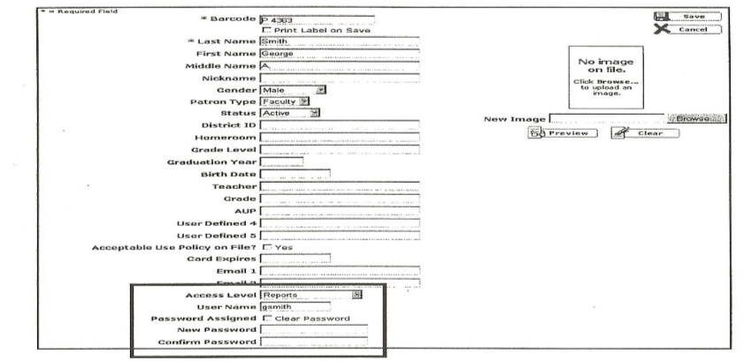
- CALL CALL CALL
- Know your Tech Support by first name.
- Keep a Troubleshooting Log
- Don’t forget to blog! Everyone in your DISTRICT has the same issues.
  - 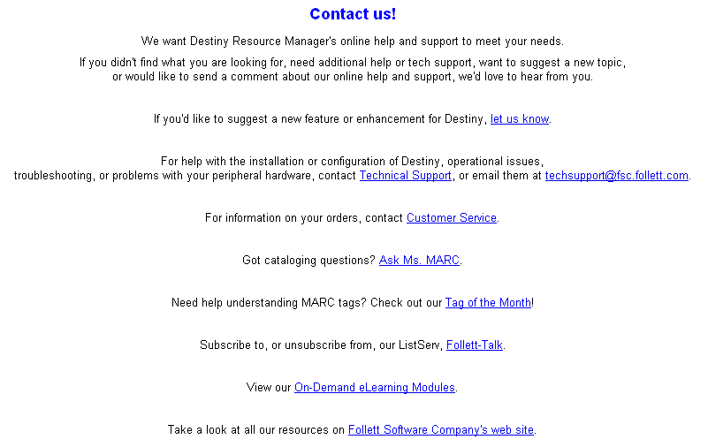

Collaboration resources

Interlibrary Loan Procedures
Other schools in Pretend County may request to borrow print materials from Clarksville Elementary. Media specialists, teachers, or students will need to give their patron ID number so that items can be checked out in their name. They will be allowed a three week checkout period. Items will be send via school mail. Reference items are not allowed to be loaned out to other schools. Award titles or other popular books may not be loaned out if they are in heavy circulation at Clarksville.

Reconsideration of Materials Procedures

The following procedures shall be followed when there is a request for reconsideration of any instructional materials:
1. The patron expresses concern in a meeting with the media specialist, teacher and/or principal.
a. Patron* is given an opportunity to express concern and ask questions regarding the material.
b. The patron filing a request for reconsideration of material must be the parent of a student in the school where the request is filed.
c. The patron is informed of procedures for filing a request for reconsideration of material.
d. If desired, the patron is given a copy of the "Request for Reconsideration of Instructional Materials."
e. Initial reconsideration for materials adopted at the system level for use districtwide will be made by the System Level Media Committee. The procedures for this process begin in item #7.
- For the purpose of this procedure, "patron" is defined as a parent or legal custodian of a student enrolled in a Fulton County school.
2. When the completed "Request for Reconsideration of Instructional Materials" is returned, a copy is filed in the principal's office and with the Coordinator of Media Services.
3. When a "Request for Reconsideration of Instructional Materials" is filed ,the Local School Media Committee will be expanded to include an equal number of parents and school personnel. A majority* of the members of the expanded committee must be present to consider a request for reconsideration.
4. The expanded Local School Media Committee is informed of the request and proceeds, as soon as possible, to read/view the material in question. Response will occur within 25 working days from the date of the formal written request for reconsideration.
5. After all members have read/viewed the materials, the committee will meet to discuss the request and make a decision as to what action will be taken. The patron may appear at the committee meeting to explain the reason for the objection to the material.
6. Upon the decision of the committee, a letter stating the decision and its rationale shall be written and mailed by certified mail to the patron within five working days. The letter is sent under the school principal's signature.
7. If the patron is dissatisfied with the local school's decision, a letter requesting system level reconsideration may be sent to the Associate Superintendent for Instructional Services. This request must be sent within 10 working days following the receipt of the letter stating the local school's decision.
8. Upon receipt of the patron's letter, the Associate Superintendent for Instructional Services will notify the Coordinator of Media Services, who will inform the System Level Media Committee of the request.
9. When a "Request for Reconsideration of Instructional Materials" is being considered at the system level, the System Level Media Committee will be expanded to include an equal number of parents and school personnel. These parents shall be designated by school level (elementary, middle, and high) for representation on the committee for one year. When a request for reconsideration is filed, members selected from the appropriate school level will become members of the expanded committee.
10. A majority of the members of the expanded committee must be present to render a decision regarding a request for reconsideration. If a majority of the committee is unable, after the second attempt, to schedule a time for the meeting within the required time frame, the chairman of the committee may appeal to the Associate Superintendent for Instructional Services for an extension beyond the required 20-day time frame.
*For the purpose of this procedure, a majority is defined as any number larger than half of the total.
12. The committee will render a decision regarding what action is to be taken within 20 working days or 30 working days if an extension has been approved. The patron may appear at the committee meeting to explain the reason for the objection to the material.
13. A certified letter will be sent with committee’s decision within five working days of the committee's meeting. A copy of the letter is also sent to the offices of the Associate Superintendent for Instructional Services, the Coordinator of Media Services, the Superintendent and the School Board. (Adapted from Fulton County Media Specialist Handbook)

Scheduling of the LMC

Teachers have access the media center sign in book in the media center and online. The media specialist checks the sign up book in the media center daily and updates the online sign in book accordingly. In the event of a conflict the media specialist will contact both teachers to work something out. Teachers may sign up for one time block a week. If there are additional time slots available on the Monday of that week they can sign up for an additional slot. When scheduling a media center visit teachers must indicate what grade they teach and what they plan on doing when in the media center. Teachers should notify the media specialist at least one week in advance if they want a lesson taught. Collaborative lessons can be planned on an individual basis with the media center. The first two weeks of school the media center is open for orientation and limited checkout. Students are allowed to check out materials after their class has had the orientation.

Paraprofessionals and Volunteers Duties

Paraprofessionals perform duties assigned by the media specialist. Sometimes parent volunteers can assist media staff with tasks in and around the media center duties. All volunteers are required to sign in and out of the front office.
Paraprofessional duties include:
-Checking materials in and out for patrons
-Sorting and reshelving items
- Assist with inventory
-Maintain media center bulletin boards
-Assist with public relations
-Monitor students in media center
-Collect fines for overdue or lost items
-Assist patrons as necessary
-Assist the media specialist in processing new materials

Volunteer duties include:
-Preparing Accelerated Reader books for shelf
-Assist with creating displays
-Sorting and reshelving items

Floor Plans, Maps, Diagrams

Sample Floor Plan Before

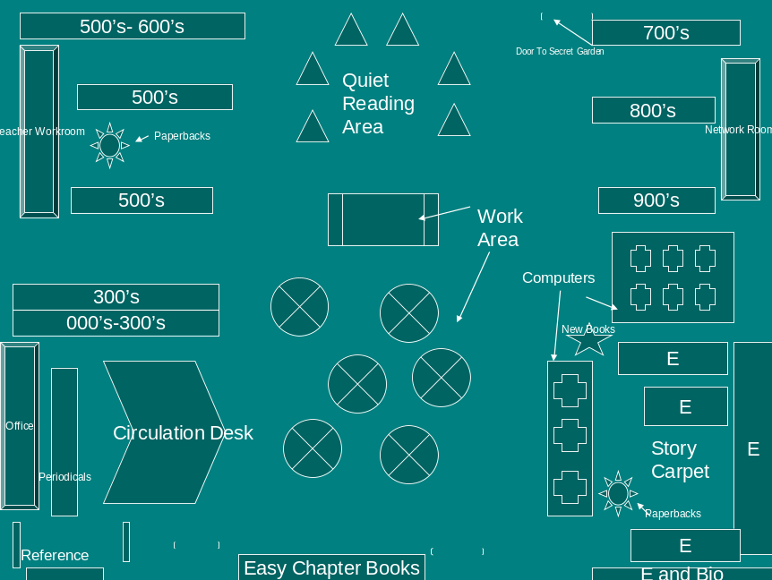

Sample Floor Plan After

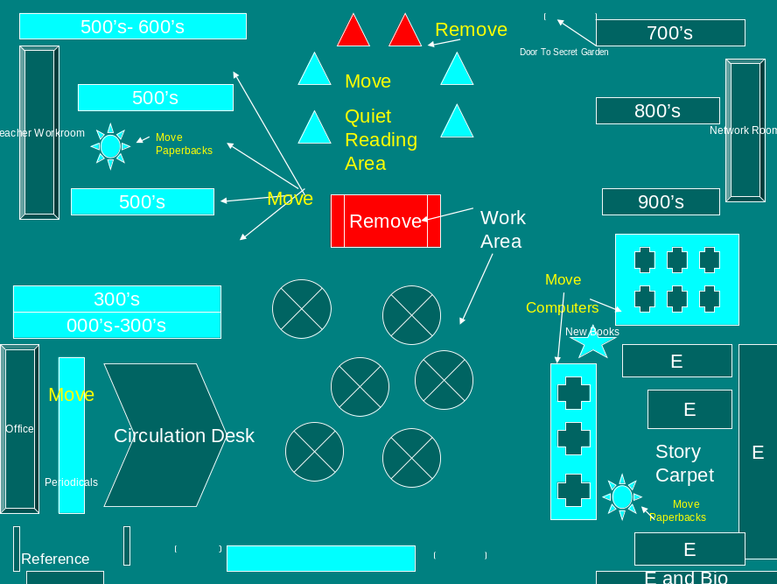

Appendix A

Clarksville Elementary Media Center Activities
2008-2009

August | Media Center Orientations
September | Author Visit
October | Book Character Dress Up Day/Read-In
November | School Media Festival
December | Winter Scholastic Book Fair
January | Begin the Year With Books
February | District Media Festival
March | Spring Scholastic Book Fair
April | National Library Week (April 12-18)  Theme: "Worlds connect @ your library."
May | Children’s Book Week (May 11-17)  End of Year AR Celebration

Appendix B

Atlanta Public Schools Criteria for Selection of Materials

- Selection criteria for materials shall reflect nationally recognized and approved professional standards.

- The criteria shall support the general educational goals of the Atlanta Public Schools and objectives of specific courses.

- Media specialists, teachers, staff, and public shall be given the opportunity to examine new materials and equipment through planned exhibits. Equipment purchases, such as overheads, laptops, carts, and LCD projectors, are made based on the need of the school. New equipment must be able to be used with existing wiring and connection. It must also be comparable to the latest technology.

- Materials selected shall support the curriculum and meet high standards of quality in factual content and presentation.

- Materials chosen shall have aesthetic, social or literary value.

- Materials shall appropriate to the subject area and to the ages, abilities, social, and emotional development of students whom selected.

- Materials selected shall be the work of competent, qualified, and accredited authors and producers.

- Materials shall foster respect for all groups and highlight their various contributions to society.

- Materials selected shall include various historical and contemporary forces that contribute to life in America today, from an impartial nonjudgmental pint of view.

- Selection of materials shall be predicated on their strengths rather than their weaknesses.

- Materials on controversial issues shall be selected with care to insure a balanced representation of varying points.

Adapted from Atlanta Public Schools Handbook of Media Specialists

Appendix C

Book Request Form

Name ______________________________________________

Title of Book ________________________________________

Author _____________________________________________

Illustrator __________________________________________

Genre ______________________________________________

ISBN _______________________________________________

Publisher ___________________________________________

Date of Publication ___________________________________

Additional Comments of Information ___________________

___________________________________________________

____________________________________________________

____________________________________________________

Adapted from the Book Request form created by the Edsel Ford Memorial Library at The Hotchkiss School
Appendix D

Star Suggestion Form

Name of Book:

Author:

Illustrator:

Other Important Information:

I think we need this book in our library because:

Star Suggestion Form

Name of Book:

Author:

Illustrator:

Other Important Information:

I think we need this book in our library because:

Copyright© Stephanie Gauthia 2008

Appendix E

PURCHASE ORDER NUMBER: 1763457

SCHOOL: Slater Elementary
Vendor: Heimann-Raintree
Address: 6277 Sea Harbor Dr., 5th Fl
City: Orlando
State: FloridaZip Code: 32887
Phone:888-454-2279Fax: 888-844-5329

SHIP TO:
Slater Elementary
1320 Pryor Rd.
Atlanta, Ga 30315
Phone: 404-802-4050

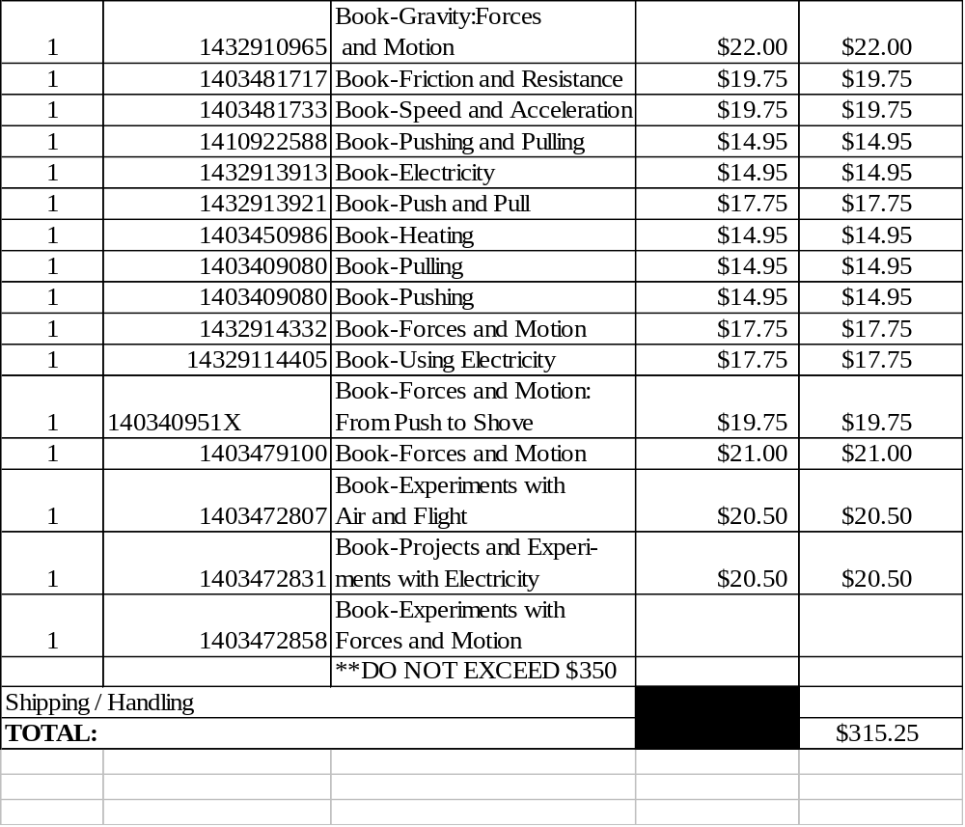
TEACHER NAME: Shondria Anthony-Nolan

Appendix F

Library Media Center Collaborative Planning Form

Teacher’s Name __________________Subject Area __________Grade Level ______

Lesson/Unit Topic _____________________________________________________________________

Students’ Final Product ________________________________________________________________

Dates Lesson/Unit will be taught ___________Assessment Date ______________

Essential Question ____________________________________________________________________

Georgia Performance Standards to be covered: ___________________________________________

Information Literacy/Technology Standards to be covered: __________________________________

What types of resources are you requiring your students to use? (DISCUS, Internet, reference books, magazines, etc.) _______________________________________________________________________

Which Information Literacy and/or Technology Skills would you like for me to work on with your students? (email, plagiarism, Internet search skills, word processing, PowerPoint, website evaluation, using graphic organizers, library orientation, source citation, etc.) ________________________________________________________________________________________________________________________________________________

Please attach any lesson plans, handouts, rubrics or other information to this sheet.

List any notes or questions here: ________________________________________________________________________
________________________________________________________________________
Role of Media Specialist: _______________________________________________________________
________________________________________________________________________

Role of Classroom Teacher: _______________________________________________________________________
________________________________________________________________________

Evaluation:
What worked: ________________________________________________________________________
________________________________________________________________________

What we would change next time: ________________________________________________________________________
________________________________________________________________________

Appendix G

Adapted From Fulton County School Media Specialist Handbook
 MEDIA SERVICES DEPARTMENT

REQUEST FOR REVIEW OF RECONSIDERATION OF INSTRUCTIONAL MATERIALS

SCHOOL:_____________________________ DATE: ______________________

NAME OF TEACHER USING THIS MATERIAL:_____________________________________________

CLASS IN WHICH USED:__________________________________________________________________

PRINCIPAL:_____________________________________________________________

PLEASE CHECK TYPE OF MATERIAL:

______ Book ______ Compact Disc
______ Periodical ______ Cassette, Audio
______ Pamphlet ______ Cassette, Video
______ Recording ______ Laser Disc
______ Kit ______ Other (Please specify)

Title:______________________________________________
Author:____________________________________________
Publisher or Producer:_________________________________

REQUEST INITIATED BY:_________________________________________________________________
ADDRESS:______________________________________________________________
CITY/STATE/ZIP:________________________________________________________
TELPHONE NUMBER:________________________________
Please answer the following questions. If sufficient space is not provided, attach additional sheets. (Please sign your name to each additional attachment.)

- State specific objections to the material.

_______________________________________________________________________________________________________________________________________________________________________________________________________________

- Quote passages you find objectionable.

_______________________________________________________________________________________________________________________________________________________________________________________________________________
- Have you read, viewed or listened to the entire item?

______ Yes _____ No

- What do you consider to be the central theme or purpose of this material?

_______________________________________________________________________________________________________________________________________________________________________________________________________________

- In your opinion, is there any educational merit to this material?

______ Yes ______ No

- What do you think might be the result of a student using this material?
__________________________________________________________________________________________________________________________________________

- For what age group would you recommend this material?

_____________________________________________________________________

- What is your recommendation for the disposition of this material?

- Do not require it of students
- Relocate to a different school level
- Remove it from the school
- Other (Please explain)

- Other comments:
_______________________________________________________________________________________________________________________________________________________________________________________________________________

Signature:__________________________________________

Date:_________________________

Patron represents: (Please check one)

- Self:___________________________________________________
- Organization(Please identify): _________________________________________________________
- Other group(Please identify): _____________________________________________________________
t:/word/forms media

Appendix H

Selection Tools

The following is a list of links to websites that can assist a school library media specialist in making selecting print and non print items for a collection.

School Library Journal

Booklinks
http://www.ala.org/ala/productsandpublications/periodicals/booklinks/booklinks.cfm

Horn Book

Library Media Connection

Science Books and Films

Booklist

Scholastic for Librarians

Big Universe

Kids First!

Cooperative Children's Book Center

Best Books

Appendix I

OVERDUE NOTICE
(Students)
Student: _____________________________________________________

Homeroom Teacher: ___________________________________________

This notice is to inform you that the following book(s) is past due.

1. __________________________________________________________

2. __________________________________________________________

Please return the book to the media center as soon as possible to avoid late fees or replacement costs. Thank you for your consideration to this matter.

OVERDUE NOTICE
(Teachers)

Mr./Ms./Mrs. ______________________ please return the following materials to the media center because they are now past due.

1. _____________________________________________________

2. _____________________________________________________

3. _____________________________________________________

4. _____________________________________________________

5. _____________________________________________________

Thank you for responding to this request in a timely manner. Others may be waiting to use these valuable materials. Thank you.

Copyright© Shondria Nolan 2008
Appendix J

LOST AND DAMAGED BOOKS

Homeroom Teacher: __________________________________

______Student’s Name______ may not check out materials from the media center until the following has been resolved.

________ Returned a damaged book to the media center. Pay fine of $0.50 cents to resume media center check out privileges.

________ Materials are two or more weeks overdue and are now considered lost. Please pay a fine of _____________ to replace the following material(s).
____________________________________________________________________________________________________________________________________________________________________________________________________________________________________________________

The replacement fine will be void if the student finds and returns the lost material prior to paying the fine. No fines will be refunded.

Copyright©2008 Shondria Nolan
Appendix K

Companies Services/Jobbers/Suppliers
Helpful Web Sites

Company | Web Site
Children’s Literature Publishers | http://aquweb.library.vanderbuilt.edu/pubr/child.html
Video Publishers and Vendors | http://acqweb.library.vanderbuilt.edu/pubr/video.html
Book bytes: How to find out-of-print books | http://marylaine.com/bookbyte/getbooks.html
Follett Library Resources | http://titlewave.com
Franklin-Essence School Library System | http://www.fehb.org
Bound to Stay Bound Books, Inc. | www.btsb.com
Landmark Audiobooks | www.landmarkaudio.com
Gumdrop Books | www.gumdropbooks.com
Library Media Services | www.librarymediaservice.com
The Bookmen, Inc. | www.bookmen.com
Listening Library® | library.booksontape.com
Story House Corp. | www.story-house.com
Baker & Taylor, Inc. | http://www.btol.com/
Regent Book Company | http://regentbook.com
Order Point | http://www.orderpoint.com/

References

Atlanta Public Schools Media Specialist Handbook.(1995).

American Library Association. (1980, January 23). Library Bill of Rights. Retrieved October 22, 2008, from http://www.ala.org/ala/aboutala/offices/oif/statementspols/statementsif/librarybillofrights.pdf

American Association of School Librarians and Association for Educational Communications and Technology. (1998). Information Power; Partnerships for Learning. Chicago: American Library Association.

Atlanta Public Schools Media Specialist Handbook.(1995).

Brodart, (n.d.). A simplified step by step guide to book repair and protection. Retrieved September 16, 2008, from www.ioba.org/StepByStepBookRepair.pdf

Clayton County Public Schools. (2008). Program development. Retrieved October 15, 2008, from http://www.clayton.k12.ga.us/departments/instruction/mediaservices/handbook

Dyal, C. & Merrill-Oldham, P. (n.d.). Three basic book repair procedures - Tipping-in-loose pages. Retrieved September 16, 2008, from
http://www.philobiblon.com/bkrepair/BookRepair3.html

Fulton County Schools (n.d). Media specialist handbook. Retrieved September 17,
2008, from http://fcmediahandbook.wikispaces.com/

Fulton County Schools (n.d). Media specialist handbook. Retrieved October 15,
2008, from http://fcmediahandbook.wikispaces.com/

Fulton County Schools (1991, December 12). Instructional media policy. Retrieved
September 17, 2008, from
http://www.boarddocs.com/ga/fcss/Board.nsf/b85702f9a50fefc885256ebb00642c8a/498890a7ae7e723085257056003acf2d?OpenDocument

Kaufman, H.C. (2004). Issues in setting up a book repair program. Retrieved September 18,
2008, from
http://www.ala.org/ala/mgrps/divs/alcts/education/presentations/kaufman.pdf

Lenix-Nexis (2008). Official Code of Georgia retrieved October 12, 2008, from http://www.lexis-nexis.com/hottopics/gacode/default.asp and hyperlink: O.C.G.A. § 20-2-167

M. Ivey, personal communication, September 22, 2008

University of West Georgia MEDT 6461. (2008). Policies and procedures handbook.
Retrieved September 16, 2008, from
https://o.view.usg.edu/webct/cobaltMainFrame.dowebct

Appendix

Important Media Center dates:

Event Date
Book fair- 2 per year | (fall/spring) Normally during the week of a PTA/PTO meeting and 1st (fall is during Open House) and spring(during final PTO/PTA meeting to close out school year)
Children’s Book Week | 3rd Week in November
Black History Month | Entire month of February
National Library Week | 3rd Week in April
Georgia Council of Media Organizations Convention in Athens | October 15-17
Georgia Children’s Literature Festival | October 15, 2008
budget deadlines | provided and approved after the fiscal year begins (for teacher requests and for finalized budget)
HOLIDAYS:
  Labor Day
  Thanksgiving
  Christmas/New Year’s
  Martin Luther King Day
  Easter Mar
  Spring Break
  Memorial Day
  Sep 03
  Nov 21-23
  Dec 21-02
  Jan 21
  Mar 23
  Apr 08-11
  May 26

VIDEO REQUEST FORM
(For film titles not obtained from the media center or CHS Film Library or not previously adopted for use.)

___________________________________ __________________
Teacher’s Name Date
___________________________________ __________________
Title Rating
Running time________________
Date/time to be shown_________________________________________________
Grade(s)/course(s) in which it is to be used______________________________
Source of the Video:
______ Personal Property (Purchased)
______ Personal Property (Privately taped off-air on ____________)
______ Rental
______ Public Library
______ Other Explain: _________________________________________________
The film supports the curriculum in the following manner: (If the title is PG, PG-13 or R-rated, please include the alternate activity for students whose parents do not give permission for their child to view the film.)
________________________________________________________________________
________________________________________________________________________________________________________________________________________________
________________________________________________________________________
________________________________________________________________________
Principal/Approved/Date (Initial) Principal/Disapproved/Date (Initial)
*File with the Principal at least five days before the proposed date of use.
White – Principal Pink – Originator
(Lely High School Media Center Handbook, n.d.)
References

American Library Association. (2007). Position Statement on the Value of Library Media Programs in Education. Retrieved September 20, 2008 from http://www.ala.org/
aaslTemplate.cfm?Section=Position_Statements&template=/

Baltimore County Public Schools. (n.d.). Selection Criteria for School Library Media Center Collections. Retrieved October 5, 2008 from http://www.bcps.org/offices/lis/office/admin/selection.html

Clayton County Public Schools. (2008). Program Development. Retrieved September 8, 2008 from http://www.clayton.k12.ga.us/
departments/instruction/mediaservices/handbook

Cobb County Public Schools. (2008). Library Media Program Goals and Standards. Retrieved September 5, 2008 from http://www.cobbk12.org/librarymedia/Program/Goals/

Dekalb County School System. (n.d.) Lithonia High School Library Media Center Handbook. Retrieved September 5, 2008 from http://www.dekalb.k12.ga.us/Lithonia/mediactr.html

District School Board of Collier County. (n.d.). Lely High School Media Center Handbook. Retrieved October 5, 2008 from http://www.collier.k12.fl.us/lhs/mediacenter/mediahandbook.pdf

Georgia Code- Title 20- Section 20-2-1013 (2006). Retrieved October 1, 2008 from
http://law.onecle.com/georgia/20/20-2-1013.html

Georgia Council of Media Organizations. (n.d.) Como 2.0, 2008. Retrieved September 20, 2008 from http://www.georgiacomo.org/

Georgia Department of Education Rule Number 160-4-7.08 (2007). Retrieved October 1, 2008 from http://www.doe.k12.ga.us/pea_board.aspx?PageReq=PEABoardRules

Greenville County Library System. (2008). What do volunteers do. Greenville County Media Handbook. Retrieved October 2, 2008 from http://www.greenvillelibrary.org/index.php/Volunteers/Volunteers.

Hillsboro County Public Schools. (2008). Media Handbook.
Retrieved October 2, 2008 from http://www.sdhc.k12.fl.us/mediahandbook/Sections/k1SpecialEvents.htm#c

Idaho Department of Education. (n.d.) Idaho School Librarian's Information Manual. Retrieved September 20, 2008 from http://www.sldirectory.com/libsf/resf/manage.html

Lamb, A. and Johnson, L. (n.d.) The School Library Media Specialist. Retrieved September 20, 2008 from http://eduscapes.com/sms/advocacy/events.html

Round Rock Independent School District. (2008). Library Operations - General Information. Retrieved October 5, 2008 from https://www.roundrockisd.org/home/index.asp?page=390#Video1

Southwest Michigan Library Cooperative. (2007). Advocacy Plan. Retrieved September 20, 2008 from http://www.smlc.lib.mi.us/

-----------------------------------------examples:-------------------------
American Association of School Librarians and Association for Educational Communications and Technology. (1998). Information Power; Partnerships for Learning. Chicago: American Library Association.

Baltimore Public School District. (n.d). Selection criteria for school library media center collections. Retrieved June 23, 2006, from http://www.bcps.org/offices/lis/office/admin/selection.html)

Booker, B. & Pannell, G. (n.d.) Contest for the School Library Media
Center from Virginia Educational Media Association handbook. Retrieved
June 19, 2006, from http://falcon.jmu.edu/~ramseyil/libcontests.htm

Booker, B. & Pannell, G. (1986). Planning A System-Level School Library
Media Day for the Virginia Educational Media Association. Retrieved on June 19, 2006 from http://falcon.jmu.edu/~ramseyil/libdistrict.htm

Brodart. (n.d.). A Simplified Step by Step Guide To Book Repair and Protection. Retrieved March 8, 2008, from http://www.shopbrodart.com/site_pages/h2guides/downloadable_guides/BookRepairManual04.pdf

Cambridge Public School District. (2003-2006). Selection policy for school library media center collections Cambridge public schools. Retrieved June 12, 2006, from http://www.cpsd.us/Web/PubInfo/LibrarySelectionPolicy.pdf

Clay County Library Media Policies and Procedures Manual, 2006.

Coweta county schools. (2001). Board Policy Manual Administrative Regulation for
School Volunteers. Retrieved July 1, 2006, from http://www.gsbaepolicy.org/policy.asp?PC=IFCD-R&S=4046&C=I&RevNo=1.21

Dartmoth College Preservation Services. (2003). A Simple Book Repair. Retrieved March 1, 2008, from http://www.dartmouth.edu/~library/preservation/index.html

Dyal, C. & Merrill-Oldham, P. (2007). Three Basic Book Repair Procedures: Hinge Tightening I. Retrieved March 8, 2006, from http://www.philobiblon.com/bkrepair/BookRepair.html#hinge1

Floyd County Schools Board Policy Manual (n.d.). Retrieved June 21, 2006, from
http://www.gsbaepolicy.org/policy.asp?PC=ECH-R&S=4068&C=E&RevNo=1.49 and
http://www.gsbaepolicy.org/policy.asp?PC=ECH&S=4068&C=E&RevNo=1.01

Georgetown I.S.D. ( n.d.) Library Procedures Manual. Retrieved June 21, 2006, from http://www.georgetownisd.org/programs/support/libmanual/manual4.htm#E.%20%20GUIDELINES%20FOR%20PROCESSING%20MATERIALS)

Georgia Code- Title 20- Section 20-2-85 (2006). Retrieved March 31, 2006, from
http://law.onecle.com/georgia/20/20-2-85.html

Georgia Department of Education (1999-2005). Professional Development Center:
Module 8: Collaborating with parents & volunteers. Retrieved March 31, 2008, from
http://www.glc.k12.ga.us/ProDev/link.asp?ResourceID=147&PathID=76

Greene County Schools Board Policy Manual. (n.d.). Retrieved June 20, 2006, from
http://www.gsbaepolicy.org/policy.asp?PC=IFBD&S=4078&C=I&RevNo=1.12

Key to Student Achievement. (2006). American Library Association. Retrieved June
19, 2006, from http://www.ala.org/ala/aasl/aaslproftools/toolkits/keystudentachievement.htm

Moseley, L. (n.d.) Russom Elementary media center procedures handbook

Paulding County Board of Education. (2006). 06-07 School Calendar. Retrieved July 1,
2006, from http://www.paulding.k12.ga.us/06_07_school_cal.htm

Paulding County Board of Education. (2006). 06 & 07 Testing Calendar. Retrieved
July 1, 2006 from http://www.paulding.k12.ga.us/06_07_test_cal.htm

Paulding County Schools (n.d.). Board Policy Manual Instructional Materials. Retrieved June 20, 2006, from http://www.gsbaepolicy.org/policy.asp?PC=IFA&S=4125&C=I&RevNo=1.34

Paulding County Schools. (n.d.). Media specialist’s handbook.

Paulding County Schools (n.d.) Paulding County Schools 2007 Budget Presentation. Retrieved June 20, 2006, from http://www.paulding.k12.ga.us/files/2007_budget_presentation.pdf

Portage la Prairie school division. (2006, May12). Book and audio-visual selection. Retrieved June 23, 2006, from http://www.plpsd.mb.ca/division/bookand.htm

Rock Hills School District Policy and Procedures Manual, 1985.

Schuck, V. (1999). LM_NET 10/26/99: HIT: Interlibrary loan policy (fwd). Retrieved July 1, 2006, from http://www.eduref.org/plweb-cgi/fastweb?getdoc+listservs+LM_NET-1999+14771+0+wAAA+interlibrary%26loan%26policy

Social Circle City Schools Board Policy Manual: Role of Media Aide. (2002). Retrieved July 1, 2006, from http://www.gsbaepolicy.org/policy.asp?PC=IFBD&S=4144&C=I&RevNo=1.11

Speranza, S. (2004). LM_NET 03/15/04: HIT: Library Aide Job Descriptions (Pt
4). Retrieved June 19, 2006, from http://www.eduref.org/plweb-cgi/fastweb?getdoc+listservs+LM_NET+116656+1+wAAA+library%26aide%26job%26descriptions

Tattnall County Schools. (2002). Board Policy Manual School Volunteers. Retrieved
July 1, 2006, from http://www.gsbaepolicy.org/policy.asp?PC=IFCD&S=4150&C=I&RevNo=1.11

The Students' right to read. (1981). National Council of Teachers of English. Retrieved on September 22, 2007, from:
http://www.ncte.org/about/over/positions/category/cens/107616.htm?source=gs

Van Orden, P. & Bishop, K (2001). The collection program in schools (3rd ed.) Westport, CT: Libraries Unlimited.

Workbook for selection policy writing. (n.d.). Office for Intellectual Freedom, American Library Association. Retrieved on September 22, 2007, from: http://www.ala.org/Template.cfm?Section=dealing&Template=/ContentManagem ent/ContentDisplay.cfm&ContentID=57020#part2

Images Cited

American Library Association. Retrieved February 22, 2008, from
http://www.ala.org

Copyright symbol. Retrieved April 9, 2008, from
http://ocw.mit.edu

