

**Development and Mobility**

The discussion in *The Autocrat of the Breakfast-Table* that precedes "The Chambered Nautilus" focuses on the various stages of life and the importance of making progress by moving on from what one previously knew. In a sense, the poem is an elaboration on this idea, because it focuses on the concept of sealing off one's previous boundaries to create new and larger spaces in which to live and develop. In the paragraphs before the poem, the autocrat of the breakfast table says that "grow we must, if we outgrow all that we love," stressing the need to keep moving and developing as one ages, even if it means that one leaves one's old relationships behind. Holmes envisions a process of spiritual and personal progress in which one constantly challenges oneself to become a better person.

"The Chambered Nautilus" expresses this idea of progress, particularly in stanza 3, which describes the nautilus's practice of living only in the outermost and largest chamber of its shell, completely dividing itself off from the chambers that it outgrows. The poet depicts the nautilus's chambers as sealed, enclosed spaces, stating that they are like a dim "cell" or a "sunless crypt," although they have rainbow ceilings and are "lustrous," or glowing. Stanza 5 compares the chambers (or what they will become) to noble, "stately mansions" while noting that the previous chambers are "low-vaulted." This contradiction emphasizes that life is in a constant state of flux and that it is necessary to seal off the past in order to better oneself.

Holmes seems to imply that completely sealing off one's old relationships has its problems in the sense that this action can be considered turning one's back on one's friends. This may be why the speaker notes that the nautilus must sneak away "with soft step" to its new dwelling, soon taking the attitude that it "knew the old no more." If people go through such a process, they may find that they are "forlorn" like the nautilus and are children "of the wandering sea." Because life itself is an "unresting sea," however, Holmes also suggests that the process of spiritual and personal growth facilitated by leaving one's previous situation is a necessary act and an altruistic method of self-improvement.

### Death and the Afterlife

Because the nautilus's building of its shell is an extended metaphor for the speaker's spiritual life, "The Chambered Nautilus" can be interpreted as an allegory about death and the journey toward the afterlife. The idea that the human body is a ship or shell containing its spirit is not a new one, and Holmes clearly suggests that the nautilus's shell represents the physical covering of the human body and that the living creature itself represents the human soul or spirit. As early as stanza 1, Holmes hints that he is discussing dualism, the idea that the immortal soul is a separate entity from the mortal body, when he characterizes the ship with "purpled wings" like those of an angel. Holmes also suggests in stanza 4 that the nautilus provides a "heavenly message" as though it were an immortal spirit providing advice to the living.

The most explicit discussion of the idea that the nautilus is a metaphor for the human spirit comes in stanza 5. The speaker instructs his "soul" to build increasingly "nobler" temples until he becomes free like the dead nautilus, whose shell has been pierced. Although the domes of the chambers of the speaker's soul "shut [him] from heaven," the last dome appears to break away when he leaves the "outgrown shell" and ascends into the afterlife. The nautilus's journey toward immortality is somewhat perilous, given the deadly sirens, and it is a "forlorn" and "frail" creature resigned to "silent toil." This journey seems justified, however, because it creates the "heavenly message" of the shell. Similarly, the soul's hard work on earth is seemingly rewarded with the "free[dom]" of heaven.

## Style

**Cool Change lyrics**  
  
If there's one thing   
in my life that's missing  
It's the time I spend alone  
Sailing on the cool   
and bright clear waters  
There's lots of those   
friendly people  
showin me ways to go  
And I never want to   
lose your inspiration  
  
Time for a cool change  
I know that it's time  
for a cool change  
Now that my life  
is so pre-arranged  
I know that it's time  
for a cool change  
  
Well I was born in   
the sign of water  
And it's there that   
I feel my best  
The albatross and the whales  
they are my brothers  
It's kind of a   
special feeling  
when you're out   
on the sea alone  
Starin' at the full moon  
like a lover  
  
(Time) Time for (a cool)  
a cool change   
(Time) I know that   
it's time (for a cool)  
for a cool change  
(Time) Now that my life  
(for a cool) is so   
prearranged (Time)  
I know that it's time  
for a cool change  
  
I've never been romantic  
and sometimes I don't care  
I know it may sound selfish  
but let me breathe the air  
  
If there's one thing   
in my life that's missing  
It's the time   
that I spend alone  
Sailing on the cool   
and bright clear waters  
It's kind of   
a special feeling  
When you're out on   
the sea alone  
Staring at the full moon   
like a lover  
  
(Time) Time for (a cool)  
a cool change   
(Time) I know that   
it's time (for a cool)  
for a cool change  
(Time) Now that my life  
(for a cool) is so   
prearranged (Time)  
I know that it's time  
for a cool change  
  
Time) Now that my life  
(for a cool) is so   
prearranged (Time)  
I know I know I know I know  
that it's time  
for a cool change  
  
Yes it is  
Yes it is  
Yes it is  
You know it's time  
for a cool change...

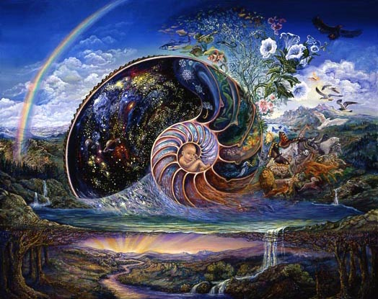

www.josephinewall.co.uk/surreal/nautilus.jpg

Image may be subject to copyright.

Below is the image at: [www.josephinewall.co.uk/nautilus.html](http://www.josephinewall.co.uk/nautilus.html)

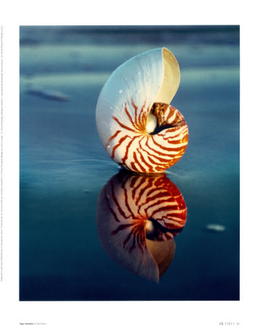

Ruth Burke-Tiger Nautilus-fine art print-9x12

**What shall we give the children?**  
  
In the long twilight of the year, the faces of the children grow luminous. Rosy with cold, arabesqued with snowflakes, leaning into the wind, or drowsing before the fire, their eyes large, they look and listen, as if they glimpsed the peripheries of miracle or heard a soundless music in the air. From the innocent kingdom of implicit belief to that uncomfortable arena where the implacable mind battles the intractable heart, the faces of children at Christmas are lighted with visions of things to come.  
  
What shall we give the children?  
  
It seems certain that they will travel roads we never thought of; navigate strange seas, cross unimagined boundaries, and glimpse horizons beyond our power to visualize. What can we give them to take along? For the wild shores of Beyond, no toy or bauble will do. It must be something more; constructed of stouter fabric discovered among the cluttered aisles and tinseled bargain counters of experience, winnowed from what little we have learned. It must be devised out of responsibility and profound caring – a home-made present of selfless love. Everything changes but the landscapes of the heart.  
  
What shall we give the children?  
  
Attention, for one day it will be too late.  
  
A sense of value. The inalienable place of the individual in the scheme of things, with all that accrues to the individual; self-reliance, courage, conviction, self-respect, and respect for others.  
  
A sense of humor. Laughter leavens life.  
  
The meaning of discipline. If we falter at discipline, life will do it for us.  
  
The will to work. Satisfying work is the lasting joy.  
  
The talent for sharing; for it is not so much what we give as what we share.  
  
The love of justice. Justice is the bulwark against violence and oppression and the repository of human dignity.  
  
The passion for truth, founded on precept and example. Truth is the beginning of every good thing.  
  
The power of faith, engendered in mutual trust. Life without faith is a dismal dead-end street.  
  
The beacon of hope, which lights all darkness.  
  
The knowledge of being loved beyond demand or reciprocity, praise or blame; for those so loved are never really lost.  
  
What shall we give the children?  
  
The open sky, the brown earth, the leafy tree, the golden sand, the blue water, the stars in their courses, and awareness of these. Birdsong, butterflies, storms and rainbows. Sunlight, moonlight, firelight.   
  
A large hand reaching down for a small hand; impromptu praise, an unexpected kiss, a straight answer. The glisten of enthusiasm and a sense of wonder. Long days to be merry and nights without fear.   
  
The memory of a good home.  
  
Author unknown.

This photo has notes. Move your mouse over the photo to see them.