Dewey Games and Activities

Dewey Read-a-Thon (Training Aid):

The following Dewey Rap introduces the subject areas and Dewey classification numbers for them. http://www.monet.k12.ca.us/curriculum/librarylessons/Lessons/4th/Dewey%20Rap.ppt

The mural on the media center wall contains pictures of computers which give the Dewey numbers and subject headings for each general area.
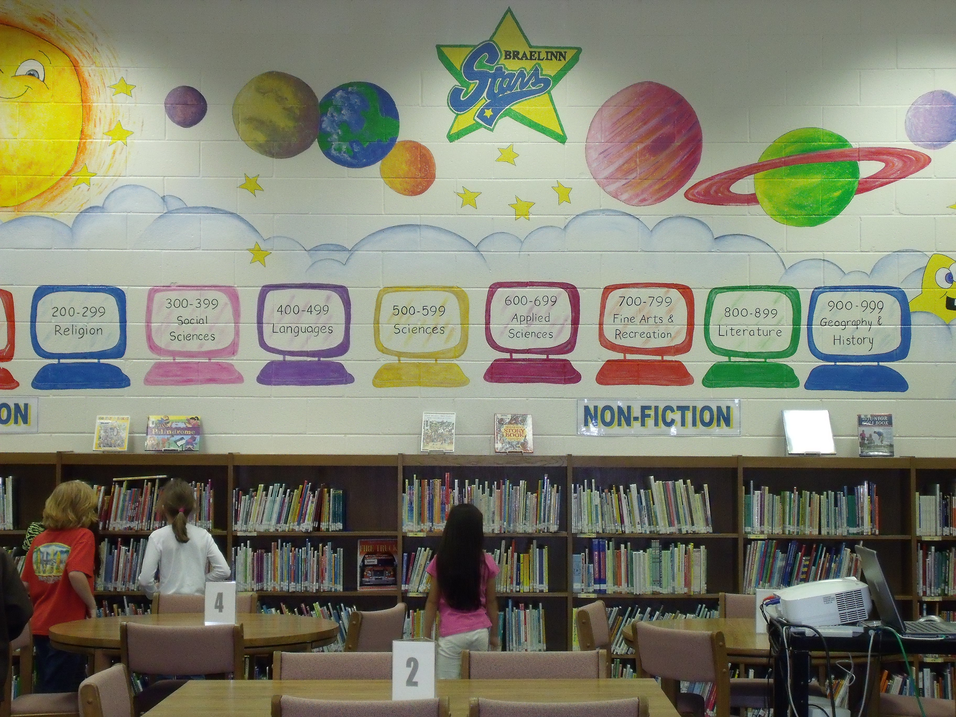

Students participate in the Olympic Read-A-Thon which encourages reading from the entire Dewey subject areas. They complete any of the Olympic Reading events of their choice. Each event is worth a certain number of points. Students receive an Olympic Read-a-Thon sheet and complete the Olympic Event coupons which are signed off by a parent or guardian. When they reach a given level, they bring their Olympic Read-A-Thon sheets to the media center. Students receive special recognition for each level that is reached via closed circuit news/announcements and bulletin board posted outside the media center. Students who reach Level 4 will receive a medal/ribbon at the close of the activity. See Dewey Power Point presentation and
C:\Documents and Settings\The Dixon's\My Documents\Read A Thon Coupon Sheet 3.doc

Olympic Read-A-Thon
Grades 3-5
Going for the Gold!

The Olympic Read-A-Thon will take place now through May and it
will encourage students to read from a wide selection of books. Students
(Microsoft Office Online, 2008)
complete any of the Olympic Reading events of their choice. Each event
is worth a certain number of points. Our Olympians will receive an
Olympic Read-a-Thon sheet and will need to complete the Olympic Event coupons which are signed off by a parent or guardian. When they have reached one of the following levels they should bring their Olympic Read-A-Thon sheets to the media center. Students will receive special recognition for each level that is reached.

Level 1 40 points Level 2 80 points Level 3 120 points Level 4 165 points

These are the Olympic Read-A-Thon events.

100 Meter Dash Read a book with a call number in the 100’s 5 points
200 Meter Run Read a book with a call number in the 200’s 5 points
300 Meter Hurdles Read a book with a call number in the 300’s 5 points
400 Meter Steeplechase Read a book with a call number in the 400’s 5 points
500 Meter Obstacle Read a book with a call number in the 500’s 5 points
600 Meter Relay Read a book with a call number in the 600’s 5 points
700 Meter Backstroke Read a book with a call number in the 700’s 5 points
800 Meter Butterfly Read a book with a call number in the 800’s 5 points
900 Meter Backstroke Read a book with a call number in the 900’s 5 points
Medley Cross Country Read a folktale from another country 5 points
Plunge for Distance Read a book longer than you’ve ever read before 10 points
Synchronized Swimming Read aloud with someone 20 min/day for 1 week 10 points
Triple Jump Read three books written by one author 20 points
400 Meter Freestyle Read 400 pages of anything 20 points
Decathlon Read 10 books of your choice 40 points
Heavyweight Boxing Event Read a book weighing at least one pound 5 points
High Jump Read a book that measure over 25 cm tall 5 points
900 Meter Individual Read a book from the biography section 5 points

Have fun reading and contact the media center if you have any questions!

Boyd, M. (2009) Olympic Read-A-Thon handout and presentation shared with students
during the first and second quarters, 2008.

Dixon, L. (2009) Dewey Power Point.

Dixon, L. (2009) Media Center photo of computers with Dewey numbers.

McElfresh, J. (2006) Retrieved March 22, 2009, from http://www.ih.k12.oh.us/esmedia/
Lessons_with_MrsWelsh/Dewey_Rap__by_joan_mcelfresh.htm

Modesto City Schools (2009) Retrieved March 22, 2009, from http://www.monet.k12.
ca.us/curriculum/librarylessons/Lessons/4th/Dewey%20Rap.ppt

Online Practice:

The following is an online quiz assessing Dewey classification of subjects. It would be very good for 3-5th grade students.

Frerichs, M. (2008). Library Skills Game. Retrieved on April 9, 2009 from http://www.
ccsd.edu/bardonia/LearningGames/LibrarySkills/

The following is online practice with matching Dewey classification numbers with their corresponding subjects. It would be very good practice for 3-5th grade students.

Quia Corporation. (2009). Dewey Decimal System Matching. Retrieved on April 9, 2009,
from http://www.quia.com/mc/7265.html

Partner/Team Games:

I found this activity online and I have included the reference information below. For this activity the media specialist bought blank dice and labeled them - one for 000-400 and one for 500-900, with a free space on each of them - to have several tables of kids playing all at once. She also cut up all the little squares and attached them to sticks in order to play "sticks and stones" (arranging the sticks next to cards with hundreds areas on them).

Wolicki, K. (2009). Dewey Bingo Cards and Instructions. Retrieved from LM_NET on
April 9, 2009 at http://lmnet.wikispaces.com/Dewey+Decimal+System

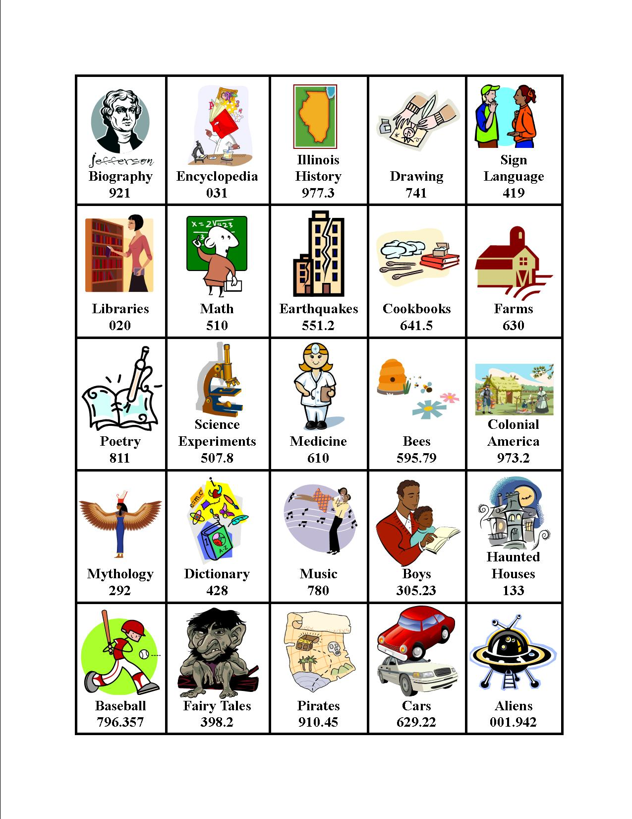
Dewey Bingo Instructions

You have 2 dice and a Dewey Bingo card.
Take turns with the other students at your table.

1. Choose 1 die to roll.

2. Say the Dewey Decimal hundreds number that you roll, and say the subject that that Dewey number stands for. If you roll a blank, you can choose a hundreds number you like.

000: General Works

100: Philosophy and Psychology

200: Religion and Mythology

300: Social Studies

400: Languages

500: Science

600: Technology

700: Arts and Recreation

800: Literature

900: History, Biography, and Geography

3. Find a space on your Dewey Bingo card that lists a subject in the Dewey Decimal number you rolled. Read the subject and the number out loud, and mark the space with a chip. You should only mark one space for each roll, even if there are multiple spaces for that hundreds number.

4. Everyone at your table should raise their hands when you have a row across, down, or diagonally.

