South Paulding High School Website Imitative
Prepared by Kirk Checkwood
Prepared for Diana Moyer AP SPHS
April 11, 2011

Executive Summary
During the 2009 – 2010 calendar school year South Paulding High School along with all elementary, middle, and high schools in Paulding County began using a centrally designed website hosted on the Paulding County School District’s computer server. The simplified website design and accessibility was implemented to insure ease of use for faculty members and to increase faculty web page/blog usage and updating. At the beginning of the 2010 – 2011 calendar school year the Assistant Principal that oversees the technology committee with Principal of South Paulding High School implemented the South Paulding High School Website Imitative (goal of 100% participation and usage by the faculty) particularly on teacher web pages/blogs incorporated in the website structure/program. With the Assistant Principal that oversees the technology committee‘s consent the evaluator began the program evaluation on February 2, 2011 with the final evaluation report due on April 11, 2011.
The following evaluation questions agreed upon by the client and program evaluator guided the evaluation process:
- Is teacher web page/blog training available?
- Is the teacher web page/blog training effective?
- To what extent is the teacher web pages/blogs being used?
- Is the Teacher Web page/Blog easy for teachers to update and navigate?
- What are perceived drawbacks and deterrents of teacher web pages/blogs?
The initial questionnaire the evaluator administered to the faulty focused on the faculty’s technological level, technological comfort level, utilization of their web page/blog, and the frequency of updating/usage their web page/blog. Surprisingly enough, at the time of the evaluation a large percentage of the faculty that took the survey ranked their own technology skill level and comfort levels high. When asked about their web page/blog comfort level the percentages decreased. With over half of the faculty members unaware of the web pages/blogs supplied and supported by the county, how faculty members used the web pages/blogs and the frequency of use and web page/blog updating percentages were minimal.
The second questionnaire the evaluator administered focused on the faculty’s web page/blog professional learning attendance, time allocated to teacher web page/blog professional learning, and overall effectiveness of teacher web page/blog professional learning. Those who attended a web page/blog professional learning session were split pretty evenly. Of those faculty members who attended, the majority felt that although the web page/blog professional learning sessions were emergent/proficient in the content there was not enough time allocated to each session.
Following the surveys the evaluator interviewed ten faculty members who were not frequently using and updating their teacher web page/blogs perceived drawbacks and deterrents of teacher web pages/blogs. The interviews primarily focused on the difficulty of using the web page/blog as well as the time or lack thereof to work on one’s web page/blog. The faculty members who agreed to take online interview also focused on web page/blog professional learning sessions stating the training was not frequent enough, individualized, or more in depth.
Based on the findings, the evaluator recommended that South Paulding High School actively promote the fact that teachers have a free resource supplied and supported by the school. This evaluator also recommended that steps were taken by the technology committee at South Paulding High School to involve the stakeholders to increase user-friendly attributes to the web page/blog application and present the findings to the Paulding County School District’s technology department to implement. Another recommendation is to increase web page/blog professional learning sessions based on learning levels and establish a group of experts who could train faculty members on an individual basis and that could also help with specific issues related to the web pages/blogs.

Introduction
South Paulding High School Website Imitative
The evaluator will focus primarily on the implementation of the South Paulding High School Website Imitative (goal of 100% participation and usage by the faculty) particularly on teacher web pages/blogs incorporated in the website structure/program. Specific areas of the evaluation will be twofold. The first area of the evaluation focus will be on teachers that readily use their teacher web page/blogs looking at the specific benefits and drawbacks. The second are of the evaluation focus will be on teachers that are not using their teacher web page/blogs looking at the reasons or deterrents to use of their teacher web page/blogs.
Most schools have turned to the World Wide Web to distribute information to their stakeholders. It is important to look at the quality of the school website insuring that they “don’t create a Web site ‘Because [they] can.’ Rather, create a Web site to serve the community and to provide that community with essential content and the possibility ‘to interact with information, not just receive it’” (Karis, 2005, p. 58). As schools – including South Paulding High School – begin to turn to school websites for communication purposes, administrators, teachers, technologists need to know how to evaluate their websites and make them best suited for themselves and other stakeholders as in parents and students.
With multiple parties involved, one must specifically insure that all stakeholders have a say in website development insuring, as stated by Quinney (2005), that developers (administrators, teachers, and technologists) are “not to be dazzled and seduced by what the technology can do but to adapt and apply the technology to what we want students to be able to do and what students themselves report as their needs and expectations and for the online tutor/e-moderator to be able to facilitate this” (p.449). As always, one’s purpose and one’s stakeholders must be taken into consideration.
Although the process of evaluating a school website can be difficult, through evaluation tools one can effectively evaluate and determine the best strategy needed to develop a school website with all the needs of the stakeholders involved accounted for. Ultimately, as explained by Cifuentes, Sharp, Bulu, Benz, and Stough (2010), “read/write Web technologies can be used to address general problems that have intrinsic societal importance” (p. 395). For this purpose alone educators must learn to and continue to evaluate and reevaluate their school’s website.
When evaluating a program such a school website where does one begin? Karis (2005) stated, “For a school library to have a superior Web site, the process must start with thoughtful evaluation of the school, its students, curriculum, and the educational goals of both the school and school library” (p. 58). Although Karis made the statement with virtual libraries in mind, the idea can easily be applied to any educational website.
In order to validate the evaluation thus creating a thoughtful evaluation the evaluator must include all stakeholders. As stated by Miller, Adsit, and Miller (2005) the evaluation and development of a successful school website must “include teaming constituted through committees, possession of a clear mission statement, minimizing load time of the site and determining site ownership [and] the use of a representative development committee during development” (p. 34). All parties must play a part – all stakeholders and their needs must be taken into consideration.
In the case of South Paulding High School, the administration put forth the imitative to heighten communication and, as explained by Chun and Soong (2007), “reach out to a large number of parents and get them involved in their children’s education” as well as “explore[ing] ways in which to use their web sites for student learning” (p. 41). Can South Paulding High School’s website accomplish this task and what is the best way to do so – through a summative evaluation this researcher hopes to answer these questions.
Purpose
The purpose of the evaluation is to determine if the South Paulding High School teacher web pages/blogs are being used and if they are being used whether or not they are an effective communication/resource tool in instruction. In addition, the purpose will be to discover why teachers are not utilizing their teacher web pages/blogs even with a school wide initiative in place.
The evaluation will be summative as the goal is to measure where teachers perceive themselves in relation to the use of their South Paulding High School teacher web pages/blogs and then to use the information to recommend improvements to the initiative already in place.
The evaluator will provide a detailed recommendation based on the analysis of the evaluation questions. Upon approval by the client, and careful analysis of the reported data, a decision will be made on how to best approach the issues – be it staff development, staff coaching – in improving the South Paulding High School Website Initiative.
Evaluation Questions
In order to provide a significant recommendation to the client of South Paulding High School through this evaluation, the following questions must be answered:
- Is teacher web page/blog training available?
- Is the teacher web page/blog training effective?
- To what extent is the teacher web pages/blogs being used?
- Is the Teacher Web page/Blog easy for teachers to update and navigate?
- What are perceived drawbacks and deterrents of teacher web pages/blogs?
Methods
Participants
All grade teachers at South Paulding High School will be asked to participate in the evaluation. This sample includes teachers from all grade levels, disciplines, experience levels, genders, degree levels, and races.
Design and Procedures
The evaluation plan consists of the following activities designed to address the four evaluation questions:
- The evaluation questions will be explored through the use of surveys and interviews. The survey will be quantitative in nature. All participants will be asked a set of multiple-choice questions specific to the evaluation questions. The data from the answers will be collected and analyzed as it relates to the evaluation questions.
- The interviews will be qualitative in nature. Teachers who are not frequently using and updating their teacher web page/blog will be asked to answer open-ended questions. These questions will be answered through a face-to-face meeting or through email depending on which format the teacher finds convenient. The data from the answers will be collected and analyzed as it relates to the evaluation questions.
Instruments
- Quantitative Survey – Survey results will determine how many teachers are currently using their teacher web pages/blogs, how frequently they update their teacher web pages/blogs, how they perceive current training methods, and effectiveness of past, current, and future teacher web pages/blogs?
- Qualitative Interviews – Interview results will determine how teachers who are not frequently using and updating their teacher web page/blog perceived drawbacks and deterrents of teacher web pages/blogs?
Data Analysis
Surveys
The researcher will evaluate each question on the survey to determine patterns of response by the participants. The evaluator will look for trends in the use of teacher web pages/blogs including but not limited to years of experience, comfort with technology, frequency of use. From the data collected and analyzed the researcher will try to determine measures that the client can take to improve the frequency of use of the teacher web pages/blogs by the teachers of South Paulding High School.
Interviews
Multiple teachers who are not frequently using and updating their teacher web page/blog will participate in the interview process. The evaluator in analyze responses to determine how teachers perceive the current training methods, and effectiveness of past, current, and future teacher web pages/blogs as well as how teachers perceive the benefits, drawbacks, and deterrents of teacher web pages/blogs. The evaluator will use this information to recommend future measures that the client may take to further the South Paulding High School Website Initiative.
Questions | Training Survey | Impediment Survey | Observations | Interviews
Training And Understanding Teacher Web Pages/Blogs | X | X | X | X
Impediments to Teacher Web Pages/Blogs |  | X | X | X

Summary of Key Findings
Survey General Information
Out of 103 teachers, 1 media specialist, and 5 administrators that make up the faculty of South Paulding High School only 43 faculty members took the survey or 40% of the faculty and staff at South Paulding High School. Of the faculty members that took the survey 35% were male and 65% were female. Looking at experience, 60% of the faculty members that took the survey have taught for five or more years while 40% have taught less than five years suggesting that the participants were older in nature. Surprisingly, 53% stated that they did not have a web page/blog while 47% stated that they did.
Impediments to Teacher Web Pages/Blogs Survey
Interesting enough, 72% of the faculty members that took the survey ranked their own technology skill level proficient to exemplary while only 28% ranked their own technology skill level emerging to not evident. Looking at technological comfort level 94% of the faculty members that took the survey ranked their technological comfort level average to high with 35% ranked the highest while only 6% ranked their technological comfort level below average. When asked about their web page/blog comfort level the percentages decreased with only 64% ranked as average to high with 14% ranked the highest and 36% ranking their web page/blog comfort level below average. Unfortunately with 53% of the faculty members that took the survey stating that they do not have a web page/blog the most common way the faculty utilized one’s web page/blog was divided relatively evenly between communication with parents, students listing assignments, posting lesson plans, other, and/or a combination of all the categories. Those who did have a web page/blog the largest percentage 16% updated their web page/blog weekly with never following closely with 12% of the faculty members that took the survey. Teachers who have a web page/blog are either adamant or apathetic about updating their web page/blog with very little room in the middle.
Training and Understanding Teacher Web Pages/Blogs Survey
Of the 43 faculty members that took the survey those who attended a web page/blog professional learning session was split pretty evenly with 49% who attended and 51% who did not. Of those faculty members who did attended 65% ranked the allocated time for web page/blog professional learning as insufficient with 35% of the faculty members that took the survey believing the time allocated as sufficient. Although it is clear that the faculty members that took the survey felt more time was needed, 51% felt that the overall training was emerging and 16% ranking the training as proficient showing that the majority felt the web page/blog professional learning sessions were successful.
Interviews
The faculty members who agreed to take online interview primarily focused on the difficulty of using the web page/blog. For example participants D, E, G, and I pointed out that the web page/blog used by South Paulding High School was not seen as “user-friendly.” Another stumbling block mentioned by faculty members who agreed to take online interview focused on time or lack thereof. The faculty members who agreed to take online interview also focused on web page/blog professional learning sessions stating the training was not frequent enough, individualized, or more in depth.

Recommendations
The fact that 53% of the faculty that took the survey stated that they do not have a web page/blog is troubling. One of the first recommendations is that South Paulding High School actively promotes the fact that teachers have a free resource supplied and supported by the school. Based upon the interview’s primary focus that the web page/blog is not “user-friendly” this evaluator recommends that the technology committee at South Paulding High School involve the stakeholders and closely look at ways to increase user-friendly attributes and present the findings to the Paulding County School District’s technology department to implement. Another recommendation based on both the Training and Understanding Teacher Web Pages/Blogs Survey and the interviews is to increase web page/blog professional learning sessions based on learning levels (i.e. Level 1 training for faculty members whose levels are not evident, Level 2 training for faculty members whose levels are emergent, Level 3 training for faculty members whose levels are proficient). The South Paulding High School technology committee could also establish a group of experts who could train faculty members on an individual basis and that could also help with specific issues related to the web pages/blogs.
Conclusion
With 94% of the faculty members that took the survey ranking their technological comfort level average to high and 72% of the faculty members that took the survey ranking their own technology skill level proficient to exemplary it is clear to this evaluator that the potential for the faculty of South Paulding High School to complete the Website Imitative (goal of 100% participation and usage by the faculty) particularly on teacher web pages/blogs incorporated in the website structure/program is more than plausible. In order to this imitative to be reached the faculty of South Paulding High School needs to feel as confident and comfortable with the web pages/blogs as possible. This confidence and comfort level will only come forth through additional training, time for the faculty to utilize the web pages/blogs effectively, and a process that includes the stakeholders – especially the teachers – creating an atmosphere conducive to the teachers “buying in” to the imitative.
References

Cifuentes, L., Sharp, A., Bulu, S., Benz, M., & Stough, L. (2010). Developing a web 2.0-
based system with user-authored content for community use and teacher
education. Educational Technology Research & Development, 58(4), 377-398.
Chun, H., & Kheng Fah Soong, A. (2007). Beyond electronic brochures: An analysis of
Singapore primary school web sites. Educational Media International, 44(1), 33-42.
Karis, C. (2005). Booking library web site redesign. Knowledge Quest, 33(3), 58-61.
Retrieved from EBSCOhost.
Miller, S., Adsit, K. I., & Miller, T. (2005). Evaluating the importance of common
components in school-based websites: Frequency of appearance and
stakeholders' judged value. TechTrends: Linking Research & Practice to Improve
Learning, 49(6), 34-40. Retrieved from EBSCOhost.
Quinney, A. (2005). ‘Placements online’: Student experiences of a website to support
learning in practice settings. Social Work Education, 24(4), 439-450. Retrieved from EBSCOhost.

Appendix
Impediments to Teacher Web Pages/Blogs Survey

1. Gender (optional)
◙ Male
◙ Female
2. How many years have you taught?
◙ 0-2 Years
◙ 3-5 Years
◙ 5-10 years
◙ 10+ years
3. Do you currently have a webpage or classroom blog? (yes/no)
4. What is your Technology Level?
◙ Not Evident
◙ Emerging
◙ Proficient
◙ Exemplary
5. On A scale of 1 to 5 what is your technological Comfort level? (1=low: 5=High)
6. What is your teacher web page/blog comfort level? (1=low: 5=High)
7. What is the most common way you utilize your teacher web page/blog?
◙ List Assignments
◙ Communicate with Parents
◙ Post Lesson Plans
◙ Communicate with Students
◙ other
8. How often do you update your teacher web page/blog?
◙ Daily
◙ Weekly
◙ Biweekly
◙ Monthly
◙ Yearly

Training and Understanding Teacher Web Pages/Blogs Survey
1. Gender (optional)
◙ Male
◙ Female
2. How many years have you taught?
◙ 0-2 Years
◙ 3-5 Years
◙ 5-10 years
◙ 10+ years
3. Do you currently have a webpage or classroom blog? (yes/no)
4. How would you rate your overall training for Teacher Web Pages/Blogs?
◙ Not Evident
◙ Emerging
◙ Proficient
◙ Exemplary
5. Have you attended teacher web page/blog professional learning? (yes/no)
6. Do you feel that the time allocated for training was sufficient?
◙ More than sufficient
◙ Sufficient
◙ Insufficient
7. Any additional comments?

Interview Questions

1. What has made using your teacher web page/blog difficult?

2. What would/could enhance your using your teacher web page/blog?

Data Collection Organization Matrix
Questions | Related Results | Required Data | Level Mega Macro Micro | Required Data Measurable Indicators | Data Source | Data Collected | Primary Responsibilities
Training, Preparation, And Understanding Teacher Web Pages/Blogs | TBD | Surveys, interviews, observations | Macro | Surveys | Surveys 1 and 2 | TBD | Evaluator
Impediments to Teacher Web Pages/Blogs | TBD | Interviews, observations | Micro | Interviews | Inter views | TBD | Evaluator

Survey General Information

Table 1: Gender
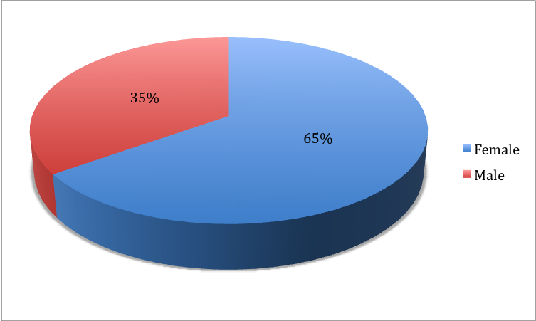

Table 2: Years of Experience
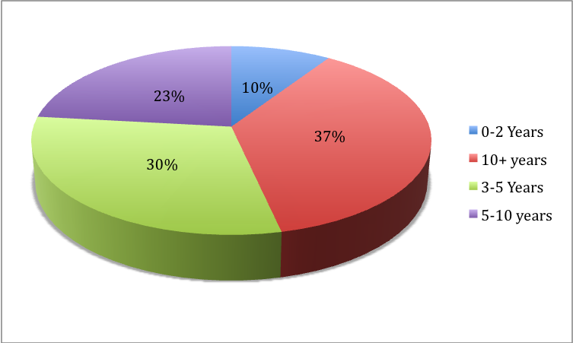

Table 3: Do you currently have a webpage or classroom blog? (yes/no)
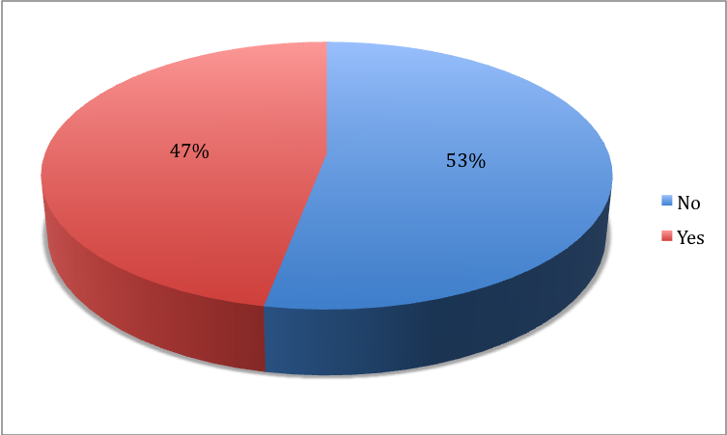

Impediments to Teacher Web Pages/Blogs Survey: Faculty’s technological level, technological comfort level, web page/blog comfort level, utilization of their web page/blog, and the frequency of updating/usage their web page/blog

Table 4: What is your Technology Skill Level?
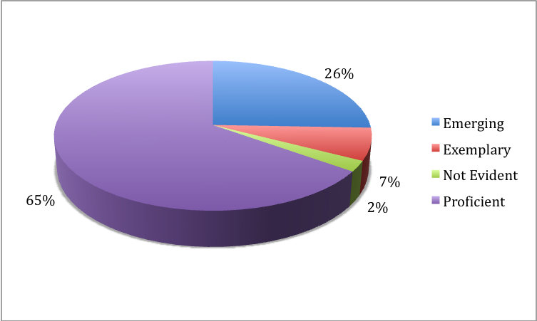

Table 5: On A scale of 1 to 5 what is your technological Comfort level? (1=low: 5=High)
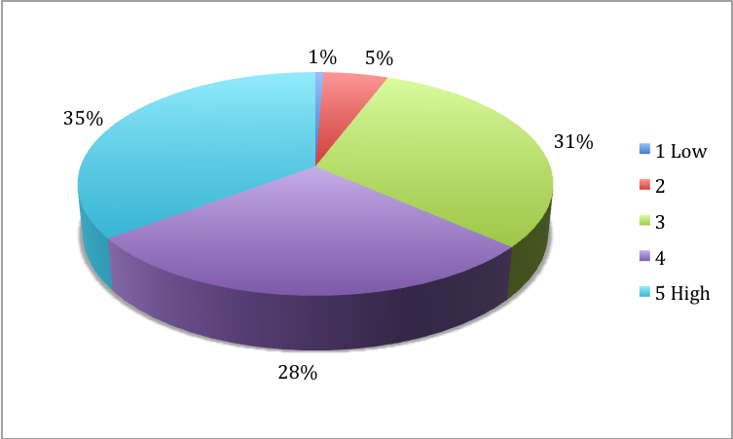

Table 6: How would you rate your web page/blog comfort level? (1=low: 5=High)
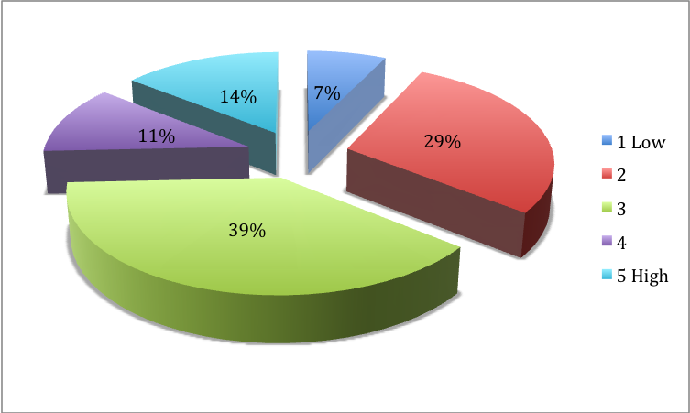

Table 7: What is the most common way you utilize your teacher web page/blog?
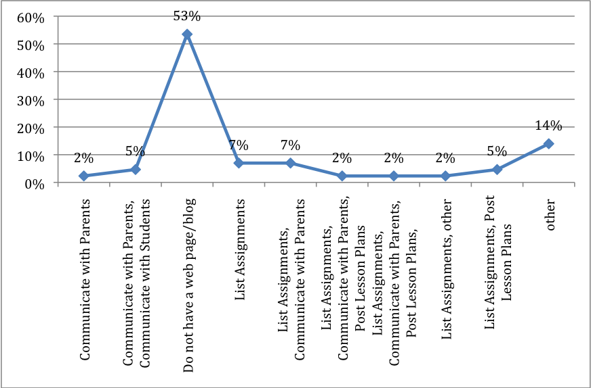

Table 8: How often do you update your teacher web page/blog?
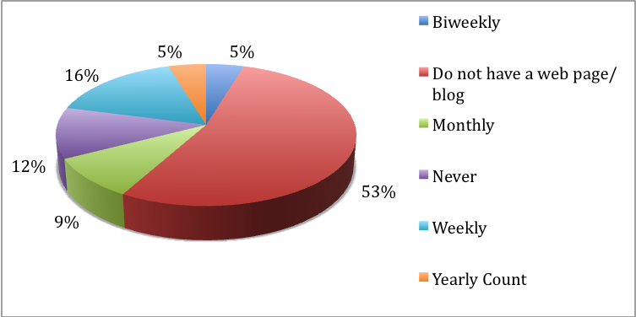

Training and Understanding Teacher Web Pages/Blogs Survey: Teacher web page/blog professional learning attendance, time allocated to teacher web page/blog professional learning, and overall effectiveness of teacher web page/blog professional learning

Table 9: Have you attended teacher web page/blog professional learning? (yes/no)
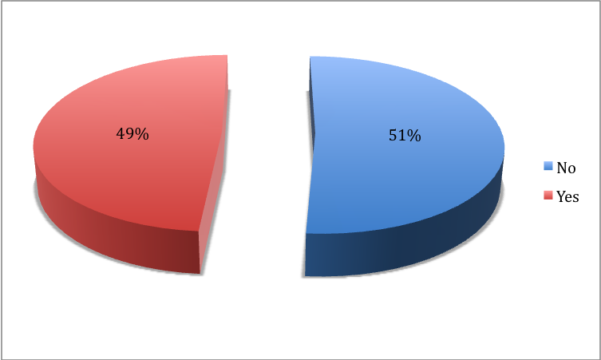

Table 10: Do you feel that the time allocated for training was sufficient?
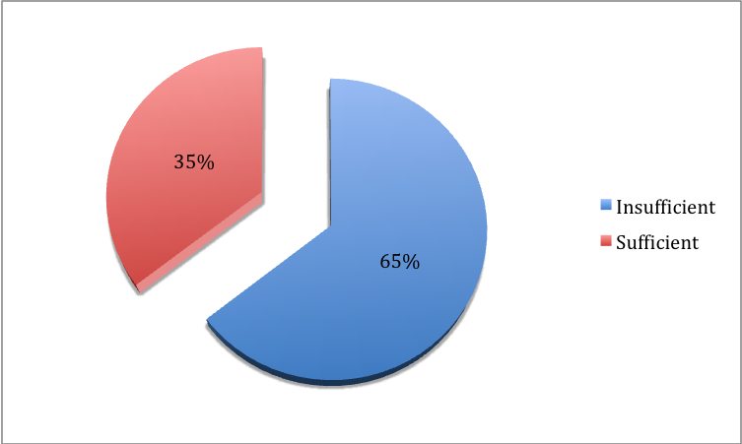

Table 11: How would you rate your overall training for Teacher Web Pages/Blogs?
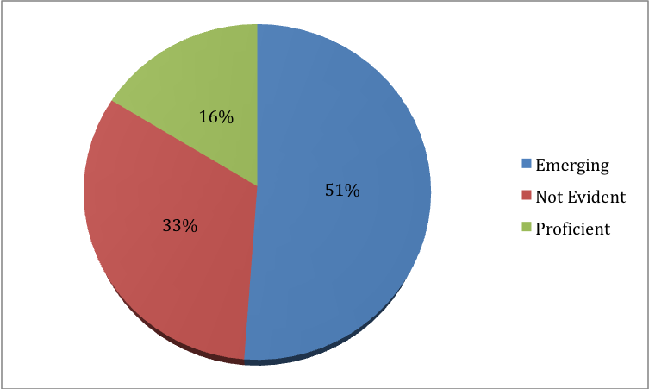

Interview Question Answers

Participant A:

1. What has made using your teacher web page/blog difficult?

Don't understand what to do. Need time to work on it.

2. What would/could enhance your using your teacher web page/blog?

HELP!!!

Participant B:

1. What has made using your teacher web page/blog difficult?

I don't have one. Not because I don't know how to use one, but because I feel it is the students' responsibility to know when assignments are due. There is no need, at the high school level, for parents to check up on them in that manner. Kids need to start taking some responsibility for themselves. I tell them and remind them of due dates many times in class.

2. What would/could enhance your using your teacher web page/blog?

Restricting parent access?! See above response for clarification.

Participant C:

1. What has made using your teacher web page/blog difficult?

That sometimes at school it will not load or assignments will not open for students at home.

2. What would/could enhance your using your teacher web page/blog?

If the one here at school was easier to use.

Participant D:

1. What has made using your teacher web page/blog difficult?

I use an external service - Blogger. It's blocked at school. I use Blogger because it's an easier interface to change around, easy to access, and has a quick update page - none of which the school-provided sites have.

2. What would/could enhance your using your teacher web page/blog?

User-friendlier interface where I could make blog posts easily.

Participant E:

1. What has made using your teacher web page/blog difficult?

Lack of training and difficulty of use.

2. What would/could enhance your using your teacher web page/blog?

Make the school website more user friendly with increased training.

Participant F:

1. What has made using your teacher web page/blog difficult?

Time, I do not easily understand the process and have little real time to become more comfortable. the training we received was pretty much an assembly line with little follow up.

2. What would/could enhance your using your teacher web page/blog?

More in depth training, with more individualized support

Participant G:

1. What has made using your teacher web page/blog difficult?

The page we are provided with the county is not as user-friendly as a blog or typepad, etc.

2. What would/could enhance your using your teacher web page/blog?

Better software with faster uploading times.

Participant H:

1. What has made using your teacher web page/blog difficult?

No enough time to keep it updated

2. What would/could enhance your using your teacher web page/blog?

Time.

Participant I:

1. What has made using your teacher web page/blog difficult?

Software provided is not use friendly.

2. What would/could enhance your using your teacher web page/blog?

Simpler program.

Participant J:

1. What has made using your teacher web page/blog difficult?

Not enough time to work on it

2. What would/could enhance your using your teacher web page/blog?

Teacher workdays

