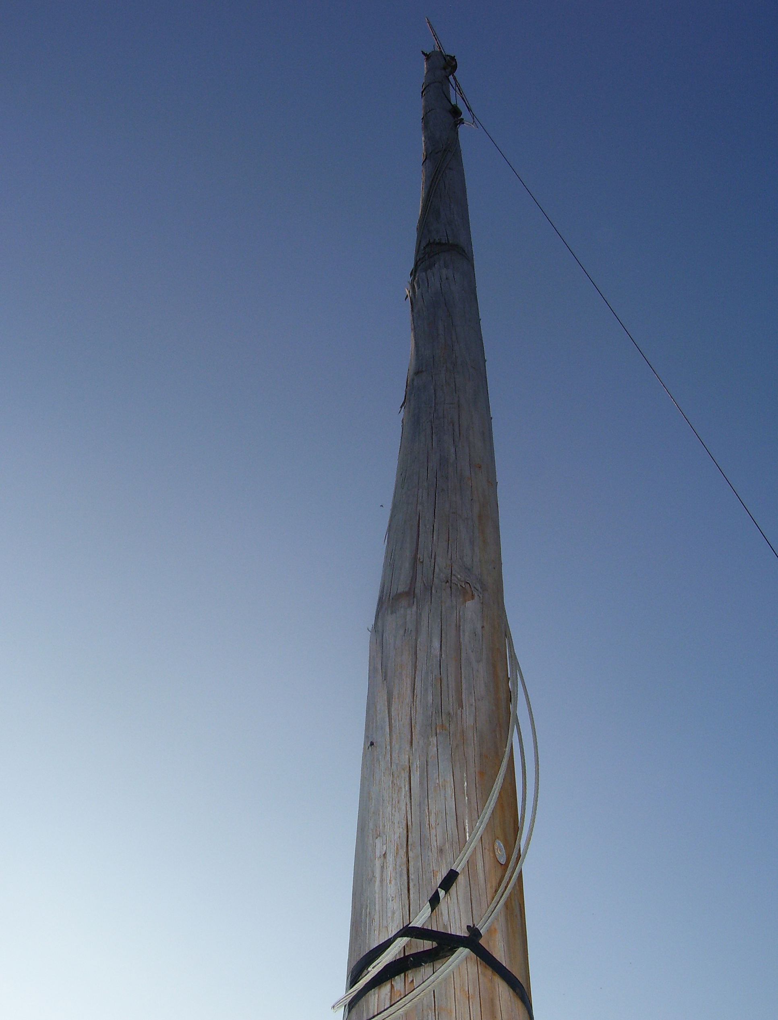

Title: “Wichita Lineman”

Three descriptive tags: “Utility Pole”, “Ant’s View”, “Point-of-View”

A self critique: Digital Photo Rubric
Objective/Criteria | Performance Indicators
 | Exemplary | Competent | Emerging
Concept | (5 points)  Does an outstanding job of communicating the concept. | (4.4 points)  Does an adequate job communicating the concept. | (3.8 points)  Does a poor job communicating the concept.
Composition | (5 points)  Photograph uses composition principles very effectively. | (4.4 points)  Photograph does a good job using composition principles. | (3.8 points)  Photograph does a poor job using composition principles
Color, Contrast & Tonal Range | (5 points)  Photography displays outstanding use of color, contrast and/or tonal range. | (4.4 points)  Photography displays good color, contrast and/or tonal range. | (3.8 points)  Photograph lacks contrast, color is weak and/or tonal range is poor.
Focus | (5 points)  Focus is a perfect match with the concept of the shot. | (4.4 points)  Focus is an adequate match with the concept of the shot. | (3.8 points)  Focus is a poor match with the concept of the shot.
Technical Aspects | (5 points)  Shutter speed and aperture were perfectly chosen to match concept. Exposure and lighting are excellent. | (4.4 points)  Shutter speed and aperture were adequately chosen to match concept. Exposure and lighting are good. | (3.8 points)  Shutter speed and aperture were poorly chosen and do not match the concept. Photo is over/under exposed and lighting is poor.
Depth of Field | (5 points)  Excellent use of depth-of-field. | (4.4 points)  Adequate use of depth-of-field. | (3.8 points)  Poor use of depth-of-field.
Title/Tags | (5 points)  Title and tags were perfectly chosen and written to express the content and concept. Spelling and word choice are excellent with no mistakes. | (4.4 points)  Title and tags were adequately chosen and written to express the content and concept. Spelling and word choice are good with only minor errors. | (3.8 points)  Title and tags were poorly chosen and written to express the content and concept. Contains multiple spelling errors or wrong word choices.
Self critique & Reflection | (10 points)  Excellent self-assessment and well written reflection that answers all reflection question thoroughly. Spelling and grammar are perfect. | (8.8 points)  Adequate self-assessment and the written reflection answers most of the questions. Spelling and grammar is mostly correct with only minor errors. | (7.6 points)  Self-assessment is not complete and/or the reflection does not answer some or all of the questions. Spelling or grammar is not on par with graduate level writing yet some effort has been shown in the work submitted.
Peer Comments | (5 points)  Peer comments posted for all members of virtual group exceed expectations and spelling is correct. Comments made for each group member’s photo include one or more suggestions on how to improve the photo and discuss at least one positive attribute of the photo. Comments are very thorough and thoughtful. | (4.4 points)  Peer comments posted for all members of virtual group meet expectations and spelling is mostly correct. Comments made for each group member’s photo include one suggestion on how to improve the photo and discuss at least one positive attribute of the photo. Comments are brief but good. | (3.8 points)  One or more elements of the peer comments were missing, incomplete or poorly written. Comments may not have been made for every member of the group but some effort was evidenced in what was written. Comments need improvement.
 |  |  | out of 50

Three Paragraph Reflection
Lying down in the dirt was interesting at best. I do not think much about ants and other little creepy crawlies in the scheme of things but now have a slight – if not skewed – sense of how the world looks to them. Luckily I only ran into one or two of them while invading their turf – no need to worry no multiple legging beasties were hurt in the process.

This was a great assignment as to how our eyes see things, empathy, and the world outside of our own bubble. It is interesting how much the angle – point-of-view – of a shot can change the meaning completely. Is it one of submission, equality, dominance, belittling, the words are endless. Getting a stable focused picture was very difficult from this viewpoint. I could have gone even lower and moved towards a steeper angle.

Point-of-View – a great lead into literature and all that it encompasses. I am trying to stick with the OPTIC (Overview-Parts-Title-Interrelationships-Conclusion) activity here as to create an overall unit. So – with this in mind – the class would focus on the interrelationship of point-of-view, artistic interpretation, and meaning. Some questions could include: What point-of-view is displayed? How does this help one interpret the photograph? How does angles change the point-of-view? Would it matter what point-of-view was used? We could then discuss how the point-of-view of a photograph can skew an audience interpretation of meaning. Then of course I would have them bring in photographs of their own to discuss.

P9 Comments
Susan Biggers: Talk about great curves – get your mind out of the gutter. This is a great shot – the lines are great – the angel is great – the perspective is great – even the title shines greatness. Composition of balance – and the colors – white against the blue sky – one could not ask for more. Just one creeping thing a flag, towel, or such hanging from one of the balconies – maybe crop that thing. Nothing too important – I really like this shot.
Kristin Limbaugh: Yummy is right – sunflowers makes me think of baseball and saliva (okay – sorry – that was gross). Great shot of the flower and the sun and great composition – rule of thirds all the way. The white of the clouds and the blue of the sky also brings about a nice balance. Changes – there are not many that I could suggest here. Maybe remove the leaf in the bottom left corner. Maybe whiten the dark part of the clouds on the lower right. Just maybes – nothing more and nothing less.
Andrea Harper: Interesting shoot if I do say so myself. Even better title – I have to admit I stumble, staggered, and tripped trying my darnedest to figure out what the purple things were. Love the green of the grass against the purple of the glasses – makes for great contrast. My only suggestion – the stuff in the lens. I think the shoot would be perfect if you could see the sky or tree line through the lens. Need to get me a pair of purple glasses.
Joy Renfro: I like the “oops, the cameraman tripped” angle of this shot. I am almost waiting for bursts of profanity and a quick call to 911. Anyway – great shot – great background fence – great greenness of the grass. All make for a well-composed shot. Maybe a change – the shadow – was the shoot from under a porch? The line almost takes away – otherwise a great shot.

