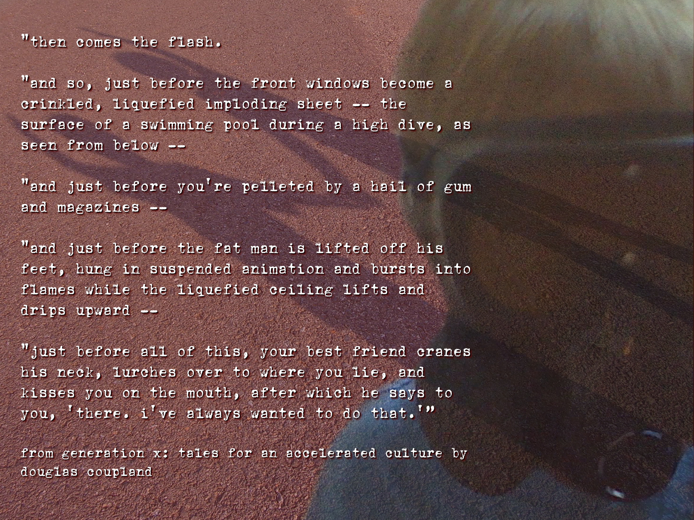

Title: “Will You Still Love Me When All of This is Gone”

Three descriptive tags: “post apocalyptic”, “generation x”, “gas mask”, “shadows”

A self critique: Digital Photo Rubric
Objective/Criteria | Performance Indicators
 | Exemplary | Competent | Emerging
Concept | (5 points)  Does an outstanding job of communicating the concept. | (4.4 points)  Does an adequate job communicating the concept. | (3.8 points)  Does a poor job communicating the concept.
Composition | (5 points)  Photograph uses composition principles very effectively. | (4.4 points)  Photograph does a good job using composition principles. | (3.8 points)  Photograph does a poor job using composition principles
Color, Contrast & Tonal Range | (5 points)  Photography displays outstanding use of color, contrast and/or tonal range. | (4.4 points)  Photography displays good color, contrast and/or tonal range. | (3.8 points)  Photograph lacks contrast, color is weak and/or tonal range is poor.
Focus | (5 points)  Focus is a perfect match with the concept of the shot. | (4.4 points)  Focus is an adequate match with the concept of the shot. | (3.8 points)  Focus is a poor match with the concept of the shot.
Technical Aspects | (5 points)  Shutter speed and aperture were perfectly chosen to match concept. Exposure and lighting are excellent. | (4.4 points)  Shutter speed and aperture were adequately chosen to match concept. Exposure and lighting are good. | (3.8 points)  Shutter speed and aperture were poorly chosen and do not match the concept. Photo is over/under exposed and lighting is poor.
Depth of Field | (5 points)  Excellent use of depth-of-field. | (4.4 points)  Adequate use of depth-of-field. | (3.8 points)  Poor use of depth-of-field.
Title/Tags | (5 points)  Title and tags were perfectly chosen and written to express the content and concept. Spelling and word choice are excellent with no mistakes. | (4.4 points)  Title and tags were adequately chosen and written to express the content and concept. Spelling and word choice are good with only minor errors. | (3.8 points)  Title and tags were poorly chosen and written to express the content and concept. Contains multiple spelling errors or wrong word choices.
Self critique & Reflection | (10 points)  Excellent self-assessment and well written reflection that answers all reflection question thoroughly. Spelling and grammar are perfect. | (8.8 points)  Adequate self-assessment and the written reflection answers most of the questions. Spelling and grammar is mostly correct with only minor errors. | (7.6 points)  Self-assessment is not complete and/or the reflection does not answer some or all of the questions. Spelling or grammar is not on par with graduate level writing yet some effort has been shown in the work submitted.
Peer Comments | (5 points)  Peer comments posted for all members of virtual group exceed expectations and spelling is correct. Comments made for each group member’s photo include one or more suggestions on how to improve the photo and discuss at least one positive attribute of the photo. Comments are very thorough and thoughtful. | (4.4 points)  Peer comments posted for all members of virtual group meet expectations and spelling is mostly correct. Comments made for each group member’s photo include one suggestion on how to improve the photo and discuss at least one positive attribute of the photo. Comments are brief but good. | (3.8 points)  One or more elements of the peer comments were missing, incomplete or poorly written. Comments may not have been made for every member of the group but some effort was evidenced in what was written. Comments need improvement.
 |  |  | out of 50

Three Paragraph Reflection
For starts – this was a blast to make. It seems I have been reading quite a bit lately and of my reading this post apocalyptic theme flashes off the pages blinding and melting and imploding the walls around me. So I thought of the horrific, the eerie, the melancholy for this assignment. I used layering and some creative filters to achieve the mood and tone of dystopian justice.

Layers – I kind of feel that I over did this one. It was very difficult to work with text – what part of the image should or could you cover, how big should you make the text. Then – of course – should you use text at all? Will it change the meaning? What should be the focal point? Difficult choices to make and ones I did not take lightly. With all that said, there is too much to mention as far as what I could fix, change, and enhance.

Could we use the OPTIC (Overview-Parts-Title-Interrelationships-Conclusion) activity once again. Since there are so many parts to this photograph – gas mask, shadows, color, text, et cetera - I would then have my students look closely at each part of the photograph individually and explain how the picture would change if one removed one or more of the individual parts. We could then discuss how the parts of a photograph can skew an audience interpretation of meaning. Then of course I would have them bring in photographs of their own to discuss.

P8 Comments
Susan Biggers: Interesting little fuzz you have got going on there. I like the subtleness of the change between the unedited and the filtered shot. It gives the photograph and nice warm feeling – not sure if this is what you were shooting for but it worked. Only change I would suggest – maybe add just a bit more filter to fuzz it like they often did in old-time movies to starlets.
Kristin Limbaugh: I really like the filter here. I really appreciate how it changes the whole tonality of the picture. Quite different from the original. What would be neat is to add some color like them old Technicolor films back in the day. Just a though. Like the picture.
Andrea Harper: Birds are crazy things – have one nesting right outside of my front door in my wee ones “Radio Flyer” wagon. Strange place to make a nest. I like the bird – I like the trees and scenic shot – I am just not sure about the placement. The bird hanging right in the middle kind of takes away from the other shot – some strange ghost bird in the sky. Anyway – great shots.
Joy Renfro: I am really impressed with this shot – as if that means anything to the world of photography. The shot by itself is a treat then you add the filtered effect and you have something close to perfection. With that said – what can I say more? I truly feel you accomplished the tone – composition – nostalgia of the shot.

