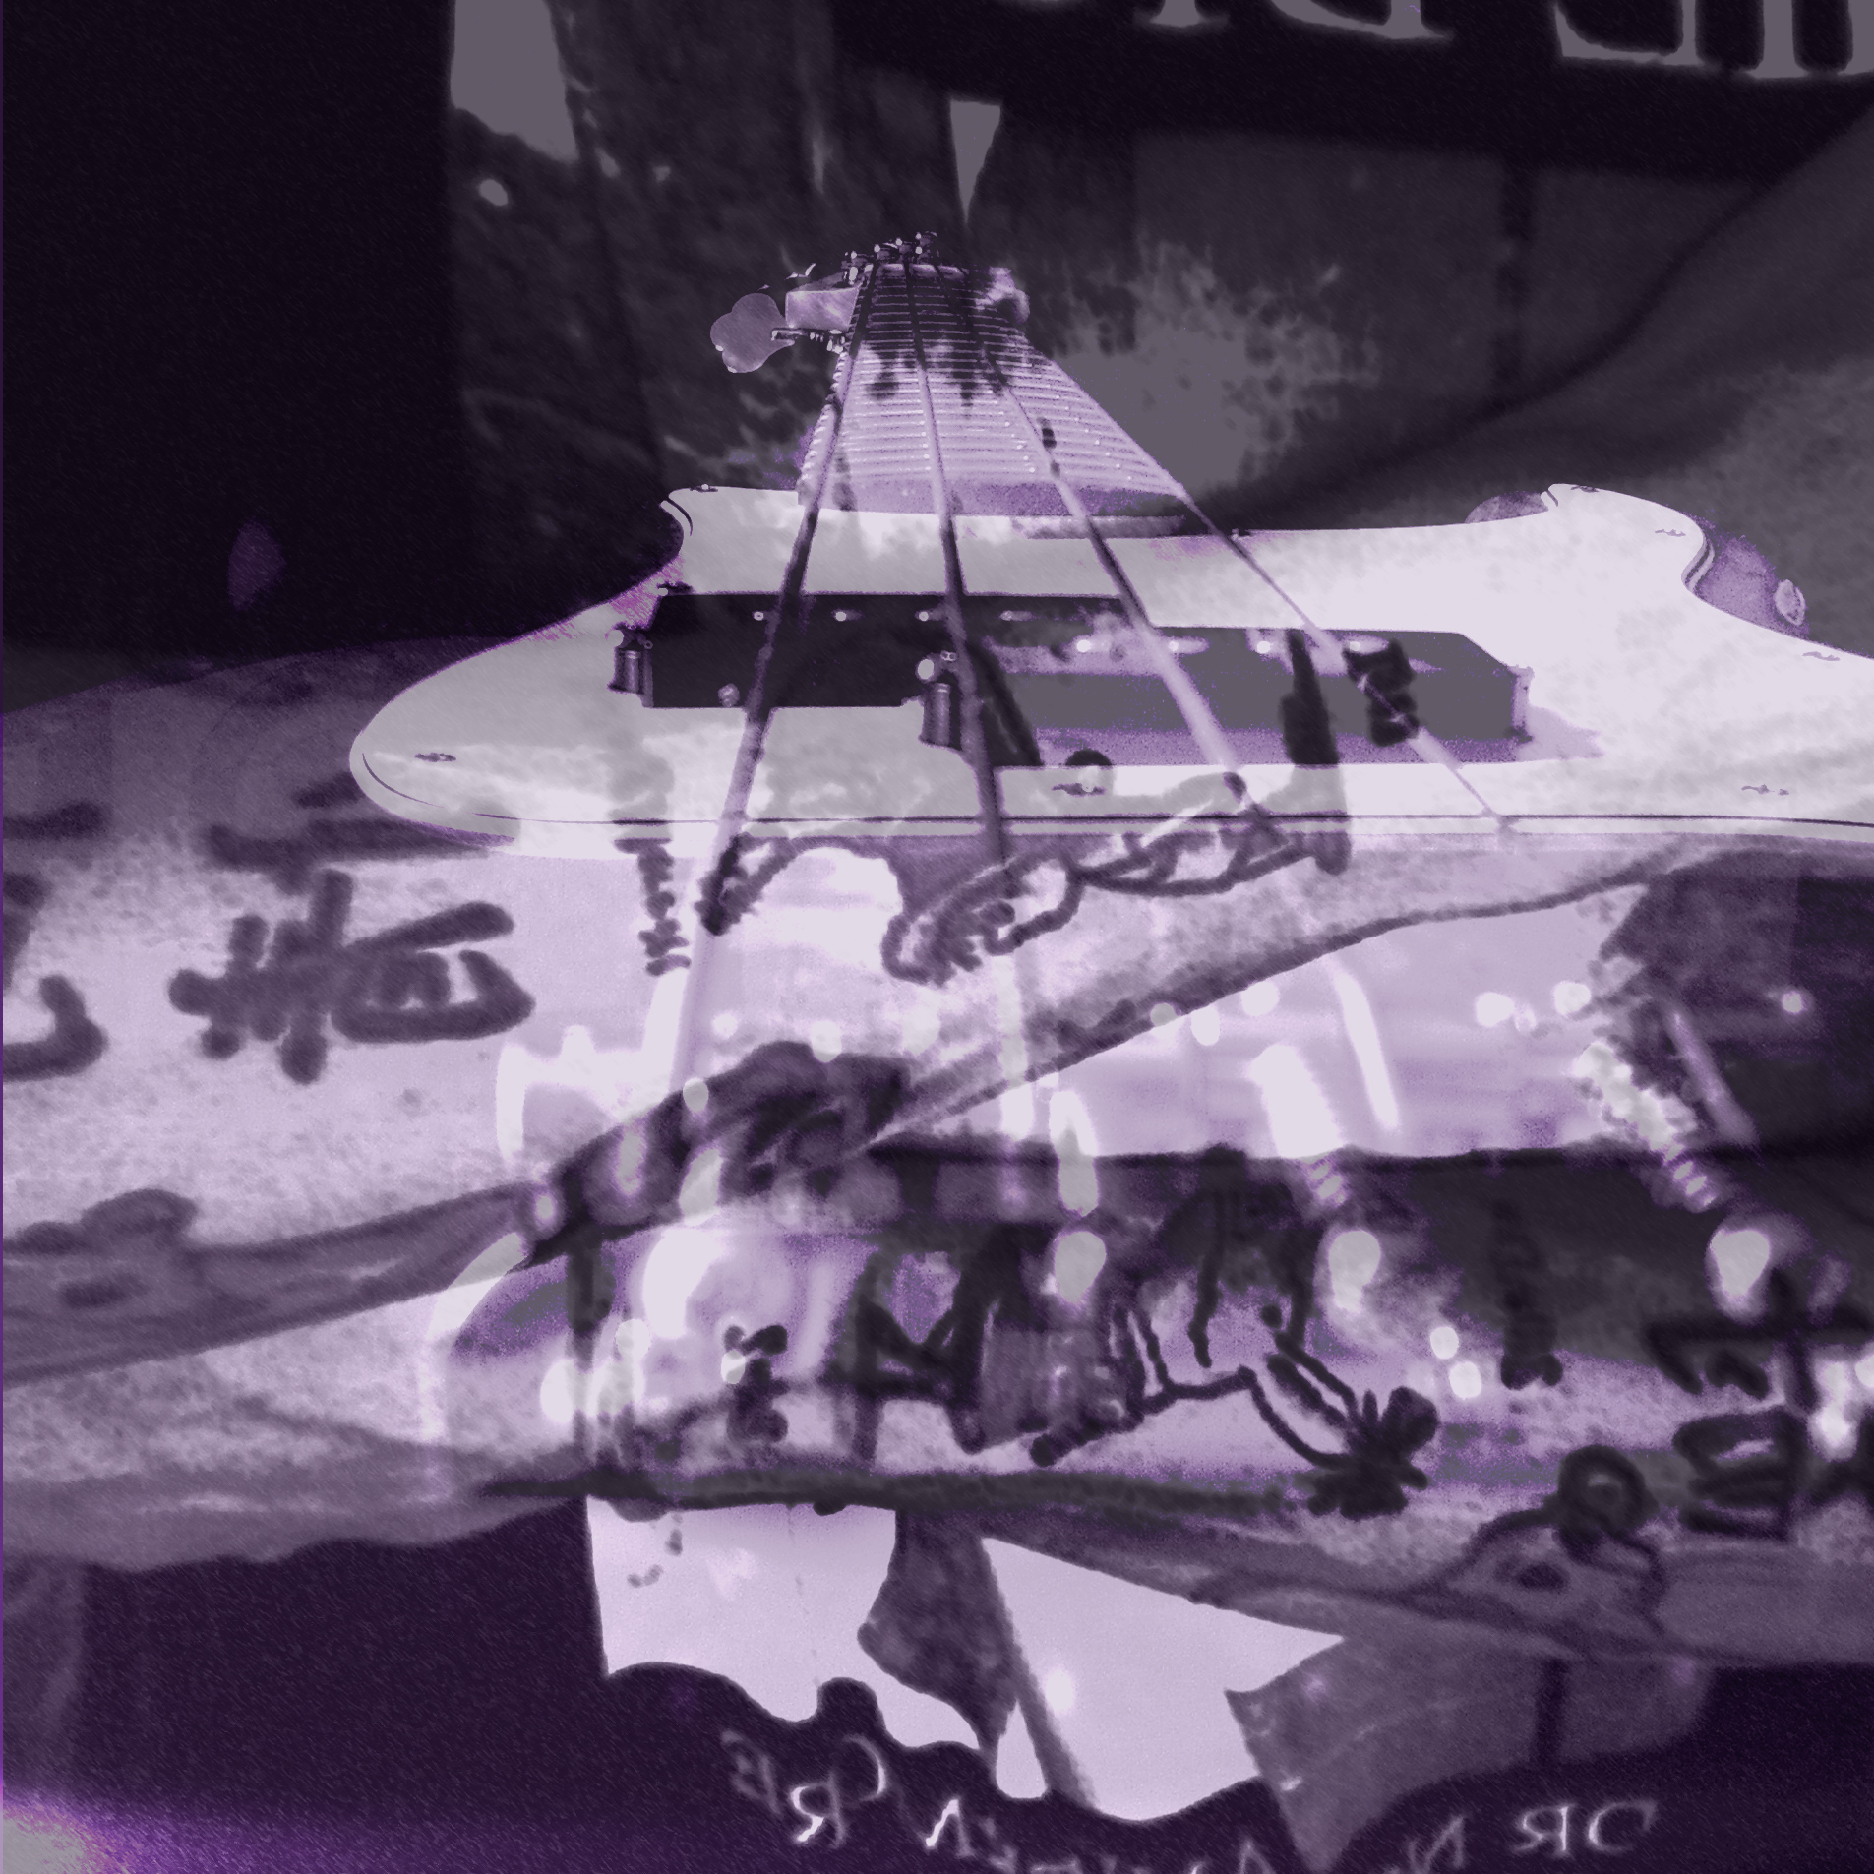

Title: “Musician’s Friend”

Three descriptive tags: “music”, “bass”, “tattoos”, “three layers”

A self critique: Digital Photo Rubric
Objective/Criteria | Performance Indicators
 | Exemplary | Competent | Emerging
Concept | (5 points)  Does an outstanding job of communicating the concept. | (4.4 points)  Does an adequate job communicating the concept. | (3.8 points)  Does a poor job communicating the concept.
Composition | (5 points)  Photograph uses composition principles very effectively. | (4.4 points)  Photograph does a good job using composition principles. | (3.8 points)  Photograph does a poor job using composition principles
Color, Contrast & Tonal Range | (5 points)  Photography displays outstanding use of color, contrast and/or tonal range. | (4.4 points)  Photography displays good color, contrast and/or tonal range. | (3.8 points)  Photograph lacks contrast, color is weak and/or tonal range is poor.
Focus | (5 points)  Focus is a perfect match with the concept of the shot. | (4.4 points)  Focus is an adequate match with the concept of the shot. | (3.8 points)  Focus is a poor match with the concept of the shot.
Technical Aspects | (5 points)  Shutter speed and aperture were perfectly chosen to match concept. Exposure and lighting are excellent. | (4.4 points)  Shutter speed and aperture were adequately chosen to match concept. Exposure and lighting are good. | (3.8 points)  Shutter speed and aperture were poorly chosen and do not match the concept. Photo is over/under exposed and lighting is poor.
Depth of Field | (5 points)  Excellent use of depth-of-field. | (4.4 points)  Adequate use of depth-of-field. | (3.8 points)  Poor use of depth-of-field.
Title/Tags | (5 points)  Title and tags were perfectly chosen and written to express the content and concept. Spelling and word choice are excellent with no mistakes. | (4.4 points)  Title and tags were adequately chosen and written to express the content and concept. Spelling and word choice are good with only minor errors. | (3.8 points)  Title and tags were poorly chosen and written to express the content and concept. Contains multiple spelling errors or wrong word choices.
Self critique & Reflection | (10 points)  Excellent self-assessment and well written reflection that answers all reflection question thoroughly. Spelling and grammar are perfect. | (8.8 points)  Adequate self-assessment and the written reflection answers most of the questions. Spelling and grammar is mostly correct with only minor errors. | (7.6 points)  Self-assessment is not complete and/or the reflection does not answer some or all of the questions. Spelling or grammar is not on par with graduate level writing yet some effort has been shown in the work submitted.
Peer Comments | (5 points)  Peer comments posted for all members of virtual group exceed expectations and spelling is correct. Comments made for each group member’s photo include one or more suggestions on how to improve the photo and discuss at least one positive attribute of the photo. Comments are very thorough and thoughtful. | (4.4 points)  Peer comments posted for all members of virtual group meet expectations and spelling is mostly correct. Comments made for each group member’s photo include one suggestion on how to improve the photo and discuss at least one positive attribute of the photo. Comments are brief but good. | (3.8 points)  One or more elements of the peer comments were missing, incomplete or poorly written. Comments may not have been made for every member of the group but some effort was evidenced in what was written. Comments need improvement.
 |  |  | out of 50

Three Paragraph Reflection
Since I have yet to post a Photograph with more than two layers I choose to play around a bit. I enjoyed taking two original photos and manipulating them in PhotoShop adding a third layer of color to enhance the tonality of the shot. I truly enjoyed this assignment allowing me to play around with the artistic side of photo editing. These are the projects I live for.

I really like the outcome of the photo and am not real sure what I could do to improve the shot. Maybe – If I think really hard on this one – I could have added another original photo (for example a close-up of my eye or face or lack of hair). I could have played around with the colors as well trying different combinations and such.

I have always been a fan of music and art and feel – just as the Pre-Raphaelite movement of the Victorian era did – that music art and literature work well together. I would use this photograph to spark discussion about tone and mood – how the choice of imagery and color reflect the title. I would have my students look at the language of the photograph using OPTIC (O - is for overview - write down a few notes on what the visual appears to be about. P - is for parts-zero in on the parts of the visual. Write down any elements or details that seem important. T - is for title-highlight the words of the title of the visual (if one is available). I - is for interrelationships-use the title as the theory and the parts of the visual as clues to detect and specify the interrelationships in the graphic. C - is for conclusion--draw a conclusion about the visual as a whole. What does the visual mean? Summarize the message of the visual in one or two sentences.) and use for discussion. This – of course – would be for a High School English class – the only class I know how to teach.

P4 Comments
Susan Biggers: Another great shot. I don’t like ducks as much as rocks though. The contrast in colors is wonderful – maybe you could brighten up those colors a bit. Maybe pull back a bit creating more of a box around the ducks – more plants and more lake centering the ducks a bit more. Heck – I am pulling for straws here. It really is a good shot.
Kristin Limbaugh: The composition of the photograph is wondrous. I am sure that it was really difficult to capture the two butterflies without losing focus or your subjects for that matter. One big “GREAT JOB” to you. Not so sure about the removal of the background color though. It is a neat concept but it seems to take away from the beauty of the butterflies themselves. It removes your subjects to the point that they looked placed more than natural. Maybe try another filter technique leaving the color in. Who knows? With that said – it is still a wondrous shot and is appreciated.
Andrea Harper: WOW – that’s some color. Great contrasts between the different varieties of flowers. From this perspective I am assuming that the rose is the focal point of this shot. With this said the vivid green (almost neon) takes away from the warmth of the peach-like color of the rose. The purple in the background looks nice though. Did you use some sort of filter on this picture or tweak the colors a bit? Anyway – good shot.
Joy Renfro: “Houses of the Holy” – okay bad Zepplin reference here, there, and everywhere (just full of them tonight). Running water is a difficult shot. I understand that the focus should be on the rocks here and the water and trees and such should be the contrasting background. All I can focus on is the water (slightly out of focus) against the rocks. The mist as well almost casting a dark spell on all of it transports me somewhere else. Is this where days of old and knights of bold comes from or maybe Tennyson’s “Lady of Shallot”? it definitely catches mood – but – is it the mood you were looking for?

