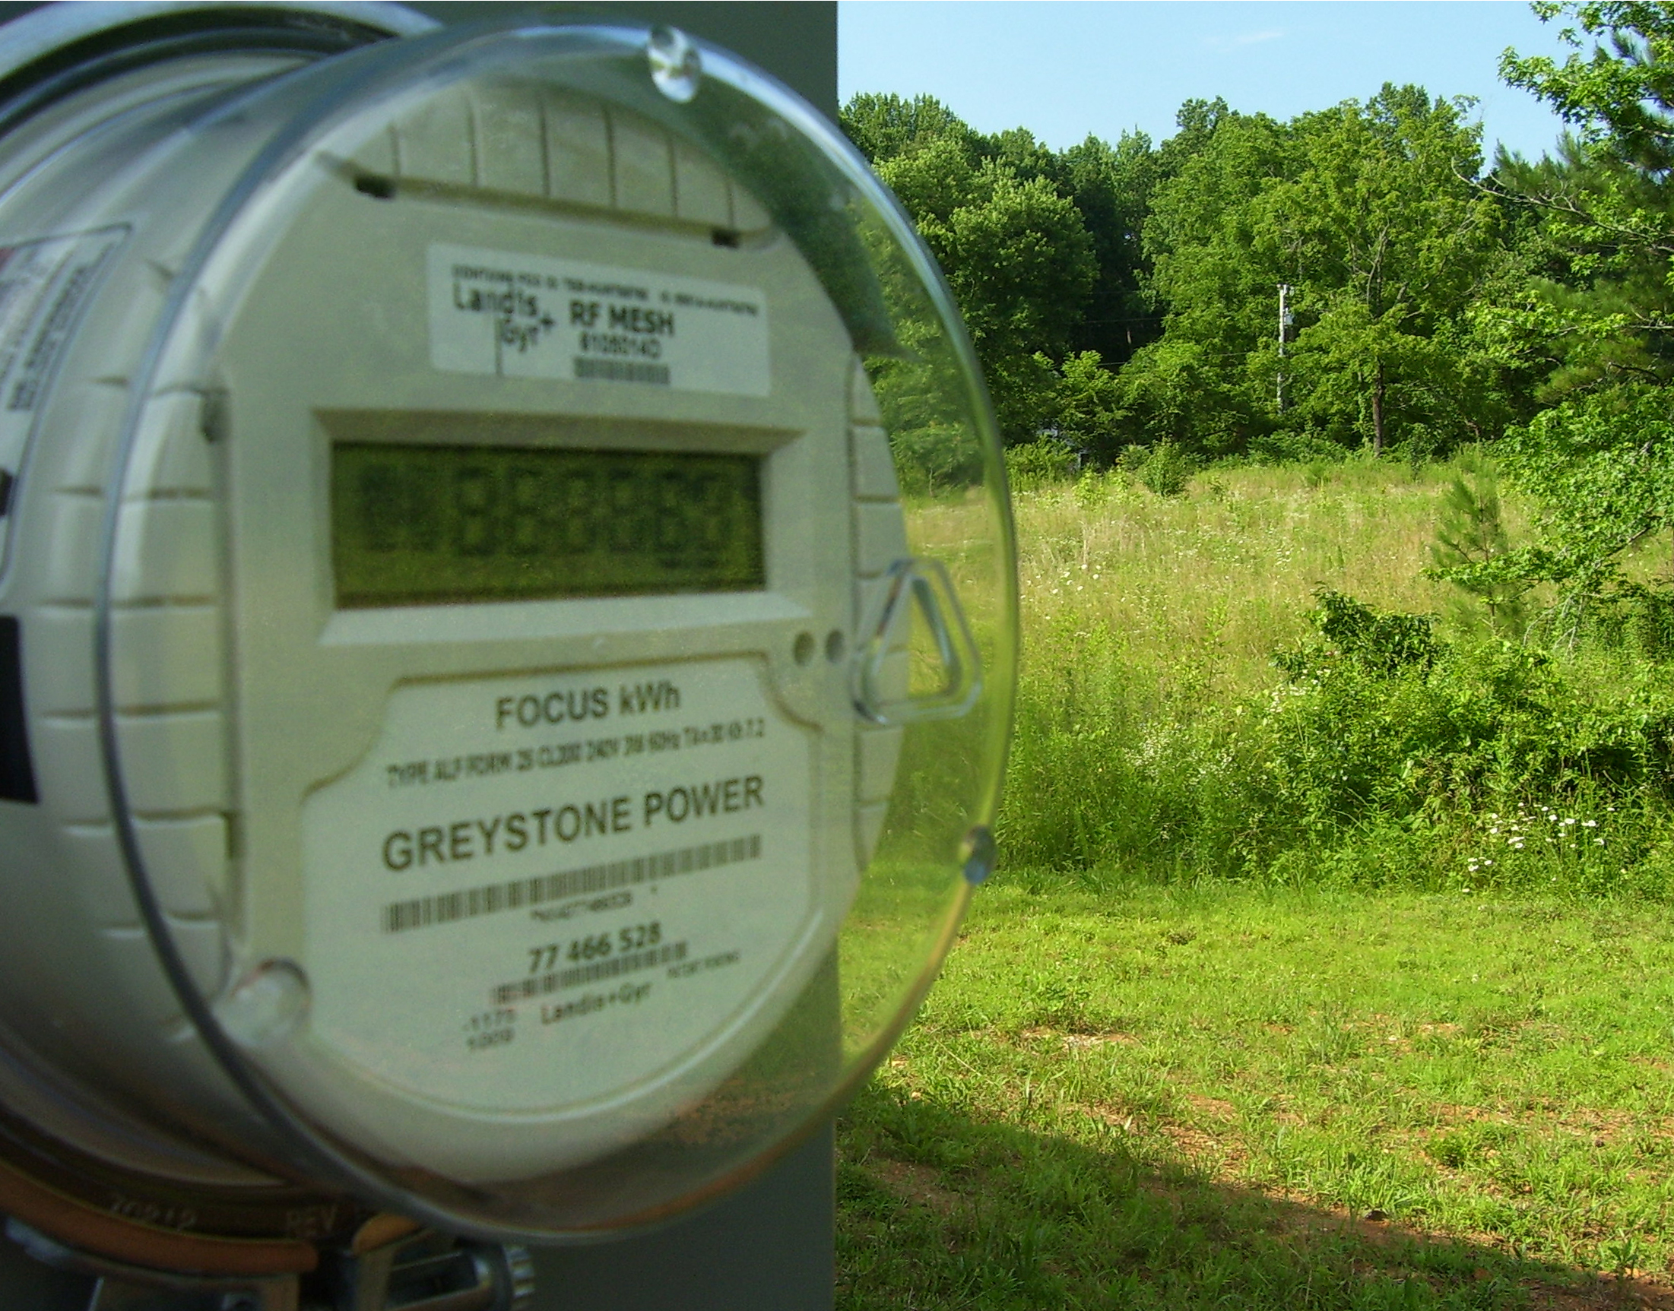

Title: “Meter Man”

Three descriptive tags: “depth of field”, “meter”, “field”, “green”

A self critique: Digital Photo Rubric
Objective/Criteria | Performance Indicators
 | Exemplary | Competent | Emerging
Concept | (5 points)  Does an outstanding job of communicating the concept. | (4.4 points)  Does an adequate job communicating the concept. | (3.8 points)  Does a poor job communicating the concept.
Composition | (5 points)  Photograph uses composition principles very effectively. | (4.4 points)  Photograph does a good job using composition principles. | (3.8 points)  Photograph does a poor job using composition principles
Color, Contrast & Tonal Range | (5 points)  Photography displays outstanding use of color, contrast and/or tonal range. | (4.4 points)  Photography displays good color, contrast and/or tonal range. | (3.8 points)  Photograph lacks contrast, color is weak and/or tonal range is poor.
Focus | (5 points)  Focus is a perfect match with the concept of the shot. | (4.4 points)  Focus is an adequate match with the concept of the shot. | (3.8 points)  Focus is a poor match with the concept of the shot.
Technical Aspects | (5 points)  Shutter speed and aperture were perfectly chosen to match concept. Exposure and lighting are excellent. | (4.4 points)  Shutter speed and aperture were adequately chosen to match concept. Exposure and lighting are good. | (3.8 points)  Shutter speed and aperture were poorly chosen and do not match the concept. Photo is over/under exposed and lighting is poor.
Depth of Field | (5 points)  Excellent use of depth-of-field. | (4.4 points)  Adequate use of depth-of-field. | (3.8 points)  Poor use of depth-of-field.
Title/Tags | (5 points)  Title and tags were perfectly chosen and written to express the content and concept. Spelling and word choice are excellent with no mistakes. | (4.4 points)  Title and tags were adequately chosen and written to express the content and concept. Spelling and word choice are good with only minor errors. | (3.8 points)  Title and tags were poorly chosen and written to express the content and concept. Contains multiple spelling errors or wrong word choices.
Self critique & Reflection | (10 points)  Excellent self-assessment and well written reflection that answers all reflection question thoroughly. Spelling and grammar are perfect. | (8.8 points)  Adequate self-assessment and the written reflection answers most of the questions. Spelling and grammar is mostly correct with only minor errors. | (7.6 points)  Self-assessment is not complete and/or the reflection does not answer some or all of the questions. Spelling or grammar is not on par with graduate level writing yet some effort has been shown in the work submitted.
Peer Comments | (5 points)  Peer comments posted for all members of virtual group exceed expectations and spelling is correct. Comments made for each group member’s photo include one or more suggestions on how to improve the photo and discuss at least one positive attribute of the photo. Comments are very thorough and thoughtful. | (4.4 points)  Peer comments posted for all members of virtual group meet expectations and spelling is mostly correct. Comments made for each group member’s photo include one suggestion on how to improve the photo and discuss at least one positive attribute of the photo. Comments are brief but good. | (3.8 points)  One or more elements of the peer comments were missing, incomplete or poorly written. Comments may not have been made for every member of the group but some effort was evidenced in what was written. Comments need improvement.
 |  |  | out of 50

Three Paragraph Reflection
This has been the most difficult shot and assignment thus far. I am still grasping the idea of depth of field using the textbook and internet sources I think I have accomplished my mission though not as well as I could have. With a point and shoot camera – as the one I have – the textbook explained it is difficult with point-and-shoot cameras to achieve separation between foregrounds and backgrounds. My hope was that the line of the house naturally dividing the photograph in halves would achieve this. Not sure how it went though.
I feel that this assignment definitely shed light on the subject of depth of field. Although I feel that with control of my aperture I would have valued this assignment quite a bit more – you work with what you have got. As far as what I could have done to improve the shot, the answer is countless and far too comprehensive to list – to put it bluntly – I have quite a bit to learn on this subject area. Finding a suitable target was difficult, lighting was difficult, color was difficult, understanding the concept was difficult, et cetera.
This is definitely an important lesson to be taught in any educational setting and one that requires hands-on attention. I would definitely have my students roam around the school snapping photos and exploring the depth of field captured with each photo. Maybe a depth of field photo journal in itself would be required. Different depths of field for different folks. As syntax is difficult when looking at language – depth of field is difficult when looking and photo composition. Both equally difficult and uniformly important.
P3 Comments
Susan Biggers: Rocks and more Rocks! Okay – don’t think me a freak for liking rocks. I really enjoy the depth of each stone pile reaching around the stream. There is great balance in this photo with the nearby rock pile and the pile in the background. It does lose some feeling – maybe the want of the same green from the close-up on the rolling hill or the lack of blue in the grey background? You could have – maybe – blued up the sky a bit with some photo editing although it might have taken away from the natural aspect. With that said – great shot. Did I happen to mention how much I love Rocks!
Kristin Limbaugh: I like the close up of your brother – nice teeth. I was wondering if you cropped the picture? For some reason it looks to me like his arm is around something. It takes away from the symmetry of it (I think that is the word I am looking for) the line is not quite straight but looks like it should be.
Andrea Harper: That is one impressive shot. It has great balance between the two towers (not a Lord of the Rings reference although it could be). The green of the trees – the blue of the sky – the white and red of the towers – even the grey of the asphalt create a wonderful blend of color and contrast. The only suggestion – one side is brighter than the other creating somewhat of a distraction – I know you can’t change the direction of the sun – but maybe tweak the levels a bit to equal it all out. Overall – I am really impressed with this photograph.
Joy Renfro: This is a great shot. It really captures depth with the focal point the door at the end and the almost perfect bending of the branches creating a very likable and welcoming archway. The name “Gate of Opportunity” is really captured here. I would try it in color. Whether the leaves are green or a nice fall background – I feel that color would help out a bit to add to the welcoming feeling that presents itself. Overall good shot.

