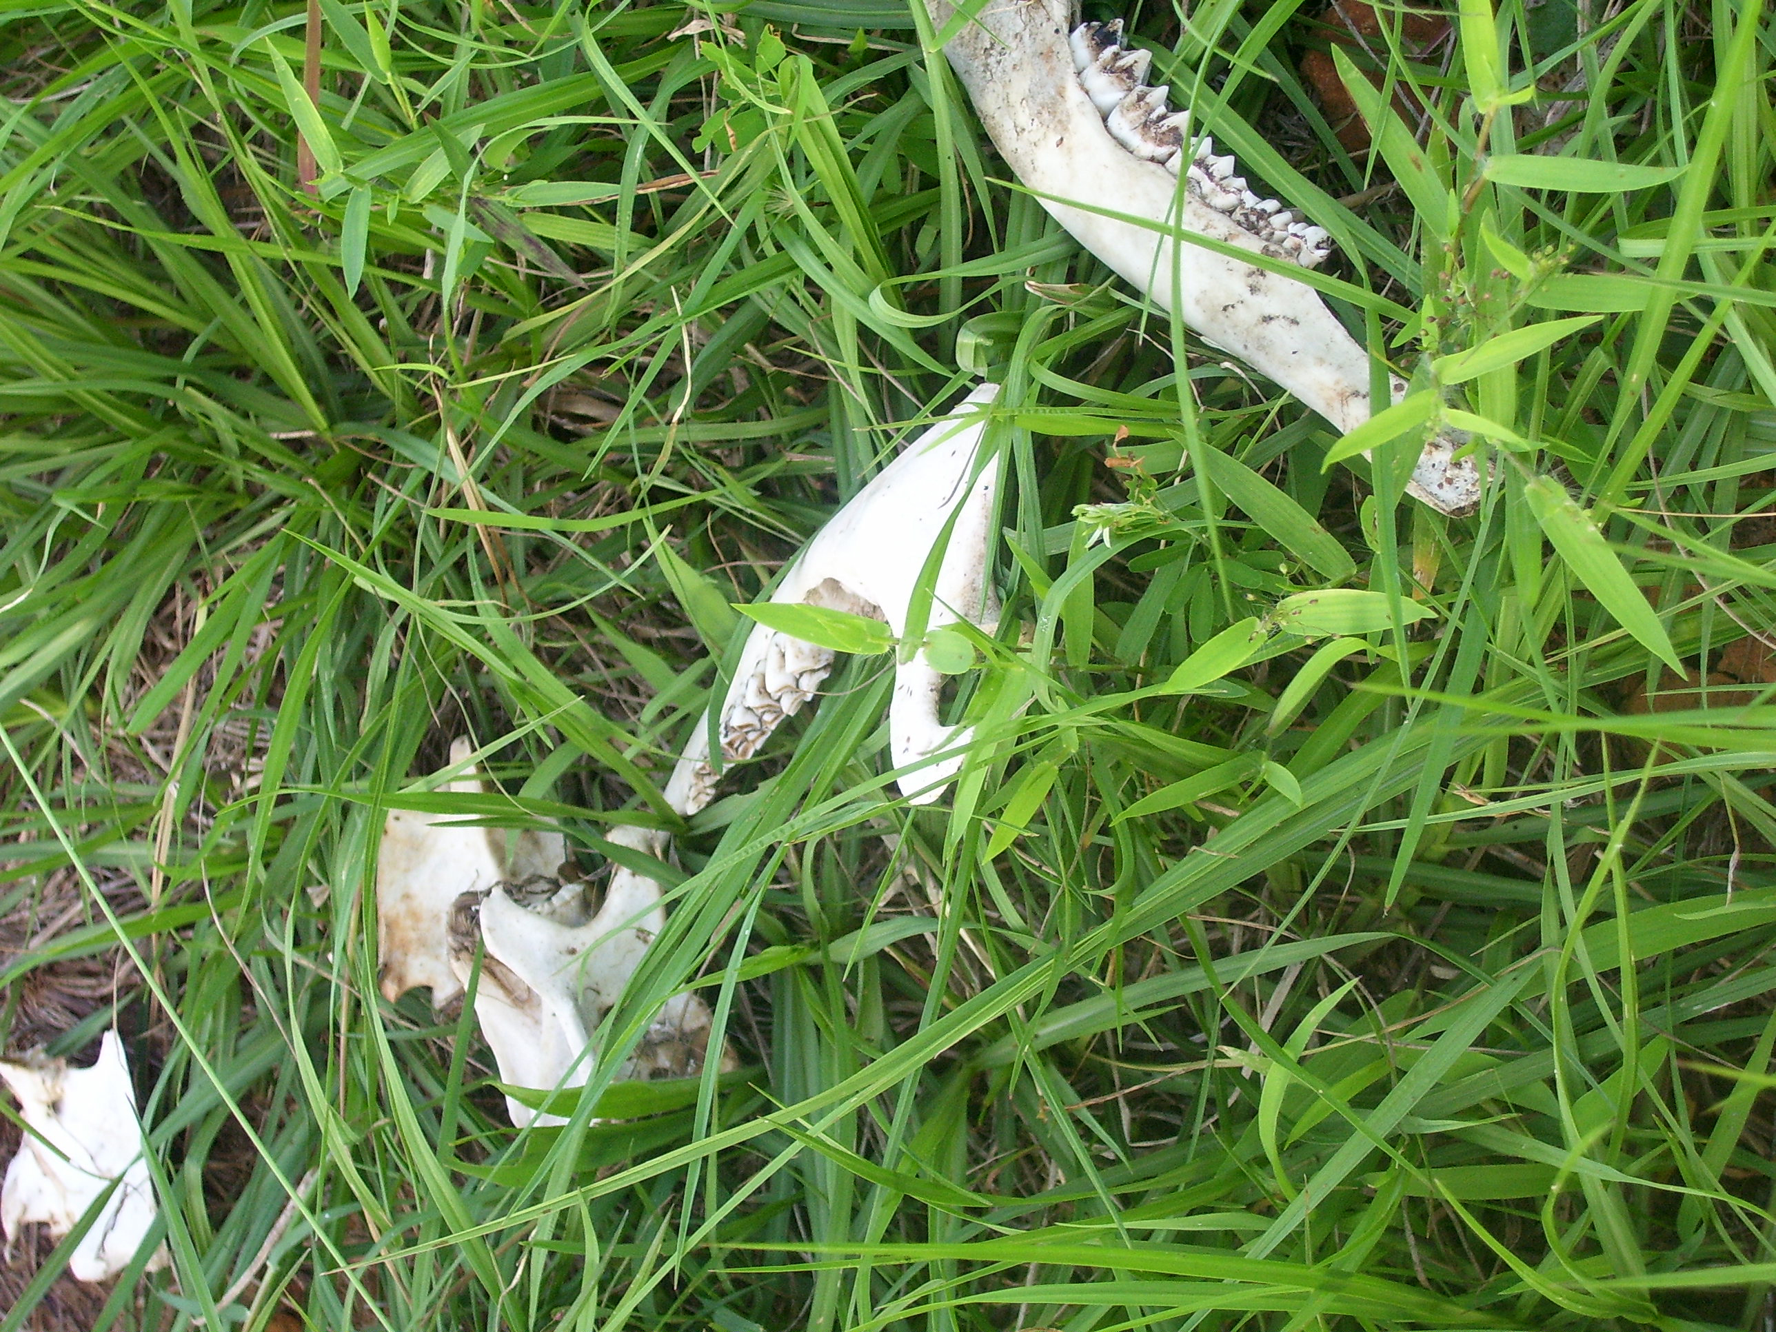

Title: “dem bones”

Three descriptive tags: “close-up”, “bones”, “grass”

A self critique: Digital Photo Rubric
Objective/Criteria | Performance Indicators
 | Exemplary | Competent | Emerging
Concept | (5 points)  Does an outstanding job of communicating the concept. | (4.4 points)  Does an adequate job communicating the concept. | (3.8 points)  Does a poor job communicating the concept.
Composition | (5 points)  Photograph uses composition principles very effectively. | (4.4 points)  Photograph does a good job using composition principles. | (3.8 points)  Photograph does a poor job using composition principles
Color, Contrast & Tonal Range | (5 points)  Photography displays outstanding use of color, contrast and/or tonal range. | (4.4 points)  Photography displays good color, contrast and/or tonal range. | (3.8 points)  Photograph lacks contrast, color is weak and/or tonal range is poor.
Focus | (5 points)  Focus is a perfect match with the concept of the shot. | (4.4 points)  Focus is an adequate match with the concept of the shot. | (3.8 points)  Focus is a poor match with the concept of the shot.
Technical Aspects | (5 points)  Shutter speed and aperture were perfectly chosen to match concept. Exposure and lighting are excellent. | (4.4 points)  Shutter speed and aperture were adequately chosen to match concept. Exposure and lighting are good. | (3.8 points)  Shutter speed and aperture were poorly chosen and do not match the concept. Photo is over/under exposed and lighting is poor.
Depth of Field | (5 points)  Excellent use of depth-of-field. | (4.4 points)  Adequate use of depth-of-field. | (3.8 points)  Poor use of depth-of-field.
Title/Tags | (5 points)  Title and tags were perfectly chosen and written to express the content and concept. Spelling and word choice are excellent with no mistakes. | (4.4 points)  Title and tags were adequately chosen and written to express the content and concept. Spelling and word choice are good with only minor errors. | (3.8 points)  Title and tags were poorly chosen and written to express the content and concept. Contains multiple spelling errors or wrong word choices.
Self critique & Reflection | (10 points)  Excellent self-assessment and well written reflection that answers all reflection question thoroughly. Spelling and grammar are perfect. | (8.8 points)  Adequate self-assessment and the written reflection answers most of the questions. Spelling and grammar is mostly correct with only minor errors. | (7.6 points)  Self-assessment is not complete and/or the reflection does not answer some or all of the questions. Spelling or grammar is not on par with graduate level writing yet some effort has been shown in the work submitted.
Peer Comments | (5 points)  Peer comments posted for all members of virtual group exceed expectations and spelling is correct. Comments made for each group member’s photo include one or more suggestions on how to improve the photo and discuss at least one positive attribute of the photo. Comments are very thorough and thoughtful. | (4.4 points)  Peer comments posted for all members of virtual group meet expectations and spelling is mostly correct. Comments made for each group member’s photo include one suggestion on how to improve the photo and discuss at least one positive attribute of the photo. Comments are brief but good. | (3.8 points)  One or more elements of the peer comments were missing, incomplete or poorly written. Comments may not have been made for every member of the group but some effort was evidenced in what was written. Comments need improvement.
 |  |  | out of 50

Three Paragraph Reflection
For this assignment each individual was to choose a different mode (other than portrait mode) for his or her photograph. Looking at all the modes available, I choose to use the close up mode with my newly acquired tripod. In the empty lot next to my house my children and I stumbled upon some white washed weather worn dog bones in some over grown grass. Using the tripod I took several pictures of the bones choosing the one I felt had the best contrast in color and one that was in focus. With this said, I enjoyed the shot and finally had the opportunity to try a new mode on my garage sale camera.
As far as improving the shot, I probably could have zoned in – or should I say zoomed in – on bone in particular and really utilized the close-up feature of the camera. I could have also changed angles, maybe shot more directly above or even ground level. That would be pretty cool.
Educational setting – this is probably a tough one that needs some thought. The photograph could easily be used to show the decomposing process in a science classroom. Although somewhat sick sounding, students could use their camera to show the different stages of decomposition in a natural environment. Not sure how happy parents would be with their sons and daughters taking pictures of road kill – but it would be interesting.

P2 Comments
Susan Biggers: Neat composition - the only fixer I see would be the extreme contrast in the top right corner of the picture. It looks sort of washed out. Maybe play with the levels a bit.
Kristin Limbaugh: I really like the lines on this one. It almost looks like it was taken through a yellow filter or that the colors are slightly off – could just be my computer. The background does look a bit hazy – like smog in the country if there is such a thing.
Andrea Harper: The colors are wonderful her. Makes me want to dive right in – taking some allergy meds first of course. Maybe it is my OCD but the lines are not straight. The roof and the curb just do not line up. It looks like it is sinking – an American leaning tower of Pizza (I could not resist).
Joy Renfro: This picture is truly great. Not sure how I would fix this one although I would not mind seeing a version in black and white - bring out that Robert Mapplethorpe meets Georgia O'Keeffe aspect.

