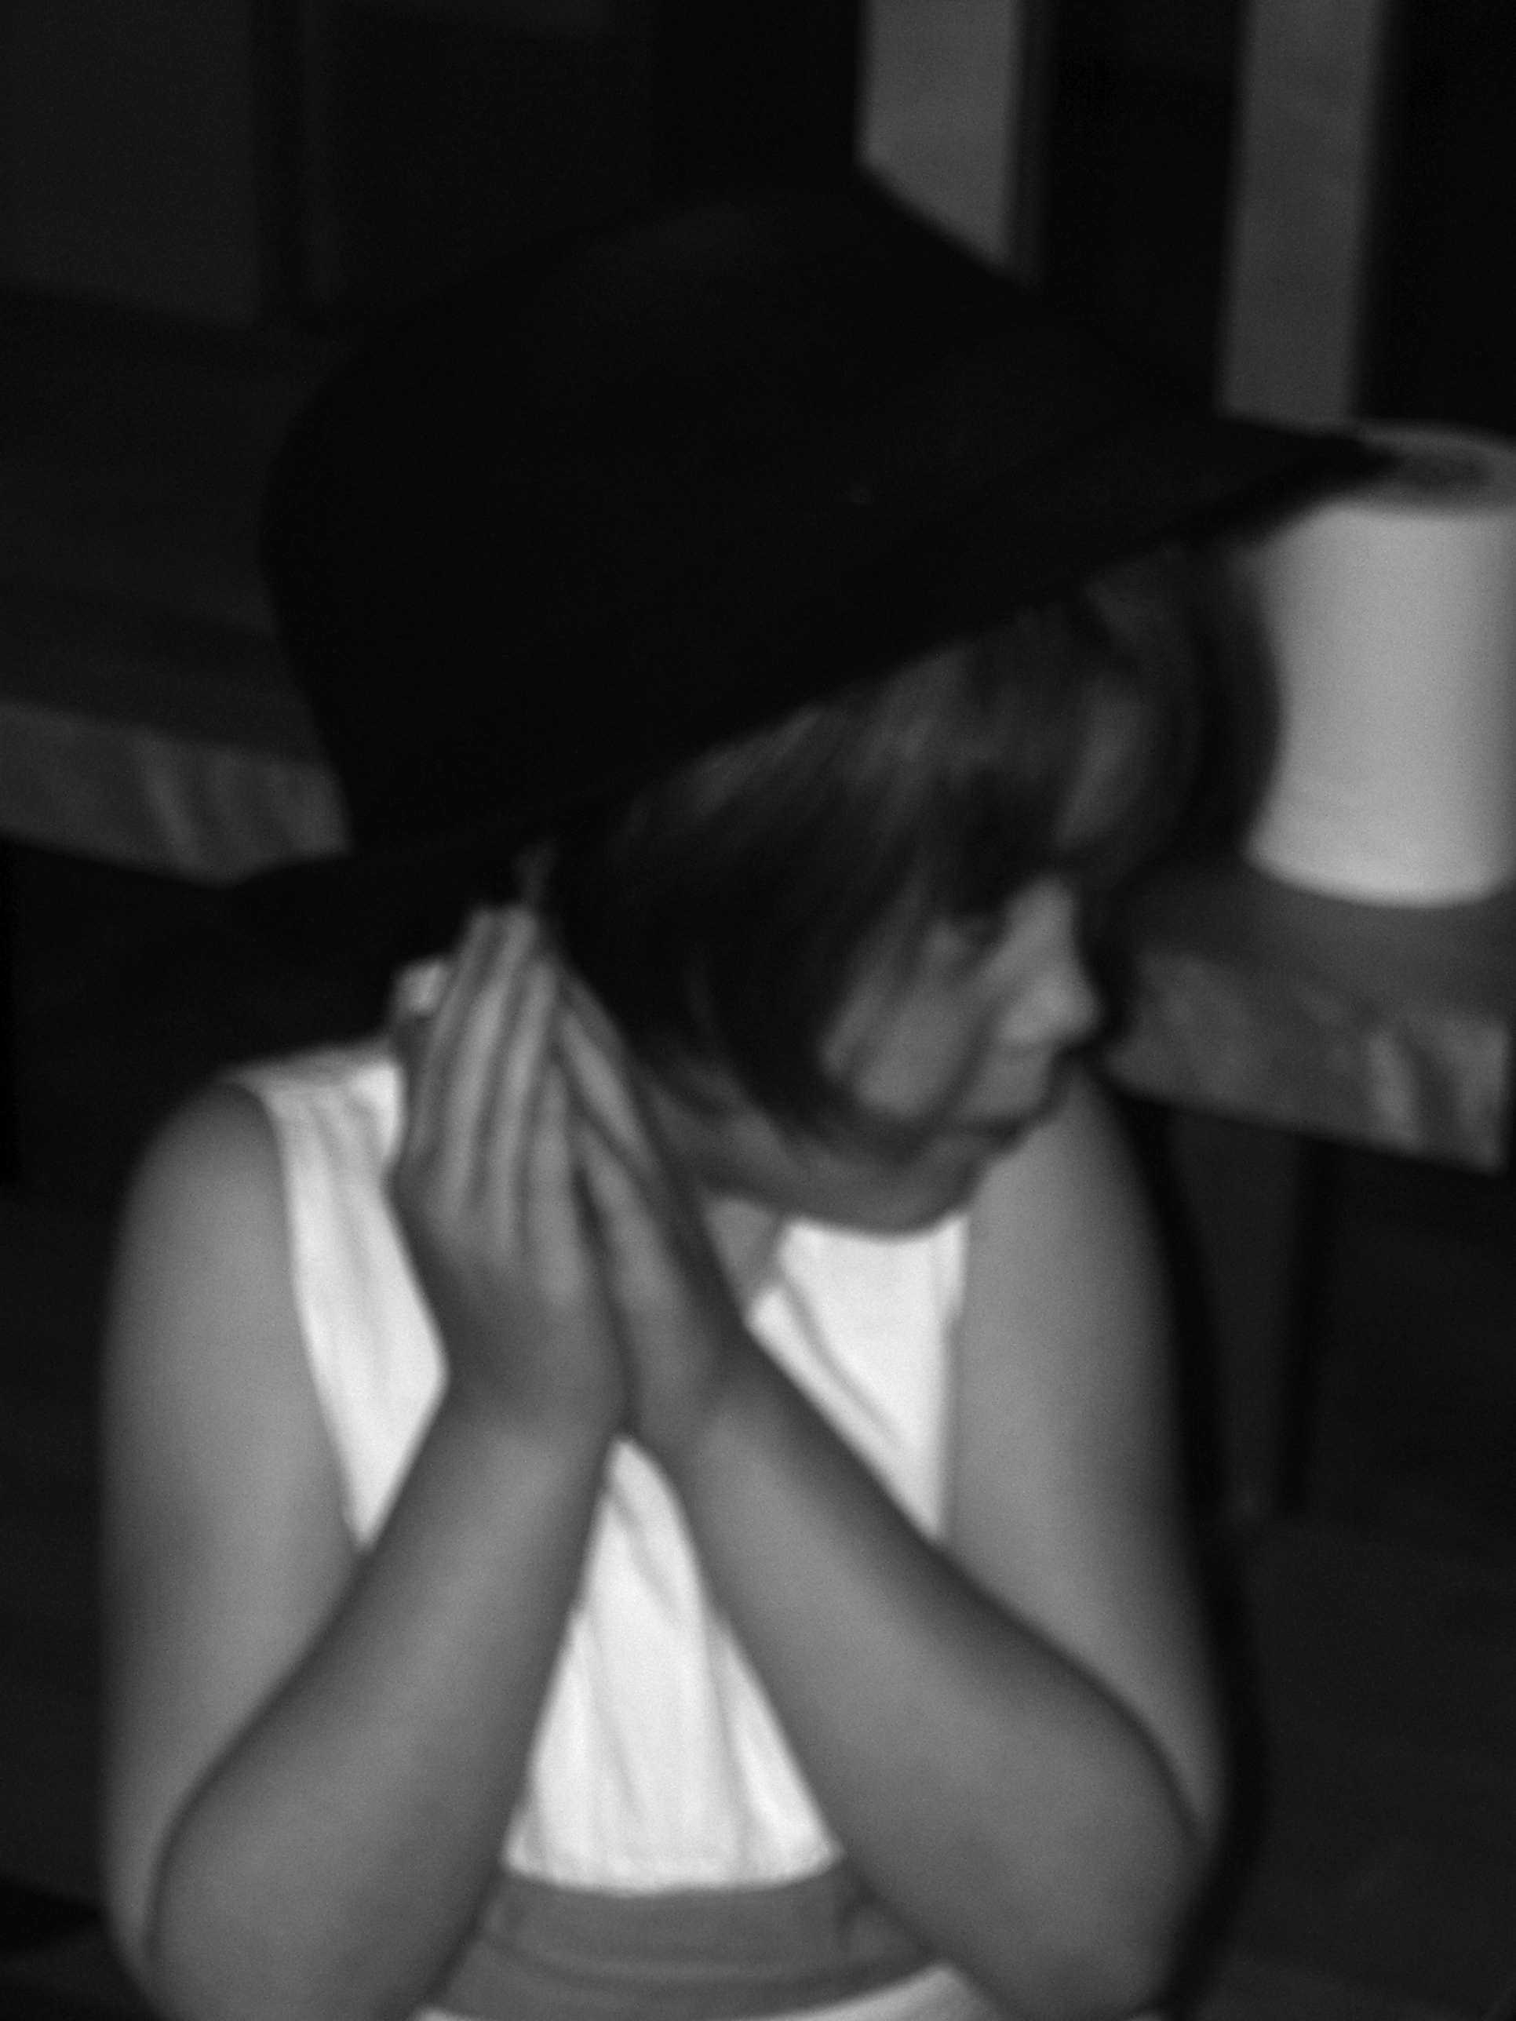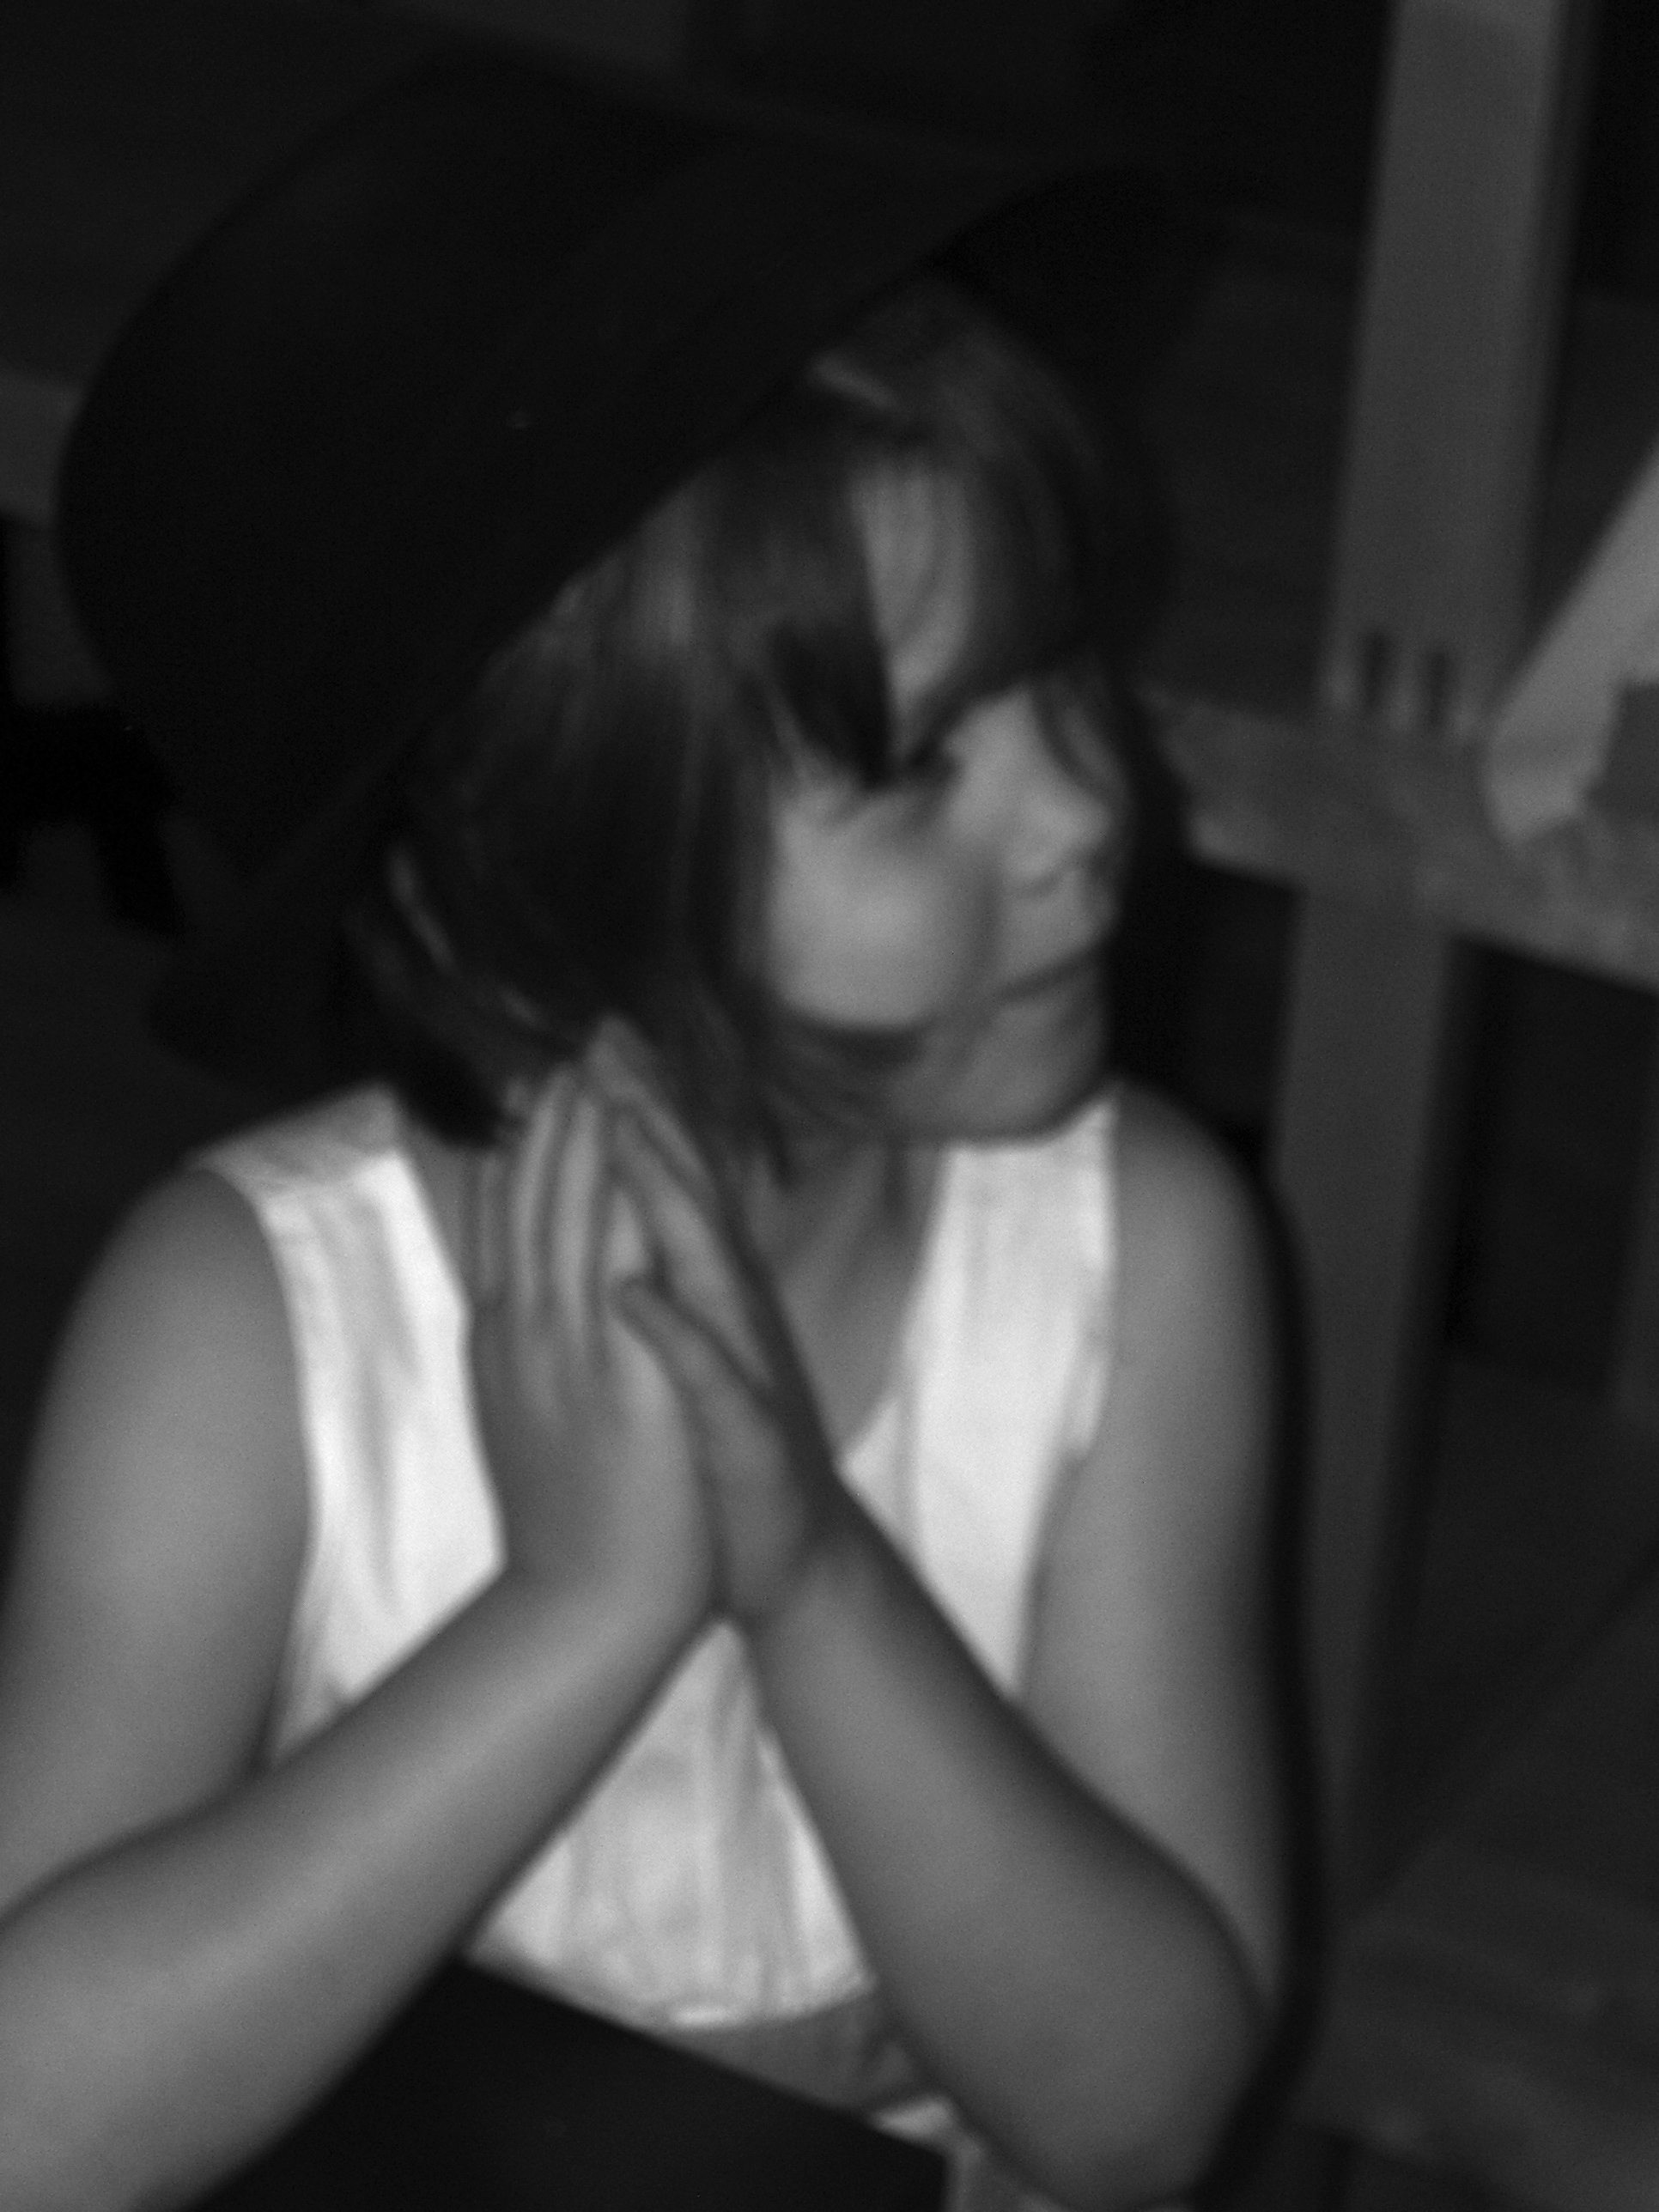

Title: “papa’s hat 01” and “papa’s hat 02”

Three descriptive tags: “papa”, “hat”, “baby z”, “first take”

A self critique: Digital Photo Rubric
Objective/Criteria | Performance Indicators
 | Exemplary | Competent | Emerging
Concept | (5 points)  Does an outstanding job of communicating the concept. | (4.4 points)  Does an adequate job communicating the concept. | (3.8 points)  Does a poor job communicating the concept.
Composition | (5 points)  Photograph uses composition principles very effectively. | (4.4 points)  Photograph does a good job using composition principles. | (3.8 points)  Photograph does a poor job using composition principles
Color, Contrast & Tonal Range | (5 points)  Photography displays outstanding use of color, contrast and/or tonal range. | (4.4 points)  Photography displays good color, contrast and/or tonal range. | (3.8 points)  Photograph lacks contrast, color is weak and/or tonal range is poor.
Focus | (5 points)  Focus is a perfect match with the concept of the shot. | (4.4 points)  Focus is an adequate match with the concept of the shot. | (3.8 points)  Focus is a poor match with the concept of the shot.
Technical Aspects | (5 points)  Shutter speed and aperture were perfectly chosen to match concept. Exposure and lighting are excellent. | (4.4 points)  Shutter speed and aperture were adequately chosen to match concept. Exposure and lighting are good. | (3.8 points)  Shutter speed and aperture were poorly chosen and do not match the concept. Photo is over/under exposed and lighting is poor.
Depth of Field | (5 points)  Excellent use of depth-of-field. | (4.4 points)  Adequate use of depth-of-field. | (3.8 points)  Poor use of depth-of-field.
Title/Tags | (5 points)  Title and tags were perfectly chosen and written to express the content and concept. Spelling and word choice are excellent with no mistakes. | (4.4 points)  Title and tags were adequately chosen and written to express the content and concept. Spelling and word choice are good with only minor errors. | (3.8 points)  Title and tags were poorly chosen and written to express the content and concept. Contains multiple spelling errors or wrong word choices.
Self critique & Reflection | (10 points)  Excellent self-assessment and well written reflection that answers all reflection question thoroughly. Spelling and grammar are perfect. | (8.8 points)  Adequate self-assessment and the written reflection answers most of the questions. Spelling and grammar is mostly correct with only minor errors. | (7.6 points)  Self-assessment is not complete and/or the reflection does not answer some or all of the questions. Spelling or grammar is not on par with graduate level writing yet some effort has been shown in the work submitted.
Peer Comments | (5 points)  Peer comments posted for all members of virtual group exceed expectations and spelling is correct. Comments made for each group member’s photo include one or more suggestions on how to improve the photo and discuss at least one positive attribute of the photo. Comments are very thorough and thoughtful. | (4.4 points)  Peer comments posted for all members of virtual group meet expectations and spelling is mostly correct. Comments made for each group member’s photo include one suggestion on how to improve the photo and discuss at least one positive attribute of the photo. Comments are brief but good. | (3.8 points)  One or more elements of the peer comments were missing, incomplete or poorly written. Comments may not have been made for every member of the group but some effort was evidenced in what was written. Comments need improvement.
 |  |  | out of 50

Three Paragraph Reflection
For this assignment each individual was to make a portrait of yourself or another person that attempts to describe aspects of the interior person as well as the exterior. I chose my five-year-old daughter in a spur of the moment shot. I feel that the photograph captures the curiosity and playfulness she radiates on a daily basis.
The shot is clearly out of focus. This would be my first fix if I had the opportunity. Not to make excuses – but it is hard to capture a moment without looking posed. She is a natural but she is also a little wiggle worm. To get her to sit still was a task in itself.
For the classroom, the self-portrait would be a great introduction assignment for the students. There is so much one can learn and so much that one can capture in a photograph. Each student could take someone else’s portrait and write a narrative based upon the image. Just a thought.
P1 Comments
Susan Biggers: The contrast is nice. It is a bit blurry and looks somewhat washed out. I understand - though - how the moment presents itself and one must just run with it.
Kristin Limbaugh: I like the close up of your brother – nice teeth. I was wondering if you cropped the picture? For some reason it looks to me like his arm is around something. It takes away from the symmetry of it (I think that is the word I am looking for) the line is not quite straight but looks like it should be.
Andrea Harper: The facial expression here is spectacular. The line the bar creates across her shoulders is also wonderful. But - unfortunately there has to be a but – I cannot decide whether to focus on her facial expression or her missing fingers. Maybe a close up of her face would work here.
Joy Renfro: Cute kid and great facial expression. Looks a bit out of focus in spots - I know how that goes – but the moment presents itself it seldom repeats and we take what we can. The ring is a bit distracting almost takes away from the look in her eyes. Not much you could do about that though.

