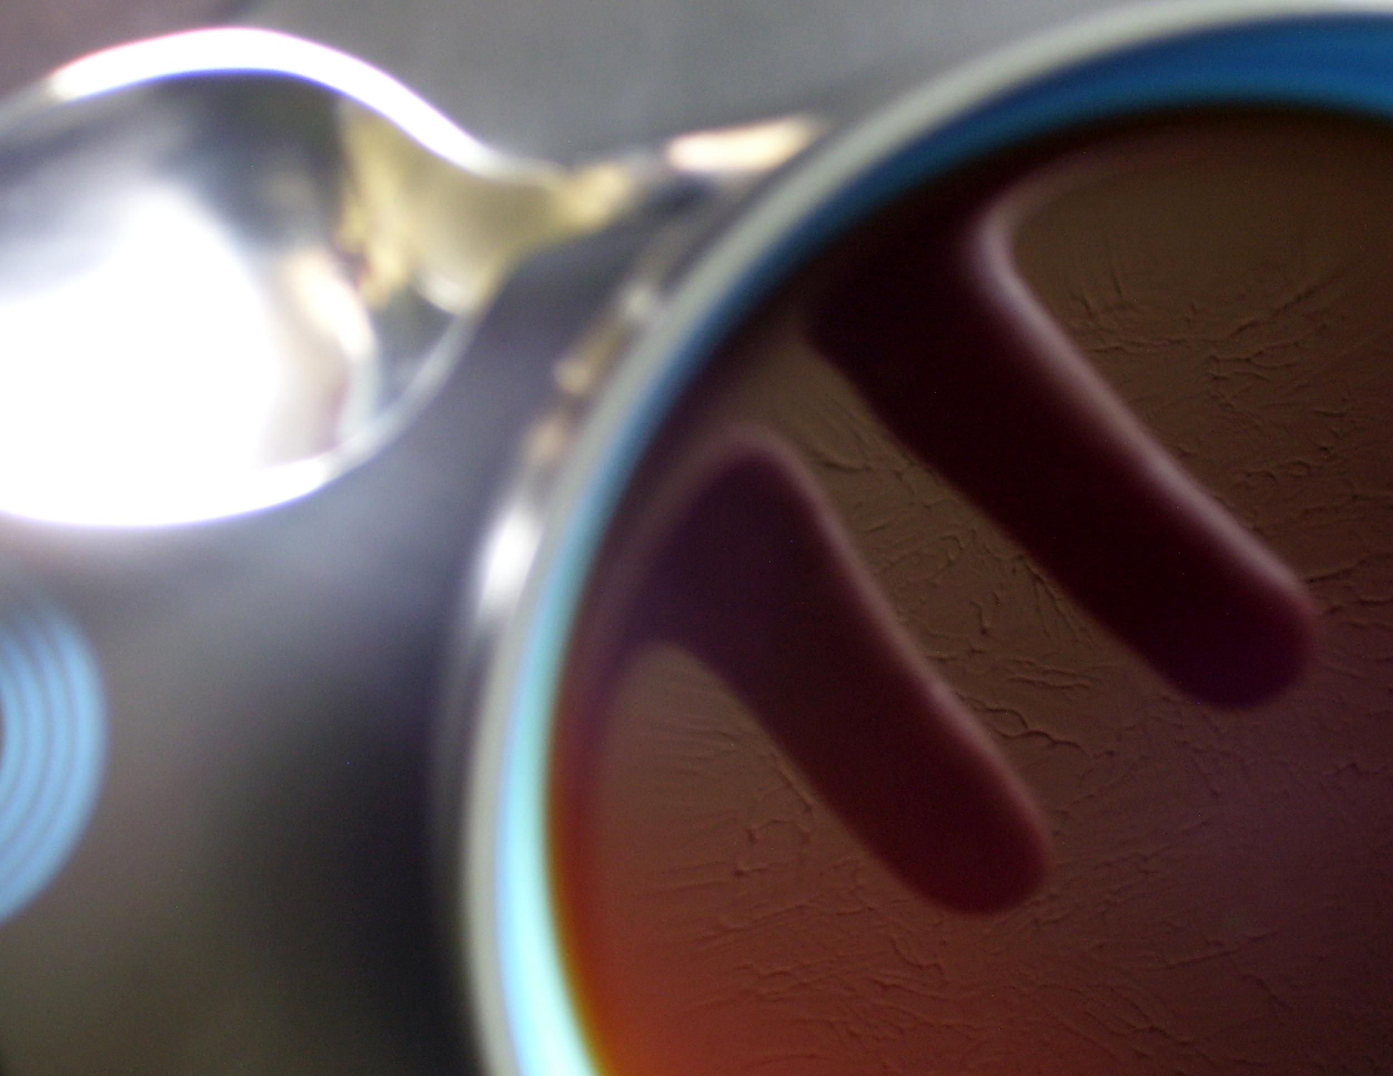

Title: “How Many Fingers?”

Three descriptive tags: “Ambiguous Space”, “Tea”, “Fingers”, “Bunny Ears”

A self critique: Digital Photo Rubric
Objective/Criteria | Performance Indicators
 | Exemplary | Competent | Emerging
Concept | (5 points)  Does an outstanding job of communicating the concept. | (4.4 points)  Does an adequate job communicating the concept. | (3.8 points)  Does a poor job communicating the concept.
Composition | (5 points)  Photograph uses composition principles very effectively. | (4.4 points)  Photograph does a good job using composition principles. | (3.8 points)  Photograph does a poor job using composition principles
Color, Contrast & Tonal Range | (5 points)  Photography displays outstanding use of color, contrast and/or tonal range. | (4.4 points)  Photography displays good color, contrast and/or tonal range. | (3.8 points)  Photograph lacks contrast, color is weak and/or tonal range is poor.
Focus | (5 points)  Focus is a perfect match with the concept of the shot. | (4.4 points)  Focus is an adequate match with the concept of the shot. | (3.8 points)  Focus is a poor match with the concept of the shot.
Technical Aspects | (5 points)  Shutter speed and aperture were perfectly chosen to match concept. Exposure and lighting are excellent. | (4.4 points)  Shutter speed and aperture were adequately chosen to match concept. Exposure and lighting are good. | (3.8 points)  Shutter speed and aperture were poorly chosen and do not match the concept. Photo is over/under exposed and lighting is poor.
Depth of Field | (5 points)  Excellent use of depth-of-field. | (4.4 points)  Adequate use of depth-of-field. | (3.8 points)  Poor use of depth-of-field.
Title/Tags | (5 points)  Title and tags were perfectly chosen and written to express the content and concept. Spelling and word choice are excellent with no mistakes. | (4.4 points)  Title and tags were adequately chosen and written to express the content and concept. Spelling and word choice are good with only minor errors. | (3.8 points)  Title and tags were poorly chosen and written to express the content and concept. Contains multiple spelling errors or wrong word choices.
Self critique & Reflection | (10 points)  Excellent self-assessment and well written reflection that answers all reflection question thoroughly. Spelling and grammar are perfect. | (8.8 points)  Adequate self-assessment and the written reflection answers most of the questions. Spelling and grammar is mostly correct with only minor errors. | (7.6 points)  Self-assessment is not complete and/or the reflection does not answer some or all of the questions. Spelling or grammar is not on par with graduate level writing yet some effort has been shown in the work submitted.
Peer Comments | (5 points)  Peer comments posted for all members of virtual group exceed expectations and spelling is correct. Comments made for each group member’s photo include one or more suggestions on how to improve the photo and discuss at least one positive attribute of the photo. Comments are very thorough and thoughtful. | (4.4 points)  Peer comments posted for all members of virtual group meet expectations and spelling is mostly correct. Comments made for each group member’s photo include one suggestion on how to improve the photo and discuss at least one positive attribute of the photo. Comments are brief but good. | (3.8 points)  One or more elements of the peer comments were missing, incomplete or poorly written. Comments may not have been made for every member of the group but some effort was evidenced in what was written. Comments need improvement.
 |  |  | out of 50

Three Paragraph Reflection
This was probably the most difficult assignment to date. Ambiguous by definition is ambiguous making the shot difficult. I pondered, I confused myself, I pondered some more, made some tea, and took the shot. As far as I can tell the fuzzy, close-up, fingers in the tea approach met the assignments requirements – ambiguous I think.

I relationship to what this assignment meant to me, I would have to answer once again I was forced into “I must look outside the box” approach – this of course is a wonderful thing as I am not much for the comfort of my own bubble when it comes to learning and stagnation (besides the smell) is not one of my favorites. As for change, try to focus on the edge just a bit – maybe try different lighting approaches, maybe even different angles. Who knows – maybe scrap the whole thing and turn to the clouds.

Ambiguity is always a wonderful subject in the English classroom. For this we return to the OPTIC (Overview-Parts-Title-Interrelationships-Conclusion) activity focusing in on the conclusion. How many different meanings can we find? What could or would change the meaning? Looking at your own thinking (Metacognition) how did you come up with the meaning? These are just a few questions to focus on. We could then discuss how the ambiguity of a photograph can skew an audience interpretation of meaning. Then of course I would have them bring in photographs of their own to discuss.

P10 Comments
Susan Biggers: This is a really interesting picture but I think the water by itself would have made a wonderful shot. The waves are really neat looking and I fear the clouds in the middle take away from that. Or even the clouds by themselves – great hues and tonality there. Anyway – I think both the shots could really stand alone and be wonderful.
Kristin Limbaugh: Limbaugh – I must say this one is a great shot. The color – or lack of color – brings about the true awesomeness of the sky, clouds, et cetera. Any suggestions – maybe just one. If you could crop the tree out of the photograph the break in the clouds would rest right on a dissecting point – perfect for composition – rule of thirds in its awestruck, mouth gaping, perfection.
Andrea Harper: Now that is cool looking. The color of the sky is just marvelous darling absolutely fabulous – okay now I sound like a drag queen in some indie film. Anyway – great contrast – composition, and balance. I especially like the lighting of it all. Only change – maybe position a break in one of the dissecting thirds (got this one from the book). Great shot.
Joy Renfro: Great sunset shot – these are always relaxing to take. Great job keeping the shot in focus with the boat on the water and all. I agree with Andrea about the sky on top – then again maybe that is the point of the shot working with space and all. The only other aspect I see is the loss of the boat parts to the shore – they blend in together too well. I found myself focusing on where one began and one ended – then again maybe that is the point. Anyway – great shot overall.

