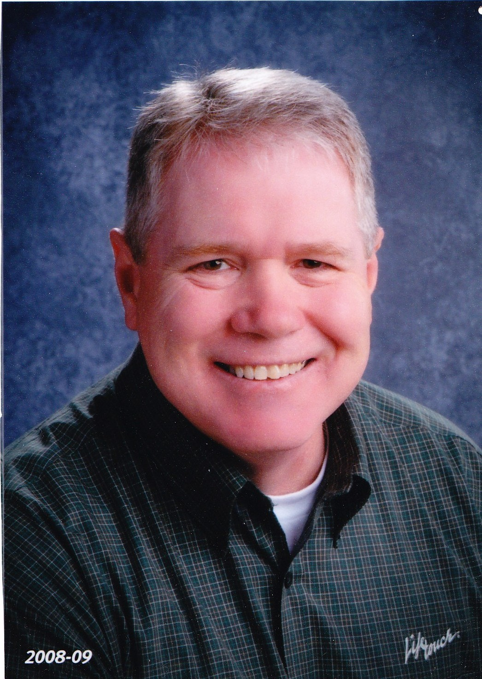
Rick Young

742 River Ridge Court
Sugar Hill, GA 30518
770-271-1618
ryoung1701@yahoo.com

OBJECTIVE:

- Bring technology into the classroom to facilitate more interest and learning.
- To become an LSTC (Local School Technology Coordinator).

EXPERIENCE:

- Currently in my 9th year teaching 8th grade physical science at Richard Hull Middle School in Duluth, GA.
- Over 20 years experience as a Registered Respiratory Therapist working with neonates, children and adults.

EDUCATION:

- Currently enrolled in Ed. S. Media/IT program at University of West Georgia with projected graduation date of May, 2011.
- M. Ed. From Georgia State University, 2007.
- B.S. Ed. From Georgia State University, 2002
- A.A.S. in Education from Georgia Perimeter College, 2000.
- A.A.S. in Cardiopulmonary Science from Southwestern Community College, Webster, N.C., 1991.
Rick Young

770-271-1618 RYOUNG1701@YAHOO.COM

AWARDS:

- Golden Key International Honor Society
- Pi Lambda Theta International Honor Society
- Dean’s List, Georgia State University
- Graduated Summa Cum Laude, Georgia State University.

SKILLS:

- Proficient with MS Word, Excel, PowerPoint.
- Proficient with Camtasia
- Proficient with MovieMaker
- Certified BLS (Basic Life Support)

HOBBIES/INTERESTS:

- Science
- Camping
- Fitness/Nutrition
- Music
- Variety of Sports
- Cooking
- Movies
- Nature

