Running Head: Evaluation Plan of Douglass’ HTM SLC

Hospitality, Tourism, and Marketing Small Learning Community Evaluation Plan
Barry D. Thibault
University Of West Georgia

Hospitality, Tourism, and Marketing Small Learning Community Evaluation Plan

Introduction
According to the Douglass High School- Hospitality, Tourism and Marketing’s (HTM) mission statement, the Small Learning Community (SLC) of HTM:
Strives to prepare students for successful entry and competitive participation in the hospitality industries at local, state, and global levels. We do this via rigorous and relevant course offerings reflective of current demands in the universities and workforce.

This mission statement is built on the framework of the Organizational Elements Model (OEM) by Kaufmann, Guerra & Platt, 2006. These authors explain that the Organizational Elements Model simply defines and links what any organization uses, does, produce and delivers with external client and societal value added. For each “element,” there is an associated level of planning (p. 37). The HTM program includes a developed plan to help students achieve curriculum and technology goals to prepare them for the HTM industry through these elements. These elements of planning start at the Mega-level which Kaufmann, Guerra & Platt (pp. 37-39) explain as the groundwork of how we prepare and what we do to prepare our students. Elements of the Mega-level will add value to all stakeholders: including HTM learners, teachers, administrators, parents, community members and politicians.
The means by which the HTM students are preparing for the local and global industries include a plan for rigorous and relevant instruction that include the use of the latest technology which can engage students with virtual and Personal Learning Environments (PLEs) . These applications can introduce scenarios for real life work experiences that meet university and industry demands in the field of hospitality and marketing. The HTM Career Lab will utilize the latest Hotel/Restaurant industry software that can help students exercise critical thinking, oral and written communication, quality service management, and other problem-solving skills. This technology can help train these essential skills which are required for success in the global world HTM industry.
School demographics and Client Information
The evaluation clients are Stephanie Bailey, assistant principal and lead administrator and Tonya Fulton, HTM Program Coordinator for the HTM SLC at Douglass High School, in Atlanta, Georgia. I, Barry D. Thibault, am the evaluator of this MEDT 8480 evaluation program study. I am the Douglass High School Theater Teacher. This evaluation is a requirement for completing an Ed.S. in the Media/Instructional Technology Program at the University of West Georgia.
The stakeholders of this evaluation include Douglass High School HTM teachers and Douglas High School HTM former students, Georgia State University, Douglass faculty, and administrative staff and local community. Douglass High School is an inner-city suburban school in Atlanta, Georgia:
The Douglass Student Demographic Table (2011)
 | Douglass High School
School Level | High school
School Type | Small Learning Community Model
Grades Offered | Grades 9 - 12
County | Fulton County, GA
Students & Faculty
Total Students | 936 students
% Male / % Female | 48% / 52%
Total Classroom Teachers | 72 teachers
Students by Grade
  Grade 09 - 301 students
  Grade 10 - 205 students
  Grade 11 - 230 students
  Grade 12 - 200 students
  This School | (GA) School Average
Teacher : Student Ratio | 1:18 | 1:15

Students by Ethnicity
  This School | (GA) School Average
% American Indian | n/a | n/a
% Asian | n/a | 2%
% Hispanic | 1% | 10%
% Black | 99% | 37%
% White | n/a | 46%

Additional Student Information
  This School | (GA) School Average
% Eligible for Free Lunch | 71% | 45%

% Eligible for Reduced Lunch | 8% | 8%

% Migrant Students Enrolled | n/a | n/a

This evaluation plan will be used to address the HTM program and how it is effectively working and supporting the needs for the Douglass students and community as well as my clients and other stakeholders.
Research by Rogers and Smith (2006), support how evaluation is either about proving something is working or needed, or improving practice or a project (Rogers & Smith, 2006). This HTM evaluation should provide my clients with an effective detailed report that can be used to improve and /or support the future of the HTM Small Learning Community. We look to evaluation as an aid to strengthen our practice, organization and programmes Chelimsky E. (1997). Finally, with this evaluation, I hope to learn some educational best practices by observations and interviews with our present and former students, teachers, organization and community.
Purpose
As an evaluator this semester, I have the opportunity to assess the program being implemented into the HTM Small Learning School at Frederick Douglass High School. Through a grant, the HTM community is in the process of creating several phases of Virtual and Personal learning Environments (VLE & PLE) including mock hotel and marketing business for learning purposes utilizing the latest Hotel/Restaurant/Marketing Industry software and productivity tools/technology to create an HTM career lab for these students.
The main purpose of this HTM Career Lab is to utilize and practice industry training software and hardware and build-out equipment to create a mock hotel for the classroom/laboratory. The mock hotel will feature a reception area with concierge, a hotel room, Point-of Sale terminals and practice laboratories but will not accept “real” guests. Students will practice customer service skills and use financial data associated with clients and the general “hotel.” In addition, the project will operate software that allows for students to develop their own, individualized virtual hotel that would encompass the appropriate number of employees, support staff, adequate number of rooms, and marketing strategies. In this, students will apply marketing principles, imagination, creativity, and other skills for their design. This project will not only create rigor in the classroom but ensure that students in our SLC will be able to apply the industry skills which are aligned to our state’s standards, to “real-life” professional careers in the hospitality industry.
This evaluation contains data that may inform the SLC leader, Stephanie Bailey, whether the program is meeting its goals, “whether the curriculum is not only the right curriculum at the right time, but students learn from the methods and materials that are introduced by the program” (Kaufman, Guerra, & Platt, 2006, p. 24). Ms. Bailey may use this evaluation data to determine how the program is beneficial to the students.
Literature Review
This collection of technology articles and evaluation methods was initially provided in the MEDT 8484 Research Methods Class from the University of West Georgia. The educational findings from the initial class and this final MEDT 8480 Evaluation Course will allow me the opportunity to explore some of the ideas behind emerging technologies including: Mobiles, Virtual Career Lab, and the Personal Learning Environment to consider why these might be useful or indeed central to learning in the future.
According to the National Educational Technology Standards, (2007), to be successful in today’s information-rich society, students must be able to use technology effectively. The International Society for Technology in Education (ISTE, 2004) advocates how technology enables the students to become:
- Capable information technology users
- Information seekers, analyzers, and evaluators
- Problem solvers and decision makers
- Creative and effective users of productivity tools
- Communicators, collaborators, publishers and producers
- Informed, responsible, and contributing citizens

These qualities mentioned, make for a well rounded and educated adult that have entirely taken advantage of the new 21st Century purpose of education: Using technology to promote learning.
The Georgia Technology Plan was created to be used by all school districts in the state to address the importance of the integration of technology. This Georgia K-12 2007 – 2012 Technology Plan will be used to prepare and guide all students and teachers with the required technology implementation. This state resource should be used as a reference when promoting local school goals related to technology usage:
- Increase broad-based community support for Georgia‘s vision to infuse 21st Century technology skills into the Georgia curriculum.
- Increase educators’ proficiency to use technology effectively in classrooms and administrative offices.
- Increase effective instructional uses of technology in order to incorporate 21st Century technology and thinking skills into the Georgia curriculum.
- Increase effective administrative uses of technology to monitor student achievement and to manage business operations in school systems.
- Increase the capacity of school systems to provide the high-quality system support necessary to realize effective technology use, especially in the areas of administrative support for effective instructional technology use; professional development; technical support for hardware, software, network infrastructure, technology planning, and program evaluation.
- Achieve and/or maintain equitable access to high-quality technology programs for all students.
- Increase access for students, educators, parents, school board representatives, and other community members to technology resources that can enhance student learning.
The former Superintendent of the Georgia Department of Education (GaDOE), Kathy Cox, expressed her attitude towards the state goals for this new 21st Century Technology Initiative: "In Georgia, we are not only teaching our students about technology, we are using technology to teach our students. Technology is one of the keys to making sure our students are ready to compete in the 21st century." In addition, she believes that, "Georgia is using technology to give every student access to an excellent education no matter whom they are or where they live. From the halls of the Capitol to the hallways of our schools, our state knows how important technology is to student achievement. We will continue to look for ways to expand use and access to technology” (GaDOE Press Release, April 2007).
Kathy Cox’s thoughts on technology describe the important instructional goals and elements faced in our state and school districts. Every child and school district in the last 20 years has been introduced to some form of technology into the curriculum and has felt the impact of this technology. The effects on student achievement and motivation as the students become familiar with the technology and its use is always worthy of further study. It is my intent to be able to use this selected evaluation to further study and explore some of the value behind technology and the Personal Learning Environment to consider why PLEs can be beneficial to the HTM program.
The idea of a Personal Learning Environment recognizes that learning is ongoing and seeks to provide tools to support that learning. It also recognizes the role of the individual in organizing his or her own learning. This will continue further with the rigor and relevance as stated in the HTM mission and goals. According to the 2011 Horizon Report, Personal Learning Environments (PLEs) are described as systems for enabling self-directed and group-based learning, designed with great capacity for flexibility and customization (2011).
The idea of a Personal Learning Environment recognizes that learning is ongoing and seeks to provide tools to support that learning. It also recognizes the role of the individual in organizing his or her own learning. This article review has given me a chance to compare and develop an understanding of the research and evaluation methods that have already been developed on some of the technology integration resources by other researchers.
As the literature suggests, teachers need to understand this "digital divide" and begin to integrate the technology into their lessons and learn how to develop lesson plans with it. The Evaluation Plan developed by the HTM Stakeholders and myself consists of the evaluation of how this HTM Career Laboratory Program utilizing the latest emerging technologies can be beneficial in preparing our students in the hotel/business industry as stated in the Georgia K-12 2007 – 2012 Technology Report.
Program Evaluating Questions
As I plan to evaluate the Hospitality, Tourism and Marketing’s (HTM) Career Program, I will us the mission statement to guide my data and research questions. HTM strives to prepare students for successful entry and competitive participation in the hospitality industries at local, state, and global levels via rigorous and relevant course offerings reflective of current demands in the universities and workforce. The Evaluating Questions that will help guide and assess the programs effect on preparing students for post-secondary options as declared in the HTM mission statement will be:
Primary:
- Is the technology/software and HTM Career Lab technology plan effective in supporting the successful achievement of the HTM SLC and HTM Small Learning Community goals?
- Does the use of the Personal Learning Environment Software and Technology successfully prepare students for entry and competitive participation in the hospitality industries at local, state, and global levels?
Secondary:
- Does the use of the Personal Learning Environment Software and Technology integrate rigorous and relevant course offerings reflective of current demands in the universities and HTM workforce?
- How will the Personal Learning Environment Software and Technology expand the dimensions of the HTM SLC?
- Does the Personal Learning Environment Software and Technology add some demonstrable pedagogical value to the Instructional Teaching and Learning?
- Does the Personal Learning Environment Software and Technology encourage authentic pedagogy for the HTM community?
Methods
Based on the research of Johnson and Christensen (2008), “We view the use of multiple perspectives, theories and research methods as strength in educational research. In fact, we view the quantitative and qualitative as complimentary to each other; it is wise to collect multiple sets of data using different research methods and approaches in such a way that the resulting mixture or combination has complementary strengths and non overlapping weaknesses” (P. 51). The comparative method relies on the constant interplay among the researcher, the data, and the developing theory. The researcher must be effective at thinking about the kinds of data needed to be collected and what aspects are the most important for the research (p. 413).
Participants
The HTM teachers and staff will be the main data source collected for this evaluation. The HTM survey will include a request for an additional study to accomplish a teacher interview and classroom observation for further studies of the HTM technology and integration. Also, I have worked on student survey questions for the Georgia State University students as a preliminary study to help guide my work for the official study that I can do with the target population at my own school (see Appendix B). This study will allow me the opportunity to collect data about the software available in the University level and how it contributes to the local HTM industry and market in Atlanta. The qualitative open ended questionnaire and interview about the classroom uses of technology will be requested of my participants with their permission. The survey and interview will be followed up with by classroom observations. All surveys and collected data will be available on Google Documents used to tally anonymous results. HTM teachers, GSU Hotel and Marketing students and former HTM students with permission will be emailed the link to the survey.

Design and Procedures
The Phased Action Plan for Evaluation (EAP) is Kaufman, Guerra and Platt's (2006) approach to program evaluation. They describe the EAP as an inquiry process consisting of four main phases: alignment and direction, observation, results, and action and adjustment. I will use this EAP as a guide for my evaluation. The initial survey will be conducted with a small group sampling of HTM teachers. Each question on the survey was carefully analyzed to determine patterns of response by the teachers. This survey provided valuable data about the opinions of class colleagues and plans to be used to analyze data from the HTM teaching staff at Douglass High School. The results and responses can be analyzed by surveying teachers with additional interviews of open-ended questions. See Appendix A
Data Collection
Data collection plans include surveys for the HTM teachers about noticeable improved interest in their curriculum along with their Qualitative Questioning interviews for their input and thoughts. Statistical Data from the Georgia State University implementation into their Hotel and Marketing courses and local industry will also be utilized for this evaluation.
Instruments Correlated to Evaluation Questions
Instruments Table 1
Evaluation Question Type  Primary/Secondary | Evaluation Questions: | Survey Instruments | Observation Instruments | Interview Instruments
Primary | Is the technology/software and HTM Career Lab technology plan effective in supporting the successful achievement of the HTM SLC and HTM Small Learning Community goals? | X |  | X
Primary | Does the use of the Personal Learning Environment Software and Technology successfully prepare students for entry and competitive participation in the hospitality industries at local, state, and global levels? | X | X | X
Secondary | Does the use of the Personal Learning Environment Software and Technology integrate rigorous and relevant course offerings reflective of current demands in the universities and HTM workforce? | X | X
Secondary | How will the Personal Learning Environment Software and Technology expand the dimensions of the HTM SLC? |  |  | X
Secondary | Does the Personal Learning Environment Software and Technology add some demonstrable pedagogical value to the Instructional Teaching and Learning? | X |  | X
Secondary | Does the Personal Learning Environment Software and Technology encourage authentic pedagogy for the HTM community? | X |  | X

Data Analysis
As I continue to research my topic I am learning of Data Analysis tools that are easy to use involving the latest technology. I would like to incorporate the data results with a technology presentation integrated with web 2.0 tools for my clients. I think this would have a major impact and effect for all stakeholders as they can use these presentations at other times for other groups. Surveys and interviews will be developed and analyzed utilizing the Google Document Survey tool. The evaluation of the HTM program will be a Mixed- Method approach with both qualitative and quantitative assessments. The interim analysis (cyclical process of collecting data) during my evaluation study will involve obtaining the data from student/ teacher interviews, observations, focus groups, HTM documents and transcripts and summarizing the findings.
Data analyzing will consist of segmenting and coding the data while looking for patterns and relationships. Data summary include using enumeration (word counting and coded categories) of the survey questions in addition to presentational diagrams that can be included. I will be "Quantitizing the Data" which will give me more data that is numerically represented for the diagrams to help with the describing of my findings to my clients. Also, I will be utilizing the software available through Google Docs as this websites does give the feedback from data in a spreadsheet format. The utilization of these tools can enhance the accuracy and reliability of data. These spreadsheets and diagrams should help my stakeholders interpret the data analyzed while creating an interesting and informative evaluation report.
Conclusion
It is the objective of the evaluator that this research will be used to assist the HTM teachers in integrating technology for instruction as well as guide decisions related to the program development of future HTM instruction and technology integrations. Perhaps this study will increase the knowledge of how technologies can be an asset to the HTM Career Plan if given the opportunity for integration by all teachers. Educators that continue to create instruction without technology in the future will fail to support important student needs that are important to the business, and Hotel/Tourism/Marketing industry our students are trying to become part of.
The results of this program evaluation will be collected and compiled into a written report that will be of assistance to the HTM program at Douglass High School. The final evaluation report will be submitted to the stakeholders, Tonya Fulton and Stephanie Bailey with input based on the collected data for future plans. It will also be submitted as a component of the MEDT 8480 course at the University of West Georgia. A copy of the final evaluation report will also be used as a part of the Exit Examination Procedure of the Specialist in Education Program at the University of West Georgia. The results of this study will be presented to a panel of professors and critiqued for methodology and purpose.

References

Alsarayreh, M. Jawabreh, O. A. Alkharabsheh, K. & ALfarajat, A. (2011). “Information technology and the performance of establishments’ hotel and tourist in Jordan”. Australian Journal of Basic & Applied Sciences, 5(6), 1401-1406.
Angeli, E., Wagner, J., Lawrick, E., Moore, K., Anderson, M., Soderlund, L., & Brizee, A. (2010, May 5). General format. Retrieved from http://owl.english.purdue.edu/owl/resource/560/01/
Chelimsky, E. (1997). “Thoughts for a new evaluation society”. Evaluation, 3(1), 89.
Cheng, K. (2009). “The effect of web-based collaborative learning methods to the accounting courses in technical education”. College Student Journal, 4, 36.
Davis, N. E. & Roblyer, M. D. (2005). Preparing teachers for the “schools that technology built”: Evaluation of a program to train teachers for virtual schooling [Electronic version]. Journal of Research on Technology in Education, 37, 399–409.
Franklin, S. Sexton. Young, L. & Hongyan M. (2007). “PDAs in Teacher Education: A casestudy examining mobile technology integration”. Journal of Technology and Teacher Education, 15(1), 39-57.
Ivanova, M. & Chatti, M. (2010). Toward a model for the conceptual understanding of personal learning environments: A case study. Journal of Educational Technology Systems, 39(4), 419-439.
Johnson, L. F. Levine, A. Smith, R. S. & Haywood, K. (2010). Key emerging technologies for postsecondary education. Education Digest, 76(2), 34-38.
Kaufman, R., Guerra, I., & Platt, W. Practical Evaluation for Educators-Finding what Works and What Doesn’t. California: Corwin Press, 2006.

Liber, O.& Johnson, M. (2008). Personal Learning Environments. Interactive Learning Environments, 16(1), 1-2.

McKimmy, P. (2005). Implementing wireless mobile instructional labs: Planning issues and case study. International Journal of Instructional Media, 32(2), 113-123.
Palak, D., Walls, R. T. (2006). Teachers’ beliefs and technology practices: A mixed-methods approach. Journal of Research on Technology in Education, 38(4), 409–424.

Rogers, A. & Smith, M.K. (2006). Evaluation: Learning what matters, London: Rank Foundation/YMCA George Williams College. Available at http://www.infed.org/biblio/b-eval.htm
Smith, Mark K. (2001, 2006). 'Evaluation' in the encyclopedia of informal education. Retrieved from www.infed.org/biblio/b-eval.htm.
Stufflebeam, D.L. (2001). Evaluation models: New Directions for Evaluation, 89, 7 –98. Retrieved from Wiley InterScience database.

Swan, K., Van’t Hooft, Kratcoski, A. & Unger, U., (2005). Uses and effects of mobile computing devices in K-8 Classrooms. Journal of Research on Technology in Education, 38(1), 99- 112.
Yang, F., & Chang, C. (2009). Examining high-school students’ preferences toward learning environments, personal beliefs and concept learning in web-based contexts. Computers & Education, 52(4), 848-857.

Appendix A. CLICK ON SECTION TO ENLARGE PDF FILE
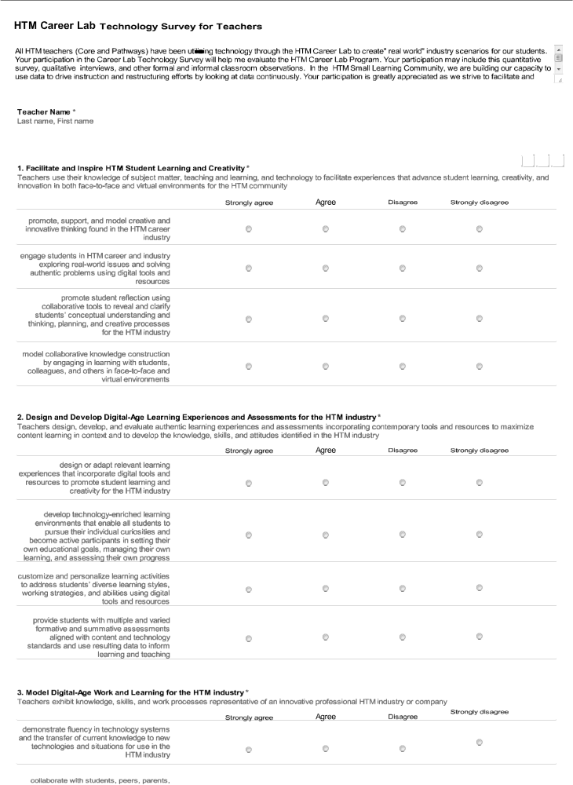 Appendix B. CLICK ON SECTION TO ENLARGE PDF FILE

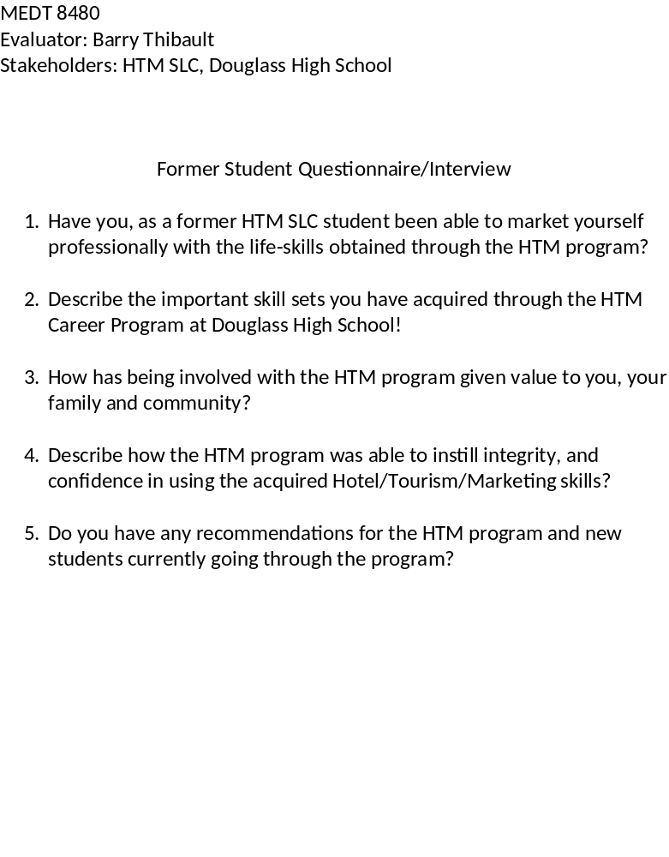
Appendix C.
Data Collection Organization Matrix
Questions | Related Results | Level | Required Data/ Measurable Indicators | Data Source | Data Collection Tools/ Procedures  Date Collected By | Primary Responsibility
Is the technology/software and HTM Career Lab technology plan effective in supporting the successful achievement of the HTM SLC and HTM Small Learning Community goals? | HTM Teacher Interview and Survey about technology plan and goals | Micro | Qualitative/Quantitative  Teacher  Opinion | Google Docs Survey  Observation  Interview | Student/Teacher interview  10/19/11  10/29/11  11/05/11 | Evaluator  Thibault
Does the use of the Personal Learning Environment Software and Technology successfully prepare students for entry and competitive participation in the hospitality industries at local, state, and global  levels? | HTM Teacher Interview and Survey about technology plan and goals | Mega  Micro  Macro | Qualitative  Interview, Observation  assessments  Quantitative | Google Docs Survey  Observation  Interview | 10/19/11  10/29/11  11/05/11 | Evaluator  Thibault
Does the use of the Personal Learning Environment Software and Technology integrate rigorous and relevant course offerings reflective of current demands in the universities and HTM workforce? | HTM former student and GSU Student Interview and Survey about technology plan and goals | micro, macro | Quantitative  GSU /HTM interview  Frequency of usage | Google Docs Survey  Observation  Interview | surveys, observation data  10/19/11  10/29/11  11/05/11 | Evaluator  Thibault
How will the Personal Learning Environment Software and Technology expand the dimensions of the HTM SLC? | HTM Survey, Interview and Observation Data Results about technology plan and goals | Micro  Macro | Qualitative  Teacher Opinion  Survey  Interview | Google Docs Survey  Observation  Interview | surveys, observation data  10/19/11  10/29/11  11/05/11 | Evaluator  Thibault
Does the Personal Learning Environment Software and Technology add some demonstrable pedagogical value to the Instructional Teaching and Learning? | HTM Teacher Interview , observation, results and survey about technology plan and goals | Macro, Mega | Qualitative Teacher Opinion  Observation  Interview | Google Docs Survey  Observation  Interview | Data  10/19/11  10/29/11  11/05/11 | Evaluator  Thibault
Does the Personal Learning Environment Software and Technology encourage authentic pedagogy for the HTM community? | HTM Teacher Interview , observation, results and survey about technology plan and goals | Macro, Mega | Qualitative Teacher Opinion | Google Docs Survey  Observation  Interview | Data  10/19/11  10/29/11  11/05/11 | Evaluator  Thibault
(Adapted from Kaufman, Guerra, & Platt, 2006)

Appendix D. Parent/Student consent form



