Wendy Cope
Policies and Procedures


(Cherokee County School District, 2010)
Purpose Statement
It is the mission of River Ridge High School to provide each student with a safe, nurturing, mutually respective environment that will encourage maximum academic, social, and physical development. Through high expectations and a diverse curriculum, we will encourage students to become self-reliant, environmentally responsible, life-long learners, and productive citizens in a highly technological and multicultural society. (Cherokee County School District, n.d.)

Demographics

River Ridge High School is the newest high school in Cherokee County located in the southeastern part of the county. River Ridge consists of only a 9th grade class during the 2009-2010 inaugural school year while the actual building is still under construction. Currently all students, staff, and faculty are housed at Mill Creek Middle School located adjacently on the same property. The RRHS building will open for the 2010-2011 school year with a 9th and 10th grade class configuration.
River Ridge High School is part of the RRHS Innovation Zone with the following feeder schools: Mill Creek Middle School, Arnold Mill Elementary School, Johnston Elementary School and Little River Elementary School.

The 9th grade enrollment for the 2009-2010 school year is predominantly White, with 28% of the population African-American, Hispanic, Asian or multiracial (Cherokee County School District, n.d.).

Cherokee County Media Program Philosophy
Our media center aims to help students become young adults who can access, evaluate, and interpret information by providing a well balanced and rich collection of print materials, databases, and digital books. Our media center also fosters an environment that embraces reading for pleasure as well as for knowledge. (Creekview High School Media Center Philosophy Statement, 2010).

Cherokee County Media Program Mission Statement
The mission of the library media program is to ensure that students and staff are effective users of ideas and information. This mission is accomplished:
- by providing intellectual and physical access to materials in all formats
- by providing instruction to foster competence and stimulate interest in reading, viewing, and using information and ideas
- by working with other educators to design learning strategies to meet the needs of individual students.
This mission focuses on offering programs and services that are centered on information literacy and that are designed around active, authentic student learning as described in the information literacy standards for student learning. The goals of today’s library media program point to the development of a community of learners that is centered on the student and sustained by a creative, energetic library media program. These goals are as follows:
- To provide intellectual access to information through learning activities that are integrated into the curriculum and that help all students achieve information literacy by developing effective cognitive strategies for selecting, retrieving, analyzing, evaluating, synthesizing, creating, and communicating information in all formats and in all content areas of the curriculum.
- To provide a physical access to information through
  - a carefully selected and systematically organized local collection of diverse learning resources that represent a wide range of subjects, levels of difficulty, and formats;
  - a systematic procedure for acquiring information and materials from outside the library media center and the school through such mechanisms as electronic networks, interlibrary loan, and cooperative agreements with other information agencies; and instruction in using a range of equipment for accessing local and remote information in any format.
- To provide learning experiences that encourage students and others to become discriminating consumers and skilled creators of information through comprehensive instruction related to the full range of communications media and technology.
- To provide leadership, collaboration, and assistance to teachers and others in applying principles of instructional design to the use of instructional and information technology for learning.
- To provide resources and activities that contribute to lifelong learning while accommodating a wide range of differences in teaching and learning styles, methods, interests, and capacities.
- To provide a program that functions as the information center of the school, both through offering a locus for integrated and interdisciplinary learning activities within the school and through offering access to a full range of information for learning beyond this locus.
- To provide resources and activities for learning that represent a diversity of experiences, opinions, and social and cultural perspectives and to support the concept that intellectual freedom and access to information are prerequisite to effective and responsible citizenship in a democracy. (American Library Association, 1998)
II. Public Relations / Marketing (System level)

The relationship of the school library media center with its patrons and the community is of utmost importance. The school library media center needs the community behind its program. Media centers are encouraged to use volunteers in order to enhance the school library media center program and to allow them to view the program. Contacts are made with the parents and community through a variety of ways: school newspapers, local newspapers, flyers, Cherokee County Schools’ website, morning shows, bulletin boards, and local television bulletin boards. Local schools participate in the READ Program featuring posters of media specialists, principals, administrators and other district personnel.

The school library media center in each school conducts a variety of special programs and events during the school year. Some of the events celebrated include book fairs, Georgia Peach Award nominations, Children’s Book Week, School Library Media Month, Georgia Legislative Day, the Georgia Children’s Literature Festival, National Library Week and Black History Month.

School Library Month is celebrated with contests for students and teachers to promote School Library Month.

The events and special programs are publicized on bulletin boards within the schools, the school media center website, newsletters to the parents, and newspaper articles (Dillon School District Two, n.d.).

III. Selection Criteria Policy

Philosophy and Objectives

Library collection development is the ongoing process of identifying strengths and weaknesses of the school’s library collection in terms of student needs. Cherokee County Schools shall provide a broad range of educational, informational, and recreational reading resources through its school libraries in order to support the school curriculum and create students who are effective users of ideas and information, competent and enthusiastic readers, independent learners, and positive contributors to the school community and to society. Quality materials should be available in a variety of formats and reading levels, offer a well-balanced coverage of subjects, and support the diverse interests, needs and viewpoints of the school community. (Chicago Public Schools, 2006, p.1)

Responsibility for Selection

The final legal accountability for all materials selection belongs to the Cherokee County School Board. The board entrusts each school’s certified library media specialist(s), who are well trained in material selection, with the responsibility of purchasing. The Library Media/Technology Committee at each school shall also be involved in the selection process by making recommendations and decisions for the improvement of the media program. This committee shall include at least one representative from each of the following: administrators, teachers, students and community members. The final decision for selection of instructional media and equipment is the responsibility of the library media specialist(s) and the school’s principal. (Bishop, 2007, p. 43)

Print and Non-print Materials

A. Criteria. The following criteria shall be used in selecting school library materials:

1. Materials should support the school’s and the district’s educational goals and policies, including the advancement of student literacy.
2. Materials should be selected to support, enrich and extend the school’s curriculum and to encourage informational, educational and recreational reading, viewing and/or listening.
3. Consideration should be given to diverse user interests, abilities, backgrounds, cultures, languages, and maturity levels. Materials intended for student use should be appropriate for the subject area and for the age, social development, ability levels, special needs, and learning styles of students served by the collection.
4. Materials should represent various viewpoints on controversial issues so that students learn to explore, analyze and make intelligent judgments.
5. The value of a work should be examined as a whole and given greater weight than individual words, phrases or passages contained in the work.
6. In order to assure quality selection the following additional factors will be weighed as they apply:
a) Educational significance and/or contribution to the curriculum;
b) Informational or recreational interest;
c) Reputation and significance of the author, producer, editor and/or publisher;
d) Degree of potential user appeal;
e) Contribution to the variety in viewpoints offered on controversial issues;
f) Accuracy and currency of information;
g) Arrangement and organization of the material (for example, indices, glossaries, tables of contents, chapter headings, etc.);
h) Artistic quality, literary style or production values;
i) Readability levels;
j) Quality and variety of format;
k) Need for duplicate copies of extensively used materials;
l) Need to replace essential/required worn, damaged, or missing materials; and
m) Value commensurate with cost and/or need.
(Chicago Public Schools, 2006, pp.1-2)

B. Selection Tools
The following are resources that may be used to assist in the selection process:
1. Reviews in professional, reputable sources such as Booklist, School Library Journal, Kirkus Reviews, Horn Book, Bulletin for the Center for Children’s Books, Voice of Youth Advocates, AASA Science Books and Films, and American Film & Video Association.
2. Recommendations by the CPS Department of Libraries and Information Services, the Chicago Public Library’s Department of Children’s and Youth Services, ALA’s Young Adult Library Services Association, and children’s literature experts such as Dr. Peggy Sharp, Michael Cart, Jim Trelease, Judy Freeman, and Hazel Rochman.
3. National and state awards such as Caldecott, Newbery, Coretta Scott King, Rebecca Caudill, Abraham Lincoln, Monarch, Alex, and Michael Printz.
4. Professional selection bibliographies such as The Best in Children’s Books, Elementary School Library Collection, Books for the Teen Age, Best Books for Young Teen Readers, Senior High School Library Catalog, and Middle and Junior High School Library Catalog.
5. Online collection development tools such as Follett’s Titlewave and Baker & Taylor’s School Selection.
6. Recommendations by faculty, administration, students or parents. (Chicago Public Schools, 2006, p. 2)

Equipment

The library media specialist, considering the recommendation of the local school Library Media/Technology Committee, will select equipment to meet the needs of and support the instructional curriculum. When questions arise concerning the purchase of equipment, discussion between the library media specialist(s) and the Department of Educational Media and/or the Instructional Technology Department will help to ensure a quality selection. Purchases of computer equipment and software to be loaded on the Ducky County School System network must be approved through the proper request procedures. The principal must approve all selections for purchase. The following criteria will be used for selection of equipment:
(1) Quality;
(2) Durability;
(3) Ease of use;
(4) Ease of maintenance and serviceability;
(5) Functionality;
(6) Safety; and
(7) Cost. (Cobb County School District, n.d.)

IV. Donated Materials Policy
Organizations and individuals frequently express an interest in donating books and other resources to Cherokee County School District libraries. Generally, professional library staff must review potential library donations using the same criteria as purchased material. Additional criteria include the following:
a) Donated materials should be new or barely used (in good to excellent condition with no writing or other defacing), complete, clean, durable, and attractive;
b) Reference materials, including atlases, encyclopedias, subject specific multi- volume sets, and other non-fiction resources should be no more than five years old; science, medical, computer, and other resources in areas in which information quickly becomes outdated should be no more than three years old. Book sets should be complete;
c) Fiction books should be no more than eight years old with the exception of books by well-known children’s authors and classics;
d) All materials should have a reading level and an interest level of Pre-K through 12th grade;
e) Non-fiction books should not reflect outdated stereotypes of racial or cultural groups in either the text or the illustrations and should avoid oversimplification of complex issues and other distortions that would give readers erroneous or misleading information; and
f) Materials that generally are not appropriate for library use, such as textbooks, consumable instructional materials such as workbooks, standardized tests, most periodicals, pamphlets, and catalogs will not be accepted. (Chicago Public Schools, 2006, pp.2-3)

V. Reconsideration of Materials Policy

The Board of Education acknowledges the right of parents and other citizens to raise questions through established procedures when materials appear inappropriate for public school use.

Though care is taken to select valuable materials for students and teachers, there may be occasional objections by the public as to the selections that have been made.

In the event that a complaint is made, the following procedures should be followed:

A. The school staff member receiving the complaint shall explain the selection process utilized and the procedures for challenged materials, but make no commitments as to personal opinion, etc. Written documentation of this contact should be filed with the school principal.

B. In the event that the person making an objection to material is not satisfied with the initial explanation, the person should be referred to the principal who shall explain the selection and reconsideration process and refrain from expressing personal opinion.

1. If, after consultation, the complainant desires to file a formal complaint, a copy of the challenged material form shall be given to the complainant by the principal.

2. The principal shall inform the complainant that the form must be completed in its entirety and submitted to the principal. It must be emphasized to the complainant that incomplete forms will be considered invalid and will not be recognized.

3. After the challenged materials form is completed and signed by the complainant, it is to be filed with the principal and copies sent to the appropriate system level personnel.

4. When referred to the system instructional media committee, as a minimum the committee shall do the following:

a. Read and examine materials referred to it;
b. Check general acceptance of the materials by reading reviews;
c. Compare values and faults against each other and form opinions based on the materials as a whole and not on passages pulled out of context;
d. Meet to discuss the material and to prepare a report on it;
e. Present the report to the appropriate personnel.

5. In the event that the above procedures do not satisfy the complainant, the matter may be referred to the Cherokee County Board of Education. The decision of the Board of Education is the final authority. (Cherokee County School District, 2001).

VI. MEDIA SERVICES POLICIES (System-wide)

1. Circulation Policy—Print and Non-print

- Students may have up to five (5) items checked out at a time. Faculty and staff have no limitations on the number of materials they may check out, nor are they bound by the checkout time frame.

  - Books may be checked out for 14 days.

  - Older magazines (over 1 month old) may be checked out for 3 days

  - Reference books may be checked out overnight.

- Students are allowed to renew items up to three times.

- For lost items, students will be charged the replacement cost of the item plus late fees up to $5.00 as well as a processing fee of $2.00 (Etowah High School, 2010).

2. Overdue Policy

Fines:

- Print and non-print materials may be checked out for four weeks. Reference items may be checked out overnight only. (K. Rubin, personal communication, September 25, 2010).

- All high school media centers charge fines for regular check out and overnight books. Elementary Schools and Middle Schools only charge fines for lost books, not for overdue books.

- Special items such as audiobooks checked out to students have the same fine as overnight books.

- No fines are charged for weekends and school holidays (Cherokee County School District, 2006).

- Overdues will be assessed on most library materials at $.10 per day to a maximum of $5.00 per item. Certain other items, such as high-demand or overnight materials, will be assessed at $1.00 per day to a maximum of $10.00 per item.

- Patrons may pay all or a portion of their overdue fines (Jefferson County Public Library, 1996).

3. Video Policy

- A teacher selects a video or DVD by looking in Destiny or by coming to look at the Media Center collection. MediaCast is also available for electronic educational materials.

- If the video or DVD is in the Media Center collection already, and it is rated “G,” no principal’s approval is needed, but the teacher needs to fill out a Video Request sheet (attached) that establishes the teaching objective and submit it to the Media Specialist, who keeps the request on file for at least five years.

- If the video or DVD is from elsewhere (for example, a guest speaker video), the teacher must use the attached sheet to get the principal’s approval to show the video. Generally, the principal of an elementary school only approves G-rated movies. At Woodstock Elementary, the sixth-grade teachers have sent home permission slips for parents to sign approving their children to watch PG movies. But PG videos and DVDs still must be approved by the principal before showing. Films rated R are only viewable by high school students with principal’s approval as well as with parent permission.

- The Media Specialist puts a confirmation sheet (see Appendix) in the teacher’s box by the afternoon before the showing, at the latest.

- Teachers frequently request to show videos for entertainment at recess time or for Fun Friday rewards. Several schools have an agreement with Movie Licensing USA to show Touchstone, Hollywood, Columbia, Tri-Star, Paramount, DreamWorks, MGS, Miramax, United Artists, Warner Brothers, Sony, and Universal videos.

4. Inventory Policy
Inventory of the entire media collection should be done through Destiny during the last two weeks of each school year.

5. and 6. Overdue/Lost/Damaged Book
Once library books paid for by public funds are issued to a student, the responsibility for the return of these materials to the school for further use shall be the total responsibility of the student and parents or guardians (Cherokee County Schools, 2001).
Students will receive written notification of overdue books. Elementary school students will not be charged a fine for overdue materials. Middle and high school students will be charged a $.10 per day late fee for overdue materials with a maximum charge of $5.00 per book. No fines will be charged for weekends and school holidays.
When library books are not returned to the school in a form suitable for continued use, it shall be the responsibility of the student and the parents/guardians to reimburse the Cherokee County School System for the full replacement cost of the library book (Cherokee County Schools, 2001).
In cases involving damaged books or materials (not usable), such materials shall become the property of the student and the parents/guardians once the school receives replacement funds. Students who do not pay for books issued to them which have been lost or damaged shall not be issued additional books or materials or shall not receive grade reports or diplomas until their debts are accounted for. In no case shall a student be eligible to participate in graduation exercises and activities of the Cherokee County School System if debts related to lost or damaged books or materials remain unpaid (The State of Georgia, 2008) (Cherokee County Schools, 2001).
Students who met graduation requirements but are ineligible for graduation exercises because of unpaid debts related to library books should receive their official high school diploma by mail along with an official transcript; however, no request for forwarding of transcripts to any source shall be honored (Cherokee County Schools, 2001).

7. Weeding

Weeding is essential to maintaining a relevant, attractive collection. The local school Media Specialist will determine the materials and equipment needed to be withdrawn from the media center with input from the media committee (Floyd County Schools, 2009). This is usually done at the end of the school year when inventory is taken. The principal must approve the removal of materials to be discarded (Cherokee County Schools, 2001). Items to be weeded from the collection will have records removed from Destiny and barcodes will be removed or blacked-out. All withdrawn materials should be boxed and marked as SURPLUS. A request should be made to the CCSD warehouse to have these materials picked up from the media center.

8. Mending and Repairing Print Materials
Books and other print materials should be mended or repaired when possible to extend the life of the resource and to avoid the expense of replacement.
The local school media specialist will determine the feasibility of mending and repairing print materials.

9.Volunteer Staff

Volunteers, whether parents, other adults, or capable students, can provide valuable assistance, especially if the school has only one media specialist. The media specialist must evaluate the capabilities of each volunteer and assign tasks accordingly. In doing so, he/she must be able to state specifically what is expected of each person in each position. Such job specifications must be realistic and feasible.

When working with adult volunteers, the media specialist should assume the role of co-worker/friend and be highly professional in his/her knowledge of the school’s staff and individual students. This is a public relations role and can be highly beneficial to the library media program and to the school (Hillsborough County Public Schools, 2009).

VI. Definition and Scope for Technical Services Policy

General Policy Statement for Media Technical Processing

Technical services keep the collections vital and up to date by procuring new library materials and organizing them for easy and convenient use. Media specialists and trained personnel maintain the library's online catalog, e-resource discovery systems, and numerous finding tools for special and digital collections (Cornell University Library, 2009).

Guiding Principles for Technical Processing

All school-owned print and non print instructional materials and equipment except basic textbooks, items purchased with categorical funds and items useful only in one specific instructional content area shall be organized and made available through the media center.

Organization of materials shall be based on nationally recognized system and designs for school media centers. Equipment shall be organized so as to provide accurate circulation, maintenance, and inventory records (Cherokee County Schools, 2001).

VII. COPYRIGHT POLICY

Cherokee County School District addresses copyright in its Board Policy Manual.
In the Supplemental Materials Selection and Adoption section of Board Policy (IFAB), Section VI entitled Copyright Compliance, Board Policy states:
The Cherokee County School System shall adhere to the Federal Copyright Law. (P.L. 94-553).
The Assistant Superintendent for Educational Programs, Student Support and Professional Development will be responsible for keeping abreast of copyright law interpretations and changes. This person shall disseminate this information to educators within the school system so that school materials, employees and equipment will not be involved in infringement of this law (Cherokee County School District, n.d.).
Movie/Home Video Copyright

Unless video tapes/movies have public performance rights, they cannot be shown in a setting that is considered ‘public’ (a public setting is, for the most part, a setting that is outside of the personal home). The exception to this law is Fair Use by teachers/instructors in an educational setting. Copyright Act of 1976, Public Law No. 94-553, 90 stat 2541: Title 17; Section 110(i) states that in order for Fair Use to be applicable, the following conditions must be met:
- The video/movie must be a lawfully made copy
- The movie must be shown as part of direct instruction
- The movie must be shown in the classroom

For a user to have a ‘public” showing of a copyrighted video/movie in a non-instructional setting, the user must obtain the permission of the specific copyright holder. Another way for a school to show copyrighted movies in a non-instructional setting is for the school to obtain a Public Performance License from a company that acts as a performance license holder for the producing company. Two (2) companies that provide such service are Motion Picture Licensing Corporation and Movie Licensing USA. Each company has a list of major movie studios that they represent. Each individual should review all providers to ascertain which provider would best suit the needs of their school.

The umbrella Public Performance License affords the school the ability to view (covered) movies in such settings as after-school programs, classroom rewards, PTA movie night, etc. The umbrella license should be read carefully to determine any limiting factors. A common limiting clause in the Public Performance license is one that states that the license does not cover performances in which a fee is charged (other than to cover the cost of the performance). Another common limiting factor states that the license does not cover performances outside of the school building. Finally, a third common limiting clause is that the umbrella license does not allow for external advertising of the name of the movie being shown. In other words, the umbrella holder (the school in our case) can advertise the movie performance within the school setting (including flyers home, newsletters, internal school broadcasts, etc.) but cannot specifically state the name of the movie being shown in a media such as the local television station or radio station (Cherokee County School District, n.d.).

Faculty Awareness Policy

The media specialist will present a PowerPoint or other presentation dealing with copyright during the first month of school, ideally during pre-planning or at the first faculty meeting. A sample PowerPoint is available on the Cherokee County Media Services website. Additionally, copyright notices will be placed at each copier as a reminder for teachers, students, and other staff to abide by federal copyright law (Cherokee County School District, n.d.).

Off-Air Taping
The Cherokee County School District Policy for Off-Air Recording of Broadcast Programming for Educational Purposes is issued to encourage legitimate educational use of off-air video recordings and to reduce the CCSD’s potential liability for copyright infringement. This policy is consistent both with the District’s instructional and research requirements and with the intent of the October 1981 Federal Guidelines for Off-Air Recording of Broadcast Programming for Educational Purposes. See the Appendix for a request form.
CCSD personnel may record off the air any copyrighted broadcast television transmission (including cable re-transmission) and use the recording for instructional or research purposes. If possible, this instructional use should occur during the first ten consecutive school days which fall within the first forty-five consecutive calendar days after the date of recording. A written explanation for any instructional or research use beyond the ten consecutive-school-day period must be submitted to the policy implementation officer within the first forty-five consecutive calendar days after the date of recording. A faculty member should use this off-air recording a maximum of twice per class in an off-air recording exhibition location during these ten days once in the course of relevant teaching activities and once for instructional reinforcement. Broadcast television programs will be recorded off the air by CCSD staff and/or faculty for use within the school system only if a request is made by an individual faculty or staff member to their school’s media specialist. Verbal requests for off-air recordings will be confirmed by a signed written request. Off-air recordings will not be made in anticipation of requests. Forty-five days after an off-air recording is made, it will be erased unless a written request for retention has first been submitted. In no case will a recording which legally requires an off-air license be held longer than one year without an arrangement being made to obtain an off-air recording license (The University of California, 1985).
VIII. LEADERSHIP AND PROFESSIONAL GROWTH POLICY (System-wide)

Commitment to lifelong learning and reflective practice is imperative for all educators. Continuing education programs and professional development activities are acknowledged as essential for information professionals (Shannon, 2001). To that end, media specialists in the Cherokee County School District are encouraged to expand their knowledge base, define current trends, and contribute to the professional conversation through participation and presentation at conferences and other inservice opportunities.

Cherokee County School District media specialists attend four quarterly district meetings per year to share best practices.
PROCEDURES FOR AUTHORIZED PROFESSIONAL LEAVE
Authorized leave is leave for which the School District has granted permission and is providing a substitute (if applicable) for the employee to attend a professional development or work related activity provided prior approval for the absence is given by the superintendent or appropriate designee.
Professional Leave Guidelines:

Guidelines and forms can be found in the Principal’s Handbook under Personnel (H-6) and Professional Development (C).

All professional activities that require time away from school must be pre-approved using the Professional Development Activity Request Form (PDARF). This form needs the principal’s signature and must be sent to the Professional Development Department for approval at least two weeks prior to the activity. The appropriate Request for Authorized Professional Leave Form (when you need a substitute or when no substitute is desired) must be submitted with the PDARF two weeks prior to the activity with any appropriate accompanying documentation.

Upon returning from the activity, you are expected to share conference/workshop information with faculty or during a media specialist meeting. Expense forms must be completed and turned in for payment within two weeks following the activity.

Requests for out of state travel (for example, to Mumford Library Books in Jacksonville, FL) require School Board approval. The PDARF must be received at least three weeks prior to the school board meeting so it can be placed on the agenda for consideration. Plan plenty of lead time, allowing for holidays and board meeting dates. The school board calendar can be found at http://www.cherokee.k12.ga.us (Cherokee County School District, 2005).

IX. INTERLIBRARY LOAN POLICY - Partnership with other libraries (System-wide)

School System Interlibrary Loans

Libraries within the Cherokee County School District have no official policy of interlibrary loan; however, media specialists themselves collaborate to ensure that the system collection is maximized. In Destiny, the home media specialist will search for a title. Destiny will then report on which schools have that item available. The home media specialist will then contact the media specialist who has the item, who will then search for the patron in the county circulation database, check out the book to that student or teacher, then place it in intercounty mail. The due dates are the same, but the home media specialist needs to take care in retrieving the book.

If the book comes back damaged or is lost, the student is responsible for the replacement cost of the book as outlined in the Lost and Damaged Book Policy of this manual (E. Brenneman, personal communication, October 20, 2010).

Public Library Interlibrary Loans

Although there are no explicit policies between the Sequoyah Regional Library System and Cherokee County Schools, Sequoyah has a form for patrons to fill out online (available by looking at Services—Request Interlibrary Loan) at http://www.sequoyahregionallibrary.org/.

Their policy reads as follows:

If a book is requested from one of the libraries in the Sequoyah Regional Library System (Cherokee, Pickens and Gilmer Counties) it is an Intra-library loan. If the book is located outside of the system it is an Inter-library loan.

1. Before requesting an item, check the library catalog to determine
if the item is in the system. Please request the loan from your
neighborhood library first.

2. Intra-library loans not picked up in 5 days
will be returned to the lending library.

3. Inter-library loans that are overdue are subject to a
.25 per day fine. Those loans not picked up are subject to a $1.00 fine.

4. Inter-library loans are subject to a mailing fee.

6. Best sellers are not loaned between libraries.

5. Please limit your loan requests to 3 books a day. (Sequoyah Regional Library System, n.d.)

Requests are not limited to books; they also may include magazines as well as nonprint materials such as DVDs or recorded books.

The Sequoyah Regional Library System extends a helpful service to the schools; they will develop and set up a temporary reference section for students about a specific topic being studied in the classroom based on a request form labeled “Homework Alert”. They will also place on “reserve” any books that students may like to check out, setting those aside for a particular teacher’s students. Despite budget cuts, the library system still reaches out to collaborate with teachers around the county (Cherokee County School District, n.d.)

PROCEDURES

I. COLLECTION MANAGEMENT
1. Consideration File
Library media specialists should maintain a consideration for future purchases. This file should reflect school needs, staff recommendations, and reviews. Technology has greatly enhanced the efficiency of creating consideration files, e.g., Follett's Titlewave. For items not available book jobbers who have online ordering and collection development, create a database to input ordering information for resources which are recommended for purchase and to output a list of resources to order. Some suggested database fields include title, author, publisher, ISBN, copyright, review source, price (CCSD, n.d.).
2. Ordering Procedures
MUNIS PROCEDURES

MUNIS procedures are contained in the manual provided by the accounting department of the Cherokee Board of Education. All authorized users are assigned a generic password to enter the program and personalize the password for use. Each user is assigned a Dept./Location code. A list of org and object codes is located in the district-issued notebook. If you do not have this information, check with your bookkeeper. The following guidelines are for specific areas related to the administration of media center funding:

GENERAL PROCEDURES FOR ENTERING A REQUISITION:
1. Click on the desktop icon for MUNIS
2. Enter your MUNIS id (usually first initial and last name up to eight
characters – no spaces) and password
3. Press enter
4. On the next screen, press option 1 to enter the live database
5. On the tree menu on the left, click on the + sign next to the
“ departmental functions” line
6. Double click on the G item – requisition entry
7. Toolbar, menu, and keyboard options:
Esc key = escape and cancels the process
Enter key = Process
Tab key or mouse = movement through the fields
X out of the window (NOT the RED X) – do not click on Exit or
press E on the keyboard
8. Click on the ADD icon on the toolbar (a new piece of paper)
9. Dept/Loc should default from your ID code
10. Fiscal year C=current (default)
11. Req # - filled in automatically
12. Gen Commodity: leave blank
13. General description (books, equipment, etc.)
14. Suggested Vendor: enter vendor number, or click the folder option to
the right to find a vendor (type name in all
Caps)
15. Status: indicates the current status of the requisition
16. Entry Date: defaults to the current date
17. Needed by: enter date the purchase is required by, must be in date
from mm/dd/yy, ASAP will not work. Not a
required field.
18. Entered by: no access to this field
19. Disc %: If the vendor offers a discount, enter the percentage here and
the amount will automatically be
calculated and deducted for you in the line portion of the screen. The
percentage entered here will impact every
line on the requisition.
20. Frgt %: don’t use this field unless you want freight calculated on each
line. Freight is usually a separate line item.
21. Freight Method/Terms: Defaults from the vendor file
22. Bill to Code: A default is entered – do not change
23. Ship to Code: Defaults to your school
24. Delivery Reference: example ATTN: Joe Smith, room number or
Media Center, or “deliver after 3 p.m.”
25. Purchase Order #: after the requisition is converted, the number will
appear in this field
26. Person creating the requisition will receive notification when the Req is
converted to a PO
27. Post-it Notes: you may add more notes, ctrl-U to add, ctrl-V to import,
ctrl-T to view
28. Lines Detail portion of the screen:
~ Line – line item number
~ QTY – enter the number of items you are requesting
~ Commodity – DO NOT ENTER
~ Inventory item – it this is a warehouse order, enter number, or
“Help” button for help screen
“Pick Ticket” will default into field – DO NOT CHANGE THIS
~ Unit Price – cost of item (do not enter if this is a warehouse order)
~ UOM – standard unit of measure for the item being ordered –
case, carton, gallon, etc.
(for warehouse orders, do not enter or change the UOM – this
will default to the correct value)
~ Frgt – defaults in
~ Dsc – discount defaults from previous screen

~ Credit – if the vendor offers a credit, or you have a credited
invoice you may enter the credit here
~ Line item total – MUNIS will multiply the Qty by unit price, add
freight and subtract the discount and/or credit
~ Description – entered a DETAILED description, accepts up to 200
characters (warehouse orders default to their description
DO NOT CHANGE)
~ Additional Desc/Notes – ctrl-U to add or click the Add Note button
to add more
~ Org – enter the Organization code for expense
~ Obj – enter Object code for expense
~ Proj – do not use
~ Description – defaults in
~ Amount – Underneath the account distribution line, MUNIS
displays your available budget
~ BUD – signifies the account is “U” under budget, or “A” means
over “above” budget
29. Press the ENTER key to add the record – if you need additional line
items choose the ADD LINE button on the Action Menu
(notice that the requisition status is now 4, “allocated” ready to be released
30. IF you are finished with your requisition, choose RELEASE from
the Action Menu to release the requisition to be approved
(notice the status is now 6, “released” waiting for approval)
31. Check the status of your requisition frequently to see whether it has
been approved, converted, or rejected

HOW TO ATTACH AN EXCEL FILE IN MUNIS:
(For use with book vendors, such as Follett, Bound to Stay Bound, etc.)

- Log in to MUNIS with your password
- Complete the initial vendor and funding information
- Click on the Paperclip icon on the toolbar to begin the process of attaching a file
- A new screen will pop up. Click on the “Find” icon
- To attach a document click on the “Attach” button. Gray box will appear and you will locate the document that you want to attach
- Once you locate your document, click on the open button
- Once Open is selected, you will notice another screen asking for a description of the file. Once the name is typed in, hit “enter” on your keyboard
- The process is complete. The document has now been attached using the paperclip functionality.
- Complete the order by “releasing” it for approval

ORDERING PERIODICALS THROUGH MUNIS:

1. Log onto MUNIS with your username and password
- Choose requisition entry
- Click on “add a new data record”
- Tab to boxes
  - Type “periodicals” in the general description
  - Choose vendor by typing first few letters of vendor’s name (in caps) & highlighting the company’s name (EBSCO)
  - Type date needed by
  - Type 1 in quantity area
  - Unit price is total amount of the order
  - Type individual periodical titles in the description box
- Org # appears automatically
- Obj # choose books & periodicals
- Click on green check twice
- Click on print – reg. format
- Click release

Send a hard copy of the periodical order to purchasing.
*Generally, the accounting office lets us know when next year’s money has been added to our accounts so that we may submit this order. You cannot purchase a following year’s periodicals with the current year’s funding.

ORDERING WAREHOUSE ITEMS IN MUNIS:

- Log onto Munis.
- Under Departmental Functions
Click on Requisition Entry.
- On the top toolbar Click- Add A New Data Record.
- Tab down to General Description.
Type in a brief description of the items you are ordering.
(example: supplies)
- Tab through several screens until you get to the screen that
is named Line Detail.
- Enter the quantity of the first item you are ordering.
- Tab down to the Item/Loc/Type line. Fill in the item number
from the CCSD Warehouse Inventory List.
This list is kept current and posted at
\\ccsd3\purchasing.
- Tab down to the bottom of the page where it says
G/L Allocations- Fill in your Org. and Obj. codes.
Then Tab Three Times.
- Click on the Green Check at the top left corner of the screen.
- To add additional items click Add A New Data Record which
is located on the toolbar at the top and go through the
process 6-9 again.
- When you have added in all the items you would like to order,
Click the Green Check again at the top left hand corner of the
screen. This will take you back to the Requisitions Page.
- Click the MAIN tab. This is a good time to check your work
and to make changes before you release it for approval.
13. Click Print so you will have a copy.
14. Then Click the Release Button on the left side of the screen and it will be
released for approval to your principal. Once it is
released you cannot make any changes unless it is rejected
by your principal and/or other people assigned to approve
all requisitions.

“RECEIVING” ITEMS IN MUNIS:

Purchase Order Receiving
All materials ordered through MUNIS must be marked received in MUNIS. Marking items in a timely manner will facilitate the payment process. Materials that arrive damaged or incorrect should not be marked as received. Instead notify CCSD Accounts Payable to prevent payment.
***You do NOT have to receive anything ordered through the warehouse.***

“RECEIVING” ITEMS IN MUNIS:

Purchase Order Receiving
All materials ordered through MUNIS must be marked received in MUNIS. Marking items in a timely manner will facilitate the payment process. Materials that arrive damaged or incorrect should not be marked as received. Instead notify CCSD Accounts Payable to prevent payment.

- With the CCSD MUNIS PO number in hand, sign on to MUNIS.
- Select Departmental Functions. (Double click the words.)
- Select K. PO Receiving File Maintenance. (Double click the words.)
- Note: The MUNIS system provides two screens for marking received items. One is the initial PO Receiving File Maintenance screen, which you see now, and one is the Quick Receipt screen. The initial screen is used when the items on a line are only partially received, such as when five copies of a book are ordered and only two arrive. The Quick Receipt screen is used when items on a line are fully received, such as when five copies of a book are ordered and five arrive. Begin the receiving process with the Quick Receipt screen.
- Open the Quick Receipt screen by clicking the button in the far left column. Explore the screen before going on. The grayed-out menu items, fields, and icons are currently inactive, but become active as the receiving process goes forward. Lightly rest the cursor on the active icons to see their function
- On the Quick Receipt screen, click the binoculars icon. Two fields will be activated.
- Click in the first field and type the four digits for this fiscal SY year.
- Tab to the second field and type the PO number there.
- Click the green check mark icon (top menu bar) or press your keyboard Enter key.
- The line details of the PO should now appear on the screen. Notice that only ten line items are displayed at a time; use the scroll bar to see more lines. The numbers in the Rec’d TD column indicate items received to date. The numbers in the Remaining Rec column indicate items remaining to be received.
- Marking items received on the Quick Receipt screen –
  - If all items on the PO arrived, click the Receive All button. Notice the changes. The Remaining Rec column is now empty and the Rec’d TD column numbers indicate all items are received. Click the Exit button.

  - If all items on a PO have not arrived use this process: Click the Select Line button in the far left column. Looking only at the lines which have numbers in the Remaining Rec column:

    - If the line is fully received, leave the check mark in the far right column.
    - If the line is not fully received, remove the check mark from the far right column. (Click on the check mark to remove it.)
- Verify your choices.
- Click the green check mark icon in the top menu bar.
- Click the Receive All button. Notice that: The fully received items moved from Remaining Rec to Rec’d TD. The not fully received items have not moved and are still in the Remaining Rec column.
- Click the Exit button to exit the Quick Receipt screen.
- The initial Receiving screen is now displayed and the “line items that are not fully received/partially received” can be processed.
- On the initial Receiving screen, select the icon that “adds a new data item.” (Paper with a “+” sign)
- Type the four digits of the fiscal SY year in the first field. Tab.
- Type the PO number in the second field. Tab.
- Type the line number in the 3rd field. Tab.
- The PO information should now appear on the screen and the cursor should be in the Quantity Received field.
- Type the quantity received. Tab.
- When you tab to the next field, the dollar amount for the received items will drop in place.
- Click the green check mark icon in the top menu bar.
- Exit
- Important Note: Contact CCSD Accounts Payable office (usually Sara Ezell) if there are open items on a purchase order that are not expected to be received. Accounts Payable will cancel the rest of the purchase order.

TIMELINE/DEADLINES:

July 1 – Funds released for the new fiscal year – ordering may begin
April 15 – All purchase orders must be complete
April – Accounting office notifies media specialists that funds for the following year have been placed in accounts for periodical orders ONLY
June 30 – All orders must have been “received” in MUNIS so that the current fiscal year can be closed out

FAQ’s:

- Locating vendor codes when ordering:
~ At the line asking for vendor information, click on the open file folder icon and type in (using all caps) the EXACT vendor name.
~ When the correct vendor is located on the list, double click to add that information to the vendor line.

- Checking the status of an order, to assure that it has been approved by all parties:
~ Log in to MUNIS
~ Click on Departmental Functions
~ Click on “D” – Purchase Order Inquiry
~ Click on the binoculars
~ Type in the fiscal year and requisition number
~ Click on the “Approvals” button to see which entities have approved it, or to see why it has been rejected

- How to view the Ledger Balances:
~ Enter MUNIS
~ Click on “A” – G/L Account Inquiry
~ Click on the binoculars
~ DO NOT fill In the first line item
~ Enter the school org and the object code
~ Click on the check mark up in the toolbar

- When ordering through a web site, the order must also be entered in MUNIS, with a note directing to NOT DUPLICATE THE ORDER

DISTRICT CONTACTS:

Joan Phyfe or Marjorie DeFrank
joan.phyfe@cherokee.k12.ga.us
Marjorie.defrank@cherokee.k12.ga.us
770-704-4265

3. Receiving Procedures: Bar Code Treatment/ Physical Processing
Reconcile order—As books are unpacked, check to be sure your order reconciles with the items listed on the packing slip. This should be done before your order is sent in for payment to the business office. Check for manufacturing defects (bad binding, text upside down, etc.) Any defective books are put aside to be returned later.
Check off each book on the invoice packed with the books on your original titles list to make sure order is complete as stated on the invoice. Note any missing titles. Be sure to note if invoice states that items are back-ordered or out-of-print. Attach the invoice/packing list to the purchase order copy and return it to central office to be paid.
Attach barcode labels on the back upper right-hand corner, vertically, reading top down (see image below). If this protocol for placing the barcode blocks summary or other important information, place the barcode so as to avoid blocking that information. Cover with label protector.
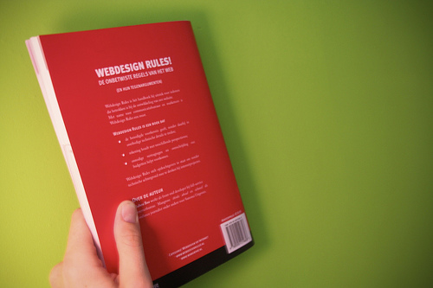
Label should be vertical, with title to the right and numbers to the left.


(Bos, 2007)
Ownership stamp- Stamp books with school library name in the following locations: Front inside cover, back inside cover, and page 51.
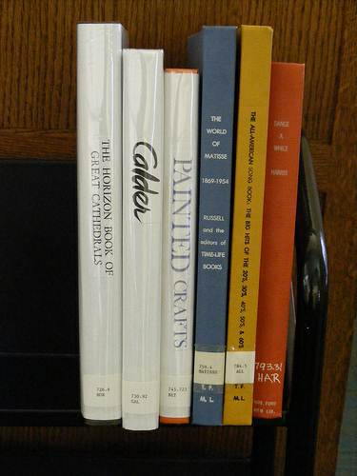
Spine Label- Print and affix to spine cover with label protector.
(Thomas Ford Memorial Library, 2009)
Best placement of label. Dewey plus first 3 letters of author’s name.

MARC- Upload new catalog records into library cataloging database. If no MARC records came with the books, and other sources have been tried, use basic cataloging practices in the Follett Destiny Library Manager or original Cataloging through Dewey Decimal Classification and Relative Index.
STANDARDS FOR SPECIAL BIBLIOGRAPHIC RECORDS
Special call numbers will be limited to the following and printed in all capital letters:

GRAPHIC NOVELS: Shelved in 741.5 (Kan, 2010).
FICTION: FIC plus the first three letters of the author's last name
BIOGRAPHY: B plus the first three letters of the SUBJECT’s (not author’s) last name (e.g. B KIN for a biography about Martin Luther King, Jr.).

REFERENCE: REF followed by Dewey number followed by the first three letters of the author's last name (e.g. REF 031.5 TIM)
NON-PRINT: AV followed by Dewey number plus first three letters of author (or title if no author)
PROFESSIONAL: PRO followed by Dewey number plus the first three letters of the author's last name.
EQUIPMENT: EQ followed by year purchased. (Georgetown Independent School District Texas, n.d.).

Organizing and Maintaining Materials and Equipment
A major organizational objective should be ready access to library materials. For the book and audiovisual materials collections, the Dewey Decimal system is used to classify items. Organizational and processing techniques should not be overly complicated, but quality of cataloging should be maintained throughout the library collection.
Maintaining Records of Materials and Equipment (monthly and yearly)
Monthly circulation statistics need to be maintained. Run the monthly circulation record at the end of each month, keeping one for the school library files and sending one to the assistant superintendent for curriculum and instruction at the Cherokee County School District office.
The library staff should maintain inventory of books, audiovisual materials, and equipment and report it to administration each year.
The library staff should make a count of the number of items. For example, the total number of books in the collection should be known, as well as the number missing, discarded, and lost and paid for during the school year.

4. Periodicals/Serials/Newspapers
A barcode will be assigned and affixed to each periodical as it comes in and issued as “permanent” in Destiny, along with the title and month of the issue. Newspapers will not be catalogued (Burke, 2002).
5. Weeding
Weeding of the media collection will be completed as outlined in the county policy.

The media specialist will determine the materials to be weeded using the following criteria:
- Currency: Subject matter is out of date, factually inaccurate, or no longer relevant to the educational program or no longer meets the criteria established for selection.
- Dispensability: Duplicate copy or copies no longer needed in the collection.
- Physical condition: Worn, torn, soiled; pages or parts missing; unable to be repaired.
- Record of use: Item not circulated in five years.
(Herward, 2003)

The media specialist or media clerk will remove the records for the weeded items from the Destiny system.

The media clerk will work with student and parent volunteers to remove or black-out all barcodes from the items being weeded and box them as SURPLUS.

The media specialist will request that the items be picked up for delivery to the CCSD warehouse.

6. Damaged Book Procedures
Books and other print materials should be repaired if it would be difficult or expensive to replace or if it has some unique value to the collection. Mending should be done to books and other print materials when needed to extend the life of the resource and to avoid the expense of replacement.

Repairs will be done by the media clerk or trained parent volunteers.

The following supplies will be kept in stock for repairs:
- Norbond Liquid Plastic Adhesive (book repair glue)
- Book Tape (clear)
- Book Jacket covers
- Reddi-Corners - durable reinforcement for book cover corners of any size
- Reddi-Covers – protects paperback covers, extends life of paperbacks
- Hinge Tape - reinforces and strengthens hinges of book covers
- Film-fiber Tape - used for attaching book jacket covers and reinforcing magazines
- Book repair wings – prevents spine breakage and fraying

Supplies will be purchased from the county warehouse catalog or county approved vendors (DEMCO or Quick Delivery).

7. Inventory

Destiny Inventory Procedures

With Inventory, you can choose to take stock of your entire collection or inspect one or more sections at a time. Your goal is to enter the barcode number of each unaccounted-for copy.
Keep in mind that, while inventorying changes a copy's inventory status (Accounted for/UnAccounted for), it may also affect a copy's copy status (Available/Checked Out/Lost/On Hold/On Order/Out for Repairs/Loaned Out/In Transit).
Inventory can notify you when the barcodes entered, scanned, or uploaded, are out of call number order. Before beginning an inventory, you'll need to set up your shelf-checking preferences in Site Configuration (Back Office tab Site Configuration link).
Important: After setting your preferences in Site Configuration, make sure to select the Check shelf order check box on the Inventory page.
Checking the shelf order
Select one of the Check shelf order based on options to make sure that copies on the shelf are in call number order. You can select how thorough you want the checking to be: by call number alone; by call number then by author; or by call number, then author and then title.
Destiny either alerts you with a message at the top of the page when you're entering barcode numbers directly on the Inventory page or, if you've uploaded a barcode file, a Destiny Remote file or an InHand scan file, adds a message to the Job Summary.
Checking the differences between Dewey numbers:
Select one of the Check for differences between Dewey numbers greater than options—100, 50, 10, or 1—to discover incorrectly shelved Dewey-range titles. This option also helps you verify that you didn't skip a shelf when scanning books.
When the difference between two consecutive barcode scans is greater than the value you select, Inventory notifies you. It either alerts you with a message at the top of the page when you're entering barcode numbers directly on the Inventory page or, if you've uploaded a barcode file, a Destiny Remote file, or an InHand scan file, adds a message to the Job Summary.

- Open Destiny Library Manager
- Click the Back Office tab
- Click the Site Configuration link
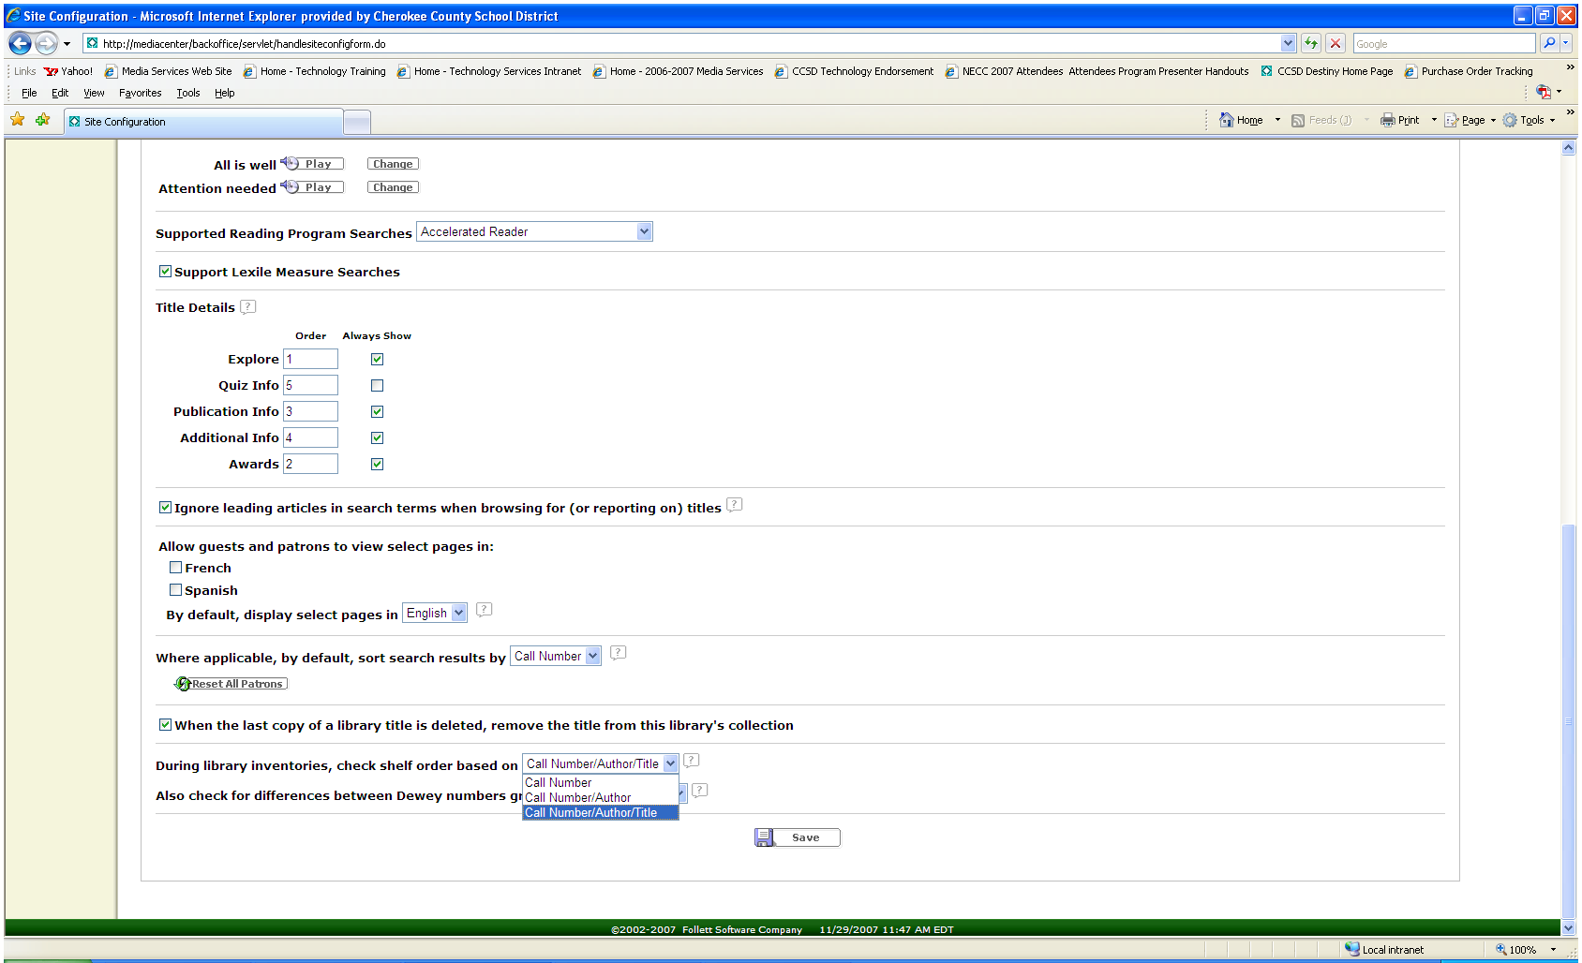
- Select the appropriate shelf-checking preferences (This is optional)
Check Shelf Order:
Select one of these options to make sure that copies on the shelf are in Call Number order. You can select how thorough you want the checking to be:
- by Call Number alone
- by Call Number then by Author
- by Call Number, then Author and then Title
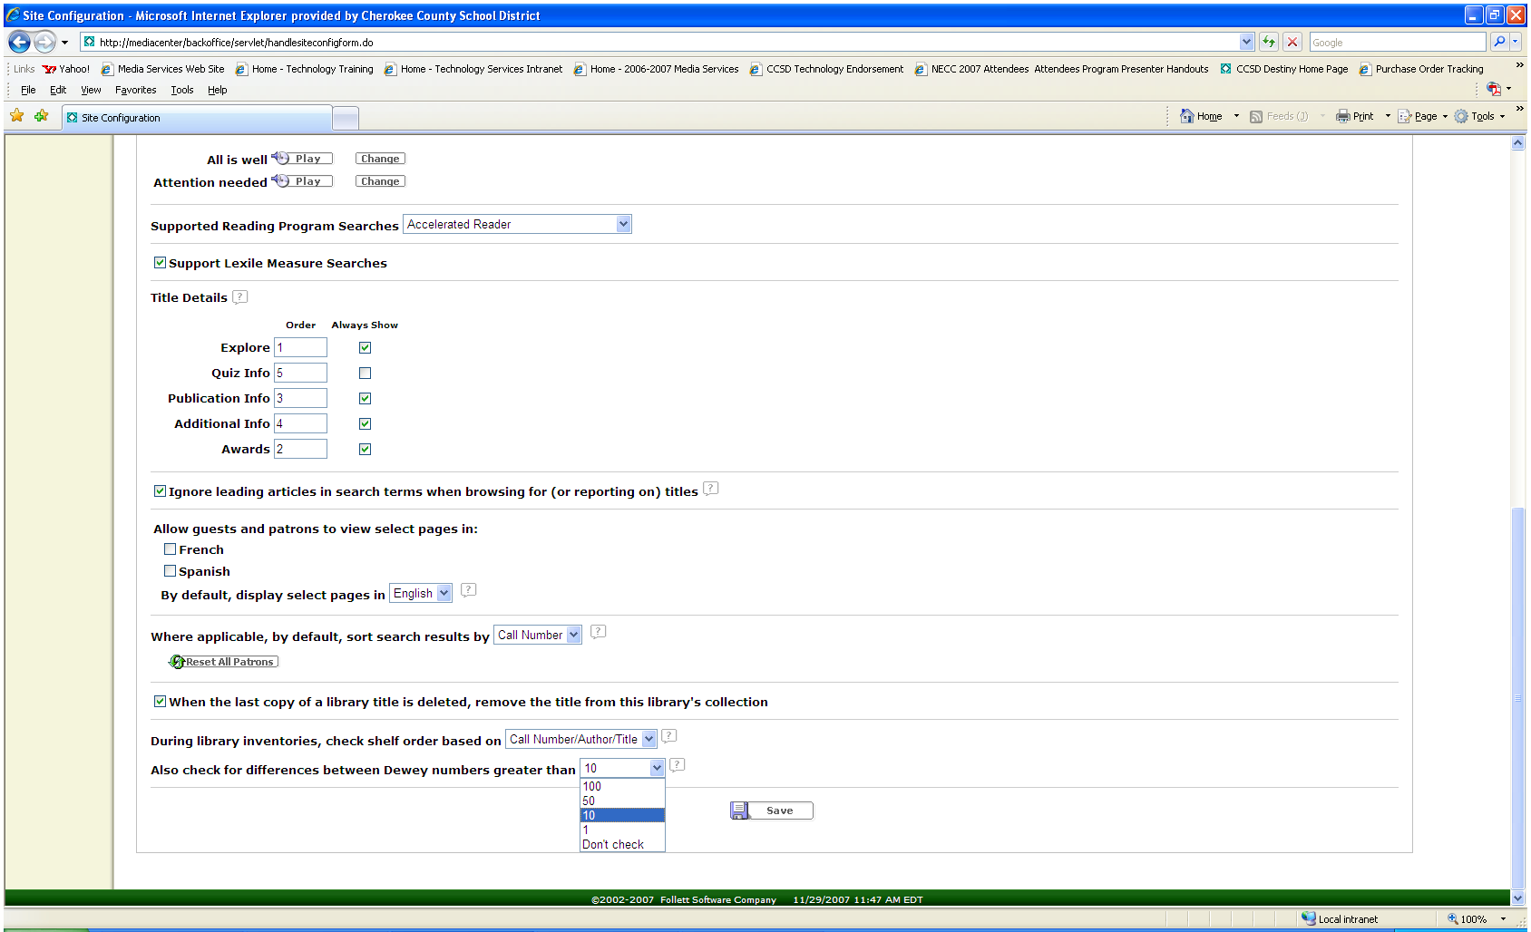
Differences between Dewey numbers:
Select one of the Dewey differences to discover incorrectly shelved Dewey range titles. This option also helps you verify that you didn't skip a shelf when scanning books.
When the difference between two consecutive barcode scans is greater than the value you select, Inventory notifies you. It either alerts you with a message at the top of the page when you're entering barcode numbers directly on the Inventory page or, if you've used a barcode file, adds a message to the Job Summary.

- Click the Inventory link
- Click the Start New Inventory button 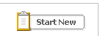
- Provide a unique name for this Inventory (up to 30 characters)
This name appears in the Inventory list on the Inventory page and on all Inventory lists and reports.
- Determine how you’re going to do Inventory:
- You can limit the inventory to copies in a particular Call Number Range
- You can exclude any copies that have been seen recently
- You can limit it to copies with certain Circulation Types
- Click YES on the confirmation page to begin the Inventory.
- You will be returned to the main Inventory page
- Scan, enter, or upload the barcode numbers to account for your copies.
- You can use your barcode reader and enter them directly on the Inventory page
- You can use your InHand/Panther portable device to create a file of barcodes to upload
- You can create a text file of barcodes and upload them
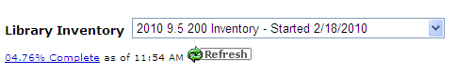
- Once you are sure you have entered the barcode numbers for all the copies, review the list of unaccounted-for copies by clicking the Percentage Complete link in the upper left corner of the Inventory page, and then See Details next to Unaccounted for:
  - If you can locate any of the copies on the list, click Found to account for it.
  - If you cannot locate a copy, click Mark "Lost" on the list to account for it.
  - You can run Reports directly from this screen – choose the Report you want then click the Run Report button
- Review the Lost Copies list.
From the Progress Details page, click the link for Lost items
  - If you can locate any of the copies that had been Lost, either click Found on the lost copy list or enter the barcode directly on the Inventory page to make it Accounted-for and change its copy status to Available.
  - To delete a lost copy from the collection permanently, click Delete on the list.
Remember that deleting a copy deletes all information about it, including its circulation statistics.
- Once the Unaccounted-for total on the Progress Details page is 0 (zero), your inventory is complete.
Click and Yes to the confirmation message.
If you still have any unaccounted-for copies, a message appears, asking whether Destiny should mark them Lost.
  - Select Mark all unaccounted for copies "lost" if you are sure that you cannot find the remaining Unaccounted-for copies. When you select Mark all... on the message and click Yes, Destiny marks all the Unaccounted-for copies Lost. Their copy status changes to Lost; they are added to the Lost Copies list and they become Accounted-for.
  - When you select Ignore them (don't mark them "Lost"), Destiny does not change their inventory status or copy status. The Unaccounted-for copies remain Unaccounted-for. Their copy status remains Available, or, for Ready Holds, On Hold.
  - To help you keep track of your inventories, click View In-Progress & Completed Inventories List for a list, details, and reports of the inventories. The reports are also available on the Library Materials tab.

REPORTS
To open your list of inventories, go to either of the following pages:
- Click the Library Materials link in the Reports tab and select
In Progress Inventories or Completed Inventories
- Click View In Progress & Completed Inventories link in Inventory in the Back Office.
To sort the list, click any column heading to sort in ascending order ().
Click again to sort the list in descending order ().
To generate an In-Progress Inventory Report:
- On the In Progress tab, click adjacent to the inventory.
- On the In-Progress Inventory page that appears, select the copies you want to include on the report.
- Click .
- Click View on the Job Manager page that appears.
- Click Report on the Job Summary that appears.
To generate a Completed Inventory Report:
- On the Completed tab, click adjacent to the inventory.
- On the Job Summary page that appears, click the View link beside the report you generated.
To delete a completed inventory, click.
Please note that, once you delete an inventory, you can no longer generate its reports.
Report Information
At the top, the report shows the name of the inventory, the school name, and the overall totals of Accounted For and Unaccounted For copies.
The report is first grouped into Accounted For and Unaccounted For sections.
If you generated an In-Progress report and chose 'Accounted For' or 'Unaccounted For', the report is limited to those copies.
For each copy, the report includes columns for the following information:
- Copy barcode number
- Call Number
- Author
- Title
- The date the copy was last seen
The date you generated the report appears at the bottom of the last page.
How is the report sorted?
If you chose "All copies in the inventory", the copies are grouped into Accounted For and Unaccounted For sections.
The report is sorted first by Call Number, then by Author, and finally by Title.
For each title, the copies appear in numerical order by barcode number.
What is the "date last seen"?
Every time Destiny updates information about a copy during one of the following transactions or processes, Destiny also updates its date last seen information:
- Check Out (Library Manager)
- Check In
- Inventory
- Individual Update in Update Copies
- Receive in Update Copies (Library Manager)
- Add titles ( or I want to "Add to the List") to a Resource List when adding records using a barcode scan, a barcode list, or a barcode file.
What information does the Inventory Job Summary contain?
Destiny makes an entry in the Job Summary for every barcode number in the uploaded file.
For exceptions, it enters one of the following messages:
- If the barcode does not match any barcode that belongs to the library,
"Skipped: Barcode <barcode number> not found" appears.
- If the copy is currently listed as checked out, it remains Accounted-for and checked out.
"Barcode <barcode number> has been accounted for, but is currently checked out and has a due date of <due date>" appears.
To make the copy Available, enter its barcode on the main Inventory page.
- If the copy was Lost, it remains Accounted-for and Lost. Any assessed fines are unaffected.
"This barcode is currently marked lost" appears.
To make the copy Available, enter its barcode on the main Inventory page.
- If you opted to have Inventory check the shelf order and the copy's call number appears to be out of order,
"This item appears to be shelved incorrectly" appears.
- If you opted to have Inventory check the differences in Dewey numbers and the copy's Dewey number is much greater than the previous one,
"The difference in the Dewey numbers of this and the previous item is greater than <number>" appears (Cherokee County Schools, 2010).

II. Technical Services
1. Tools Necessary for Original Cataloging
Purchased Cataloging. Cataloging may be purchased from Follett, Bound to Stay Bound, or Mackin, our three approved vendors, and should adhere to the guidelines of this manual: Sears subject headings and Dewey Decimal Classification.
Manual Cataloging. Manual Cataloging should use the Abridged Dewey Decimal Classification and Relative Index with Sears List of Subject Headings and should be entered into the school’s OPAC system (Destiny) (Lynch, 1999).
Online Resources for Cataloging. Our OPAC system, Follett Destiny Library Manager, has system-wide and Follett-based Cataloging available to use when entering new, unprocessed materials (Dunham, 2010).
2. Cataloging Procedures
The Destiny Qwikstart Guide is available online here (CCSD, 2010).
Standards/Format Indicators & Shelving Considerations
After media has been received into the library, it is ready for processing. All the steps necessary in order to prepare an item for check out are included in the following procedural practices for Cherokee County Schools. Cataloging practices shall be as consistent and uniform as possible in all libraries in Cherokee County Schools. All subject headings shall be assigned from the Sears List of Subject Headings.
Print Materials
After media has been received into the library, it is ready for processing. Processing includes all the steps necessary to prepare media for use. The process used should follow standard library practices, be an easily followed routine, and be performed in a routine manner. Cataloging practices shall be as consistent and uniform as possible in all Cherokee County Schools libraries.
Non-print (AV) and Equipment
Each item of equipment should be bar-coded and entered into the computer database. Item records should be recorded by make, model and serial number. If a district number is assigned, this should also be recorded on the local record. All equipment items should be marked with Cherokee County School District, school name, serial number and bar code number with a permanent marker or preferably with an engraver and permanent marker. AV materials and equipment shall be shelved/stored in a media center office that can be locked for security.

3. Directions Sheet for Para-Professionals, Volunteers, and Student Assistants

INTRODUCTION
The River Ridge High School Media Center is a wonderful, busy place with excellent resources for students, staff, and parents to share. Thank you for your time helping our students in the library. Your active participation here and elsewhere at school shows your children how much you value education in general and reading in particular--a powerful message!
Below are guidelines for basic library services. Please do not feel you have to know everything right away. Over time you will grow to be comfortable and knowledgeable about library operations and services.

LIBRARY MISSION
The goal is for children to have a positive experience in the library. This is where “YES!” happens.

Volunteer Duties
As a volunteer, you will probably spend most of your time shelving books that have been either checked out and returned or used for research by students in the Media Center. In addition, you may be asked to help with any number of additional tasks, such as the following:
Circulation duties: Book check-in/check-out
Shelve books
Straighten books and read shelves
Straighten furniture
Answer phone, take messages
Assist students in finding books
Greet authors and special visitors
Process new books and periodicals
Assist with special projects as directed by the librarian (i.e. book fairs, authors, cleaning of equipment, birthday book club, preparing showcases and bulletin boards)
Assist with computer work as needed(Georgetown Independent School District, n.d.)

SHELVING GUIDELINES
It is imperative to shelve items correctly. If a book is in the wrong spot, it may as well be lost. Ask for help if you are not sure.

Fiction Books

These books will have a label on the book spine showing an F (for Fiction) and the first three letters of the book author’s last name. Here is an example:

F Section of the Media Center
Cle 1st 3 letters of the author’s last name

Shelving in the Fiction section of the Media Center is in alphabetical order by book author’s last name.

Non-Fiction Books
Non-Fiction books are shelved using the Dewey Decimal system. Books using the Dewey Decimal system are in numerical order.

These books are in correct Dewey decimal order. It is just like counting. Notice that the only time we worry about the alphabetical order in the second line is when the Dewey number is exactly the same. You can see this in the 567 books.

Reference Books
Mostly reference/research books, these books will have a label on the book spine showing Ref (for Reference), the Dewey Decimal number, and then the first three letters of the book author’s last name. Here is an example:

Ref Section of the Media Center
525.6 Dewey Decimal number
Cle 1st 3 letters of the author’s last name

Professional Books
Mostly books housed for teacher/professional use, these books will have a label on the book spine showing a Prof (for Professional), the Dewey Decimal number, and first three letters of the book author’s last name. Here is an example:

Prof Section of the Media Center
372.9 Dewey Decimal number
Cle 1st 3 letters of the author’s last name

LIBRARY SHELF MAINTENANCE

Our collection gets heavy use. To make sure a book can be found when it is needed it is helpful to “read the shelves” when there is extra time. Applying general shelving rules, the spine label of each book is read book by book to make sure every book is where it should be. Follow the posted schedule to make sure the entire library is checked regularly:

Monday: Fiction A-J
Tuesday: Fiction K-Z
Wednesday: Nonfiction 000-499.99
Thursday: Non-fiction 500-999.99
Friday: Biography and Reference sections (Cherokee County School District, n.d.)

CIRCULATION
At River Ridge High School, we use the catalog system DESTINY to record book check-outs/check-ins. Training for the system will be provided during the volunteer training session.

Students/teachers/parents can access the Destiny catalog from the classroom, the Media Center or from home.
(Cherokee County School District, n.d.).

CIRCULATION DESK PROCEDURES

Check-Out

- Watch the screen during the transaction for accuracy, messages, and overdue books.

- Check in or renew all items before checking out new materials.

- Students may check out 3 items at a time.

- Teachers may check out an unlimited number of items.

- Magazines are circulated as “temporary” items. Instructions are posted at the circulation desk.

- Be sure to “bump out”/demagnetize the books before allowing students to leave with them; otherwise, they will trigger the alarm.

- "Be here now" for the kids! While checking out books engage the student in a conversation about his or her choice, or make a positive statement about the choice. Talk to the student rather than to the parent working alongside you.

Check-In
- Check in or renew all items before checking out new materials.

- Watch the screen during the transaction for accuracy, messages, and overdue books.

- “Bump in” or re-magnetize the books before shelving them. This prevents loss and/or theft.

OTHER GUIDELINES

Please turn off your cell phone while working in the library or the classroom.
Please respect privacy and confidentiality while volunteering at school.

The time spent helping at school should not be used to talk to the teacher about your child. Please make other arrangements for a teacher conference.

Thank you so much for supporting the media center and for fostering a life-long love of reading in our students! (H. Snively, n.d.)

Volunteer’s Statement of Commitment

It is understood that my time will be worked out cooperatively with the school volunteer coordinator and the teacher or staff member with whom I am working. I agree to attend an orientation meeting and any meetings that may occasionally be necessary to help me in my job. If I find that I must be absent, I will notify the school as far in advance as possible.

To the best of my knowledge I have no physical or mental disability that would prevent my working with students, and I agree to abide by all the school rules and Board of Education regulations that apply.

Signed: _________________________ Date: ____________

4. Overdue books:

- A student may not check out a book with an overdue book.

- The Georgia Confidentiality Law (O.C.G.A. 24-9-46 (2010)) prohibits the disclosure of any patron information, including titles checked out, amount of fines/fees owed, and phone numbers/addresses. All library staff recognizes the strict confidentiality of library records, and shall not disclose any information regarding library patrons unless legally compelled. If proper legal documents are presented, a Library Director or designee must approve the decision to release confidential records (Athens Regional Library System, 2009).

- Overdue notices will be sent out every two weeks to first period teachers. The notice will be stapled so that it only shows the student’s name but not the book titles to preserve patron confidentiality (J. McLaughlin, personal communication, August 28, 2010).

5.Lost books:

- Students will be charged the replacement cost of the book plus late fees up to $5.00 as well as a processing fee of $2.00.

- Mark the book as lost and paid so that the media center catalog information is current.

- Add the title to the media center consideration file.

- Delete the title from the media center collection at the end of the year after Inventory (Cherokee County School District, 2006).

- Patrons will be responsible for paying the replacement cost of a lost or damaged item. A processing fee of up to $10.00 may be charged for the replacement of their items (Jefferson County Public Library, 1996).

III. Collaboration Resources

1. Reconsideration of Materials Procedures
Challenged Media

The Board of Education acknowledges the right of parents and other citizens to raise questions through established procedures when materials appear inappropriate for public school use.

Though care is taken to select valuable materials for students and teachers, there may be occasional objections by the public as to the selections that have been made.

In the event that a complaint is made, the following procedures should be followed:
A. The school staff member receiving the complaint shall explain the selection process utilized and the procedures for challenged materials, but make no commitments as to personal opinion, etc. Written documentation of this contact should be filed with the school principal.
B. In the event that the person making an objection to material is not satisfied with the initial explanation, the person should be referred to the principal who shall explain the selection and reconsideration process and refrain from expressing personal opinion.
1. If, after consultation, the complainant desires to file a formal complaint, a copy of the challenged material form shall be given to the complainant by the principal.
2. The principal shall inform the complainant that the form must be completed in its entirety and submitted to the principal. It must be emphasized to the complainant that incomplete forms will be considered invalid and will not be recognized.
3. After the challenged materials form is completed and signed by the complainant, it is to be filed with the principal and copies sent to the appropriate system level personnel.
4. When referred to the system instructional media committee, as a minimum the committee shall do the following:
a. Read and examine materials referred to it;
b. Check general acceptance of the materials by reading reviews;
c. Compare values and faults against each other and form opinions based on the materials as a whole and not on passages pulled out of context;
d. Meet to discuss the material and to prepare a report on it;
e. Present the report to the appropriate personnel.

5. In the event that the above procedures do not satisfy the complainant, the matter may be referred to the Cherokee County Board of Education. The decision of the Board of Education is the final authority.

Challenged Media Form
http://portal.cherokee.k12.ga.us/departments/curriculum/Curriculum%20Documents/Challenged_Material_Form.pdf
2. Instruction/Inservice/Staff Development

Instruction is a cornerstone of the library services we offer. Whether it is direct classroom instruction or an online module; whether it’s teaching an information literacy skill, a technology or Web 2.0 tool; or even refreshing copyright rules for teachers, the media specialists are ready and willing to create instruction of any format for any purpose. Just ask!

3. Advocacy: Tips for Stakeholders

The Media Center and Public Relations


- Public relations in the newspaper, television, and other media sources in a major way to let the community know what is going on in your library media center.
- Public Relations in paper form:
  - With the abundance of word processing and desktop publishing programs, dull or sloppy documents should not be produced to represent the media center. Be sure anything produced from the media center is attractive and stand out from other documents. This can be achieved by using:
    - Clip art
    - Colored paper stock
    - Font and size
  - The text for each document should be targeting a specific audience. Word choice should be given great thought so that it is geared toward the target audience.

- Public Relations on the web:
  - Posting newsletters and other information on school/media center websites and/or blogs shows that the library media center is modern and technologically enhanced.
  - Messages can be broadcast to the community faster and can be updated quickly and easily.
  - Be sure that if posting a word processed document to a webpage, view the document once it is posted to be sure the format of the document was not changed. Images should be saved in .gif or .jpeg format in order to keep from being lost.
  - Include videos, digital photos, powerpoint presentations, etc. on a media center webpage in order to make the events of the media center come alive to its viewers.
- Public Relations in the news
  - When submitting photos of activities to the newspaper, include a description of what is happening and any names of people in the photo.
  - Create a relationship with the person at the newspaper who is in charge of putting together news stories from schools. This relationship will help when wanting specific events, stories, etc. in the paper.

- Developing a Public Relations Outreach Program
  - Create a database of names and addresses for mailings
    - News media contacts
    - Names of central office staff
    - Names of school board members
  - Make regular phone calls to media contacts and follow up every phone call with written information.
  - Every submission may not make it into the community’s media (newspaper, local tv station), but continued contacts will let the reporters know that you are an educational resource.
  - Know newspaper deadlines and approaches that usually work when trying to get something in the paper.
  - Standard PR procedures should be:
    - Send newsletters to an extended audience (board members, public officials, etc.); news media can be sent a newsletter (after a firm contact has been established)
    - Use the newsletter to create a news release to be sent to the local newspaper
    - Think of a way in which the public can be involved in an event or how they can benefit from it and include it in the news release.
- Writing a news release
  - First, determine the purpose of putting the information in the newspaper.
  - 7 steps to composition of the release
- In the upper left-hand margin under the letter head, type FOR IMMEDIATE RELEASE in boldface and uppercase.
- Skip a couple of lines and type in boldface and uppercase: CONTACT INFORMATION: follow this with your name, title, telephone number, fax number, and email address.
- Skip a couple more lines under the contact information and list the main headline in bold face. Don’t have a cutesy font.
- Begin the first sentence of the release with a dateline (name of city of release and date of mailing the release).
- Write the lead paragraph. It should catch the reader’s attention and tell who, what, when, where, and why.
- Following paragraphs should give plenty of details, but should remain precise. The release should not be more than a page in length.
- Signify the end of the release with the following notation, centered: ###.

References
Farmer, L. S. J. (2000). Tech-Savvy Public Relations. Book Report, May/June, 6-8.
McElmeel, S. L. (2000). Making PR an Outreach Activity. Book Report, May/June, 10-11.


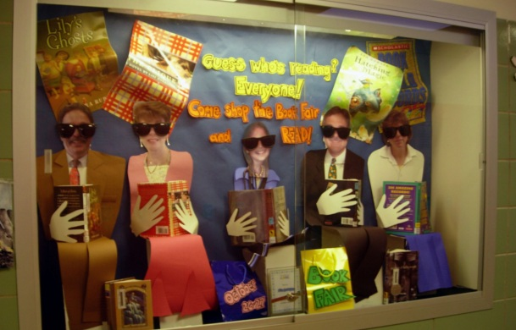
• Meet with teachers to ask how to
assist, and let teachers assist in the
media center so they can see what
it’s all about.
• Make lists of big ideas/topics for
each grade and provide lists of
books and materials available for
check out. Invite teachers and para-professionals to assist.
• Meet with teachers to plan collaboratively when possible. Design lessons with teachers, and offer to co-teach lessons.
• Include a section in media newsletters that highlights how the media center has assisted with specific instructional activities for individual classrooms to model how it can be done effectively.
• Create multimedia presentations for that include student products of information literacy lessons...evidence-based.
Be Everything to Everyone
Tips for the media center
Teaming Up with Teachers
Let the world know what is in the media center...new and even older items.

Share old book jackets for teachers to use to sort to teach the various genres.

Make small improvements that make the media center user friendly such as improved signage.
Little Things Matter Too
www.jerichoschools.org
Take photos of teachers and their students to highlight in displays that promote the media center and school-wide programs.
Microsoft Office Online, 2007



Brookwood
Media Center
501 Central Ave.
Dalton, GA 30705

Contributing Writers:
Sharon Folds
Molly Smith
Leigh Anne Smith

Advocacy & outreach go hand in hand.
Work with the living, and the dead will arise.
Microsoft Office Online, 2007
Collaborate with all teachers, coaches, and administrators. So not forget art, music, P.E., the counselor, and the nurse, just to name a few.
Microsoft Office Online, 2007
• Include teachers in the ordering
process when possible.
• Sponsor giveaways from the media center
such as books during book fairs, new
headphones (maybe wireless) for the
classes that have the highest rates of
checkouts for listening sets, etc.
• Find teachers willing to try out
new ideas from the media center.
• Offer to fill a space on classroom newsletters
with a note from the media center to brag
on students reading rates and checkout rates.
• Recognize teachers’ achievements (advanced degrees, etc.) by placing a new book in the media center in their honor. Also use it as a press release for the media center newsletter.
- Recognize teachers’ technology advances, such as new teacher
created web pages. Showcase in newsletters
or in multi-media form at PTA meetings.
- Develop web-based tutorials for teachers when possible.
Microsoft Office Online, 2007
May: Book Club dinner with a favorite author or illustrator. Have a formal dinner catered where student and teacher members enjoy a guest speaker and discuss their favorite books, the writing and illustrating processes, etc.
Sponsor a book club, with meetings before school, after school, or maybe during club schedules for students and teachers. Provide coffee & juice.
September: Opening event-
Book Talks Galore-offer teachers the opportunity to share a favorite book with students through a multi-media presentation.
February: For the Love of Books-let students share a favorite book in a multimedia presentation modeled after their teachers.

Media Center Book Clubs
Microsoft Office Online, 2007
References
Anderson, M. (2010). Your circle of influence. MultiMedia & Internet @ Schools, 17(5), 25-30. Retrieved from EBSCOhost.
Ballard, S. (2009). Sample job description: School Library media specialist. Knowledge Quest, 38(2), 80-82. Retrieved from EBSCOhost.
Bates, J., McClure, J., & Spinks, A. (2010). Making the Case for Evidence-Based Practice. Library Media Connection, 29(1), 24-27. Retrieved from EBSCOhost.
Gavigan, K., & Kurfts, S. (2010). Together we can: Collaborating to meet the needs of at-risk students. Library Media Connections, 29(3), 10-12. Retrieved from EBSCOhost.
Gilmore-See, J. (2009, January). Call to Action for Library Media Specialists. School Library Media Activities Monthly, 25(5), 51-53. doi: 1606164171
Purcell, M. (2010). All librarians do is check out books, right? A look at the roles of a school library media specialist. Library Media Connection, 29(3), 30-33. Retrieved from EBSCOhost.
Purcell, M. (2010). The Name Game: What's in a Name? Library Media Connection, 29(2), 20-21. Retrieved from EBSCOhost.
Young, Jr., T. E. (2010, May/June). Marketing your school library media center: What we can learn from national bookstores. Library Media Connection, 28:6, 18-20. Retrieved from EBSCOhost.

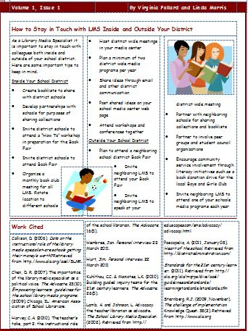
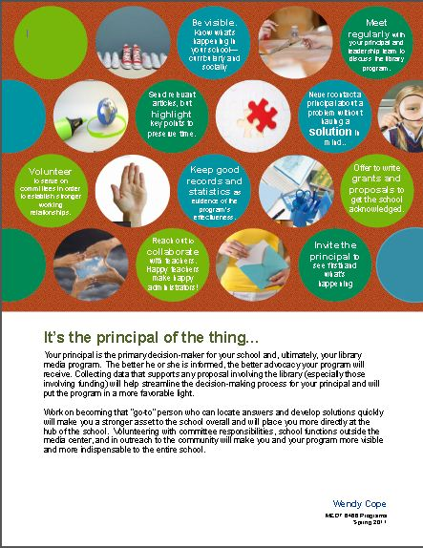

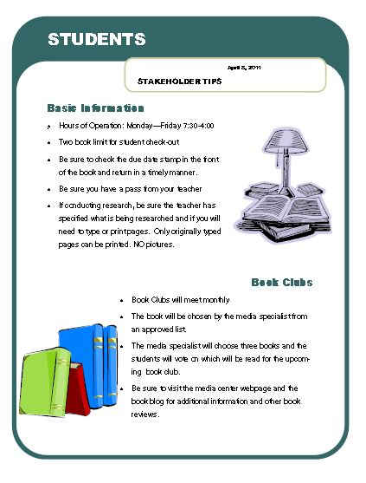
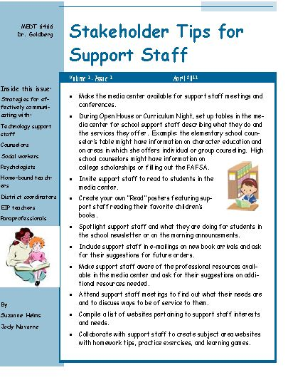

4. School Website
Maintenance of the school website is the responsibility of Leigh Rogers, RRHS webmaster. Media specialists are responsible for the maintenance of the media center page and related Libguides.
5. School TV News, Video Streaming, and GPB Educational Resources
All video streaming is available to teachers on an individual basis from MediaCAST.

The River Ridge High School Video Broadcast class will handle all school TV news. The media specialist uploads it to the MediaCAST server for school-wide broadcast.

6. Media Center Scheduling

River Ridge High School Media Center operates on a flexible schedule, providing services to as many students and faculty as possible.

The school media center is a valuable resource for teachers and students. A wide variety of print, audio-visual-based materials and technology-based resources relating to curriculum needs are available in the media center, and each school also has at least one media specialist to assist teachers in scheduling and using these resources. Teachers and students are encouraged to make full use of the media center. Some guidelines for use are listed below.

a. CLASS VISITS - Media center use and research are encouraged and should be scheduled in advance in person or by email so that adequate work space and materials can be made available. Teachers should remain with their classes and are responsible for the discipline of their students. Because of obvious reasons, media center use should not be part of a substitute’s plans unless arranged in advance with the media specialist.

b. INDIVIDUAL STUDENT VISITS - Passes for media center use may be issued during class periods when space is available. Teachers may issue passes for up to five (5) students at one time during a class. In situations where class visits are scheduled, fewer than five students at once may become necessary. Teachers should fill out the yellow student grid as a pass and include the purpose of the media center visit.

c. CLASSROOM COLLECTIONS - Print and non-print materials and specialized bibliographies will be assembled by media specialists on request.

d. AUDIO-VISUAL MATERIALS - Items to help enhance curricula, such as video recordings, sound recordings, etc., are available from the media center, and are listed in Destiny, the district's online media catalog. Space can be scheduled to view AV materials either in the media center computer lab or in the media center education area.

e. COMPUTER USE—Computers are available for classroom use both in the media center as well as the computer lab off of the media center. Both the computer lab and the media center computers are scheduled through the media specialist. Email your requests or contact your media specialist for availability.

f. AUDIO-VISUAL EQUIPMENT - Each media center has a list of AV equipment available. Equipment should be reserved in advance and returned at the end of the school day. Media specialists will train teachers and student operators. Only trained operators should be permitted to use equipment. The principal must approve the use of equipment off campus.

g. PROFESSIONAL USE- Use of the media center for faculty meetings and professional development should be coordinated through administration and the media specialist.

h. INTERNET USE - Teachers will monitor student access to the Internet. Use of the Internet by students should only be for school-related purposes (Hillsborough County Schools, 2009).

i. ADDITIONAL SERVICES – The media specialist is available to help plan, teach, and even assess (yes, grade!) projects and other assignments.

j. LIBRARY ORIENTATION CLASSES: Library orientation classes are given to 9th grade English classes (including Special Education and ESOL). Please watch for reminder announcements at the beginning of the year. Any other teachers may request orientation classes as well. The orientation may be designed to fit your needs (such as Dewey Decimal System only, finding a book in Destiny, research skills). Feel free to contact me to discuss your class needs: wendy.cope@cherokee.k12.ga.us. (Helman, n.d.)

IV. Appendices
Floor Plan: River Ridge High School 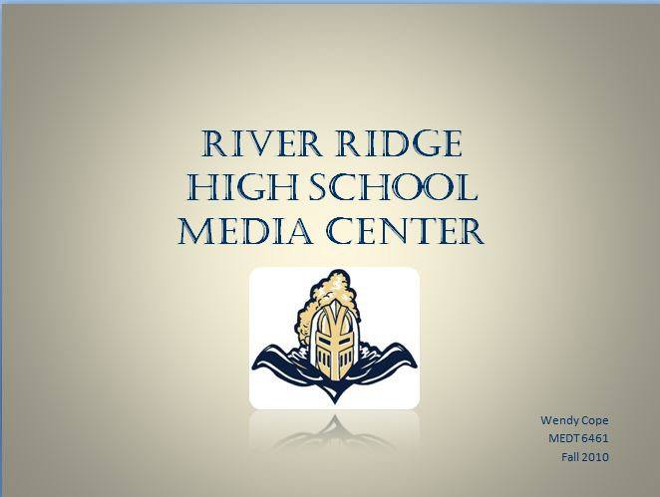

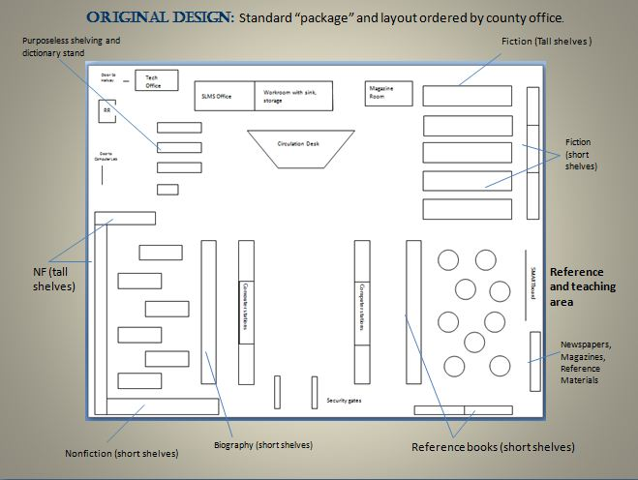

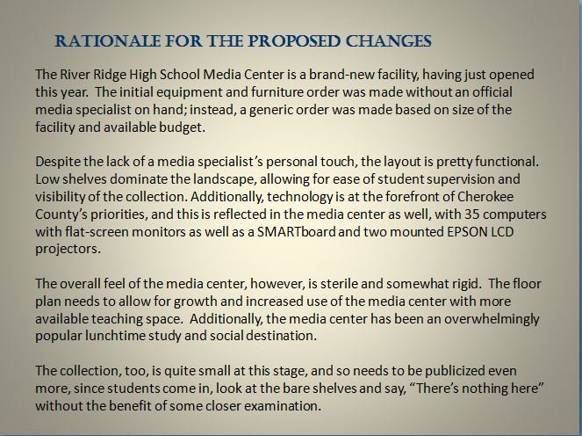

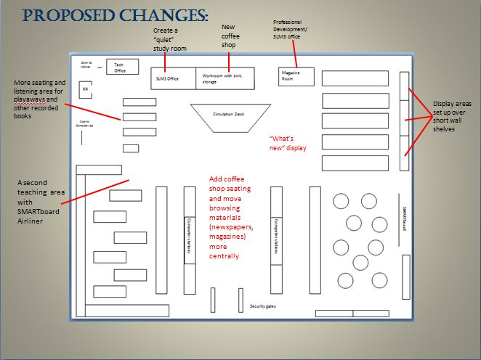

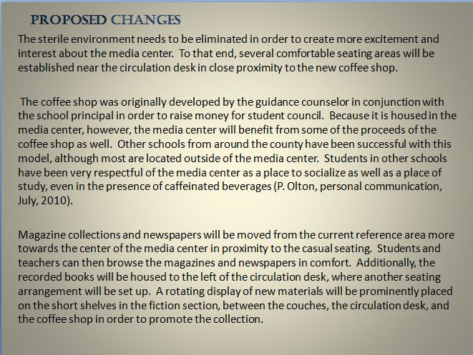

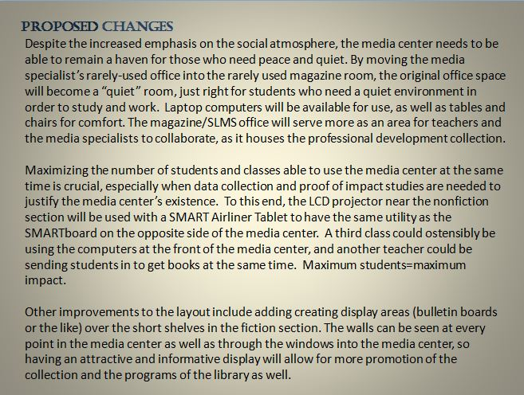

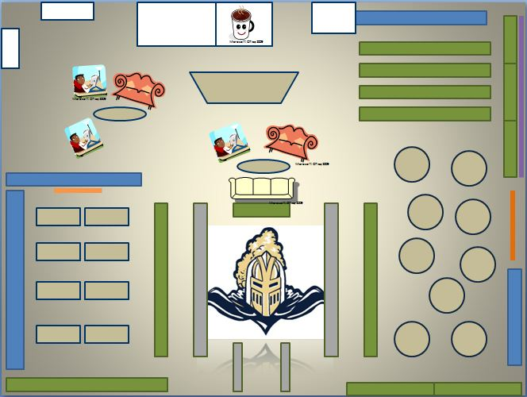

MCMS Map/ Network Diagram
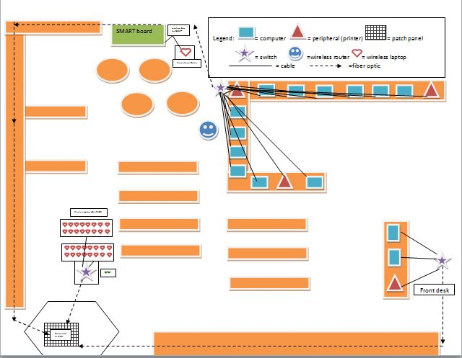
Sample MARC Record
16 – The Book of numbers
(Additional information: ix, 310 pages; black and white and color illustrations; 24 cm.; bibliographical references; index; LCCN: 95-32588; ISBN: 0-387-97993-X (hardcover: alk. paper)
Summary: Guides readers at different levels of mathematical sophistication in understanding the origins, patterns, and interrelationships of numbers.)

LCCN 010 95-32588
ISBN 020 ISBN: 0-387-97993-X (hardcover: alk. paper)
Local call # 082 512
Main entry 100 Conway, John H.
Title info 245 $a The book of numbers $c by John H. Conway and Richard K. Guy
(Varibale) 246
Edition 250
Computer file 256
Pub info 260 $a New York $b Springer-Verlag $c c1996
Physical desc. 300 $a ix, 310p $b ill.(some col.) $c 24cm.
(Play time) 306
Series 490
General note 500
(Bibl., note) 504 Includes bibliographical references and index.
(Citation tag) 510
(Summary) 520 Guides readers at different levels of mathematical sophistication in understanding the origins, patterns, and interrelationships of numbers

Subjects 600 Number theory.
Added entry 700 $a Guy, Richard K.
Local call # 852 512

Cherokee County School District

Media Print Awarded Vendor Contact List
Vendor | Contact Information | Vendor Address | Vendor Phone/Fax/Web
JOBBERS
Baker and Taylor, Inc.  (Jobber) | Jennifer Rhyne  Phone: 800-775-1100  Fax: 800-775-7480  orders@btol.com | 251 Mt. Olive Church Road  Commerce, GA 30599  http://www.btol.com | 800-775-1100  800-775-7480 (Fax)  http://www.btol.com
Follett Library Resources  (Jobber) | David Starnes  Phone:888-511-5114  Voice Mail 715  customerservice@flr.follett.com | 1340 Ridgeview Drive  McHenry, IL 60050-7048  http://www.titlewave.com | 888-511-5114  800-852-5458 (Fax)  http://www.titlewave.com
PRE-BOUND
Bound to Stay Bound Books  (Pre-Bound) | Sarah Schmidt  Phone: 800-637-6586 Ext. 3116  Fax: 800-747-2972  sschmidt@btsb.com | 1880 West Morton  Jacksonville, IL 62650-2697  http://www.btsb.com | 800-637-6586  800-747-2872 (Fax)  http://www.btsb.com
Sagebrush Corporation  (Econo-clad)  (Pre-Bound) | Kay Twite  Phone: 800-442-7332  Fax: 800-628-2410  orders@sagebrushcorp.com | 131 Bissen Street  Caledonia, MN 55921-1811  http://www.sagebrushbooks.com | 800-442-7332  800-628-2410 (Fax)  orders@sagebrushbooks.com
PREVIEW/ON-SITE PREVIEW
Gumdrop Books  (Preview/On-site Preview) | Nancy Crovetti  Phone: 800-821-7199  Fax: 660-425-3910 | P. O. Box 505  Bethany, MO 64424  http://www.gumdropbooks.com | 800-821-7199  660-425-3910 (Fax)  wecare@gumdropbooks.com
Mumford Library Books  (Preview/On-site ) | Doug McNamara  Phone: 800-367-3927  Fax: 904-730-8913 | 7847 Bayberry Road  Jacksonville, FL 32256  http://www.books-library.com | 800-367-3927  904-730-8913 (Fax)  info@books-library.com
SELECTION SERVICE
Junior Library Guild  (Selection Service) | Tiffany Nulph  800-743-4070  800-827-3080  tnulph@juniorlibraryguild.com | 7858 Industrial Parkway  Plain City, OH 43064  http://www.juniorlibraryguild.com | 800-743-4070  800-827-3080 (Fax) sales@juniorlibraryguild.com

Planning for 2010-11 @ your library®

Fall Overview: Book Fair
Author/Illustrator Visit

August Overview:
- School Readiness
- Media Center Readiness
  - Student Files Ready
  - Automation System Ready
  - Media Committee Meeting
    - Budgets (IM Books and Periodicals, IM Equipment, Local) Proposed)
    - Members discuss proposed budget with grade levels
  - Budgets Set
  - Media Displays
- Orientation
- Plan to attend North Georgia Media Consortium Meeting in the fall
- Plan for fall book fair

August 2 School starts

August 13 GOLD/GALILEO Users Group, UGA Continuing Ed
http://www.georgialibraries.org/lib/gold/ggugc2010/

August 26 1st District Media Meeting (12-4)
Ball Ground Elementary Media Center

September Overview:
- Media Committee Meeting
  - Budgets finalized and submitted to principal for approval
- Planning with Grade Levels or Departments
- Faculty Meeting – Copyright Law Overview
- Reader Recognition
- Meet with Science and Social Studies Departments to collaborate concerning research skills lessons to prepare students for the Science & Social Science Fairs
- Banned Books Week

September 3-5 Decatur Book Festival
http://www.decaturbookfestival.com/

September 8 International Literacy Day
www.reading.org

September 9 1st North GA RESA Consortium Media Meeting
Ellijay (9-3)

Sept. 19-25 National TV Turnoff Week
April 18-24 www.tvturnoff.org

Sept. 23-25 American Library Services to Children (ALSC) Institute, Emory
http://www.lita.org/ala/mgrps/divs/alsc/confevents/institute/index.cfm

September 25 National Book Festival
www.loc.gov/bookfest

Sept. 25-Oct. 2 Banned Books Week
www.ala.org/bbooks/

October Overview:
- Media Committee Meeting
- Reader Recognition
- Form Book Club team for Helen Ruffin Reading Bowl
- National Teen Read Week
- Georgia COMO Conference
- AASL Fall Forum/National Conference (alternates years)

October National Book Month
http://www.nationalbook.org/nbm.html

October Georgia Archives Month
http://soga.org/archivesmonth

Oct. 1-2 Georgia Conference on Information Literacy, Savannah
http://ceps.georgiasouthern.edu/conted/infolit.html

October 1-3 National Storytelling Festival, Jonesborough, TN
www.storytellingcenter.com/festival

October 13-15 COMO, Athens
http://www.georgiacomo.org/

October 22-23 Georgia Literary Festival, Statesboro
http://www.georgialiteraryfestival.org/

October 17-23 Teen Read Week
www.ala.org/teenread/

November Overview:
- Media Committee Meeting
- Planning with Grade Levels or Departments
- Children’s Book Week
- Reader Recognition
- GAETC

November 2 2nd District Media Meeting (12-4)
Chapman Intermediate Media Center

November 3-5 Georgia Educational Technology Conference, College Park
www.gaetc.net

November 11 2nd North GA RESA Consortium Media Meeting
Ellijay (9-3)

December Overview:
- Media Committee Meeting
- Christmas/Holiday Special Library Events/Lessons
- Reader Recognition
- Plan to attend North Georgia Media Consortium Winter Meeting
- Plan your spring book fair

Spring Overview: Spring Book Fair
Author/Illustrator Visit

January Overview:
- Media Committee Meeting
- Planning with Grade Levels or Departments
- Reader Recognition
- ALA Midwinter Meeting/Conference

January Caldecott and Newbery announcements
www.ala.org

January 11 CCSD HRRB Competition for Middle and High
Freedom Middle School 6 P.M.

January 18 3rd District Media Meeting (12-4)
Holly Springs Elementary Media Center

CCSD HRRB Competition for Elementary
Freedom Middle School 6 P.M.

January 27 3rd North GA RESA Consortium Media Meeting
Ellijay (9-3)

February Overview:
- Media Committee Meeting
  - Teacher input requested for magazine order
- Reader Recognition
- Reference and CRCRT readiness lessons
- County Helen Ruffin Reading Bowl competition

February 5 Regional Helen Ruffin Reading Bowls
www.glma-inc.org/readingbowl.htm

March Overview:
- Media Committee Meeting
  - Magazine order finalized and submitted to principal
- Planning with Grade Levels or Departments
- Read Across America/ Dr. Seuss Day
- Reference and CRCRT readiness lessons
- Reader Recognition
- IM budgeted monies encumbered by March through MUNIS system (check with principal for final date)
- Kennesaw State Annual Conference on Literature for Children and Adolescents
- National Poetry Month

March 2 Read Across America Day
www.nea.org/readacross

March 6-12 Teen Tech Week
http://www.ala.org/teentechweek/

March 4-5 Children’s Literature Conference, UGA
State Helen Ruffin Reading Bowl
www.coe.uga.edu/gachildlit

March 30 (Elem) Conference on Literature for Children & Adolescents, KSU
March 31 (MS/HS) http://www.kennesaw.edu/education/mge/childlit/

April Overview:
- Magazine orders placed for upcoming year (Funds drawn upon next year’s IM books and periodicals)
- Media Committee Meeting
- Reference and CRCRT Readiness lessons
- Reader Recognition
- Georgia Children’s Literature Conference at UGA
- National Library Week/School Library Month (ALA)

April National Poetry Month School Library Month
http://www.poets.org/npm/ www.ala.org/aasl

April 10-16 National Library Week
www.ala.org/pio/nlw/

April 28 4th North GA RESA Consortium Media Meeting
Ellijay (9-3)

May Overview:
- Media Committee Meeting
- Planning with Grade Levels or Departments
- Reader Recognition
- Global Due Date publicized
- Inventory
- Last Day of School
- Annual Report of Media Program due to county office
- Revise and present annual Program Design and Evaluation Plan (PDE) to administration and media committee
- Inventory Completion and report filed with principal (Inventory is not filed with county office.)
- Post Planning

May Get Caught Reading Month
http://www.getcaughtreading.org/

May 3 4th District Media Meeting (12-4)
River Ridge High School Media Center

May 8-11 International Reading Association, Orlando
www.reading.org

May 2-8 Children’s Book Week
www.cbcbooks.org

May 24 Last day of school (students)

June Overview:
ALA Annual Conference

June-TBA GLMA Summer Institute, Macon
http://www.glma-inc.org/

June 23-28 ALA Annual Conference, New Orleans
www.ala.org

June 26-29 NECC, Philadelphia
http://www.iste.org/

(Cherokee County School District, n.d.)

Classroom Video/DVD Form

Teacher: _______________________________________

Date: _______________________________________

Video to be Shown:________________________________________

Video Rating: _________________

Subject Area: _________________

Instructional Value:

This program complies with the school’s policy on the evaluation and selection of instructional materials. It is appropriate for the grade level and the instructional content enhances the curriculum. If this program has been recorded off-air, I affirm that it will be erased according to “fair use” interpretations of federal copyright regulations.

Teacher’s Signature

Submit to an administrator prior to viewing.

________Approved _________Not approved

________________________________ ________
Adminstrator’s Signature Date

Example of Video/DVD Request Forms:

Video/DVD
Request Sheet for the
Media Center

Give this to the Media Center at least 24 hours
before you want to watch the video.

Video title:__________________________________________________

Attach Principal’s permission form from the faculty handbook if the video is not from our Media Center collection.

Teacher requesting:________________________________________ Phone number____________

Learning objective (if the video is from our Media Center): ___________________________________________________________________________________

Date needed: _______________________ (Cherokee County School District, 2006)

Overdue Notice
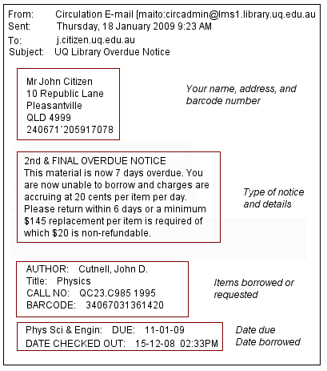
(The University of Queensland (AU) Library, 2009)
Procedures for Showing Videos and DVD’s in Your Room

- Select video.
- Fill out the form below at least 24 hours before planning to show the video. Submit to an administrator prior to viewing.
- Wait for the decision. A copy of the decision will be placed in your mailbox.

Note: Videos cannot be shown if they do not have an instructional value unless the children pay for performance rights. (Cherokee County School District, 2006).

1. Copyright Web Resources
10 Myths about Copyright
American Library Association
Becker Copyright
Bellingham Public School System
Copyright 101 for Educators
Copyright Activity for Students
Copyright and Fair Use
Stanford University Libraries
Copyright and K-12
Copyright and K-12 Schools Blog
Copyright Bay
Copyright Central
Copyright for Media Specialists
Copyright in an Electronic Environment
Copyright Law in the Electronic Environment
Copyright Issues Facing Educators
Copyright Management Center: Fair Use
Digital Millennium Copyright Act of 1998
The Educator’s Guide to Copyright and Fair Use
Fair Use Guidelines for Educational Multimedia
Fair Use of Copyrighted Materials
Georgia Learning Connection Copyright Links
Groton Public Schools
Copyright Resources on the Internet
Jefferson County Public Schools Copyright Guidelines
Library Video Company Copyright Information
Regents Guide to Understanding Copyright and Educational Fair Use
The United States Copyright Law
A Guide for Music Educators
To Copy or Not to Copy –That is the Question
United States Copyright Office
What is Copyright?
Media Specialists Institute
Copyright: Module 10
Sources for Copyright Cleared Materials
Creative Commons
Google Advanced Web Search (Choose appropriate Usage Rights from drop down menu)
Copyright Cleared Background Music (Soundzabound)
Copyright Cleared Background Music (GMPMusic)

2. INSTRUCTIONAL VIDEO APPROVAL

Movie Title: ___________________________________________________________
Teacher: __________________________ Date to be shown: ___________
Length of movie (minutes):____________ Class/Grade : _______________
Rating*: _______ *Parental permission is required for PG-13. No R rated videos may be viewed.
If movie is not rated, what is its source (A&E, etc):______________________________
Material Rented ___________ Purchased ________________
Taped off-air from channel: ______________ Date taped: _________________
Purpose (why is the movie being shown?):____________________________________
______________________________________________________________________
Objective (what is to be learned?)___________________________________________
______________________________________________________________________
Performance Standard it addresses: ________________________________________
______________________________________________________________________
Evaluation method: ___________________________________________________________________________________________________________________
Movie previewed by: _____________________________________________________
Was the language acceptable? __________________ Questionable:____________
Was the content acceptable? ____________________ Questionable:____________

This program is appropriate for the grade level and the instructional content enhances the curriculum. It complies with the county’s policy on the evaluation and selection of instructional materials. If this program has been recorded off-air, I affirm that it will be erased according to currently federal copyright regulations.

Teacher’s Signature: ____________________________________________________

For Office Use Only: Approved _______ Not Approved _________

Administrator’s Signature: _____________________________ Date: _____________

3. Request for Off-Air Taping Within An Institution
This tape was recorded by me/at my request on _______________________.
(date)
The 10th consecutive school day for the recording date is __________________.
(date).

I will not use this recording more than once in relevant teaching activities. I will not repeat it more
than once for reinforcement.

The 45th day after the recording date will be ___________________________.
(date)

I understand that I may use this recording from the 11th to the 45th day for teacher evaluation only.
It will not be used for student exhibition during this time unless authorization is obtained from the
copyright holder.

___________ copies have been made of this recording. Each one bears a copy of this statement.

This recording (these recordings) will be erased/destroyed no later than the 45th day as indicated above.

Teacher Signature ___________________________

Media Staff Signature _________________________ (Cherokee County School District, n.d.)

4. Request to Duplicate Copyrighted Material

TO:
Date:
Firm:
Address:

FROM:

School District:

Department:

Telephone:

Person Making Request: Title:

We are requesting authorization to duplicate the following copyrighted materials:
Title:

Author:

Subject:

Medium:

Rationale:

Number of copies to be made:
Copy Medium:

Use of Copies:

Anticipated date of first use:

Distribution of copies:

PRODUCER/PUBLISHER REPLY:
Permission: _____________ Granted _______________ Denied
Details/Restrictions:

Signature:

Title: Date:

(Cherokee County School District, n.d.)
5. Copyright Notice/Signs

Copiers:
NOTICE: The copyright law of the United States (Title 17 U.S. Code) governs the making of photocopies or other reproductions of copyrighted material. The person using this equipment is liable for any infringement.

Other Equipment

NOTICE: Computers, CD-ROMs, DVDs, videocassette programs and audio recordings are protected by copyright law (Title 17, U.S. code). Unauthorized use or copying may be prohibited by law (Cherokee County School District, n.d.).

6. Copyright Permission Letter
DIRECTIONS: Whenever a student or staff member wishes to "re-publish" someone else's writing or graphics on a Cherokee County School website, explicit permission must be obtained from the owner of copyright or evidence must be provided that the materials are "in the public domain." The form below may be copied and pasted into an e-mail message sent to the owner of the site and/or the owner of copyright. An e-mail reply which answers all questions fully and grants permission should be printed out and presented along with any web pages being submitted to the library media specialist for publication. Every web page containing such items must provide full credit to the source, indicate that permission was granted and include a notice clarifying that all rights are still reserved by the copyright owner.
************** Copy the letter below and E-Mail to Site Owner ************

Cherokee County Schools Copyright Permission Request
(Type Name of Site here)
(Type Name of Site Manager here)
(Type e-mail address of Site Manager here)
(Type URL (s) (addresses) of Web page containing desired item(s)
Dear (insert name of Site Manager):
I am a (insert either "student" or "teacher") in the Cherokee County (GA) School District creating web pages for a school project. My school is (insert name of school). My e-mail address is (insert full e-mail address).
We are currently engaged in a project which (insert description of the project and its goals here).
While doing research for this project, I visited your excellent site and was very much impressed with what you have done.
I am interested in gaining permission to "re-publish" the following material from your website on our school's website:
(describe first item)
(describe additional items)
Are you the holder of a copyright for these materials?
____ Yes ____ No
If you are not the holder of a copyright, can you identify the owner and supply an e-mail address so that I may contact the owner?
____________________________________________________________
If you are the holder of copyright, may we "republish" these items, including at the bottom of the Web page a clear notice that we are "re-publishing" the item with your permission, with all rights reserved?
____ I give my permission.
____ I do not give my permission.
Please write the words you wish for us to place at the bottom of the page describing your copyright restrictions.
____________________________________________________________
____________________________________________________________
Thanks so much for your time and assistance. We appreciate your contribution to the development of excellent content on the Web.
Please send back this whole message with your name and title at the bottom so that we can identify the source of permission.
Sincerely,
(insert your name)

Schools and non-profit organizations may copy and make use of these materials within their own school districts or may republish the pages on their Web sites provided that a clear notice of source is included on the Web page (Bellingham Public Schools, 2003).

7. Professional Organizations in School Library Media

Key National Organizations and Divisions
AASL (American Association of School Librarians), a division of the American Library Association
http://www.ala.org/aasl
A professional organization of school library media specialists from around the world. Their mission is to "advocate excellence, facilitate change, and develop leaders in the school library field." They publish two journals: KnowledgeQuest and SLMR.
Association for Educational Communications and Technology
http://www.aect-members.org/smt/
A professional organization that provides leadership in the "use of educational technology and its application to the learning process in the K-12 school environment." Awards the School Library Media Specialist of the Year award. AECT has a Division of School Media and Technology.
International Society for Technology in Education, The
http://www.iste.org/
A professional organization that provides a community for school library media specialists to gather and learn about technologies to improve school library media programs. ISTE has a SIG (Special Interest Group) Media Specialists SIGMS.
State Organizations
Georgia Association for Instructional Technology, Inc.
http://www.gait-inc.org/
Georgia Library Media Association, Inc. http://www.glma-inc.org/
School Library Media Division of the Georgia Library Association http://gla.georgialibraries.org/div_media.htm

Other Library and Related Organizations
ALSC (Association for Library Service to Children) a division of the American Library Association
http://www.ala.org/ala/mgrps/divs/alsc/
A network of children's and youth librarians.
The Association of Library Trustees, Advocates, Friends and Foundations (ALTAFF) is a division of the American Library Association (ALA)
http://www.ala.org/ala/mgrps/divs/altaff/
Mission is to motivate and support local Friends groups across the country in their efforts to preserve and strengthen libraries.
International Reading Association (IRA)
http://www.reading.org/
Society of School Librarians International
http://societyofschoollibrarians.webs.com/
Mission is the development of school library programs to meet the needs of a literate citizenry in an Information Society (School Library Media Specialist, n.d.).

8. Interlibrary Loan Request Form: Sequoyah Regional Library System: Sample Form
If a book is requested from one of the libraries in the Sequoyah Regional Library System (Cherokee, Pickens and Gilmer Counties) it is an Intra-library loan. If the book is located outside of the system it is an Inter-library loan.

1. Before requesting an item, check the library catalog to determine
if the item is in the system. Please request the loan from your
neighborhood library first.

2. Intra-library loans not picked up in 5 days
will be returned to the lending library.

3. Inter-library loans that are overdue are subject to a
.25 per day fine. Those loans not picked up are subject to a $1.00 fine.

4. Inter-library loans are subject to a mailing fee.

6. Best sellers are not loaned between libraries.

5. Please limit your loan requests to 3 books a day.

Title

Author

Edition

Format of item
Book | Large Print | Book on tape | Book on CD

If requesting an article: Author/Title

Name of magazine

Volume

No.

Date

Copyright

Pages

Borrow from
Inside the Sequoyah Regional Library System
Outside the Sequoyah Regional Library System

Need material by

Patron name

Patron address

E-mail Address

Patron phone number

Patron library card number

Maximum cost you are willing to
pay for loans outside our system

Subject of request

Purpose of request

At which library will you pick up your loan?

(Sequoyah Regional Library System, n.d.)
9. Homework Alert from Sequoyah Regional Library System (n.d.)
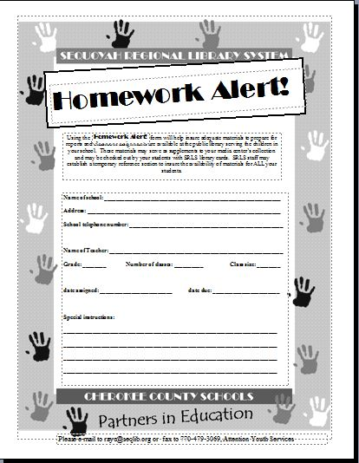
Media Center Student Volunteer Application
Name _________________________________________ Date __________________

Grade ____________ Homeroom Teacher ________________________

Lit/Comp Teacher ________________________

Extra Curricular Activities: ______________________________________________________

______________________________________________________________________________

Have you ever been a Media Center Volunteer? __________ If so, what school?_____________________

Why are you interested in becoming a Media Center Volunteer?
__________________________________________________________________________________________________________________________________________________________________________________________________________________________________________________________________

Place the following Fiction book labels in order:
F AND F HOL F COL F ANZ
__________ __________ __________ __________
Place the following non-fiction book labels in order:
340 DAV 340.332 GIL 341.9 ASA 340.3 DAV
__________ __________ __________ __________
** You may only come to the media center when ALL other academic work is complete. Being a MC student volunteer is a privilege that must be earned by going to class prepared and having a good attitude. ☺
(Cherokee County School District, n.d.)

Websites for Copy Cataloging
ALIS Cat
GALILEO Interconnected Libraries
Library of Congress
PINES (Public Information Network for Electronic Services)
Sunlink

References
American Library Association (1998). Information power: building partnerships for learning (1st ed.). Washington, D.C.: American Library Association.
American Library Association (n.d.). Mission and Goals of the School Library Media Program. Retrieved June 20, 2010, from http://www.ala.org/ala/mgrps/divs/aasl/guidelinesandstandards/informationpower/missiongoals.cfm
Athens Regional Library System (2009, 9 July). Policies. Retrieved 3 Oct 2010 from http://www.clarke.public.lib.ga.us/arls/policies/regional/circ.pdf
Bellingham Public Schools (2003, Feb 14). Copyright permission letter. Retrieved October 20, 2010 from http://www.bham.wednet.edu/sites/default/files/COPYPERM.HTM
Bishop, K. (2007). The collection program in schools: concepts, practices, and information sources (library and information science text series) (4 ed.). Englewood, Colorado: Libraries Unlimited.
Bos, R. (2007, June 9). Webdesign rules!-back cover. Image retrieved July 5, 2010, from http://www.flickr.com/photos/rbos/537092842/

Burke, J. (2002, September 8). HIT circulating magazines.
Message posted to Educator’s Desk Reference LM_NET electronic mailing list, archived at http://www.eduref.org/plweb-cgi/fastweb?getdoc+listservs+LM_NET-2002+10531+1+wAAA+cataloguing%26magazines

Cherokee County School District (n.d.) 2010-2011 calendar of media events. Retrieved September 15, 2010 from http://training.cherokee.k12.ga.us/mediaservices/Media%20Services%20Information/Forms/AllItems.aspx?RootFolder=%2fmediaservices%2fMedia%20Services%20Information%2f1.
Cherokee County School District (2010). 2010 Destiny inventory procedures. Retrieved October 5, 2010 from http://training.cherokee.k12.ga.us/mediaservices/pages/Destiny%20Library%20Manager.aspx?RootFolder=%2fmediaservices%2fSubject%201%20Notes%2f1%2fInventory&FolderCTID=&View=%7b1217A2FF%2d4A73%2d4131%2dACD0%2d2F334F2188EA%7d.
Cherokee County School District (n.d.). Beginning of the year copyright presentation. Retrieved October 22, 2010 from http://training.cherokee.k12.ga.us/mediaservices/default.aspx?RootFolder=%2fmediaservices%2fMedia%20Services%20Information%2f1%2fCopyright%20Information%2fBeginning%20of%20Year%20PowerPoint&FolderCTID=&View=%7b3B7F49D7%2dE6F2%2d4CCE%2dA636%2d3B1048E975E7%7d.
Cherokee County School District (n.d.). Cherokee County School District copyright policy. Retrieved October 20, 2010 from http://training.cherokee.k12.ga.us/mediaservices/default.aspx?RootFolder=%2fmediaservices%2fMedia%20Services%20Information%2f1%2fCopyright%20Information%2fCopyright%20Handbook&FolderCTID=&View=%7b3B7F49D7%2dE6F2%2d4CCE%2dA636%2d3B1048E975E7%7d.

Cherokee County School District (2010). Creekview High School Media Center Webpage. Retrieved June 20, 2010 from http://www.cherokee.k12.ga.us/Schools/creekview-hs/media_center/media_center/Media%20Center.aspx
Cherokee County School District (2006). Media center guidelines and procedures. Retrieved 28 Sep 2010 from http://training.cherokee.k12.ga.us/mediaservices/default.aspx?RootFolder=%2fmediaservices%2fMedia%20Services%20Information%2f1%2fMedia%20Specialist%20Handbook%2fGuidelines%20and%20Procedures&FolderCTID=&View=%7b3B7F49D7%2dE6F2%2d4CCE%2dA636%2d3B1048E975E7%7d.
Cherokee County School District (n.d.).Media services information: Volunteers. Retrieved November 14, 2010 from http://training.cherokee.k12.ga.us/mediaservices/default.aspx?RootFolder=%2fmediaservices%2fMedia%20Services%20Information%2f1%2fVolunteers&FolderCTID=&View=%7b3B7F49D7%2dE6F2%2d4CCE%2dA636%2d3B1048E975E7%7d
Cherokee County School District (n.d.). New media specialist’s checklist. Retrieved September 17, 2010 from http://training.cherokee.k12.ga.us/mediaservices/Media%20Services%20Information/Forms/AllItems.aspx?RootFolder=%2fmediaservices%2fMedia%20Services%20Information%2f1%2fMedia%20Specialist%20Handbook%2fMedia%20Specialist%20Checklist&FolderCTID=&View=%7b2019CF2A%2dA225%2d4532%2d953D%2d9420EEB9684B%7d.
Cherokee County School District. (n.d.) River Ridge High School School Improvement Plan. Retrieved June 20, 2010 from http://www.cherokee.k12.ga.us/Schools/riverridge-hs/about/default.aspx.
Cherokee County School District (August 2, 2001). Supplemental materials selection and adoption. Retrieved July 5, 2010 from https://eboard.eboardsolutions.com/ePolicy/Policy.aspx?Sch=4034&S=4034&PC=IFAB&revNo=1.21&srch=media+materials&ktype=
Cherokee County Schools. (2001). Supplementary materials selection and adoption. IFAB. In Cherokee County Schools board governance system [Board policy]. Retrieved March 9, 2010, from https://eboard.eboardsolutions.com/ePolicy/policy.aspx?PC=IFAB&Sch=4034&S=4034&RevNo=1.21&C=I&Z=P
Chicago Public Schools (2006). Policy Manual. Retrieved June 20, 2010 from http://policy.cps.k12.il.us/documents/604.7.pdf
Cobb County School District. (n.d.) Library Media Services Administrative Rules. Retrieved June 20, 2010 from http://www.cobb.k12.ga.us/centraloffice/adminrules/I_Rules/Rule%20IJK.htm
Confidential nature of certain library records. O.C.G.A. § 24-9-46 (2010). Retrieved September 28,2010 from http://www.lexis-nexis.com/hottopics/gacode/default.asp.
Cope, W. (2010). Dewey training aid. Retrieved July 6, 2010, from http://rrhsmedia.wikispaces.com/Dewey+Training+.

Cope, W (2010). The Dewey Decimal System: so simple, even a caveman can do it. Powerpoint retrieved July 6, 2010, from http://rrhsmedia.wikispaces.com/Dewey+Training+.
Cornell University Library (2009, April 28). Library technical services mission. Retrieved July 5, 2010, from http://lts.library.cornell.edu/.
Dewey, M., & Mitchell, J. S. (2004). Abridged Dewey decimal classification and relative index (14th ed.). Dublin (OH): OCLC Online Computer Library Center.
Dillon School District Two (n.d.). Library policies and procedures manual. Retrieved September 15, 2010, from http://www.dillon2.k12.sc.us/staff/librarypoliciesproceduresmanual.asp.
Dunham, A. (2010, April 9). Follett Destiny- Hit compiled (long). Message posted to Educator’s Desk Reference LM_NET electronic mailing list, archived at http://www.eduref.org/plweb-cgi/fastweb?getdoc+listservs+LM_NET+423827+4+wAAA+online%26cataloging
Etowah High School Media Center (2010). Getting to know your media center. Retrieved October 3, 2010 from http://portal.cherokee.k12.ga.us/Schools/etowah-hs/mediacenter/default.aspx
Federal Copyright Law (1976). Public Law 94-553, Oct. 19, 1976: an act for the general revision of the copyright law, title 17 of the United States Code, and for other purposes. Retrieved October 20, 2010 from http://www.copyright.gov/title17/92chap1.html.
Floyd County Schools. (2009, June 2). Fines and fees. In Board policy: Media centers IFBD. Retrieved March 27, 2010, from https://eboard.eboardsolutions.com/‌ePolicy/‌policy.aspx?PC=IFBD&Sch=4068&S=4068&RevNo=1.22&C=I&Z=P
Georgetown (TX) Independent School District (n.d.). Library procedures manual. Retrieved July 5, 2010, from http://www.georgetownisd.org/programs/support/libmanual/manual4.htm#E.%20%20GUIDELINES%20FOR%20PROCESSING%20MATERIALS.
Georgetown (TX) Independent School District (n.d.). Volunteers. Retrieved November 14, 2010 from http://www.georgetownisd.org/programs/support/libmanual/manual2.htm#Volunteers
Helman, K. (n.d.) Manual Arts High School Library policies and procedures. Retrieved Nov 10, 2010 from http://www.mahs.org/pdf/MAHS%20Library%20Policies%20and%20Procedures%20.pdf
Herward, L. (2003, November 19). Reevaluation of the collection. In Library selection policy. Retrieved March 27, 2010, from Falk Lab School website: http://tc.education.pitt.edu/‌library/‌AboutLibrary-2009/‌SelectionPolicy.htm
Hillsborough County (FL) Public Schools. 4 Aug 2009. Administration. Retrieved Nov 14, 2010 from http://lms.mysdhc.org/handbook/administration.
Jefferson County Public Libraries (1996, 11 July). Policies. Retrieved 3 Oct 2010 from http://www.jefferson.public.lib.ga.us/policies.php.
Kan, K. (2010, July 5). Cataloguing graphic novels. Retrieved July 5, 2010, from http://bookshelf.diamondcomics.com/public/default.asp?t=1&m=1&c=20&s=181&ai=37812&ssd=.

Lynch, J. (1999, April 27). HIT: using Sears or LC subjects. Message posted to Educator’s Desk Reference LM_NET electronic mailing list, archived at http://www.eduref.org/plweb-cgi/fastweb?getdoc+listservs+LM_NET-1999+7031+0+wAAA+manual%26cataloging
May, D. (2009, June 20 ). In remembrance: library checkout cards. Barcode image. Retrieved July 5, 2010, from http://ntstudies.wordpress.com/2009/06/20/in-remembrance-library-checkout-cards/
Miller, J., & Goodsell, J. (2004). Sears list of subject headings (18 ed.). New York: H. W. Wilson.
The School Library Media Specialist (n.d.). Overview: professional organizations. Retrieved October 22, 2010 from http://eduscapes.com/sms/overview/orgs.html.
Sequoyah Regional Library System (n.d.) Services: request interlibrary loan. Retrieved October 24, 2010 from http://www.sequoyahregionallibrary.org/.
Shannon, D. (2001, July 1). The education and competencies of school library media specialists: a review of the literature. AASL. Retrieved October 22, 2010 from http://www.ala.org/ala/mgrps/divs/aasl/aaslpubsandjournals/slmrb/slmrcontents/volume52002/shannon.cfm.
Simpson, C. (2005). Copyright for Schools. Worthington, Ohio: Linworth Books.
Snively, H. (n.d.) Grand View Elementary School library volunteer information. Retrieved Nov 14, 2010 from http://grandviewlibrary.info/volunteers.htm.
South Carolina Department of Education (2007, April). Copyright FAQ brochure. Retrieved October 20, 2010 from http://ed.sc.gov/agency/Standards-and-Learning/Academic-Standards/old/Instructional-Promising-Practices/Library-Media-Services/CopyrightandPlagiarism.html.
South Carolina Department of Education (2007, April). Copyright quick tips. Retrieved October 20, 2010 from http://ed.sc.gov/agency/Standards-and-Learning/Academic-Standards/old/Instructional-Promising-Practices/Library-Media-Services/CopyrightandPlagiarism.html.
Stormonth Elementary School (n.d.). Library media center volunteer handbook. Retrieved Nov 13, 2010 from http://www.foxbay.k12.wi.us/Students/Stormonth/PDFs/LMCVolunteers.pdf
The State of Georgia. (2008). § 20-2-1013. Free textbook system; care and protection of
textbooks, library books, and media materials; reimbursement by pupils or
parents. In Official Code of Georgia. Retrieved July 12, 2009, from http://w3.lexis-nexis.com/hottopics/gacode/default.asp
Thomas Ford Memorial Library (2009, January 29). Three old bindings and then three with custom jackets. Image retrieved July 5, 2010 from http://www.flickr.com/photos/thomasfordmemoriallibrary/3237088856/.
The University of California (1985, Sept 24). University of California policy for off-air recording broadcast programming for educational purposes. Retrieved October 22, 2010 from http://www.ucop.edu/ucophome/coordrev/policy/9-24-85.html.
The University of Queensland (AU) Library (2009). Overdue notice. Retrieved 3 Oct 2010 from http://www.library.uq.edu.au/borrow/recipborrow.html.
Woodholme Elementary School (n.d.) Media center volunteer manual. Retrieved Nov 14, 2010 from http://woodholmees.bcps.org/library/volunteer%20manuel.pdf.

