How to change a light bulb in an overhead projector
3M 1800 series

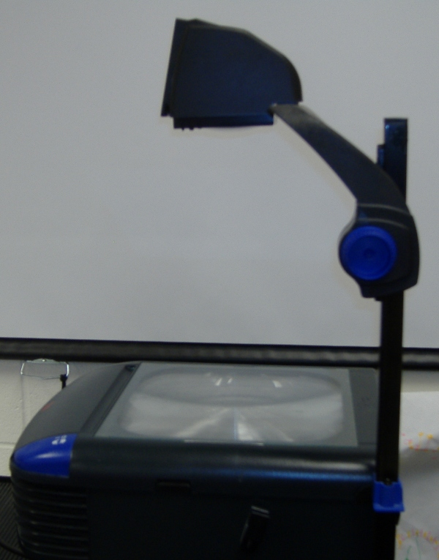

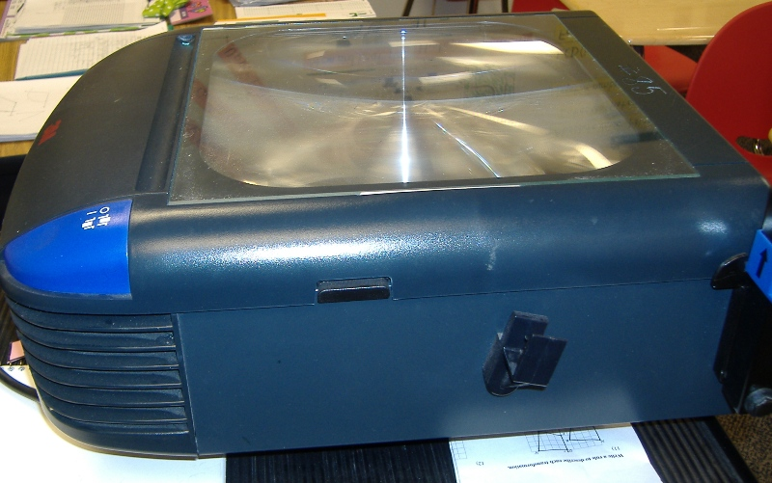
- Unplug the electrical switch.

- Find the button that releases the top plate of the over head.

- Press the button and pull the top plate up.

Release Button

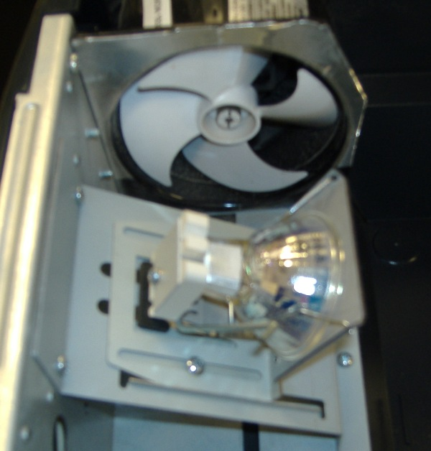

4. Remove the light bulb by pressing the lever down. Pressing the lever down will release the light bulb. Use two fingers and pull the light bulb out.

Lever to release light bulb

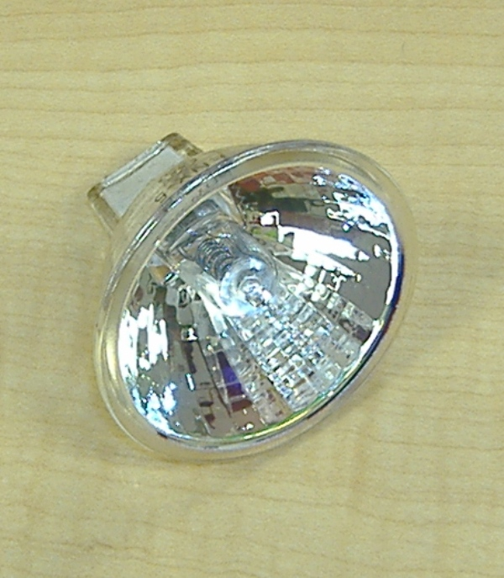

5. Get a new light bulb

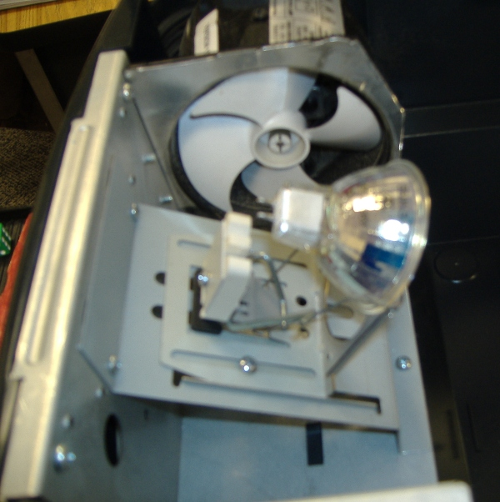
6. Slide the new light bulb into the grooves of the light fixture. Press firmly with your fingers to be sure it is locked in. Make sure the spokes are locked into the sockets.

7. Plug electrical cord back into the wall.

8. Turn switch on to make sure light bulb is working and to make sure the fan is running.

On/off switch

